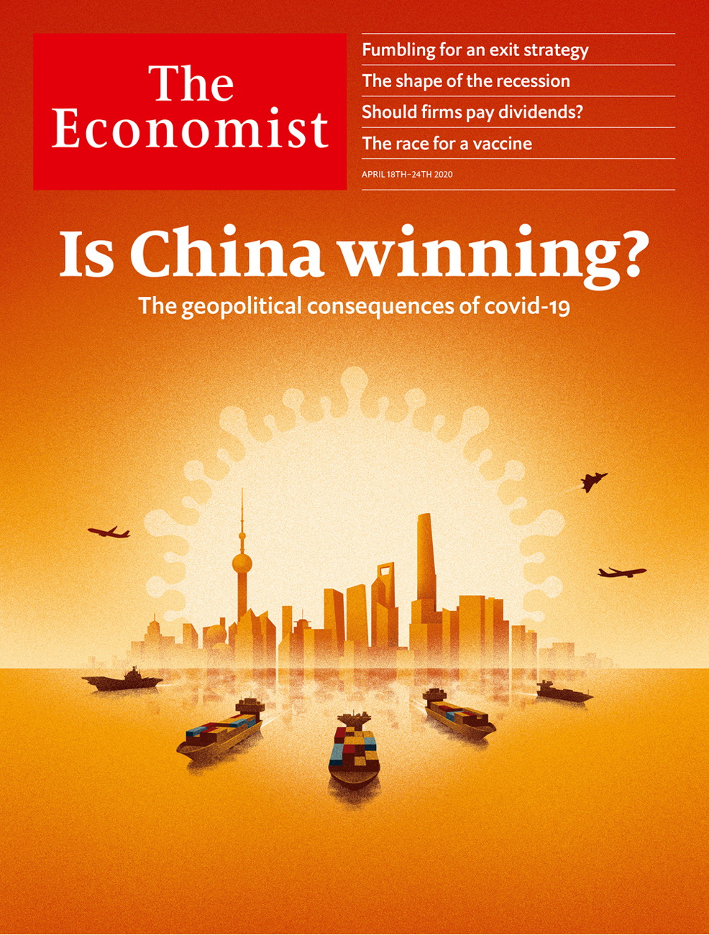

# Table of Contents

The world this week

Politics this week

Business this week

KAL’s cartoon

Leaders

China and covid-19: Is China winning?

The oil industry: A view of the future

Covid-19 lockdowns: Fumbling for the exit strategy

Should dividends be cut?: Jam postponed

Postal voting: Two myths

Letters

Letters to the editor: On Africa, covid-19, Mount Everest, Dutch swear words, podiums, exacting

Briefing

Creating immunity to covid-19: So many possibilities, so little time

Convalescent plasma and artificial antibodies: Survivors as saviours

United States

Coronavirus and inequality: Unequal protection

Violence and the virus: Ceasefire, for now

Revolution interrupted: Democrats in array

Military recruitment: Social climbing

Lexington: The paradox of the pandemic

The Americas

Mexico: Shoestring king

Bello: The light that flickers

Asia

Ethnic strife in Myanmar: Guerrillas with attitude

Informal workers and covid-19: Get sick or go hungry

Covid-19 in Japan: Déjà flu

Politics in South Korea: Infectious enthusiasm

Banyan: In hot water

China

Global influence: Thanking big brother

Chaguan: China’s self-censoring nationalists

Middle East and Africa

Public health: What South Africa learned from AIDS

Remittances and Africa: Covid dries up a cash cow

Gaming in the Middle East: Covideo heaven

The war in Yemen: Looking for an exit

Quackery in Iran: A bad time for bad medicine

Europe

Spain: A house divided

The coronabonds row: Dutch courage

Poland’s election: Epidemocracy

Wildlife encroaches in Italy: Rus in urbe

Charlemagne: Unlucky millennials

Britain

Covid-19: What went wrong?

Farm labour: Your polytunnel needs you

Care homes: Careless

Small business: The bank manager will see you now

Magazines: Glitz-krieg

Newspapers and covid-19: Breaking: news

Government debt: Printing money

Brexit negotiations: Extension rebellion

Bagehot: The establishment strikes back

International

How to end lockdowns: Emergency exit

Jobs at The Economist: We’re hiring

Business

Corporate fraud: Who’s lost their trunks?

ByteDance: Unabashed

Dividends and buy-backs: Chop chop

Non-essential retailers: Fashion victims

Bartleby: Lessons from the front line

Schumpeter: Slumbering serpents

The world after covid-19: By invitation: Mark Carney

Finance and economics

The recession in rich countries: Picking off the weak

Earnings on Wall Street: Dispatch from the front

China’s economy: Fighting with shadows

Finance and geopolitics: Bucking the trend

Buttonwood: A shrewd counterweight

Free exchange: The cost of living

Science and technology

Contact-tracing: A global microscope, made of phones

Disease transmission: Not so guilty

Climate change: Scorched earth

Global health: WHO’s in trouble?

Solitude and its consequences: Immunity from being alone

Books and arts

Covid-19 and entertainment: Sealed without a kiss

Tales of survival: Exodus and odyssey

Demography: The big ask

Lives of the plutocrats: The money tree

Johnson: Locked and learning

Home Entertainment: Listen to Bertrand Russell, the English Voltaire

Home Entertainment: The joy of making your own tortellini

Economic and financial indicators

Economic data, commodities and markets

Graphic detail

The internet and covid-19: Get used to it

Obituary

Hal Willner: Mr Music Man



### Friday, April 17, 2020

|  |  |
| --- | --- |
| The world this week | 3 |
| Leaders | 5 |
| Letters | 1 |
| Briefing | 2 |
| United States | 5 |
| The Americas | 2 |
| Asia | 5 |
| China | 2 |
| Middle East and Africa | 5 |
| Europe | 5 |
| Britain | 9 |
| International | 2 |
| Business | 7 |
| Finance and economics | 6 |
| Science and technology | 5 |
| Books and arts | 7 |
| Economic and financial indicators | 1 |
| Graphic detail | 1 |
| Obituary | 1 |

|  |  |  |
| --- | --- | --- |
|  | Sections | Leaders |

The world this week

Politics this week

.

Business this week

.

KAL’s cartoon

.

|  |  |  |
| --- | --- | --- |
|  | Sections | Leaders |

|  |  |  |  |
| --- | --- | --- | --- |
|  | Articles | Sections | Next |

# Politics this week

Apr 18th 2020 |

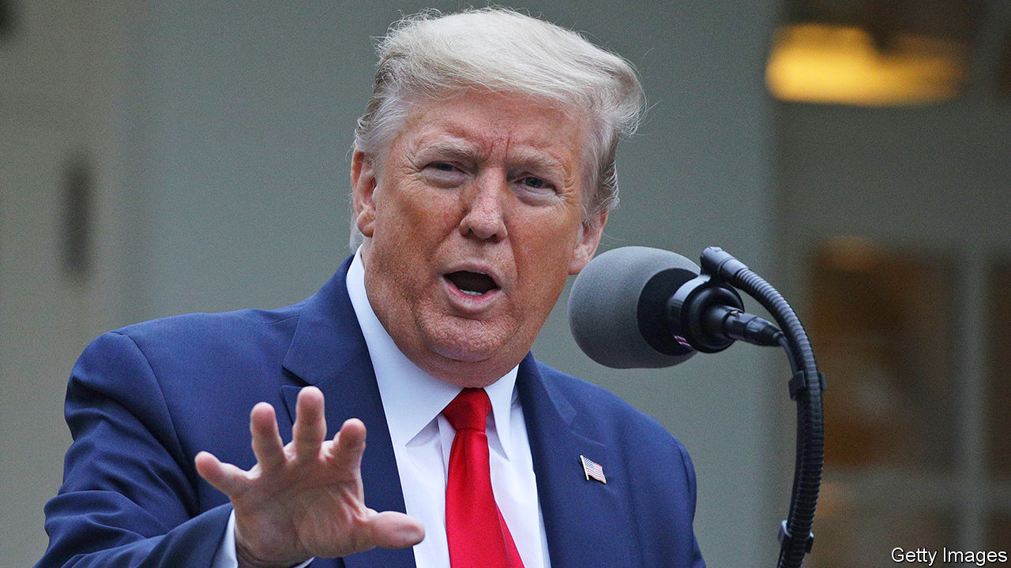

Donald Trump said that data suggested America was past the peak of the covid-19 outbreak, as he mooted guidelines to reopen the economy. The president created a council to look at the options, some of whose members were surprised to be included. Earlier he started a row with state governors who are trying to co-ordinate the lifting of some restrictions. He claimed they needed his permission; the constitution says they don’t. When a journalist asked Mr Trump what he had done all February to prepare for covid, he called her “disgraceful”.

Mr Trump said he would suspend American funding to the World Health Organisation, accusing it of pushing “China’s misinformation” on the coronavirus. See [article](https://www.economist.com/science-and-technology/2020/04/16/the-world-health-organisation-is-under-fire-by-americas-president).

Bernie Sanders bowed out as the sole remaining challenger to Joe Biden and endorsed his hitherto rival for president. Mr Sanders said he was endorsing Mr Biden now so they can unite the Democratic Party in trying to defeat Mr Trump in November’s election. See article.

A sailor serving on the USS Theodore Roosevelt died from covid-19. More than 600 crew members have now tested positive, including the former captain, who was sacked by the navy after he asked for help. He was fired for seeking assistance outside the proper lines of communication.

South Korea went ahead with legislative elections despite the covid-19 epidemic. Turnout was high. The ruling Minjoo (Democratic) party won an outright majority in the unicameral national assembly. Before the election Minjoo had been governing in coalition with several smaller parties. See article.

Migrant workers protested in Mumbai and other Indian cities as the government extended the country’s three-week-old lockdown by a further three weeks. The workers want to be able to return to their home villages, but are not able to because of the suspension of public transport. The government did relax restrictions on farming and construction work.

Bangladesh hanged Abdul Majed, one of a group of former army officers who killed the country’s founding father, Mujibur Rahman, during a military coup in 1975. Majed had been convicted of murder in absentia in 1998, and had been in hiding in India until last month. The current prime minister, Sheikh Hasina Wajed, is Mujib’s daughter.

The Saudi-led coalition fighting the Houthi rebels in Yemen began a unilateral two-week ceasefire aimed at stemming the spread of covid-19. Shortly after the move was announced, Yemen confirmed its first case of the virus (though it has carried out little testing). Years of war have devastated the country’s health system. See article.

Despite calls for a ceasefire in Libya, fighting between the internationally recognised government and forces led by Khalifa Haftar, a rebellious general, continued. The government seized two towns, Surman and Sabratha, on the coast. But it struggled to deal with a power cut in the besieged capital of Tripoli.

Iraq’s president nominated Mustafa al-Kadhimi, the intelligence chief, as prime minister. Mr Kadhimi is the third person tapped for the job since November, when Adel Abdul-Mahdi resigned under pressure from anti-government protests. The previous two nominees failed to win enough support in parliament to create a government.

Economic shutdowns are leading to food-price inflation and shortages in several African countries including Zimbabwe, Kenya and Sudan. Aid groups such as the World Food Programme are struggling to respond because of restrictions on movement.

Efforts to contain Ebola in the Democratic Republic of Congo suffered a setback with the emergence of three new cases, the first in 54 days.

The G 20 said its member governments would suspend loan repayments from developing economies until the end of the year. It encouraged private creditors to do the same. Separately, the IMF postponed repayments from 25 countries.

A group including American anti-drug agents and Interpol arrested one of Brazil’s most wanted suspected criminals, Gilberto Aparecido dos Santos (aka Fuminho), in Maputo, Mozambique’s capital. He allegedly trafficked cocaine worldwide as a leader of First Command of the Capital, a gang based in São Paulo, and evaded capture for 20 years.

Several European countries moved to ease their lockdowns. In Spain work was allowed to restart in some factories and on construction sites, and in Italy some small shops were allowed to re-open. Germany is allowing small shops to trade and schools to open; social-distancing measures remain in place. But France and Britain extended their lockdowns into May. Death tolls continued to rise across Europe, but in almost all instances at diminishing rates. See article.

The European Commission, stung by criticism that it has been absent during the crisis, outlined a roadmap that it hopes EU member states will follow to co-ordinate the easing of restrictions. EU ministers agreed on an aid package of up to €540bn ($590bn) for hard-hit countries. The European Central Bank had said up to €1.5trn was needed.

## Coronavirus briefs

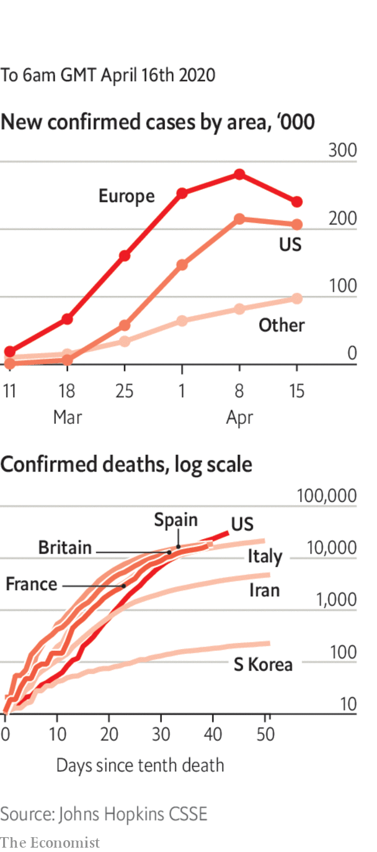

Boris Johnson was discharged from hospital, where he had been admitted to intensive care. The British prime minister is convalescing at Chequers, an official residence.

Taiwan reported no new coronavirus cases on April 14th, the first such interlude in more than a month. China recorded scores of new cases, including an increase caused by local infections. A cluster of cases was discovered on China’s north-east border with Russia.

Russia reported several record daily surges in new cases, bringing its total to 25,000.

New York City’s cumulative death toll soared past 10,000 as officials added 3,700 previously unrecorded deaths from the disease to the rolls. See article.

America’s Supreme Court said it would hold its first-ever hearings by telephone conference, starting next month.

This article was downloaded by calibre from <https://www.economist.com/the-world-this-week/2020/04/18/politics-this-week>

|  |  |  |  |
| --- | --- | --- | --- |
|  | Articles | Sections | Next |

|  |  |  |  |
| --- | --- | --- | --- |
| Previous | Articles | Sections | Next |

# Business this week

Apr 18th 2020 |

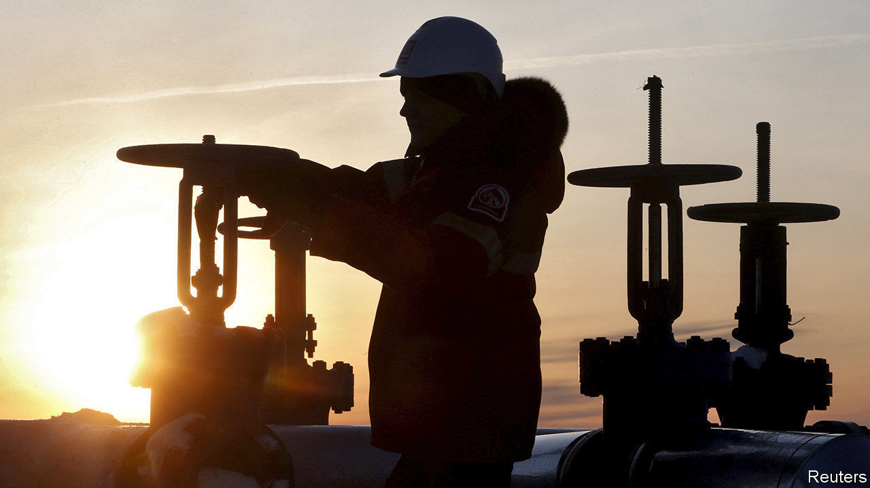

Saudi Arabia and Russia ended their oil-price war, agreeing to a deal that will see oil-producing countries cut output by a record 9.7m barrels a day over the next two months, around 10% of global supply. There will be smaller cuts thereafter. The rally in oil markets that greeted the announcement soon faded, however. The International Energy Agency forecast that global demand for oil will fall by 9.3m barrels a day in 2020. This month “may go down as Black April in the history of the oil industry”, said the head of the agency. See article.

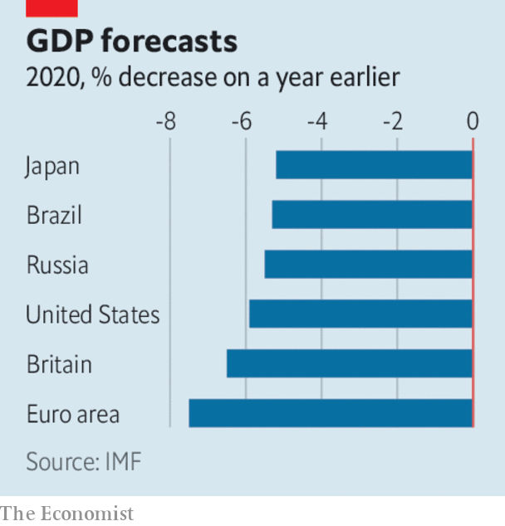

In its direst warning yet about the effects of the pandemic, the IMF said that “the great lockdown” will result in the biggest economic downturn since the Depression. Assuming that covid-19 and restrictions on daily life peak in the second quarter, the fund thinks global GDP will shrink by 3% this year, although advanced economies are expected to contract by an average 6.1%. If the crisis does not ease in the second half the world economy could shrink by a further 3%. The fund urged countries to continue with measures to slow the spread of the disease so that economic activity can resume. See article.

The Federal Reserve took more unprecedented measures to prop up the American economy, announcing a series of programmes that will provide $2.3trn in credit and support to households, businesses and state and local governments. The central bank is backing up to $600bn in loans to small and mid-sized firms, which must demonstrate a “reasonable effort” to retain staff. The Fed surprised markets by expanding its interventions to include buying stakes in exchange-traded funds that own risky, high-yield debt.

## Irrational exuberance

Stockmarkets continued to swing wildly. The S&P 500 had its best week since 1974 for the four days ending April 9th, rising by 12% (markets were closed on Good Friday).

At an emergency meeting South Africa’s central bank slashed its benchmark interest rate by another one percentage point, following a cut last month of the same size. The repo rate is now 4.25%, a record low. The move came after a further downgrade to credit ratings on South African debt, making it harder for the government to borrow.

The hard fall in China’s exports softened in March. Exports were down by 6.6% compared with the same month last year, much better than expected. China chalked up a trade surplus of $19.9bn, reversing the deficit of January and February, when factories were locked down. Many of those facilities have now reopened, though they face a squeeze from a global slump in consumer demand for their products.

China’s central bank took more steps to increase liquidity, pumping another 100bn yuan ($14bn) into the financial system ahead of the release of data expected to show the first quarterly contraction in GDP, year on year, since 1976.

The Asian Development Bank tripled the size of its aid package to member countries to $20bn. That includes some grants to governments to buy medical and personal protective equipment.

Retail sales in America fell by 8.7% in March compared with February, the biggest decline since the official run of data began three decades ago.

Releasing their first-quarter earnings, big banks in America revealed that they are putting billions aside to guard against an expected surge in loan defaults. JPMorgan Chase’s credit costs rose to $8.3bn in the quarter, for example, resulting in a sharp fall in net profit, to $2.9bn. See article.

America’s biggest airlines said they had agreed to the terms of a $25bn bail-out from the government. Under the deal dividends will be suspended. American Airlines is to receive a direct grant of $4.1bn, a low-interest loan of $1.7bn, and will apply for a separate $4.8bn loan from the Treasury.

In response to the surge in online shopping Amazon is employing another 75,000 staff, on top of the 100,000 additional workers it hired recently. In Seattle Amazon sacked two activist employees for continuing to post claims on Twitter that conditions at its warehouses during the pandemic are unsafe. In France Amazon closed its warehouses for cleaning after a court said it should do more to protect staff.

Amazon’s share price hit new highs. It is up by a third since mid-March, giving the company a market value of $1.15trn.

## Closing time

Forced to shut without much notice, Britain’s pub industry pondered what to do with an estimated 50m pints of beer lying undrunk in cellars. The rules have been relaxed on reclaiming tax for ullage, or wasted beer, so that the man from the brewery does not need to be present when it is disposed of, though social distancing is making it hard to lift the full kegs. With pubs closed, alcohol sales in supermarkets have soared.

This article was downloaded by calibre from <https://www.economist.com/the-world-this-week/2020/04/18/business-this-week>

|  |  |  |  |
| --- | --- | --- | --- |
| Previous | Articles | Sections | Next |

|  |  |  |  |
| --- | --- | --- | --- |
| Previous | Articles | Sections | Next |

# KAL’s cartoon

Apr 18th 2020 |

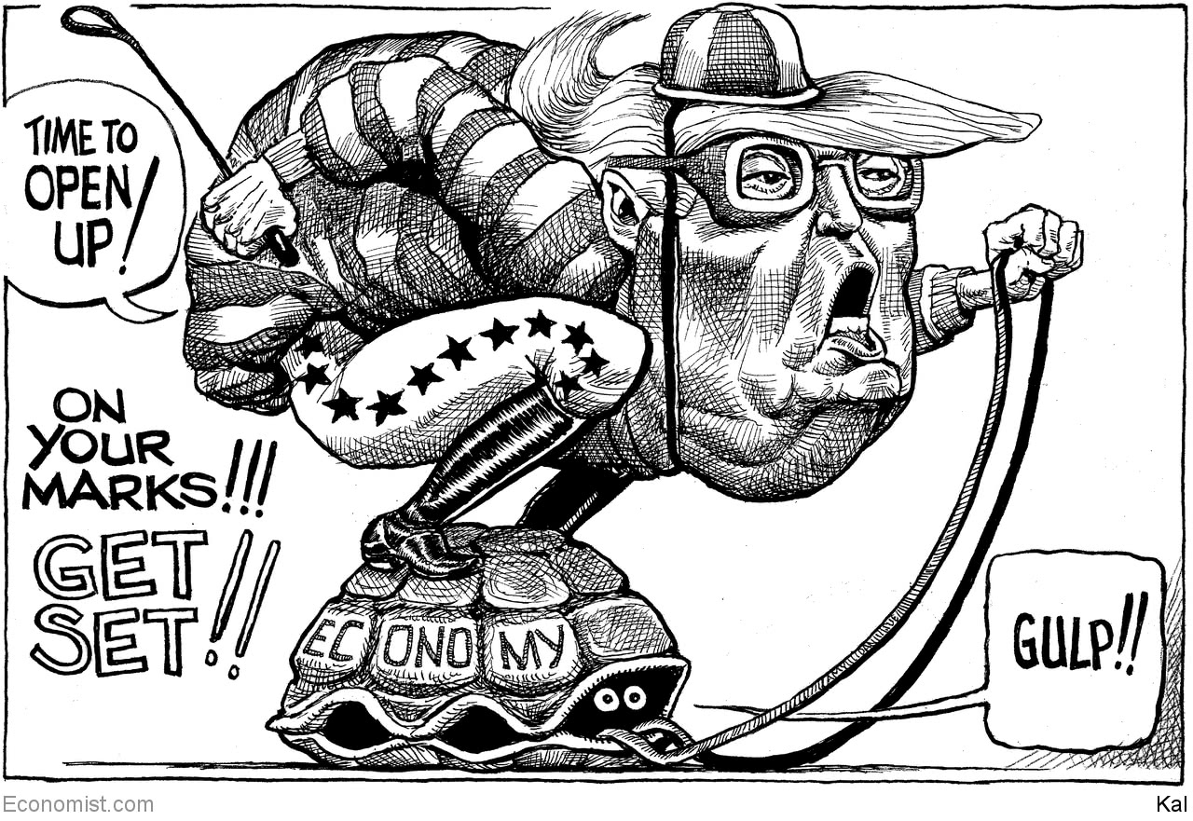

This article was downloaded by calibre from <https://www.economist.com/the-world-this-week/2020/04/18/kals-cartoon>

|  |  |  |  |
| --- | --- | --- | --- |
| Previous | Articles | Sections | Next |

|  |  |  |
| --- | --- | --- |
| The world this week | Sections | Letters |

Leaders

China and covid-19: Is China winning?

.

The oil industry: A view of the future

.

Covid-19 lockdowns: Fumbling for the exit strategy

.

Should dividends be cut?: Jam postponed

.

Postal voting: Two myths

.

|  |  |  |
| --- | --- | --- |
| The world this week | Sections | Letters |

|  |  |  |  |
| --- | --- | --- | --- |
|  | Articles | Sections | Next |

#### Pandemic geopolitics

# Is China winning?

The geopolitical consequences of covid-19 will be subtle, but unfortunate

Apr 16th 2020 |



Editor’s note: The Economist is making some of its most important coverage of the covid-19 pandemic freely available to readers of The Economist Today, our daily newsletter. To receive it, register [here](https://www.economist.com/newslettersignup). For our coronavirus tracker and more coverage, see our [hub](https://www.economist.com/coronavirus)

THIS YEAR started horribly for China. When a respiratory virus spread in Wuhan, Communist Party officials’ instinct was to hush it up. Some predicted that this might be China’s “Chernobyl”—a reference to how the Kremlin’s lies over a nuclear accident hastened the collapse of the Soviet Union. They were wrong. After its initial bungling, China’s ruling party swiftly imposed a quarantine of breathtaking scope and severity. The lockdown seems to have worked. The number of newly reported cases of covid-19 has slowed to a trickle. Factories in China are reopening. Researchers there are rushing candidate vaccines into trials (see Briefing). Meanwhile, the official death toll has been far exceeded by Britain, France, Spain, Italy and America.

China hails this as a triumph. A vast propaganda campaign explains that China brought its epidemic under control thanks to strong one-party rule. The country is now showing its benevolence, it says, by supplying the world with medical kit, including nearly 4bn masks between March 1st and April 4th (see article). Its sacrifices bought time for the rest of the world to prepare. If some Western democracies squandered it, that shows how their system of government is inferior to China’s own.

Some, including nervous foreign-policy watchers in the West, have concluded that China will be the winner from the covid catastrophe. They warn that the pandemic will be remembered not only as a human disaster, but also as a geopolitical turning-point away from America.

That view has taken root partly by default. President Donald Trump seems to have no interest in leading the global response to the virus. Previous American presidents led campaigns against HIV/AIDS and Ebola. Mr Trump has vowed to defund the World Health Organisation (WHO) for its alleged pro-China bias (see [article](https://www.economist.com/science-and-technology/2020/04/16/the-world-health-organisation-is-under-fire-by-americas-president)). With the man in the White House claiming “absolute power” but saying “I don’t take responsibility at all”, China has a chance to enhance its sway.

Even so, it may not succeed. For one thing, there is no way to know whether China’s record in dealing with covid-19 is as impressive as it claims—let alone as good as the records of competent democracies such as South Korea or Taiwan. Outsiders cannot check if China’s secretive officials have been candid about the number of coronavirus cases and deaths. An authoritarian regime can tell factories to start up, but it cannot force consumers to buy their products (see article). For as long as the pandemic rages, it is too soon to know whether people will end up crediting China for suppressing the disease or blaming it for suppressing the doctors in Wuhan who first raised the alarm.

Another obstacle is that China’s propaganda is often crass and unpleasant. China’s mouthpieces do not merely praise their own leaders; some also gloat over America’s dysfunction or promote wild conspiracy theories about the virus being an American bioweapon. For some days Africans in Guangzhou were being evicted en masse from their homes, barred from hotels and then harassed for sleeping in the streets, apparently because local officials feared they might be infected. Their plight has generated angry headlines and diplomatic rebukes all over Africa.

And rich countries are suspicious of China’s motives. Margrethe Vestager, the EU’s competition chief, urges governments to buy stakes in strategic firms to stop China from taking advantage of market turmoil to snap them up cheaply. More broadly, the pandemic has fed arguments that countries should not rely on China for crucial goods and services, from ventilators to 5G networks. The World Trade Organisation expects global merchandise trade to shrink by 13-32% in the short run. If this turns into a long-term retreat from globalisation—which was already a worry before covid-19—it will harm China as much as anywhere.

More fundamental than whether other countries are willing to see China supplant America is whether it intends to. Certainly, China is not about to attempt to reproduce America’s strengths: a vast web of alliances and legions of private actors with global soft power, from Google and Netflix to Harvard and the Gates Foundation. It shows no sign of wanting to take on the sort of leadership that means it will be sucked into crises all across the planet, as America has been since the second world war.

A test of China’s ambitions will be how it acts in the race for a vaccine. Should it get there first, success could be used as a national triumph and a platform for global co-operation. Another test is debt relief for poor countries. On April 15th the G20, including China, agreed to let indebted nations suspend debt payments to its members for eight months. In the past China has haggled over debt behind closed doors and bilaterally, dragon to mouse, to extract political concessions. If the G20’s decision means the government in Beijing is now willing to co-ordinate with other creditors and be more generous, that would be a sign it is ready to spend money to acquire a new role.

Perhaps, though, China is less interested in running the world than in ensuring that other powers cannot or dare not attempt to thwart it. It aims to chip away at the dollar’s status as a reserve currency (see article). And it is working hard to place its diplomats in influential jobs in multilateral bodies, so that they will be in a position to shape the global rules, over human rights, say, or internet governance. One reason Mr Trump’s broadside against the WHO is bad for America is that it makes China appear more worthy of such positions.

China’s rulers combine vast ambitions with a caution born from the huge task they have in governing a country of 1.4bn people. They do not need to create a new rules-based international order from scratch. They might prefer to keep pushing on the wobbly pillars of the order built by America after the second world war, so that a rising China is not constrained.

That is not a comforting prospect. The best way to deal with the pandemic and its economic consequences is globally. So, too, problems like organised crime and climate change. The 1920s showed what happens when great powers turn selfish and rush to take advantage of the troubles of others. The covid-19 outbreak has so far sparked as much jostling for advantage as far-sighted magnanimity. Mr Trump bears a lot of blame for that. For China to reinforce such bleak visions of superpower behaviour would be not a triumph but a tragedy. ■

Dig deeper:  
For our latest coverage of the covid-19 pandemic, register for The Economist Today, our daily [newsletter](https://www.economist.com/newslettersignup), or visit our [coronavirus tracker and story hub](https://www.economist.com/coronavirus)

This article was downloaded by calibre from <https://www.economist.com/leaders/2020/04/16/is-china-winning>

|  |  |  |  |
| --- | --- | --- | --- |
|  | Articles | Sections | Next |

|  |  |  |  |
| --- | --- | --- | --- |
| Previous | Articles | Sections | Next |

#### The OPEC oil deal

# The future of the oil industry

The oil slump is a glimpse of what is to come

Apr 18th 2020 |

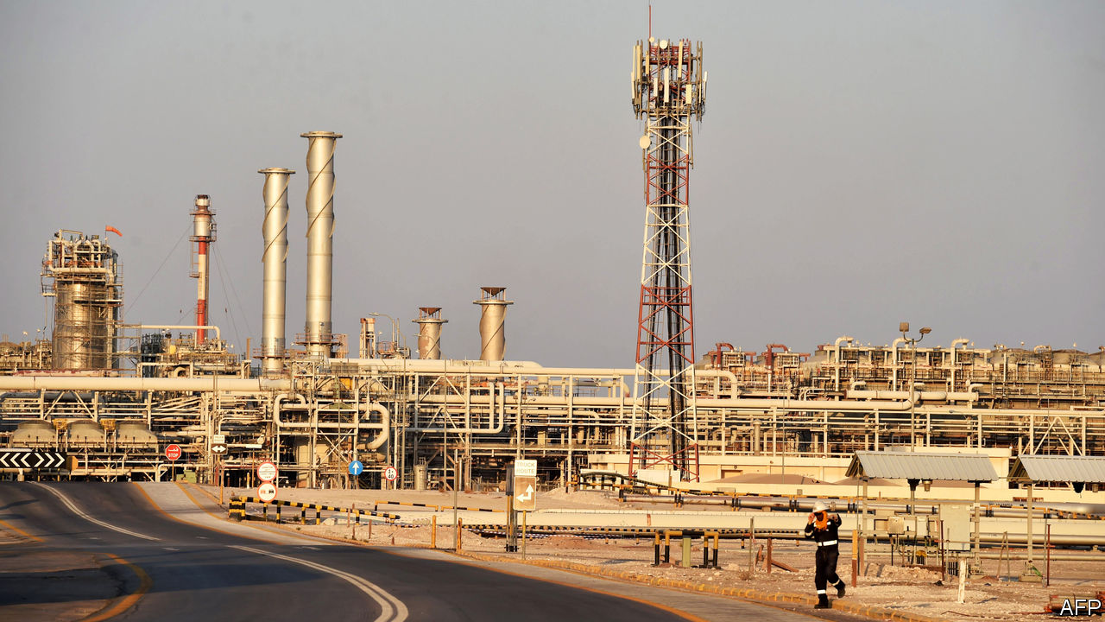

OIL, IT HAS been said, is the blood coursing through the veins of the world economy. In 2020 the economy is bleeding red. As covid-19 keeps workers at home and planes on the ground, demand for oil has fallen faster and further than at any point in its history. Amplifying the shock, a furious row between Saudi Arabia and Russia set off a price war in early March. Last month oil prices fell by more than half, leaving a giant industry reeling.

On April 12th the world’s energy superpowers broke bread and reached a new deal to try to prop up prices. The Organisation of the Petroleum Exporting Countries (OPEC) and its allies, including Russia, said they would slash production by 9.7m barrels a day from May to the end of June, a record, and restrain output for two years. In the 20th century Uncle Sam was keen to undermine OPEC, but in 2018 America became the biggest oil producer, ahead of Saudi Arabia and Russia. President Donald Trump’s re-election depends on the shale states of Texas, Pennsylvania and Ohio. He argued for the pact and said the industry would recover “far faster” than expected.

In fact private oil firms, state-controlled companies and countries that rely on energy exports should brace themselves for a long period of pain, and use the crisis to begin the restructuring that will have to take place if the planet is to deal with climate change.

This week’s grand bargain is unlikely to work. For a start the sums don’t add up. Global demand may fall by 29m barrels a day this month, three times the OPEC deal’s promised cuts. Private firms outside the alliance may reduce output, too, but by how much is uncertain. And no one knows when demand will pick up. Oil stockpiles are rising and storage capacity could be exhausted within weeks.

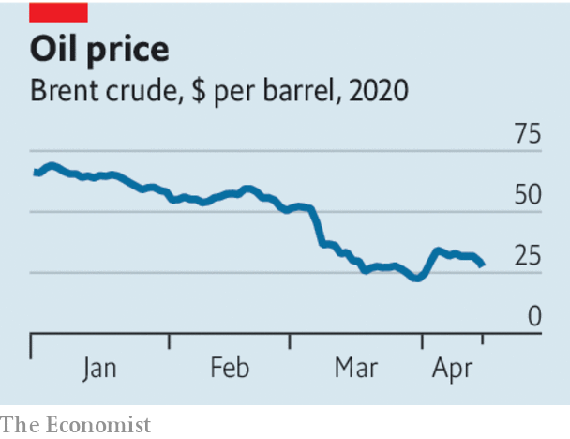

The alliance is shaky. Russia, the world’s second-biggest producer, has worked with OPEC since 2016 but routinely ignored the terms of deals. It is unlikely that America will permanently join OPEC in creating a new energy order. The new pact involves assurances that output will fall in America but Texan frackers respond to price signals and the profit motive, not government quotas. The deal almost fell apart when Mexico refused Saudi Arabia’s terms, illustrating how one country can prompt an unravelling. And Saudi Arabia continues to offer deep discounts on crude bound for Asia, a sign of its eagerness to defend its powerful position in oil’s most important market.

A last reason for scepticism is that the covid-19 crisis could further dampen long-term oil demand. Hundreds of millions of people are living through an experiment with home-working, fewer flights and less urban pollution. This could help change public opinion about the desirability of a faster shift from an economy built on fossil fuels.

Rather than stability, then, oil producers face volatile demand and production. Iran and Venezuela, already squeezed by American sanctions, will see more unrest. Countries with high costs and poor governance, such as Nigeria and Angola, face capital flight and balance-of-payments crises. Last year bankruptcies among American oil producers jumped by 50%. In 2020 that figure will soar.

Beyond this year a deeper adjustment awaits. Volatility will dampen investors’ appetite for new projects. Oil companies have already slashed capital spending by about 25% this year. Some pricey oil will be left underground for good. Shale’s frenetic growth will abate. Big oil exporters, including Saudi Arabia, will have to cut public spending and diversify.

For years the oil industry has faced the possibility that demand might fall, as governments moved to limit climate change. That threatened to heap chaos on oil producers, as capital dried up and companies battled for their share of a dwindling market. A peak in demand may still be years away. But oil producers should see covid-19’s turmoil for what it is: not an aberration, but a sign of what is to come.■

This article was downloaded by calibre from <https://www.economist.com/leaders/2020/04/18/the-future-of-the-oil-industry>

|  |  |  |  |
| --- | --- | --- | --- |
| Previous | Articles | Sections | Next |

|  |  |  |  |
| --- | --- | --- | --- |
| Previous | Articles | Sections | Next |

#### How to ease a covid-19 lockdown

# Fumbling for the exit strategy

Overwhelmed by the crisis, most governments are ill-prepared for what comes next

Apr 18th 2020 |

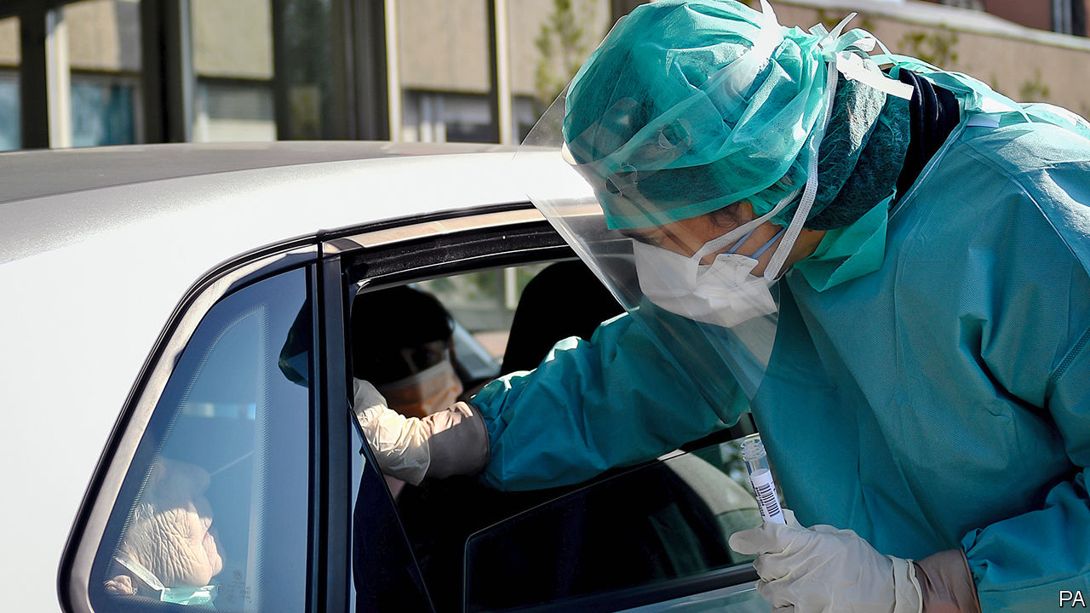

Editor’s note: The Economist is making some of its most important coverage of the covid-19 pandemic freely available to readers of The Economist Today, our daily newsletter. To receive it, register [here](https://www.economist.com/newslettersignup). For our coronavirus tracker and more coverage, see our [hub](https://www.economist.com/coronavirus)

SUDDENLY EVERYONE has a plan. Ideas for exiting the covid-19 lockdown are spreading faster than the virus ever did. Spain has let builders return to work, Italy has opened stationers and bookshops, Denmark is allowing children back into nurseries and primary schools. South Africa’s opposition is calling for a relaxed “smart lockdown”. In America President Donald Trump has been sparring with state governors over who should decide what reopens when.

Every country is different, but already two things are clear. First, governments need to explain to their people that the world is not about to return to normal. Without a vaccine or a therapy, life will be constrained and economies will remain depressed. Second, testing and contact-tracing are vital to keeping the virus at bay. Countries that failed to invest enough in them when the disease first emerged in China risk repeating the mistake.

The need to devise exit plans is urgent. The alarming cost of hard lockdowns is becoming clearer. This week the IMF forecast that extending full lockdowns well into the third quarter of 2020 would turn a 3% contraction of the world economy this year into a 6% one. An analysis by Norway’s covid-19 task-force, published on April 7th, compared an 18-month hard lockdown with a “slowdown” and concluded that the statistical value of the extra lives it saved would be dwarfed by its long-term cost.

And yet, however much exits are needed, they are also hard, because most of the world remains susceptible to a second wave of covid-19. Spain is the country with the highest number of recorded cases per head. Yet only a tiny share of the population has been infected. Even if the actual number of cases were 100 times higher than official numbers suggest, two-thirds of its population would still be vulnerable—more if immunity is short-lived. Lockdowns have been sold as a way to “beat” covid-19. In fact, they reset the clock. Having failed to stop the disease taking hold, countries have bought themselves a chance to try again. But unless they act differently the virus will surge once more.

What should they do? Governments need to choose from the menu of options by comparing the costs of each measure with the benefits it brings—and the calculus will differ in different countries. Should masks be mandatory? (Yes, if supplies are adequate.) Should schools take pupils back? (More research is needed.) Which industries can safely reopen? (Factories can; hospitality is harder.) Do you shut borders or quarantine travellers? (Quarantine is better.) Policies will evolve as the science improves or the disease flares up. Sometimes, that will mean tightening the rules again.

China offers a snapshot of what this means. Since restrictions were relaxed there the streets have filled up, many people have gone to back to work and life has become more liveable. However, consumers remain anxious so some of them stay at home. The talk is of a 90% economy (see article)—better than a 50% economy, certainly, but nonetheless the greatest global economic catastrophe since the 1930s.

Managing this part-locked-in, part-let-out world depends on testing. Testing can tell governments about the running rate of infections and which measures work and which do not. It isolates new cases, allowing the tracing of their contacts, helping arrest the spread of the disease. The better the testing, the less all-embracing the social distancing needs to be, because infected people are routinely removed from the population—in theory it could replace distancing altogether.

Governments talk about testing a lot. It will not be available on a truly mass scale for many months. One cheap substitute is taking temperatures, but people free of fever can still be infectious. Another idea, boosted by recent news of a collaboration between Apple and Google, is to use mobile-phone apps to log contacts automatically so that testing can be targeted on those people most likely to be infected. But the apps need to be widely downloaded to work and they still require vast numbers of testers and tracers to identify new infections and check that people are isolating themselves (see article). One proposal says that America will need 260,000 recruits, up from just 2,200 today (see article). Until governments begin to grapple with such numbers, exits will be underwhelming, dangerous even.

No wonder the world is racing for a vaccine (see Briefing). This is a global effort as it should be—no country has a monopoly on science. Again, though, to produce and distribute a vaccine fast and efficiently calls for hard work today. Without investment now, even before a vaccine has been proven, there will be a shortage of manufacturing capacity, disrupting routine vaccinations for diseases like measles and polio. For as long as there is a shortage some countries may try to corner the market, leaving health workers and the most vulnerable at risk elsewhere.

Talk of exiting lockdowns raises the spirits and justly so. Yet the frustrations and the hard choices are just beginning. ■

Dig deeper:  
For our latest coverage of the covid-19 pandemic, register for The Economist Today, our daily [newsletter](https://www.economist.com/newslettersignup), or visit our [coronavirus tracker and story hub](https://www.economist.com/coronavirus)

This article was downloaded by calibre from <https://www.economist.com/leaders/2020/04/18/fumbling-for-the-exit-strategy>

|  |  |  |  |
| --- | --- | --- | --- |
| Previous | Articles | Sections | Next |

|  |  |  |  |
| --- | --- | --- | --- |
| Previous | Articles | Sections | Next |

#### Payouts in a pandemic

# Which firms should pay dividends?

Dividends are a healthy part of capitalism. In the covid era, many firms should cut them

Apr 18th 2020 |

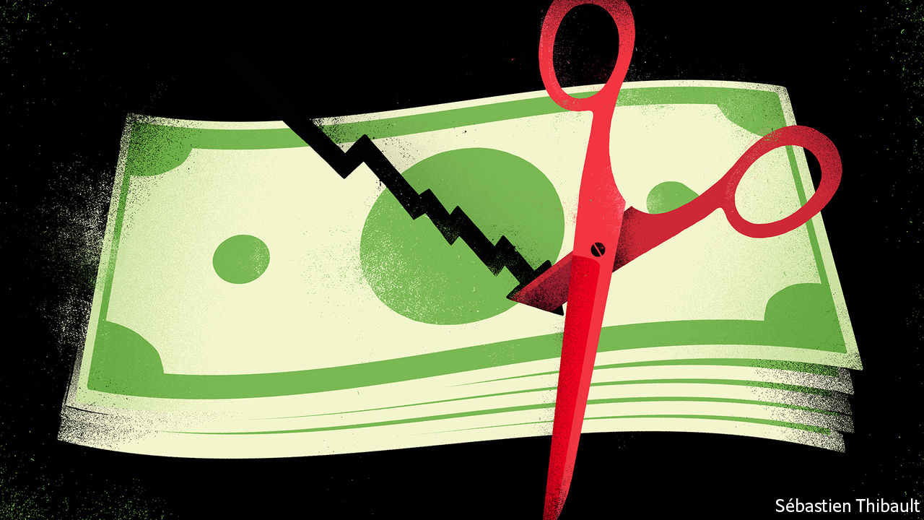

Editor’s note: The Economist is making some of its most important coverage of the covid-19 pandemic freely available to readers of The Economist Today, our daily newsletter. To receive it, register [here](https://www.economist.com/newslettersignup). For our coronavirus tracker and more coverage, see our [hub](https://www.economist.com/coronavirus)

OVER THE next month the toll that lockdowns are inflicting on businesses will become more visible as big Western companies report their first-quarter results and start to give investors a steer on what to expect for the rest of 2020. For some, bankruptcy beckons—this week America’s banks warned of a surge in bad debts as households and firms go bust (see article). Most companies will remain going concerns, but face a collapse in profits. As a result a fraught debate is taking place in boardrooms all over the world about whether firms should cut their dividends, the recurring payments they make to their owners.

That may sound like a technicality but it is not. Dividends and share buy-backs (another way of returning money to a company’s owners) amounted to $2.2trn last year for listed firms worldwide. A necessary feature of a market economy, they get a bad rap from those who think plutocratic shareholders are the outsized beneficiaries of modern capitalism. But retirement schemes depend on a steady stream of income from dividends to honour their commitments; if dividends are cut they may instead have to sell shares at exactly the wrong time, during a stockmarket slump. And when mature or cash-rich companies distribute excess cash it can be recycled into funding young companies or to firms whose balance-sheets need repair.

Companies are loth to make sudden, big changes to their dividend payments. Yet analysts reckon the total amount paid to shareholders could drop by 30% or more this year. The pressure to cut comes because lower profits make payouts less affordable; because governments, reasonably, want some firms to preserve their cash and capital buffers; and because many bosses, haunted by the public backlash against bank bail-outs in 2008-10, worry about being seen to be paying out billions during a crisis.

What to do? The dividend debate can be solved by sorting companies into three buckets. In the first are systemically important firms where cuts should be required by governments. Any firm that receives a bespoke or disproportionately large taxpayer bail-out should automatically fall into this category: airlines, for example. Taxpayers should be repaid before investors are entitled to a reward. This does not mean, however, that companies that have taken advantage of stimulus measures available to all firms—such as furlough schemes or central-bank liquidity—should be made to cut payouts. There is no need to disrupt the economy more than is already the case.

Banks also belong in the first category, because the money they pay out could instead be used to support more lending. Regulators in the euro area and Britain have already enforced dividend bans. American banks have stopped share buy-backs but nearly all are sticking with paying dividends, which amount to about $55bn a year. The Federal Reserve, which regulates lenders, should nip this corporate bravado in the bud. Although banks are a lot better capitalised than in the past the crisis will be a strain. One of the biggest American lenders, Wells Fargo, has just reported that its profits dropped by 99% in the first quarter compared with a year earlier. Remember that taxpayers are on the hook should the financial system totter.

In the second bucket are firms that are stretched but feel that keeping up reliable dividends sends an important signal. The danger here is that they rack up debts in order to do so. That strategy might sound mad but could in fact become common. Roughly a quarter of big listed European and American firms are forecast to make lower profits in the next quarter than needed to sustain their dividends. Several of the oil supermajors may end up choosing to borrow in order to pay dividends. Boards should think twice. The cash payments they promised their firms’ owners were implicitly predicated on business-as-usual—and can surely wait until business does indeed return to usual.

In the third bucket are a group of businesses that have strong balance-sheets and are operating near full tilt, for example tech firms and other utilities. They should pay dividends, rather than hoard cash, even if it provokes ill-judged grumbles from some quarters. That money can help maintain the incomes of pensioners and other savers. And investors can use the cash they receive to recapitalise companies whose finances have been shattered by the covid-19 crisis. There will be a lot of them. ■

Dig deeper:  
For our latest coverage of the covid-19 pandemic, register for The Economist Today, our daily [newsletter](https://www.economist.com/newslettersignup), or visit our [coronavirus tracker and story hub](https://www.economist.com/coronavirus)

This article was downloaded by calibre from <https://www.economist.com/leaders/2020/04/18/which-firms-should-pay-dividends>

|  |  |  |  |
| --- | --- | --- | --- |
| Previous | Articles | Sections | Next |

|  |  |  |  |
| --- | --- | --- | --- |
| Previous | Articles | Sections | Next |

#### Two myths

# America should prepare now for voting by mail in November’s election

Opposition to absentee voting is based on a pair of misconceptions

Apr 18th 2020 |



ONE OF Donald Trump’s special talents is to hold every conceivable position on a given subject at the same time. So it is with voting by mail in American elections. The president used a postal ballot to vote in Florida’s Republican primary last month. He has also denounced postal voting as an invitation to fraud. He has said voting by mail “doesn’t work out well for Republicans”. And he has said that postal voting should be expanded for older voters and for members of the armed forces, two groups he assumes would favour him in November.

The president’s interventions have turned something that should be uncontroversial into yet another excuse for partisan warfare. America has a presidential election this year. It also has thousands of congressional, state, county and mayoral elections. As the country with the most recorded cases of covid-19, it needs to start planning in case voters cannot get to polling stations. There is only one practical way to hold elections under these circumstances: to expand the use of voting by mail.

This ought not to be hard. All states let ill or absent voters post their ballots. Five states already allow everyone to post their vote in any election. A further 16 states allow it for some elections or in some remote counties where getting to a polling station requires a long drive. These states have accumulated experience that others can learn from, in particular when it comes to reducing the opportunities for voting fraud that can come with mail-in elections.

In 2018 a Republican strategist in North Carolina allegedly collected and spoiled absentee ballots, which led to a re-run of a congressional election. Back in 1998, 18 people were arrested over a scam involving postal votes in Miami’s mayoral election. Such incidents are serious but exceptionally rare. Between 2000 and 2012, a period in which billions of votes were cast, America saw 491 cases of absentee-voting fraud. During that same period 497 Americans were killed by lightning. In Britain, where anyone can request a postal vote, the electoral commission has warned of the possibility of electoral fraud, though it has not recently found much evidence of it actually taking place.

If Americans had to choose between a slightly increased risk of electoral fraud or cancelling the elections altogether, it would be a straightforward decision. But they don’t. States such as Oregon and Colorado, which allow everyone to vote by mail in every election, have developed sophisticated techniques, which make fraud even more unlikely.

In Colorado, for example, voters can track their ballots through each stage of the electoral process, opting to receive a text message when their ballot is mailed, when it is returned, and when it has been counted. Oregon reckons that it has dispatched 100m postal ballots since 2000, and seen fewer than a dozen cases of electoral fraud.

The second argument against postal voting—that it is supposedly better for Democrats—ought not to matter. Both parties should want as many people as possible to participate in their democracy. Politically, though, it does—because if Republicans think that voting by mail will disadvantage them, they will block federal efforts to fund it, or state-level initiatives to introduce it.

Fortunately the suspicion that postal voting is a Democratic plot is unfounded, too. The most comprehensive recent study of the political effects of introducing voting by mail, which comes from academics at Stanford, compared results from elections as absentee voting was rolled out across the states that now use it, between 1996 and 2018. It found that the reform increased turnout but did not benefit either party disproportionately.

How to hold an election in less than seven months’ time might not seem like a pressing problem when there is so much else going on. Yet election officials from states that already know how to run socially distanced elections warn that it takes time to build the systems needed to make voting by mail secure, and to train people to use them. If America wants to be certain of carrying out a proper national election in November the time to start preparing is not October. It is now.■

This article was downloaded by calibre from <https://www.economist.com/leaders/2020/04/18/america-should-prepare-now-for-voting-by-mail-in-novembers-election>

|  |  |  |  |
| --- | --- | --- | --- |
| Previous | Articles | Sections | Next |

|  |  |  |
| --- | --- | --- |
| Leaders | Sections | Briefing |

Letters

Letters to the editor: On Africa, covid-19, Mount Everest, Dutch swear words, podiums, exacting

.

|  |  |  |
| --- | --- | --- |
| Leaders | Sections | Briefing |

|  |  |  |  |
| --- | --- | --- | --- |
|  | Articles | Sections | Next |

#### On Africa, covid-19, Mount Everest, Dutch swear words, podiums, exacting

# Letters to the editor

A selection of correspondence

Apr 18th 2020 |

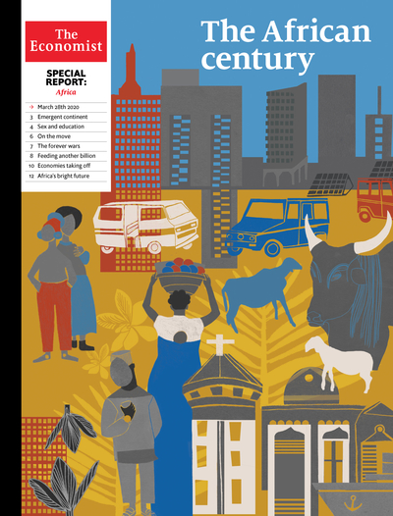

## The youth of today

Africa’s population is indeed large, young and rapidly increasing ([Special report on the African century](https://www.economist.com/special-report/2020/03/26/africa-is-changing-so-rapidly-it-is-becoming-hard-to-ignore), March 28th). But it is the ratio of working-age people to dependents that is important, and that ratio is not increasing. At low levels of development the ratio boosts economic growth, given the contribution that a growing labour pool makes to national productivity. The ratio reduces in importance once countries become middle- and high-income economies.

Because of its extraordinarily young population, Africa will get to its demographic dividend—1.7 working-age people to every dependent—only at mid-century. Until then Africa’s very large number of children actually serves as a drag on development. The large demand for education means that governments have to focus on building more schools and associated infrastructure. As a result, there is little ability to improve the quality or quantity of teaching provided to those already in the system. In fact, the gap in schooling between Africa and the rest of the world has not narrowed but is as concerning now as it was 30 or 50 years ago.

Advancing Africa’s demographic dividend is key. This can be achieved mainly through the empowerment of women, providing education (secondary schooling in particular) and rolling out access to modern contraceptives.

JAKKIE CILLIERS  
Head of African futures and innovation  
Institute for Security Studies  
Pretoria, South Africa

According to the World Bank GDP per person (at PPP) crept up from $2,000 to $4,000 in sub-Saharan Africa over the past 30 years. During the same period GDP per person rose from $15,000 to $43,000 in the European Union. However, the EU’s population is set to drop over the rest of this century. Sub-Saharan Africa’s population is expected to explode, to about 4bn people. It is difficult to put a positive economic spin on this.

JOHN HOLLAWAY  
Ashford, Surrey

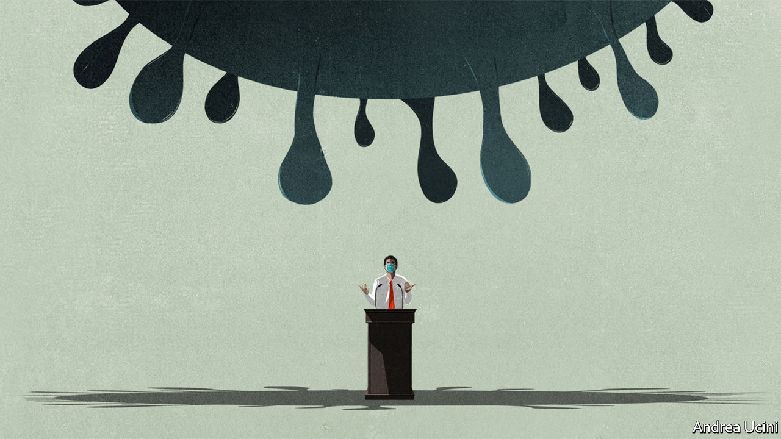

## Keep calm and carry on

I am a huge fan of The Economist. As we all navigate this pandemic, I would like to urge world leaders to keep their cool and do the right thing (“[The politics of pandemics](https://www.economist.com/leaders/2020/03/12/the-politics-of-pandemics)”, March 14th). We all make mistakes, so let’s be more forgiving. Let’s keep perspective and stick to the facts. Let’s avoid sensationalist headlines that promote fear. What is the point of could have, would have, should have? It doesn’t matter. We are doing it now. More than 90% of those who are infected fully recover and they are the source of a cure or vaccine. The saddest aspect is the worry that increasing surveillance will breed distrust among friends, neighbours and family. We all know what fear does to a community. The increased stress and anxiety can cause long-lasting crippling effects.

Please, let’s not get sidetracked from the goal at hand.

JIHYUN CHO  
Hong Kong

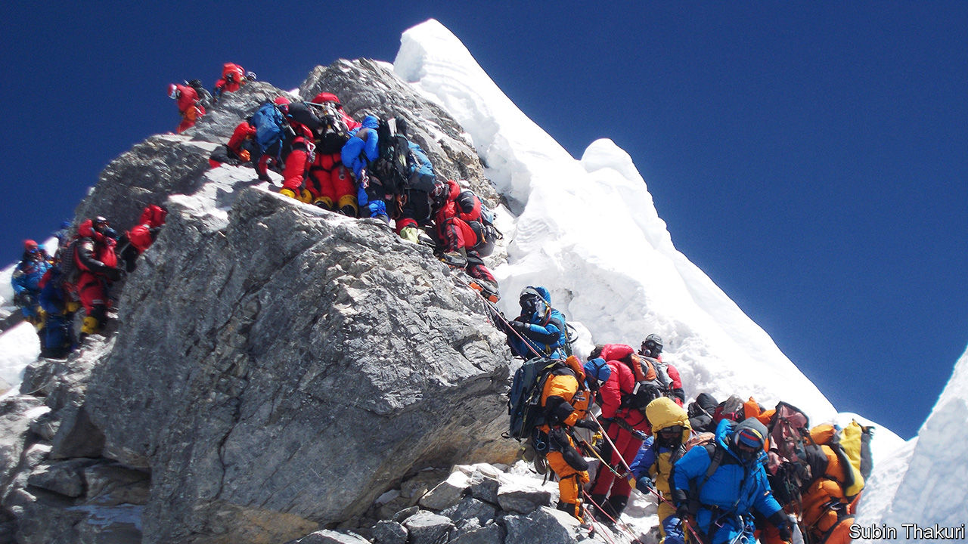

## The top of the world

The crowding and environmental damage on Everest, both on the mountain and throughout the Khumbu region, are contrary to the commitments each country has made in accepting the area’s World Heritage status (“[High and climbing](https://www.economist.com/asia/2020/03/12/new-rules-to-limit-numbers-on-everest-are-delayed)”, March 14th). “Because it is there” has lost its original meaning of almost a century ago. A few years before his death, Sir Edmund Hillary urged the Nepalese government to close Everest to climbing for a number of years, but he was ignored. Any death on the mountain that is caused by overcrowding rather than by the natural hazards of this formidable challenge is unacceptable. The waste being deposited, including dangerous drugs, is deplorable. Some splendid clean-up work is being carried out by joint teams of Nepalese and overseas climbers. Most encouraging is the Mount Everest Biogas Project, spearheaded by Dan Mazur and Garry Porter. If sufficiently funded their solar-powered composting facility could alleviate the cultural, health and aesthetic problems caused by human waste on and around this sacred peak.

Everest is off limits now because of covid-19, but closing it completely is not the answer for a country heavily dependent on tourism.

JACK IVES  
Former director  
United Nations University Mountain Project, 1978-2002  
Ottawa, Canada

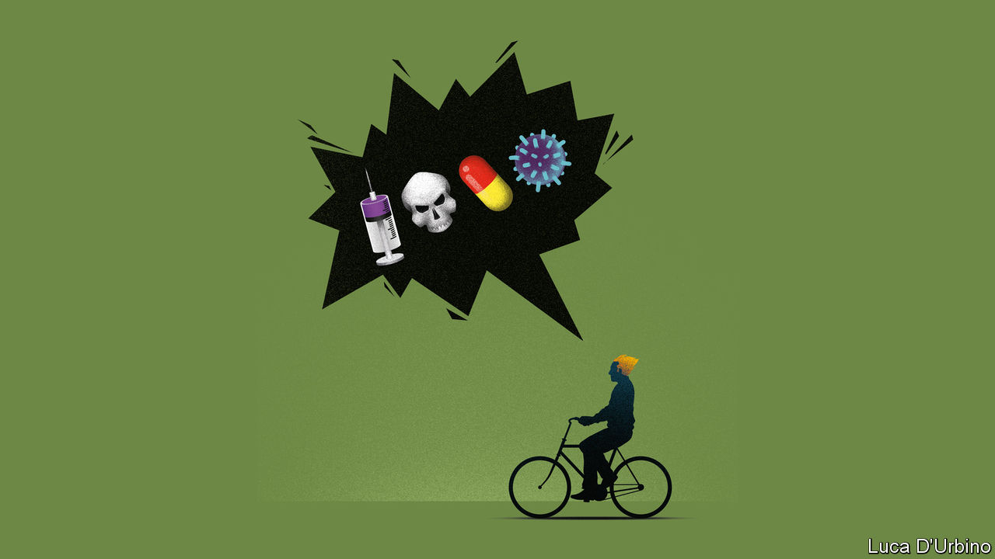

## Vox pox

Your intriguing article on why so many Dutch swear words relate to disease instead of sex made me wonder why in Belgium, where most people speak the same language, people do not use the same curses (“[Dutch disease](https://www.economist.com/europe/2020/03/26/why-dutch-swear-words-are-so-poxy)”, March 28th). In the 16th century, after the Calvinist revolt and the separation of the Netherlands, our histories diverged and the south experienced a vigorous counter-reform under the Spanish monarchy.

As a result, swearing in Dutch-speaking Belgium relates to the Catholic religion: loop naar de duivel (go to the devil), Godverdomme (Goddamn), and so on. But of late, youngsters in both countries use the same American street English they pick up from television, cinema, festivals, etc. So that after so many centuries they are once again united, at least in swearing.

ANDRÉ MONTEYNE  
Former liberal MP  
Brussels

Ironically, that English four-letter word starting with an f may well have originated from the Dutch fok, meaning to breed. It was re-adopted with an interesting twist. Instead of using the English word literally, Dutch youths domesticated it into their native fok. A fine example of how modernisation can sometimes marry the old fashioned.

FREDERIK OEGEMA  
Deventer, Netherlands

On your suggestion that one day we will have coronalijer doing the rounds in Dutch playgrounds, I would like to add “corona train wreck”. This could apply to the performance of our finance minister during the pandemic, such as when he called for an investigation into countries without the financial ability to weather the crisis. This combination of pettiness and poor timing torpedoed an excellent opportunity to promote the spirit of the EU and pull together.

WYNAND HOOGERBRUGGE  
Sotogrande, Spain

## Taking a stand

Et tu The Economist, that you don’t know the difference between a podium and a lectern. Joe Biden was not “standing behind a podium” at his home to deliver a message to supporters (“[Electoral distancing](https://www.economist.com/united-states/2020/03/19/joe-biden-builds-an-insurmountable-lead)”, March 21st). You stand on a podium and behind a lectern. Signed: a fusspot.

EBERHARD NEUTZ  
Laguna Beach, California

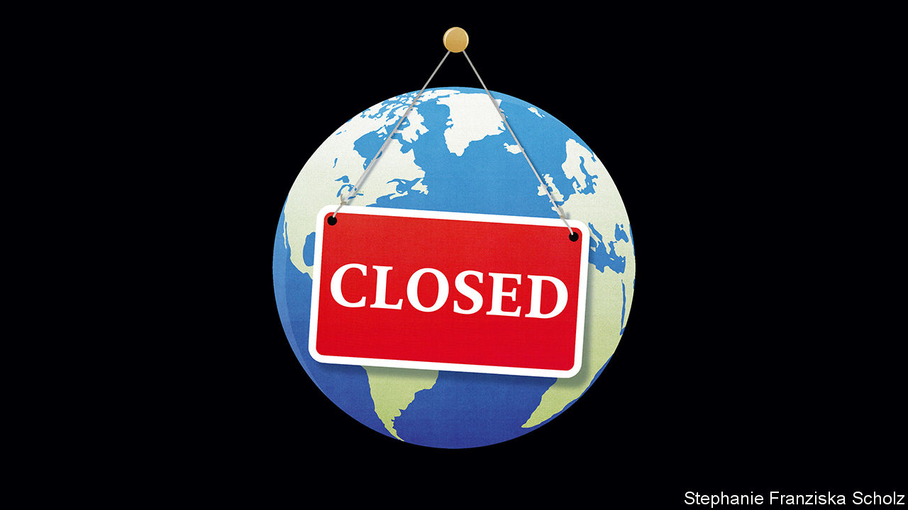

## To be exact

Your recent leader on paying for the pandemic said that such measures will still not prevent the coronavirus from “extracting a heavy toll” (“[Closed](https://www.economist.com/leaders/2020/03/19/paying-to-stop-the-pandemic)”, March 21st). The correct expression should be “exacting” a heavy toll. “Extracting a toll” is an eggcorn, a misheard word or phrase that retains its original meaning. Thanos, a supervillain, said “this day extracts a heavy toll” in “Avengers: Infinity War”. So I guess now we are stuck with it.

MARTHA GROVES  
Los Angeles

This article was downloaded by calibre from <https://www.economist.com/letters/2020/04/18/letters-to-the-editor>

|  |  |  |  |
| --- | --- | --- | --- |
|  | Articles | Sections | Next |

|  |  |  |
| --- | --- | --- |
| Letters | Sections | United States |

Briefing

Creating immunity to covid-19: So many possibilities, so little time

.

Convalescent plasma and artificial antibodies: Survivors as saviours

.

|  |  |  |
| --- | --- | --- |
| Letters | Sections | United States |

|  |  |  |  |
| --- | --- | --- | --- |
|  | Articles | Sections | Next |

#### So many candidates, so little time

# Can the world find a good covid-19 vaccine quickly enough?

And can it mass produce it fairly if it does?

Apr 16th 2020 |

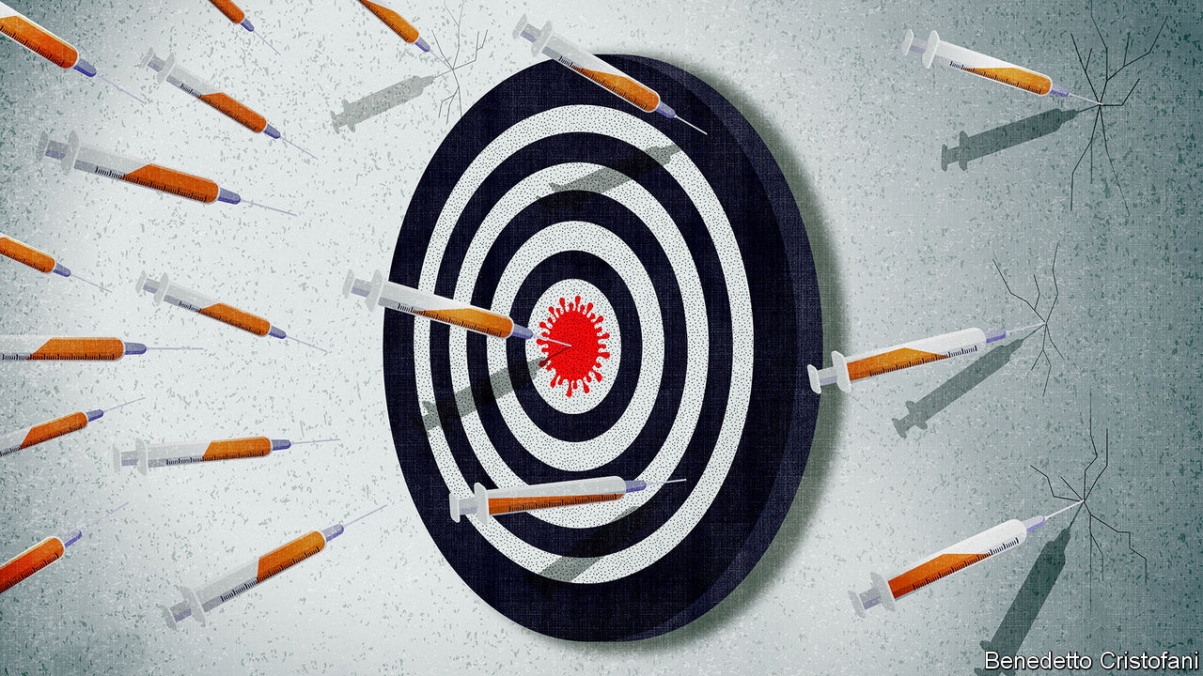

Editor’s note: The Economist is making some of its most important coverage of the covid-19 pandemic freely available to readers of The Economist Today, our daily newsletter. To receive it, register [here](https://www.economist.com/newslettersignup). For our coronavirus tracker and more coverage, see our [hub](https://www.economist.com/coronavirus)

THE EBOLA outbreak which began in 2013 was the largest the world has ever seen; over three years it killed more than 11,000 people in Guinea, Liberia and Sierra Leone. It also saw the first human trials of a vaccine against the disease.

In the late 1990s, Canadian scientists trying to understand how Ebola worked had put some of its genes into the genome of a normally harmless virus and injected it into mice. The mice did not become sick, as the scientists had expected; instead they became immune to Ebola. By 2005 that serendipitous development had become a vaccine that could plausibly be given to humans. But there were no Ebola outbreaks that needed it.

As the west African Ebola outbreak gathered speed in 2014 the Wellcome Trust, a British funder of medical research, put that vaccine into early safety trials, also known as phase I trials, in healthy volunteers in Britain, Kenya, America and elsewhere. By the middle of 2015, its efficacy was being tested in phase III trials in Guinea, where it was declared a success. That vaccine—rVSV-ZEBOV (Ervebo)—is now approved for use around the world.

For a vaccine to get from phase I to phase III trials in just ten months, as rVSV-ZEBOV did, was unheard of at the time—a startling example of what urgency and organisation can do. Now a repeat performance, ideally taken at an even faster tempo, is the sum of the world’s desire. In the middle of April more people are dying of covid-19 every three days than died of Ebola in west Africa over three years. A vaccine would not just save lives; it would change the course of the pandemic in two separate, if related, ways. It would protect those who were vaccinated from getting sick; and by reducing the number of susceptible people it would prevent the virus from spreading, thus also protecting the unvaccinated.

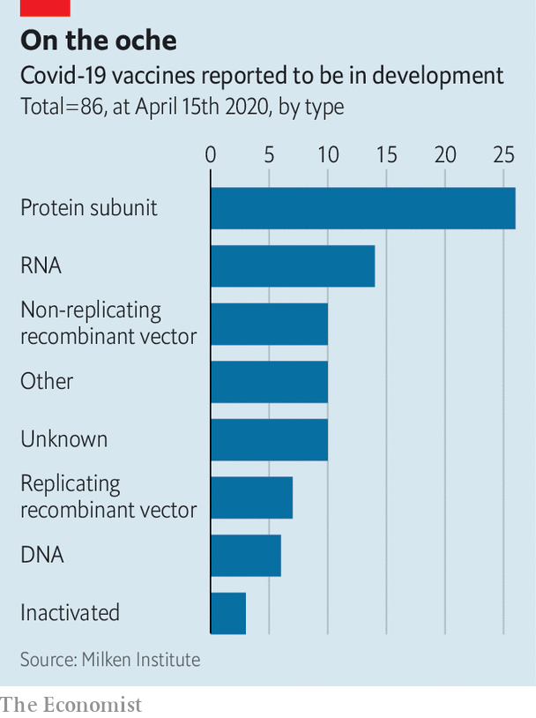

There were no pre-existing vaccine candidates handily squirrelled away when the genetic sequence of SARS-CoV-2, the virus which causes covid-19, was published on January 10th. But science moves pretty quickly these days. There are reports of some 86 candidate vaccines against SARS-CoV-2 being developed around the world, taking a wide array of approaches (see chart). Three have already started phase I trials. One of these, made by CanSino Biologics, a Chinese biotechnology company, in collaboration with a unit of China’s Academy of Military Medical Sciences run by Chen Wei, a major-general feted in the media, has been approved for phase II trials, which are designed to find out if a vaccine can provoke an immune response that might fight off the virus. It is recruiting 500 volunteers in Wuhan.

That one or more of these many efforts will lead to a working vaccine seems quite likely. Vets have been using vaccines to protect farm animals against coronaviruses for years. In most people infected with SARS-CoV-2 the immune system is quite capable of dealing with the virus; that is why they do not get sick. Among those who do, in most cases the immune system eventually rids the body of the virus. An immune system forewarned by a vaccine should be able to do so better and quicker.

But it is not enough that a vaccine be feasible. The job of making it available around the world will be just as taxing. A candidate which goes on to become a practical vaccine may be identified before the end of summer—perhaps more than one. But showing how well it works, finding any rare problems it may encounter, and manufacturing it in quantities large enough for the whole world will still take time. Melinda Gates, who with her husband has spent tens of billions of dollars on vaccines through the Bill and Melinda Gates Foundation, has suggested that getting a covid-19 vaccine ready and distributed could take 18 months.

In terms of human welfare, what matters is making that time as short as safely possible. In terms of prestige and politics, though, who gets to do it matters a lot, too. Producing an effective SARS-CoV-2 vaccine will be a huge feather in the cap of the researchers, companies and nations responsible. If the cap in question is Chinese, as it could well be, the development will be presented as a triumph both of Chinese science and the Chinese system; mutatis mutandis, something similar will be true for any other country, too.

The identity of the successful team may not just matter in terms of prestige. The demand for a vaccine that provides reliable and safe protection to whole populations will be huge. The world currently makes over 5bn doses of vaccine a year, of which roughly 1.5bn are seasonal-flu vaccines. Some companies and governments are already adding capacity in advance of a SARS-CoV-2 vaccine being developed. But without knowing which vaccine approach will do best, there is a limit to how much capacity can be readied beforehand.

If vaccine production capacity is constrained, the politics of vaccination may get nasty. An optimum strategy for using limited stocks of vaccine in a way that best benefits the world might see them devoted to populations at particular risk. But a country with a lead in vaccine manufacture might prefer to devote its limited stocks to universal coverage for its own citizens, securing a narrow advantage for itself at the cost of a broader loss to the world. As Richard Hatchett, who runs the Coalition for Epidemic Preparedness Innovations (CEPI), an NGO, puts it, “Countries are in a real-world prisoner’s dilemma.”

## Antigen-X

At the heart of every vaccine is an antigen, so-called because it is the thing which provokes the body to generate antibodies as well as other immune responses. When a cell that has been infected by a virus is forced to make viral proteins, it will display bits of those proteins as antigens on its surface, waving them around like little flags to draw the attention of the immune system.

This is not the only way antigens come to the system’s attention. Some of its cells engulf virus particles, or just bits of them, without getting infected, and process them into antigens. When those antigens are in turn presented to other immune cells, the production of antibodies gets under way.

Antibodies are proteins that stick to the antigen wherever they may find it. In so doing, they prevent virus particles from infecting other cells and flag them up for destruction. Building up a full immune response against a previously unencountered virus’s antigens in this way takes time. Covid-19 patients typically do not start producing antibodies until they are in their second week of symptoms.

Before the advent of genetic engineering, doctors had three ways to let the immune system get acquainted with viral antigens it needed to know about. They could present it with a strain of the virus, or a related virus, that was capable of infecting cells but had been hobbled in some way so as not to cause sickness—what is called a live-attenuated vaccine. This is the approach taken with many of the more common established vaccines, such as those against measles, mumps and rubella. Alternatively they could present it with a virus that had been inactivated, and thus could not cause infection. This was the path to the Salk polio vaccine, and is the technique used for seasonal-flu jabs. Finally they could present it with the antigen itself, harvested from the blood of those infected—the approach originally taken to make the hepatitis B vaccine.

Two of these approaches are being investigated for use against SARS-CoV-2. A live-attenuated vaccine in which the SARS-CoV-2 genome is “deoptimised” is being developed by Codagenix, an American biotech company, in collaboration with the Serum Institute of India. Sinovac Biotech, based in Beijing, is following the inactivated route. During the SARS outbreak of 2003, Sinovac created a vaccine against the coronavirus responsible—SARS-CoV, which is closely related to SARS-CoV-2—which used inactivated virus particles. The vaccine made it through a phase I trial, but not before the outbreak had ended. Now Sinovac is taking the same approach to SARS-CoV-2.

In the past few decades genetic engineering has increased the range of possible vaccines considerably (see diagram). Today’s version of the hepatitis B vaccine, for example, no longer consists of antigen harvested from blood; it consists of antigen made by adding the gene for the protein that forms the virus’s outer coat to cell cultures and thereby producing the protein in a pure form. Many teams are looking at SARS-CoV-2 vaccines that consist of a single protein mass produced in this way, including Clover Biopharmaceuticals, a Chinese biotech company, Novavax, an American biotech company, Sanofi Pasteur, a French firm which is one of the largest established vaccine companies, the University of Queensland and the US army. Most of these efforts are aimed at the conspicuous spike proteins that stud the virus’s outer layer.

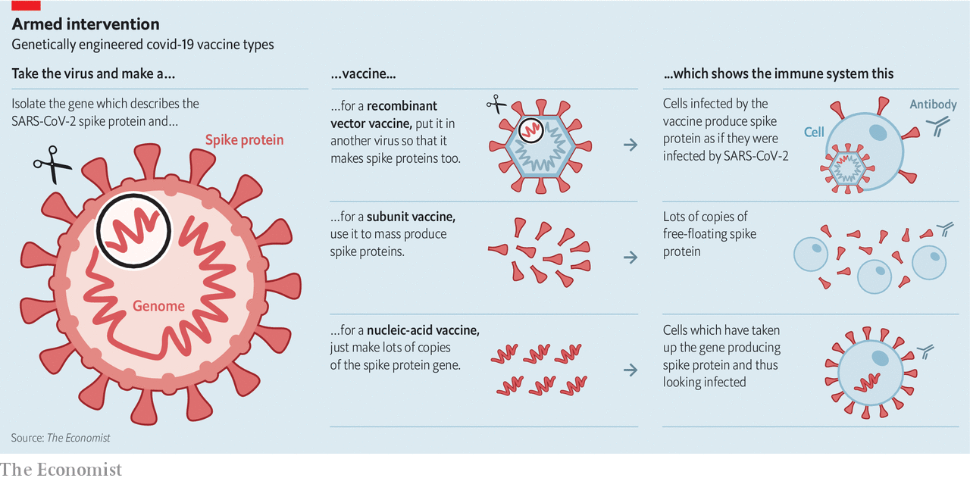

## Look, no proteins!

It is also possible to move antigen production into the patient’s own body by putting the relevant gene into another, otherwise innocuous virus—sometimes one that can reproduce itself in the body, sometimes one that cannot. This sheep-in-wolf’s-clothing approach is how the rVSV-ZEBOV Ebola vaccine works, as well as some veterinary vaccines, but it has not as yet been used widely in humans.

The CanSino covid-19 vaccine that is reported to have entered phase II trials is a “recombinant vector” vaccine of this type, an adenovirus engineered to express the spike protein. Other groups using this approach include the German Centre for Infection Research, the Institut Pasteur, Johnson & Johnson, a pharmaceutical company, and the University of Oxford.

The most novel of the vaccines produced through genetic engineering are nucleic-acid vaccines. The idea here is simply to introduce the gene for the antigen of interest into the body as a piece of either DNA or RNA, a related molecule that many viruses use as a medium for storing genes. The body’s cells manufacture the antigen the vaccine describes, and that produces an immune response. There are two such vaccines already in phase I trials: a DNA vaccine developed by Beijing Advaccine Biotechnology and Inovio Pharmaceuticals, Chinese and American biotechnology companies respectively; and an RNA vaccine from Moderna, an American biotechnology company working with the National Institute of Allergy and Infectious Diseases (NIAID). A number of other firms are not far behind.

Nucleic-acid vaccines have various advantages, according to their advocates. Their production is completely independent of viruses, or even cells, making contamination highly unlikely, and should in principle be easy to scale up. Last year CEPI funded CureVac, a German biotech company, to develop an “RNA printer” that would simply churn such vaccines out. If such production technologies work, there is a chance that they could be scaled up far faster than the techniques used for other vaccines. That could be a very big deal.

## Challenge or disaster

The problem is that no RNA or DNA vaccine has yet been licensed for use in humans anywhere in the world. Animal studies suggest there could be something there, but Adrian Hill, boss of Oxford University’s Jenner Institute, says describing them as vaccines is like saying you have a car without being able to say if it moves. Though experimental DNA vaccines have produced immune responses in humans, RNA vaccines have yet to get even that far, according to Stanley Plotkin of the University of Pennsylvania, who developed the rubella vaccine. “We will have to see if it works,” says Christos Kyratsous, the senior infectious-disease scientist at Regeneron, an American biotech company.

The type of the vaccine is not the only variable trials have to look at. The dose matters, too, and some vaccines need to be administered more than once. There are also adjuvants, chemical cofactors that can enhance a vaccine’s effect on the immune system. The right adjuvant can make a big difference, for reasons that are not always well understood.

Indeed, for all the molecular mastery vaccine makers now have at their disposal, much of the immune system’s workings remain mysterious. The BCG vaccine used against tuberculosis, for example, seems to have a stimulating effect on the immune system that goes well beyond TB. That is why four countries are running trials of BCG against covid-19 even though no specific new antigens have been added to it.

Sorting out effectiveness and dosing is one of the reasons you need trials. So, too, is safety. A particular safety worry for covid-19 vaccines is “antibody dependent enhancement”. In some diseases, and in some circumstances, antibodies can make a viral infection more damaging. The effect was recently seen in some people vaccinated with CYD-TDV (Dengvaxia), a vaccine against Dengue fever made by Sanofi. During attempts to develop vaccines for SARS-CoV in the early 2000s, some laboratories saw test vaccines apparently improve the ability of the pathogen to enter cells. “Everybody is aware of this,” says Dr Plotkin. “Some think it is real, some think it is not real.” As Dr Hill says, “There is always a risk that this will be difficult.”

Moving from safety to efficacy, Dr Plotkin thinks researchers should consider speeding things up with “challenge” trials. Instead of vaccinating a lot of people and then seeing how many get how sick in the natural course of events, as normal field trials do, challenge trials deliberately expose vaccinated volunteers to the virus. The ethical ramifications of such trials are troubling, but a committee of experts convened by NIAID in 2017 found that in the case of research into Zika, a disease which can cause miscarriages, challenge trials could be justified under certain conditions. A group of Harvard scientists recently suggested the same for covid-19, if the volunteers were young and healthy, fully informed, able to pull out at any time and guaranteed good care. A small challenge trial, Dr Plotkin says, can produce results comparable to those of a much larger field trial in weeks.

Whatever sort of trials are chosen, many seem likely to take place. That suits Paul Hudson, the boss of Sanofi. He argues the world needs alternative approaches to a covid-19 vaccine not just to cover all the biological bases, but “because manufacturing capacity is a question-mark.”

Making vaccines is a lot more complicated than making ordinary pills. Those which use whole viruses have to grow them up in some highly standardised way and purify them exactingly. Those which just use proteins need other forms of ultrafiltration and purification to ensure that only the desired antigen gets into the patient’s body. Dozens of quality checks are done every step of the way; they may add up to more than half of the production time.

## Won’t get fooled again

Because profits in vaccine making are low, not many Western companies find such capabilities worth the candle. Almost all the pharmaceutical industry’s vaccine-manufacturing know-how is concentrated in just four companies: GSK, Johnson & Johnson, Pfizer and Sanofi. And these four are generally wary of developing vaccines for pandemics, not least because developing vaccines for diseases that then vanish is even less profitable. “Look at what happened with the excellent Zika vaccine as soon as it turned out America wasn’t going to get slammed. Look at the 2009 flu pandemic vaccine,” says Laurie Garrett, author of “The Coming Plague”, a prescient book published in 1994. A decade ago, after the H1N1 influenza pandemic fizzled out, the governments of America and various European countries backed out of promised contracts, leaving pharmaceutical companies holding the bag which contained hundreds of millions of dollars of development costs. Nevertheless, all four are contributing to covid-19 vaccine efforts. In an unusual collaboration, GSK is providing a particularly promising adjuvant to Sanofi’s protein subunit programme.

In theory, manufacture of covid-19 vaccines using conventional approaches could be scaled up quickly by the four big companies, and by some of the Chinese and Indian companies that make vaccines for markets in the global south. But doing so might mean fewer regular vaccines get made because, as Paul Stoffels, the managing director of Johnson & Johnson, confirms, “there is no excess capacity.” Indeed, the World Health Organisation (WHO) reports that there are already unrelated shortages of vaccines for yellow fever and measles. The seasonal nature of flu vaccinations means that those production facilities have spare capacity at some points in the year. But Sanofi reckons that, at best, that would allow it to make 600m doses a year of a covid-19 vaccine before cutting into flu-vaccine production. If the new vaccine turned out to require a lot of antigen, that figure might fall to 100m.

## All together now

This means that governments, charities and other potential vaccine buyers do not just need to find ways to assure the industry that they will pay for what it produces. According to Bill Gates, they need to spend billions of dollars building manufacturing plants for the half dozen or so leading vaccine candidates before vaccine trials have reached conclusive results about what vaccine or vaccines are best. Some of those billions “will be wasted”, Mr Gates acknowledges, and billions matter a lot in global public health. Stacked up against trillions of dollars of lost economic output, though, overspending on vaccine-production capacity is penny-ante stuff.

Governments have yet to co-ordinate their response in this way. Some in industry are going it alone. The Serum Institute of India, one of the largest volume manufacturers of vaccines for the poor world, says it is ready to step into the breach. It estimates that responding to covid-19 will require building a bulk manufacturing and filling plant costing some €150m ($164m). Johnson & Johnson has committed $1bn to expanding manufacturing on a “very, very large scale,” says Mr Stoffels. He adds it will sell its vaccines on a “not for profit basis.” Mr Hudson has also committed Sanofi to scaling up “with no profit motive”.

Despite such efforts, though, the ability to make vaccines will not be as widely distributed as the populations in need of them, triggering fears of Dr Hatchett’s prisoners’ dilemma. To try to ensure that an optimal vaccine-distribution strategy is pursued instead, he and Seth Berkley of GAVI, a public-private partnership which supports vaccination efforts worldwide, have been urging the G20 to try and reach some kind of consensus on vaccine production and then fund it. The G20 has in turn asked the WHO to outline a plan for the equitable distribution of the goods needed to fight covid-19. This will be part of a broader WHO initiative, the details of which have yet to be announced, which will be led by a former head of GSK.

Dr Hatchett says that uncertainty over which vaccine will actually work provides an incentive for co-operation: no one is sure to lose out; everyone stands to benefit. “As we become more and more certain about which vaccines are going to win, that advantage may go away and national interest may begin to assert [itself],” he adds. The science of vaccination may well offer humankind a viable exit from the straits that the covid-19 pandemic has stuck it in. Politics could still see some people trampled underfoot in the rush to get out. ■

Dig deeper:  
For our latest coverage of the covid-19 pandemic, register for The Economist Today, our daily [newsletter](https://www.economist.com/newslettersignup), or visit our [coronavirus tracker and story hub](https://www.economist.com/coronavirus)

This article was downloaded by calibre from <https://www.economist.com/briefing/2020/04/16/can-the-world-find-a-good-covid-19-vaccine-quickly-enough>

|  |  |  |  |
| --- | --- | --- | --- |
|  | Articles | Sections | Next |

|  |  |  |  |
| --- | --- | --- | --- |
| Previous | Articles | Sections | Next |

#### Other people’s antibodies

# Some benefits of a covid vaccine could come early

Antibodies from recovered patients and biotech companies could help

Apr 18th 2020 | NEW YORK

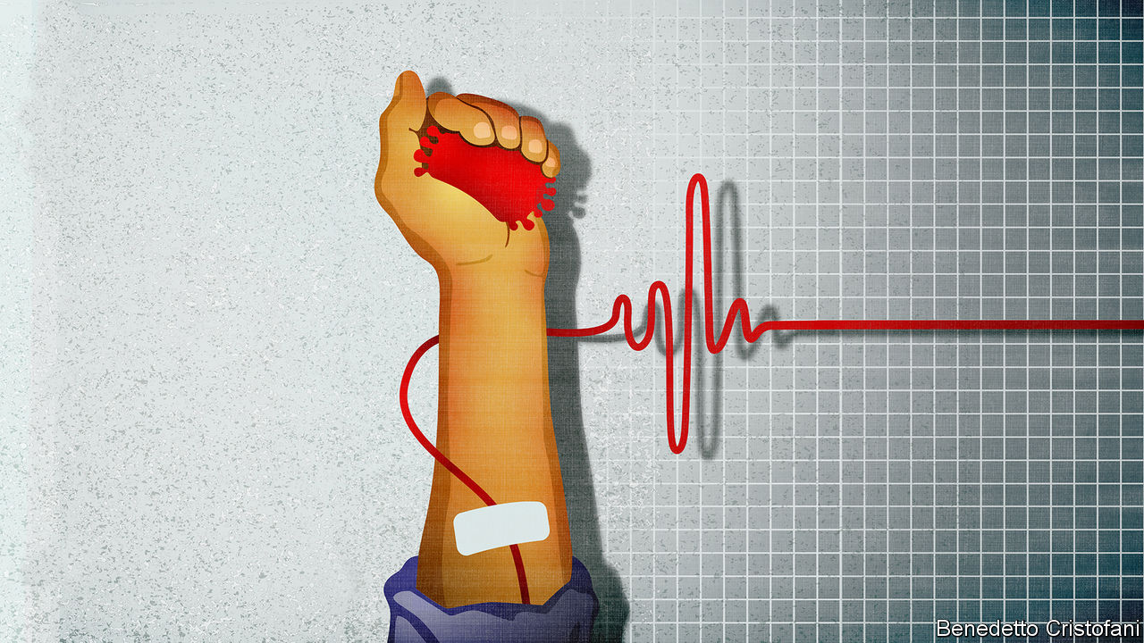

Editor’s note: The Economist is making some of its most important coverage of the covid-19 pandemic freely available to readers of The Economist Today, our daily newsletter. To receive it, register [here](https://www.economist.com/newslettersignup). For our coronavirus tracker and more coverage, see our [hub](https://www.economist.com/coronavirus)

DURING THE flu pandemic of 1918-19 doctors at an American naval hospital developed a treatment which, according to the American Journal of Public Health, had “a decided influence in shortening the course of the disease and in lowering the mortality”. It involved clotting and then centrifuging blood from people who had got over the disease so as to separate out the antibodies it contained, then giving those antibodies to patients in dire need.

Since then antibody-rich “convalescent plasma” (CP) has been used as a treatment for various diseases, including SARS and the pandemic strains of H1N1 and H5N1 influenza. Now covid-19 has joined the list. A recent study in Wuhan found that severely ill covid-19 patients treated with CP did significantly better than patients matched with them by age, gender and severity of infection had done earlier in the epidemic.

Michael Joyner of the Mayo Clinic, which leads a CP research effort in America, expects randomised control trials to begin in a few weeks. They will not just look at CP’s potential as a treatment, but also as a prophylactic. If that worked, it would be a sort of halfway house on the road to a vaccine.

Even though CP donors get the other components of their blood—cells, platelets and the like—returned to them after the antibodies have been removed, the process is still something of a palaver, requiring a lot of medical attention. Despite the fact that various companies are trying to make a go of it, it is hard to see it scaling up all that far. But there is an alternative. Antibodies are proteins, and that means a bit of genetic engineering will allow cell lines at biotechnology and pharma companies to mass produce them. The resulting product should be less prone to contamination, more consistent, and easier to scale up than CP.

This approach has already been successful against Ebola. Regeneron, an American biotech company, developed a cocktail of three antibodies which recognised different parts of the protein’s coat. Trials in the Democratic Republic of Congo showed this therapy to be better than remdesivir, a drug designed to block the Ebola vaccine’s reproduction which is now, as it happens, being tested as a medicine for covid-19.

Regeneron is now making a pair of antibodies that target the SARS-CoV-2 spike protein. It hopes to have produced enough to start trials soon. As with CP, it is possible that such antibodies may temporarily confer immunity on the uninfected, as well as helping the infected fight the disease.

Dig deeper:  
For our latest coverage of the covid-19 pandemic, register for The Economist Today, our daily [newsletter](https://www.economist.com/newslettersignup), or visit our [coronavirus tracker and story hub](https://www.economist.com/coronavirus)

This article was downloaded by calibre from <https://www.economist.com/briefing/2020/04/18/some-benefits-of-a-covid-vaccine-could-come-early>

|  |  |  |  |
| --- | --- | --- | --- |
| Previous | Articles | Sections | Next |

|  |  |  |
| --- | --- | --- |
| Briefing | Sections | The Americas |

United States

Coronavirus and inequality: Unequal protection

.

Violence and the virus: Ceasefire, for now

.

Revolution interrupted: Democrats in array

.

Military recruitment: Social climbing

.

Lexington: The paradox of the pandemic

.

|  |  |  |
| --- | --- | --- |
| Briefing | Sections | The Americas |

|  |  |  |  |
| --- | --- | --- | --- |
|  | Articles | Sections | Next |

#### Unequal protection

# American inequality meets covid-19

Some already yawning gaps are being pushed farther apart by the virus

Apr 18th 2020 | WASHINGTON, DC

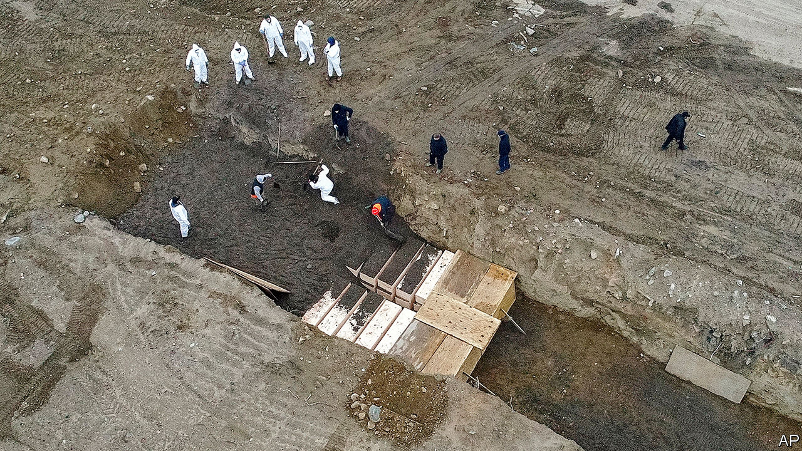

Editor’s note: The Economist is making some of its most important coverage of the covid-19 pandemic freely available to readers of The Economist Today, our daily newsletter. To receive it, register [here](https://www.economist.com/newslettersignup). For our coronavirus tracker and more coverage, see our [hub](https://www.economist.com/coronavirus)

THE COVID-19 epidemic in America is two-pronged—a contagious sickness first, followed by an economic malaise. Despite a big stimulus programme from Congress, including the temporary introduction of something like a universal basic income that ought to benefit the poorest disproportionately, it is the least advantaged who are suffering most.

The country is now in the unenviable position of having more covid-19 cases—638,000 confirmed—and deaths (31,000) than any other in the world. At least 17m people, or more than one-tenth of the civilian workforce, have filed for unemployment benefits in the past three weeks. The official tabulations on what is happening will arrive weeks and months from now. But the best available evidence shows that the already yawning divides in American society are widening.

Roughly one in three deaths in America thus far has been in New York City. The brunt of the disease has not fallen evenly there. Data released by the city’s health department on April 6th show that black and Hispanic residents are twice as likely to die of the disease as white city dwellers. That trend has not been confined to America’s largest city. In the few states and cities that have released similar breakdowns of fatalities, an uncomfortable pattern emerges from Milwaukee to New Orleans. Black Chicagoans are five times as likely to die of covid-19 than white ones.

Exactly why this is happening is still an open question. There are elevated rates among African-Americans of chronic conditions such as high blood pressure and diabetes, which are thought to increase the chance of death. Poverty, and its attendant consequences, may also be at play: blacks (and especially Hispanics) are less likely to have health insurance, and may thus avoid seeking testing and treatment. Despite the large differences in mortality, The Economist’s analysis of zip-code level data in New York City shows that neighbourhoods with large black and Hispanic populations only have marginally more testing. Without space to self-isolate, a private car and a job that can be performed remotely, the chances of infection necessarily increase.

A team of biostatistics researchers at Harvard have pointed out that there is an alarming correlation between long-term exposure to fine particulate matter—which damages lungs—and county-level death rates from covid-19, a respiratory illness. An increase of merely one microgram per cubic metre is associated with a 15% increase in covid-19 fatalities. In America, black residents are disproportionately exposed to fine particulate matter. Even after accounting for population density, air pollution and pre-existing health factors like smoking rates and obesity levels, the same analysis shows that race is tied to covid-19 deaths nationwide. For every one standard-deviation increase in the share of Hispanic and black residents, county death rates increase by 16% and 52%, respectively.

It is also uncertain whether this racial disparity would dissipate if the virus spread beyond big cities and into rural parts of the country. If poverty, pollution, pre-existing conditions, and patchy health and social safety nets are leading to excess deaths among minority residents in American cities, then they will apply with no less force to poor whites outside them.

Adherence to social-distancing guidance also seems to differ by income and party affiliation. A recent study by a team of researchers armed with cell-phone-location data found that compliance with the new behavioural guidelines was substantially lower in counties with lower incomes, greater exposure to recent trade wars and higher rates of support for Mr Trump. The few governors who have not recommended shelter-in-place orders as of April 14th are of all Republican-led, largely rural states like Arkansas and South Dakota (where over 500 workers in a pork processing plant recently tested positive for the virus).

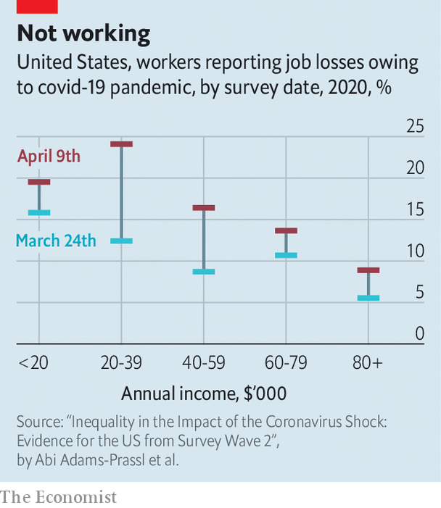

Although the uneven health effects of the pandemic are still being worked out, there is little doubt already about where the economic effects have been most severe. Official unemployment numbers are tabulated every month and have not yet incorporated the worst weeks of the economic downturn. When they catch up, the Peterson Institute for International Economics, a think-tank, reckons that they will show an unemployment rate of 20% by early summer—a number not seen since the Great Depression. A survey of 4,000 American workers conducted by a team of European economists found that 16.4% had already lost their job because of the viral shock. For the 20% of American workers least able to work from home, nearly 40% have lost their jobs, according to the survey results. Workers who are younger, poorer or lack a university education have disproportionately lost their source of income (see chart). For some, that has also meant losing their employer-sponsored health insurance in the middle of an epidemic.

The negative effect of these job losses on low-income and precariously employed Americans ripples through their families. Elizabeth Ananat, an economist at Barnard College, and Anna Gassman-Pines, a professor of public policy at Duke University, spent months recruiting hourly service-sector workers with young children in a big American city to study the effect of a new law limiting short-notice schedule changes. In the middle of their survey, the coronavirus hit—ruining their intended study, but providing valuable detailed information about how relatively low-paid workers in hotels and restaurants are dealing with the crisis. Of their sample, 43% had lost their jobs (half of them permanently). Of those, 23% also lost their health insurance. Measures of parental and child mental distress also shot up.

In theory, the safety net should cushion these effects. Compared with those of other rich countries, America’s is less generous, for fear of discouraging work. But now that swathes of the economy are closed off for the good of public health, these worries look less important. In its recent $2.2trn spending bill, Congress temporarily reinforced the safety net—including a $600 weekly top-up on unemployment benefits, a $1,200 cheque for most American adults and a $350bn bail-out fund for small businesses on the brink of closing.

## Two nations

Sensible as this seems, the time before firms and families actually benefit may be quite long. State unemployment offices are contending with extreme levels of claims and antiquated technology. The governor of New Jersey put out a call to programmers fluent in COBOL, a programming language created in 1959, to help fix its office’s back-end software. Of the unemployed service workers in Ms Ananat’s and Ms Gassman-Pines’s sample, only 46% had successfully applied for benefits. Only 4% have actually received them. And while the IRS is expected to start depositing cheques soon, those without a previous tax filing or a bank account (who presumably need the cash most) will have to wait longer.

The roll-out of the small-business bail-out scheme has been bumpy, too, with owners reporting unclear guidance and considerable paperwork. A nationwide survey of small businesses, conducted by a team of economists, found that 43% of companies had closed temporarily, shedding 40% of their employees.

Assessing the long-run effect of the last economic downturn on children, some of America’s leading scholars on poverty concluded: “The near immunity of college-educated families and the large negative consequences for less-educated families mean that the Great Recession increased the already large divide between families at the top and bottom of the income distribution.” There is little reason to doubt that the same dynamic will reappear this time.■

Dig deeper:  
For our latest coverage of the covid-19 pandemic, register for The Economist Today, our daily [newsletter](https://www.economist.com/newslettersignup), or visit our [coronavirus tracker and story hub](https://www.economist.com/coronavirus)

This article was downloaded by calibre from <https://www.economist.com/united-states/2020/04/18/american-inequality-meets-covid-19>

|  |  |  |  |
| --- | --- | --- | --- |
|  | Articles | Sections | Next |

|  |  |  |  |
| --- | --- | --- | --- |
| Previous | Articles | Sections | Next |

#### The crime decline

# Could America’s slump in crime be the beginning of something?

Police departments in violent cities have long talked of making a firebreak. Now they have one

Apr 18th 2020 | CHICAGO

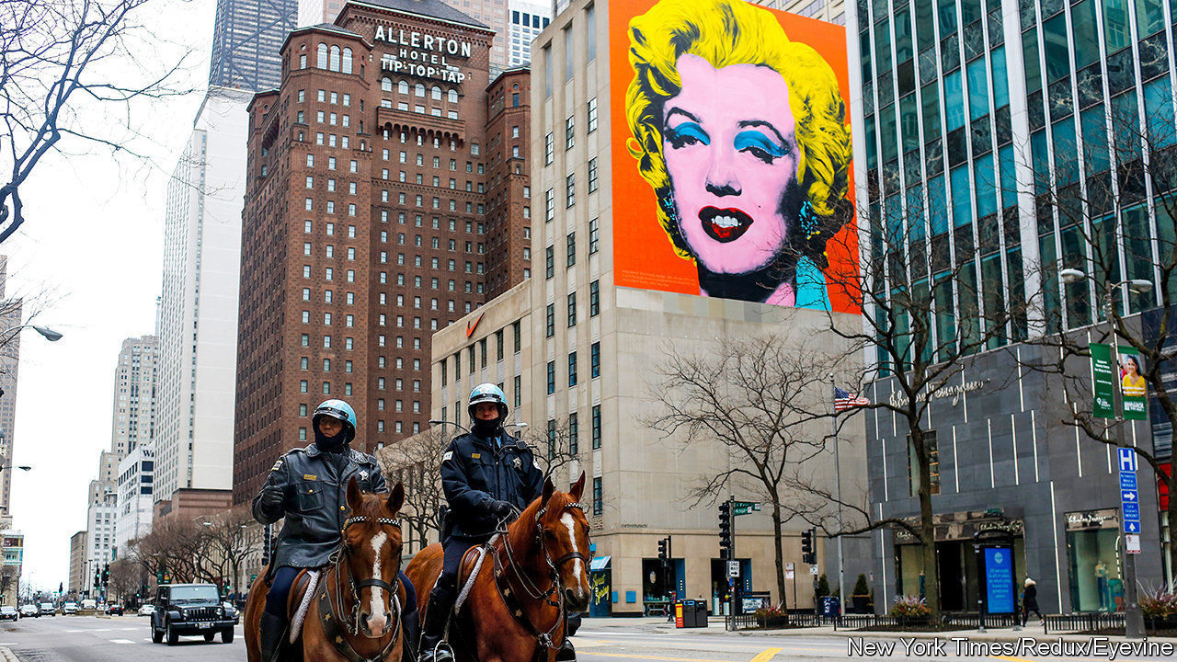

Editor’s note: The Economist is making some of its most important coverage of the covid-19 pandemic freely available to readers of The Economist Today, our daily newsletter. To receive it, register [here](https://www.economist.com/newslettersignup). For our coronavirus tracker and more coverage, see our [hub](https://www.economist.com/coronavirus)

FOR YEARS, activists, police and others hoping to reduce gun violence in cities have asked if creating a temporary firebreak—a way to pause tit-for-tat killings—could help in the long term. In troubled neighbourhoods in Chicago, for example, “interrupters” who are often former gangsters themselves have tried dissuading young gunmen from seeking revenge immediately after a shooting. The idea is to let hot heads cool, so preventing a cycle of deadly feuding.

Courtesy of covid-19, a chance might now exist to test the firebreak idea. Stay-at-home orders are keeping many potential perpetrators and victims off the streets. That has led to a remarkable fall in violence, including murders, rapes, robberies and assault. Data on crimes recorded by a dozen cities’ police departments, collected this week for The Economist by Christopher Herrmann at the John Jay College of Criminal Justice, show a deep slump in the 28-day period to early April, from a year earlier (see chart for a selection). In some New York neighbourhoods, he says, crime is down by two-thirds.

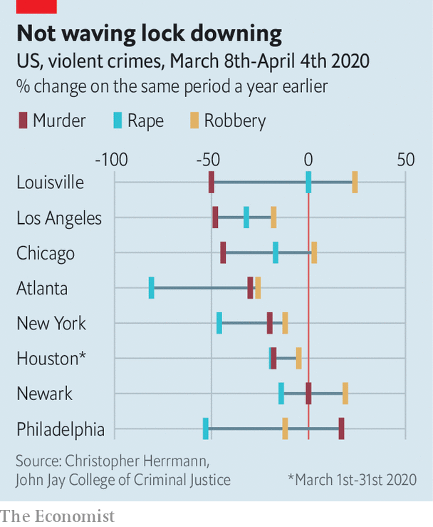

The reductions are widespread, if not entirely unexpected. Mr Herrmann used to analyse crime statistics for New York’s Police Department. He notes periods of heavy snowfall or big storms can also keep people indoors and cause dips in crime. Temporary closures of subway stations can do the same at a local level. Warm weather or school holidays that send more youngsters on to the streets tend to drive rates up. The last pandemic in America, the Spanish flu of 1918, also seemed to have an effect. Leigh Bienen, who runs a project tracking homicides in Chicago since 1870, notes that 130 people were shot dead there in 1918, a noticeable drop from 159 the year before. Gun killings then rose fast as the pandemic petered out.

The scale of the crime downturn now is unprecedented, says Mr Herrmann. Cities are seeing sharp falls even as police patrol less—as they too fall sick with covid-19. And unlike a storm, the lockdown in most places has already lasted for weeks. Were that to extend to three months, says a crime analyst in Chicago, some young-guns might change habits. An older man who was imprisoned for murder agrees that a long-enough hiatus could help. Being locked down, he says, is a “moment to breathe, stop, think—there’s something to be said for that in the chaos.”

Could the pandemic-induced firebreak have a longer-lasting effect? Where shootings are mostly by gangs fighting over control of drug sales, say, a quick return to old levels of violence could be expected. But police in Chicago, at least, liken some shootings to a game of tag played with firearms. Young, ill-educated teenagers, with too-easy access to guns, fall into feuding almost as a deadly sport. Some grudges are then held for years and are even passed between generations.

Those involved in such shootings could be the most susceptible to change. A group called READI, run by Eddie Bocanegra in Chicago, has for the past 20 months been giving frequent sessions of behavioural therapy and counselling to 700 young men judged likeliest to perpetrate the next killings (or be the next victims). Mr Bocanegra’s team works on despite the pandemic, though phone and video sessions have replaced personal meetings. He believes some cycles of violence are being broken.

Still, the idea of a firebreak bringing benefits after de facto curfews are lifted does not convince everyone. Lockdowns do generally seem to reduce crimes in public but they can also result in more violence indoors. It is likely that domestic abuse is becoming more common. In Houston cases of assault leapt in March, mostly because of attacks within the home. And another crime analyst, in Chicago, says being exposed to abuse at home is a strong predictor that someone will get involved in other violence later.

Nor can anyone be sure how other pandemic-related changes under way will affect longer-term crime rates. Early releases of prisoners, police making fewer arrests, an 85% surge in national gun sales in March and record increases in unemployment could all return crime to levels seen before the lockdowns. Trying to make use of the firebreak makes sense. But keeping crime lower will prove difficult indeed. ■

Dig deeper:  
For our latest coverage of the covid-19 pandemic, register for The Economist Today, our daily [newsletter](https://www.economist.com/newslettersignup), or visit our [coronavirus tracker and story hub](https://www.economist.com/coronavirus)

This article was downloaded by calibre from <https://www.economist.com/united-states/2020/04/18/could-americas-slump-in-crime-be-the-beginning-of-something>

|  |  |  |  |
| --- | --- | --- | --- |
| Previous | Articles | Sections | Next |

|  |  |  |  |
| --- | --- | --- | --- |
| Previous | Articles | Sections | Next |

#### Berning out

# Bernie Sanders’s endorsement of Joe Biden leaves Democrats in array

The Democratic Party is not ready for a revolution quite yet

Apr 18th 2020 | WASHINGTON, DC

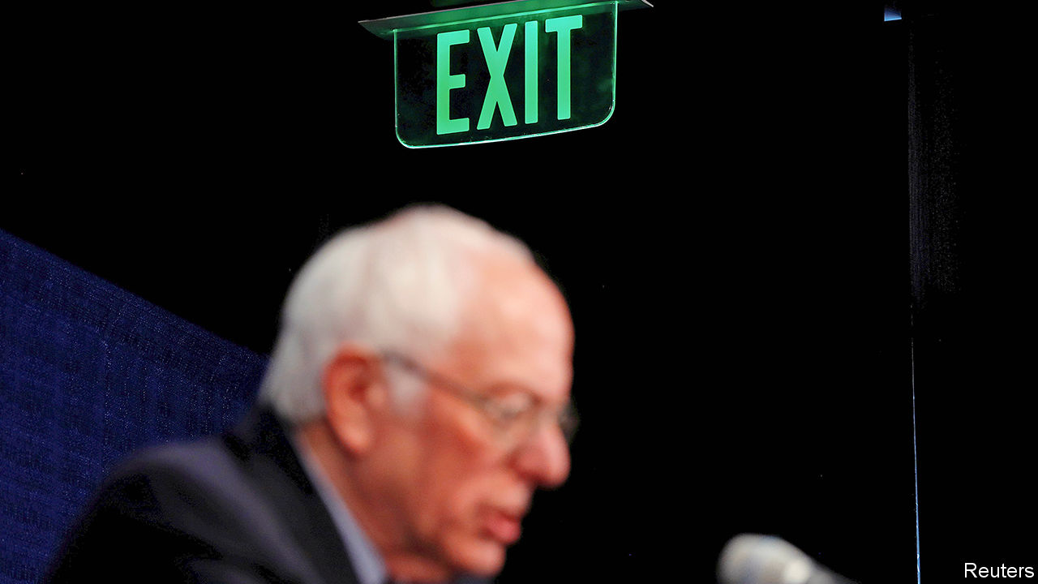

ONE OF THE reasons why Hillary Clinton lost to Donald Trump was that around a quarter of her Democratic rival’s voters spurned her. Most of Bernie Sanders’s disaffected supporters voted for third-party no-hopers or Mr Trump in 2016. Some stayed at home. In an election settled by tiny margins—a few tens of thousands of votes in three rustbelt states where Mr Sanders was popular—it is tempting to wonder what might have happened had he tried a good deal harder to reconcile his supporters to Mrs Clinton than he did.

Having again failed to secure the Democratic ticket, Mr Sanders has sought to forestall a re-run of this scenario. In 2016 he stumped on until he had no mathematical chance of victory; he did not endorse Mrs Clinton until the eve of the party’s convention in July. This time around he did not wait. On April 13th, days after ending his campaign, he endorsed Joe Biden while appearing on a live-stream broadcast with him. “We need you in the White House,” he told the former vice-president.

This completes an astonishing turnabout for both men. Only six weeks ago—or until the votes started coming in from South Carolina—the socialist from Vermont was leading a querulous pack, Mr Biden was flailing, and the prospects of the primary being decided before this year’s convention seemed remote. Now Mr Biden is the presumptive nominee after what has turned out to be the shortest Democratic primary since 2004. The party appears to be unified: Elizabeth Warren, the other tribune of the left, also endorsed Mr Biden this week. So did Barack Obama, in a speech that included almost as much praise for Mr Sanders (“an American original”) as Mr Biden. And because of the pandemic there may be no convention.

The virus is also behind Mr Sanders’s timely concession, Mr Trump’s response to it having renewed Democrats’ dread of disunity and another defeat to him. That is not something Mr Sanders, who at 78 will almost certainly not run again, would want to be laid on him. His endorsement, he told Mr Biden, was intended to help him beat “the most dangerous president in the modern history of this country.”

Mr Biden also deserves some credit. The former vice-president is a poor campaigner—always verbose and now increasingly doddery—who will keep Democrats’ hearts in their mouths to the end. Yet he has a gift for being liked, to which even ornery Mr Sanders is susceptible. He resented Mrs Clinton yet calls Mr Biden a friend. The former vice-president’s political skills are correspondingly far silkier and more effective at building consensus than Mrs Clinton’s were. That is apparent in the show he is now making of deferring to Mr Sanders on aspects of policy.

Mr Biden welcomed Mr Sanders’s support by saying he needed him “not just to win the campaign but to govern.” He also credited him with leading the Democratic drive for a $15 federal minimum wage, which Mr Biden supports. The two men said they would set up joint policy task-forces. This will probably result in some sops to Sandernistas in the forthcoming Democratic platform, perhaps on energy or education or policy. That looks like sensible party management. It does not represent a big concession to the left.

Party platforms rarely come to much. And though Mr Biden is running on more left-wing promises than Mrs Clinton, especially on health-care and climate-change policy, he was the most unambiguously moderate contender in the primary and far to the right of Mr Sanders. Though Democrats have generally moved to the left, most do not consider Mr Sanders’s statist vision credible, even where desirable. That is one of the two main reasons why he lost.

The angry response his concession drew from diehard Sandernistas illustrated the other one. “I don’t endorse Joe Biden,” announced the senator’s former press secretary, Briahna Joy Gray, to her quarter of a million Twitter followers. Notwithstanding his well-judged climb-down, Mr Sanders, an independent who has never joined the Democratic Party, has encouraged that insurgent spirit. “I’ve got news for the Democratic establishment. They can’t stop us,” he tweeted after winning in Nevada, at what would prove to be the high point of his campaign. He was probably right, but ordinary Democratic voters, who mostly like their party and don’t want to see it threatened, could and did.

Their drift to the left mirrors a course already taken by their right-wing opponents. Yet Democratic primary voters remain less angry, suspicious of authority and unwilling to compromise than Republicans are. That is why Mr Sanders’s effort to launch a Democratic Tea Party fell flat.

For all the heat and light he has generated over the past five years, this is not a great record. Mr Sanders has not converted Democrats to his pet causes, including above all Medicare-for-all. He has not swollen the party’s vote, by bringing in a promised horde of young and working-class voters. He has not expanded its hard-left faction, representing around a third of the party, from which he drew his support.

His more modest achievement is to have focused and energised that base on a set of issues, vigorously championed by the activist leaders he has inspired. In an interview with the New York Times this week, the most prominent, Congresswoman Alexandra Ocasio-Cortez, sounded almost as reconciled to Mr Biden’s victory as Mr Sanders. She said she would support him though knew she could not change him: “There are limits to what Biden will do and that’s understandable—he didn’t run as a progressive candidate.” She also signalled how temporary this truce will be.

The hard-left does not feel beaten: it never will. Yet with Mr Trump in its sights, it seems to be making its peace with Mr Biden in a way it never did with Mrs Clinton. That is excellent for Democrats and potentially awful for the president.■

This article was downloaded by calibre from <https://www.economist.com/united-states/2020/04/18/bernie-sanderss-endorsement-of-joe-biden-leaves-democrats-in-array>

|  |  |  |  |
| --- | --- | --- | --- |
| Previous | Articles | Sections | Next |

|  |  |  |  |
| --- | --- | --- | --- |
| Previous | Articles | Sections | Next |

#### Social climbing

# Recruits to America’s armed forces are not what they used to be

Once a ladder into the middle class, military service has gone upscale

Apr 18th 2020 |

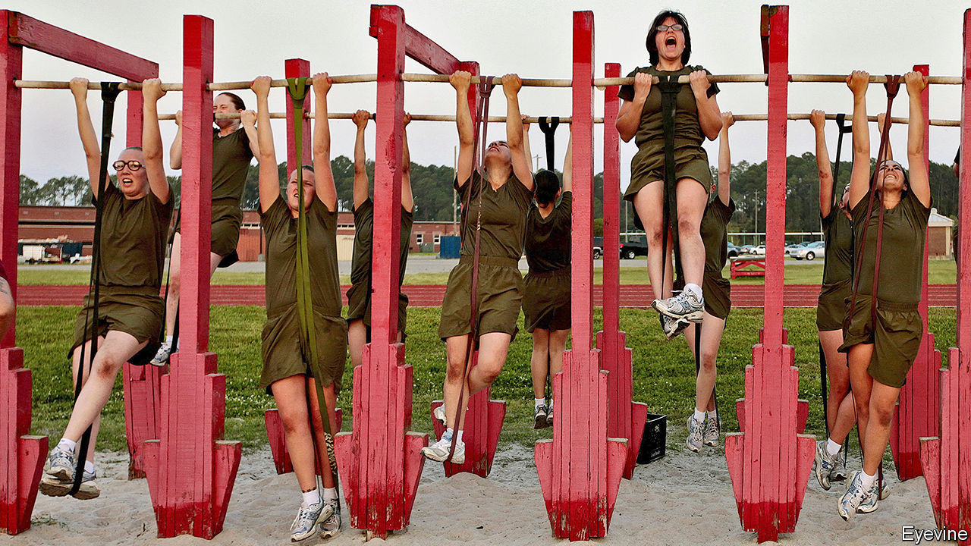

“FOR POOR blacks and poor whites there was simply nothing like the Army,” wrote Charles Moskos, a military sociologist, in 1986, over a decade on from the abolition of the draft. The stereotypical grunt was proletarian cannon fodder: an unskilled young man, from the impoverished boondocks or inner city, driven to the recruiting office by desperation and the promise of self-betterment. “Take a look at the Marines—what you see is black faces, from the ghettos,” said Noam Chomsky in 1989. “Sometime in the Seventies, the American army shifted to a traditional mercenary army of the poor.”

If there was once some truth to that, it is now a myth, according to a new paper* published in the Journal of Strategic Studies. Its authors compared data from the National Longitudinal Surveys of Youth from 1979 (those born between 1957 and 1964) and 1997 (born 1980-84), which involved thousands of subjects interviewed regularly year after year. In the first cohort, who came of age in the aftermath of Vietnam, those who enlisted did indeed have lower parental income and wealth than equivalent civilians.

But for the millennial soldiers, reared in an age of American swagger, the opposite is true. Their median family income is more than $73,000, compared with $66,000 for civilians, and recruits are most likely to come from families in the middle of the wealth distribution, with median wealth of $87,000, almost $10,000 more than civilians. Blacks, overrepresented among the poor, and a disproportionately large veteran presence in the 1979 cohort, as Mr Chomsky noted, have dwindled as a share of recruits. Separately, as the armed forces shrank in size and grew choosier, recruits tended to be cleverer (measured by a cognitive skills test) than their civilian peers. Indeed, among the poorest recruits it is the cleverest—not the drop-outs or deadbeats—who are likeliest to sign up.

In short, soldiering has become a middle-income business. “The widespread belief among academics, the American public and lawmakers that those fighting America’s wars come mostly from the poorest groups is probably a product of trends from the past,” conclude the authors, who note that their findings are robust across the army, navy, air force and marines, and apply to officers and enlisted personnel alike.

Since the strongest correlate of enlistment is proximity to a military base, these trends may reflect recruitment from the upwardly mobile offspring of serving personnel and their communities, says Kori Schake of the American Enterprise Institute, a think-tank. Technology plays a role too, say the authors. Modern warfare relies less on hordes of expendable infantry and more on sophisticated platforms. Today’s military personnel include cyber-attackers, satellite controllers and software engineers. As America’s enemies have acquired better arms of their own, tactics have also grown more complex and demanding. All of that requires skill.

This military gentrification has political consequences. Some political scientists once reckoned that elites might be happier to wage war if a disenfranchised underclass would bear the brunt. In fact, the data show that “men and women who serve are likely to embody the values and culture of the median voters.” But if the armed forces skim off the better-educated and better-skilled, they may no longer serve as the vehicles of upward social mobility they once were. The very poorest Americans may be spared foreign battlefields—but they may also be spared college degrees.■

* Andrea Asoni, Andrea Gilli, Mauro Gilli and Tino Sanandaji, “A mercenary army of the poor? Technological change and the demographic composition of the post-9/11 U.S. military” (2020) Journal of Strategic Studies

This article was downloaded by calibre from <https://www.economist.com/united-states/2020/04/18/recruits-to-americas-armed-forces-are-not-what-they-used-to-be>

|  |  |  |  |
| --- | --- | --- | --- |
| Previous | Articles | Sections | Next |

|  |  |  |  |
| --- | --- | --- | --- |
| Previous | Articles | Sections | Next |

#### Lexington

# The paradox of the pandemic

Covid-19 is bringing Americans together locally even as it exposes their divisions

Apr 18th 2020 |

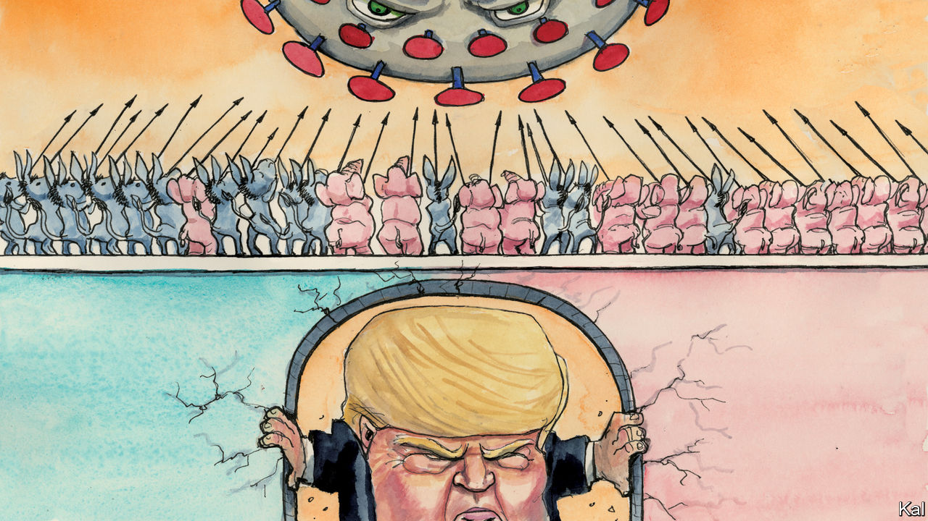

Editor’s note: The Economist is making some of its most important coverage of the covid-19 pandemic freely available to readers of The Economist Today, our daily newsletter. To receive it, register [here](https://www.economist.com/newslettersignup). For our coronavirus tracker and more coverage, see our [hub](https://www.economist.com/coronavirus)

THE FACT that British and American politics have been heading in the same direction in recent years—towards populism and rancour—makes their sudden divergence all the more striking. Boris Johnson, fresh out of intensive care, is preaching his country’s secular faith, love for the National Health Service, and seeing his ratings soar. Indeed almost every Western leader, including Giuseppe Conte, Emmanuel Macron and Angela Merkel, has received similar or bigger double-digit boosts as their voters rally around the flag in this time of peril. America is a different case.

After a small jump in the first weeks of the crisis, Donald Trump’s ratings are back to their pre-pandemic lows. Most Republicans are with him, most others loathe him, and his handling of the coronavirus is viewed accordingly. Squinting past his vacillation and incompetence, the president’s supporters say he is doing well; almost everyone else disagrees. The coronavirus has killed 31,000 Americans, but it has not broken their partisan spirit.

This is hardly surprising. America was divided long before Mr Trump launched himself on it as a human wedge. The exceptionally bitter 2000 presidential election, which both parties claim to have won, looks like a watershed moment, as perhaps the last decided by persuadable voters. Each subsequent poll has been won by whichever party did best at mobilising its supporters—or, to put that emotively, by whichever felt angriest on the day. Surveys point to Republicans and Democrats becoming increasingly unable to empathise and reluctant to socialise with one another. Even before Mr Trump made factionalism a governing strategy, it was hard to imagine a president wrapping his arms around his crisis-stricken country, as George W. Bush did after 9/11, and rallying it to him.

And of all imaginable crises, the coronavirus has shown a unique power to accentuate political differences. Though more devastating than any foreign attack, it is hard to figure as the sort of common enemy Osama bin Laden was. Notwithstanding Mr Trump’s effort to give it a Chinese face (he reverted this week to calling it the “Wuhan virus”) it is spread by Americans. That has created an extra layer of suspicion, especially as Republicans, taking their cue from Mr Trump, were slower to adopt social distancing. Yet the virus is mainly accentuating partisanship because Republicans and Democrats are experiencing it differently.

At the time of writing, over half of America’s 638,000 known infections were in New York and three neighbouring states, all solidly Democratic. So is every other major hotspot, including Chicago, Detroit and New Orleans. Infectious diseases like density, which is one of the most reliable predictors of Democratic support there is. More sparsely populated Republican areas have seen only scattered tragedies, typically in care homes, where almost a quarter of Texas’s 391 deaths have occurred. This makes Republicans more receptive than Democrats to Mr Trump’s call for a reopening of the economy: an issue that—by pitting the certain tragedy of 17m unemployed workers against the likelihood of additional infections—could scarcely be more polarising.

America’s gravest political differences were already matters of life and death—and the pandemic has deepened them specifically. For Democrats, it has vindicated their overriding demand for better, cheaper health care. Republican states including Texas and Ohio have meanwhile used the lockdown to try to ban abortions, even as cultural warriors such as William Barr, the attorney-general, rail against its implications for religious liberty. The best explanation for the recent implacability of American partisanship is that many pre-existing, not necessarily partisan, differences, concerning race, region, expertise and so forth, have become starkly aligned with partisan identity. Covid-19, a disease that disproportionately hurts urban-dwelling non-whites and demands rigorously science-based action has worked with the grain of that alignment. Yet these depressing facts are not the whole story.

Even as their national politics has taken yet another downwards lurch, Americans are feeling much the same sense of solidarity as locked-down Asians or Europeans. A survey by More in Common, a group that studies polarisation, finds that almost half say America is more united than it was before the pandemic. The portion that believes it is “very divided” has dropped from 62% to 22%. Over 90% of Americans believe “we’re all in it together”, compared with 63% before the virus hit. And though there remain partisan differences in how seriously Americans view the virus, they have narrowed a lot. Republicans and Democrats alike are afraid of it, for the sake of their country, as well as their family and communities. Despite the partisan squabbling, this suggests most people are quietly minimising their differences and pulling together.

The main explanation for this apparent contradiction is that politics is local. In America’s system, state and local governments are the front line against the pandemic. And most state governors are duly enjoying the same ratings boosts as European prime ministers or presidents—even in fiercely contested states. Andy Beshear of Kentucky, a Democrat who was elected by a mere 5,000 votes last November, has an approval rating of 81%. The main exceptions are the governors most tied to national politics, such as Ron DeSantis of Florida, a Trump proxy with ratings to match.

## A local pandemic

This suggests America is fundamentally the same country of concerned, good-hearted citizens it ever was. Even when its national politics is seized by demagogues, responsibility and accountability matter in everyday governance. The unhappier flip-side is that this divergence helps explain why Americans can bear to put up with, and thereby sustain, such dreadful national politics. It plays a much smaller role in their lives than the apparent momentousness of its life-and-death issues might suggest. In the current catastrophe, that is a consolation. But it also stands in the way of the political renewal America so badly needs.■

Dig deeper:  
For our latest coverage of the covid-19 pandemic, register for The Economist Today, our daily [newsletter](https://www.economist.com/newslettersignup), or visit our [coronavirus tracker and story hub](https://www.economist.com/coronavirus)

This article was downloaded by calibre from <https://www.economist.com/united-states/2020/04/18/the-paradox-of-the-pandemic>

|  |  |  |  |
| --- | --- | --- | --- |
| Previous | Articles | Sections | Next |

|  |  |  |
| --- | --- | --- |
| United States | Sections | Asia |

The Americas

Mexico: Shoestring king

.

Bello: The light that flickers

.

|  |  |  |
| --- | --- | --- |
| United States | Sections | Asia |

|  |  |  |  |
| --- | --- | --- | --- |
|  | Articles | Sections | Next |

#### Shoestring king

# Mexico’s bazooka-shy president

Andrés Manuel López Obrador is reluctant to spend money to fight a recession

Apr 18th 2020 | MEXICO CITY

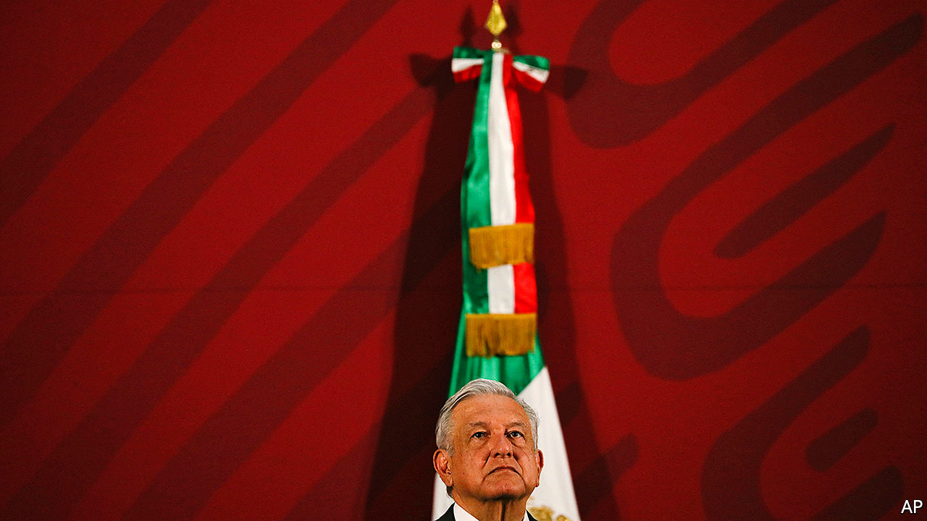

NO ONE CAN accuse Andrés Manuel López Obrador of panicking. As covid-19 sickened people and ravaged economies across the globe, Mexico’s president snapped selfies with supporters. Now that the cost to Mexico’s economy is becoming clear, he is sticking with the idiosyncratic mix of populism and austerity that has guided policy since he became president in December 2018. His stubbornness may worsen what could be Mexico’s deepest recession in almost a century. That could wreck the popularity of a leader whose approval ratings have been among the world’s highest and end his dream of a pro-poor “fourth transformation” of Mexico.

The country’s economy, which shrank by 0.1% last year, is among the most vulnerable in Latin America. It depends on trade with and remittances from the United States, tourism and exports of oil, all of which are being battered by covid-19. In the four weeks to April 6th Mexico lost 347,000 formal jobs, more than the total created in 2019. The IMF expects GDP to contract by 6.6% this year. In Latin America only Venezuela’s economy will shrink more.

Governments the world over are fighting recessions with fiscal bazookas. Mr López Obrador, usually known as AMLO, has resisted. Although his plans for transforming Mexico call for lavishing money on infrastructure and the poor, he has been committed to maintaining fiscal stability. The finance ministry, which had aimed for a surplus before interest payments this year, now expects a smallish deficit of 0.4% of GDP. AMLO said it was too pessimistic.

To combat recession, he has deployed a peashooter. Mexico’s Congress set up a fund worth 0.7% of GDP to fight the health and economic crises. The government has created a rainy-day kitty worth 250bn pesos ($10bn), 1% of GDP, by putting together existing funds. AMLO has not said how much of these resources he will spend. Peru, by contrast, has announced a spending plan worth 7% of GDP, according to the IMF, and Brazil’s measures are worth 2.9%. To compensate for his extravagance, AMLO plans to cut further his own salary and that of senior bureaucrats. (He slashed his salary in half at the start of his term, which forced other top salaries down.)

AMLO’s reasons for being bazooka-shy are complex. The left-wing president fears that large debts would give bond buyers (or perhaps the IMF) a hold over Mexico. He has sound reasons for avoiding a Mexican version of rich-country governments’ schemes to replace the salaries of furloughed private-sector workers. More than half of workers are in the informal sector. Most earn a pittance. They would resent big payoffs to richer formal workers. But to offer those workers just the minimum wage (123 pesos a day in most of Mexico) would leave many without enough for rent.

So AMLO is asking firms, themselves reeling from recession, to take the burden. He has told them to keep paying wages and threatened to shame, and maybe fine, those that don’t. Those that lack cash will have to borrow. Nacional Financiera, the main development bank, may provide guarantees that would allow commercial banks to reduce interest rates on such loans to small and medium-sized firms (PYMEs), says Luis Niño de Rivera, president of Mexico’s banking association. The largest companies will get no extra help. The government rejected pleas from business organisations for a 90-day deferment of corporation tax, which is calculated based on the prior year’s profits.

Some businessmen, who are among AMLO’s fiercest critics, suspect his intent is to weaken them. “I understand that those who for a long time applied the policy of privatising profits and socialising losses do not share our vision of development,” he explained in defence of his cheeseparing fiscal policies. Towards microempresas, firms that have fewer than ten workers but which employ two-fifths of the workforce, the president is more generous. Their bosses are eligible for 25,000-peso ($1,000) public loans. More help is promised to the country’s 200,000 fishermen.

AMLO claims, implausibly, that his policies will create 2m new jobs during the rest of 2020. He is pressing ahead with pet projects, such as the Maya tourist train across southern Mexico. But the course he has chosen is risky. Money for microempresas will not start flowing until early May, by which time many may have shut down. Loans to PYMEs, which are more productive, will take longer. Many may not survive to jump-start an economic recovery.

This approach has alienated prosperous northern states. Four governors have called for changes to fiscal rules under which their states pay more in tax than they get in government spending. Chambers representing 20,000 firms in Tamaulipas say their members will not pay taxes. There is talk of northern separatism.

AMLO is one of the few world leaders whose approval rating has dropped during the pandemic. According to one poll, it fell to 47.5% in April from 55.7% February. An economic slump is bound to push it down further. His Morena party risks losing in congressional and state elections due next year. That will put his fourth transformation in jeopardy.■

This article was downloaded by calibre from <https://www.economist.com/the-americas/2020/04/18/mexicos-bazooka-shy-president>

|  |  |  |  |
| --- | --- | --- | --- |
|  | Articles | Sections | Next |

|  |  |  |  |
| --- | --- | --- | --- |
| Previous | Articles | Sections | Next |

#### Bello

# The flickering light of liberalism in Latin America

Do liberal ideas suffer in the region because they are imported?

Apr 18th 2020 |

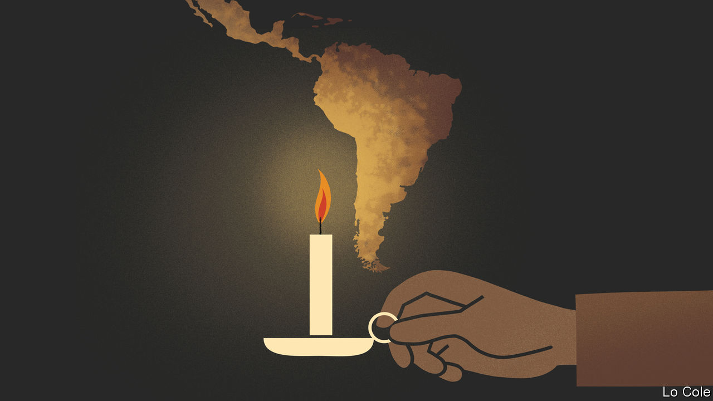

IN “THE LIGHT THAT FAILED”, an influential recent book, Ivan Krastev, a Bulgarian political thinker, and Stephen Holmes, an American law professor, argue that the rise of populist nationalisms in central and eastern Europe is in large part due to frustration with the way that liberalism was foisted on these countries after the fall of the Berlin Wall in 1989. The practice of copying a foreign model, presented to citizens as if there were no alternative, is a humiliating one that denies national traditions and identities, they write. For Latin America their argument raises an interesting question. It, too, formed part of the global wave of democratisation in the 1980s and 1990s, and it, too, has seen a recent resurgence of populist nationalisms. So are the troubles of liberalism in Latin America down to it being a foreign import, with few local roots?

The answer must start with liberalism’s long history in Latin America, a region that has seen waves of copying of foreign ideas and of their rejection. It achieved political independence two centuries ago under the twin inspirations of the European enlightenment and the constitutionalism and republican values of the fledgling United States. But those Latin American founders who set out to build nations, ravaged by the independence wars, on liberal principles quickly ran into crude local realities of power and social and racial inequality. They yielded to caudillos (strongmen, often military), who embodied “the will of the popular masses”, according to Juan Bautista Alberdi, an Argentine political theorist.

Liberalism came into its own in the region from the mid-19th century until the 1930s. Civilian governments, albeit often elected fraudulently, became the norm. They suppressed church privileges and opened economies to the world. Yet then Latin American liberalism lost its way. It partly morphed into positivism, which exalted science but denigrated freedom, while industrialisation posed new challenges. The region’s new mass societies became more interested in social than political or civil rights. Leaders and intellectuals embarked on a search for “authentic” national formulae incorporating indigenous cultures. For Mexico, European liberalism was “a philosophy whose beauty was exact, sterile and in the long run empty”, complained Octavio Paz, a poet and thinker, in 1950.

The desire for national authenticity reached its apogee with the Cuban revolution of 1959. Fidel Castro, its leader, claimed to be at war against American imperialism in the name of egalitarian national liberation. In fact, to stay in power he became the biggest copycat of all, slavishly imitating the Soviet Union. His disciples elsewhere were opposed by military dictators of the right.

Despairing scholars began to argue that Latin America’s Catholic, corporatist heritage made it impervious to liberalism. Yet the failure of dictatorships, nationalists and Castroism brought liberals (who by then included Paz) back in, with democratisation and pro-market economic reforms from the 1980s. The liberal achievement has been mixed, and politically fragile. Electoral democracy and constitutional rule have generally held up. But the separation of powers is often more notional than real. Liberalism’s opponents on the left have damned its economic recipes, often called the “Washington consensus”, as an alien import, even as many have continued to follow them.

Contemporary Latin American liberalism suffers from two weaknesses. It has failed to shed the damning characterisation that it is heartless “neoliberalism”. In part that is because some who call themselves “liberals” in Latin America (and Iberia) are in fact conservatives, who oppose efforts to reduce unacceptable inequalities from which they benefit. Second, genuine liberalism tends to be the preserve of an upper-middle-class elite, with degrees from foreign universities. They have failed to produce a new generation of effective leaders to replace those who steered democratisation.

Yet it is liberalism that is best placed to provide many of the things that Latin Americans want: justice systems that check the powerful; equality of opportunity; the public good rather than the protection of private privilege; better public services at an affordable fiscal cost; the defence of minority rights and tolerance in the face of renewed religious bigotry; and science rather than ideological quackery. Covid-19 makes all these things more urgent. This should be Latin American liberalism’s hour.

This article was downloaded by calibre from <https://www.economist.com/the-americas/2020/04/18/the-flickering-light-of-liberalism-in-latin-america>

|  |  |  |  |
| --- | --- | --- | --- |
| Previous | Articles | Sections | Next |

|  |  |  |
| --- | --- | --- |
| The Americas | Sections | China |

Asia

Ethnic strife in Myanmar: Guerrillas with attitude

.

Informal workers and covid-19: Get sick or go hungry

.

Covid-19 in Japan: Déjà flu

.

Politics in South Korea: Infectious enthusiasm

.

Banyan: In hot water

.

|  |  |  |
| --- | --- | --- |
| The Americas | Sections | China |

|  |  |  |  |
| --- | --- | --- | --- |
|  | Articles | Sections | Next |

#### Guerrillas with attitude

# An ethnic militia with daring tactics is humiliating Myanmar’s army

The government’s flailing response seems to be boosting the Arakan Army

Apr 18th 2020 |

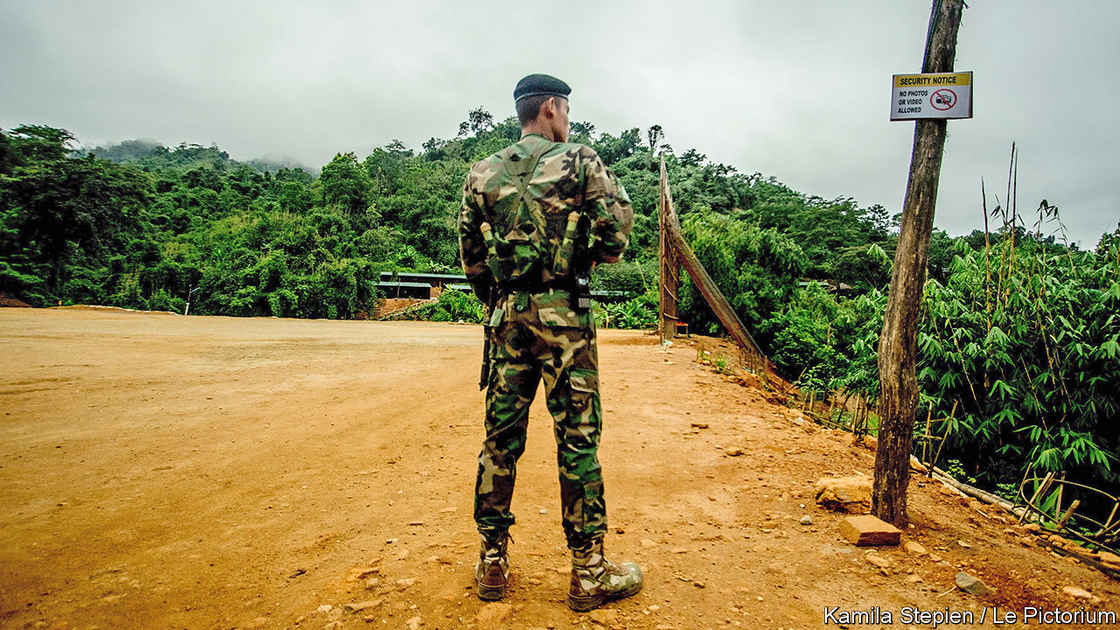

IN RAKHINE AND Chin states, in the far west of Myanmar, bullets fly and villages burn. Dead bodies lie slumped in ditches. These “clearance operations”, as the Burmese government calls them, evoke those of 2017, when the army drove hundreds of thousands of Rohingyas, a Muslim ethnic group, from their villages, killing and raping many as they did so, in what the UN described as genocide. Three years later the army’s sights are trained on a different ethnic group: the Rakhine. Like disgruntled members of many other minorities scattered across Myanmar’s ethnic patchwork, some Rakhines are waging a war of independence against the Bamar majority. Unlike the others, they are making headway.

Conflict erupted last year on January 4th, Myanmar’s independence day. Several hundred fighters from the Arakan Army (AA), a Rakhine armed group, attacked four police posts in northern Rakhine state, killing 13 officers (Arakan is the rebels’ preferred name for the state). The AA and the Tatmadaw, as the Burmese army is called, had skirmished occasionally since 2014, but the insurgents had never before attempted anything so bold. The government, helmed by Aung San Suu Kyi, winner of a Nobel Peace Prize, instructed the army to “crush” the rebels. The Tatmadaw has since deployed 15,000-20,000 troops, according to Anthony Davis, a security analyst, in what he describes as an “unprecedented” mobilisation, involving heavy artillery, air strikes and even naval patrols.

“The AA has departed markedly from patterns of guerrilla warfare in Myanmar,” says David Mathieson, another analyst. Rather than hiding in redoubts in the jungle, it also operates in urban areas; instead of simply taking potshots at army patrols it has conducted bombings and abducted hundreds of civil servants, policemen, soldiers and politicians. The Tatmadaw, accustomed to siege warfare, is floundering in its response. Mr Mathieson reckons it has suffered at least a couple of thousand casualties. Mr Davis labels the AA “the most serious insurgency the Burmese military have faced since independence”.

The AA is better organised and equipped than most ethnic rebels. Its commander, Twan Mrat Naing (pictured), is educated, charismatic and young, unlike the septuagenarian leaders of most of the country’s other insurgencies. The AA also commands overwhelming support from Rakhines, and can pick and choose among recruits.

Rakhines are rushing to enlist because they have lost faith in the political system. They say they have been neglected for decades by the central government: Rakhine is one of Myanmar’s poorest states. The advent of civilian government under Ms Suu Kyi in 2016, after many decades of military rule, only exacerbated tensions. The Arakan National Party (ANP), which won a majority of parliamentary seats in Rakhine, believed that her party, the National League for Democracy, would let it nominate the state’s chief minister. Instead the NLD appointed one of its own. The killing of seven Rakhine protesters by the police in 2018 and the subsequent arrest of Aye Maung, the ANP’s chairman, further radicalised Rakhines. His imprisonment also left a vacuum, into which the AA has stepped.

“Throw off the shackles of Burmese racism and colonialism,” Mr Twan Mrat Naing recently urged his fellow Rakhines, harking back to the long periods when Rakhine state was an independent kingdom. The rousing message is hammered home in the group’s slick social-media videos, featuring hale young soldiers declaring undying love for their homeland.

The AA is intent on inflicting so much damage that the government will have to make concessions. Over the past six months, more than 210 government employees in Chin state, where much fighting has taken place, have resigned after being threatened by its fighters. Officials from the central government are sufficiently unsafe in Rakhine that they must seek special permission to go there and often travel with a military escort. The AA also threatens to take the fight to the Bamar-inhabited regions at the heart of Myanmar. “We should reciprocate,” says Mr Twan Mrat Naing. “They are basically looking to destabilise the [national] government’s activities in Rakhine state as much as they can,” says Mary Callahan, a military historian, “and they’ve succeeded.”

The government’s efforts to hamper the AA look flailing. It has blocked mobile-internet service to about 1m people in Rakhine and Chin states since June, according to Human Rights Watch. On March 23rd it also blocked access to several news websites that report on the conflict and designated the AA a terrorist organisation. The police have since charged several journalists who interviewed Mr Twan Mrat Naing with violating the counter-terrorism law.

Rakhine civilians are also coming under fire. Amnesty International claims that the army has been shooting indiscriminately at Rakhine settlements and torturing and murdering civilians. At any rate, more than 100,000 people have been displaced by the fighting. Analysis of media reports by Nyan Lynn Thit Analytica, a Burmese think-tank, shows that 42 civilians have died since March 23rd.

The Tatmadaw risks turning “a war in Rakhine into a war on the Rakhine”, says Mr Davis. He believes that doing so will only encourage Rakhine civilians to rally around the AA with greater fervour. The rebels do not have the firepower to defeat the Tatmadaw militarily, but he is not sure that they need to. If they inflict sufficient humiliation on the Tatmadaw, he reasons, the government may decide to retreat from the fight and seek a political settlement. ■

This article was downloaded by calibre from <https://www.economist.com/asia/2020/04/18/an-ethnic-militia-with-daring-tactics-is-humiliating-myanmars-army>

|  |  |  |  |
| --- | --- | --- | --- |
|  | Articles | Sections | Next |

|  |  |  |  |
| --- | --- | --- | --- |
| Previous | Articles | Sections | Next |

#### Hunger strike

# Asia’s workers can’t afford to stay at home

Governments are trying to change that

Apr 18th 2020 | DELHI AND SINGAPORE

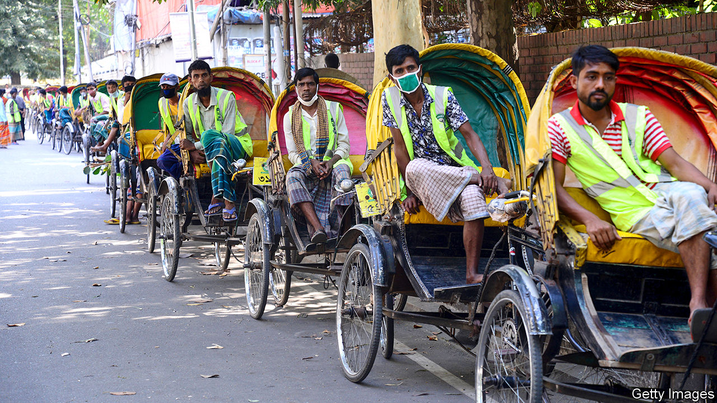

Editor’s note: The Economist is making some of its most important coverage of the covid-19 pandemic freely available to readers of The Economist Today, our daily newsletter. To receive it, register [here](https://www.economist.com/newslettersignup). For our coronavirus tracker and more coverage, see our [hub](https://www.economist.com/coronavirus)

BANGLADESH WENT into lockdown on March 26th, but that didn’t stop Zohirul from taking his bicycle rickshaw out onto the backstreets of Dhaka, the capital, a couple of times. On his first outing he earned just 200 taka, or $2.40, less than a fifth of what he normally makes. On the second he was caught by the police, who beat him, injuring his leg so badly he can no longer peddle his rickshaw. Since then he’s been nursing his wounds and husbanding his stores of rice. “I don’t know how I’m going to earn or buy food once this runs out,” he says.

As Asian governments impose quarantines to curb the spread of covid-19, the continent’s usually hectic streets have gone quiet. Restrictions vary, but almost everywhere the message is the same: stay home. Such measures threaten to ruin the majority of Asians. Seventy per cent of workers in Asia and the Pacific do not have formal jobs, with contracts, salaries or sick leave, but instead do things like driving rickshaws for a living, according to the Economic and Social Commission for Asia and the Pacific (ESCAP), the UN agency for the region (see chart). In many places there is not much of a safety net for the poor or unemployed either. Some workers feel they face a choice between getting sick and going hungry.

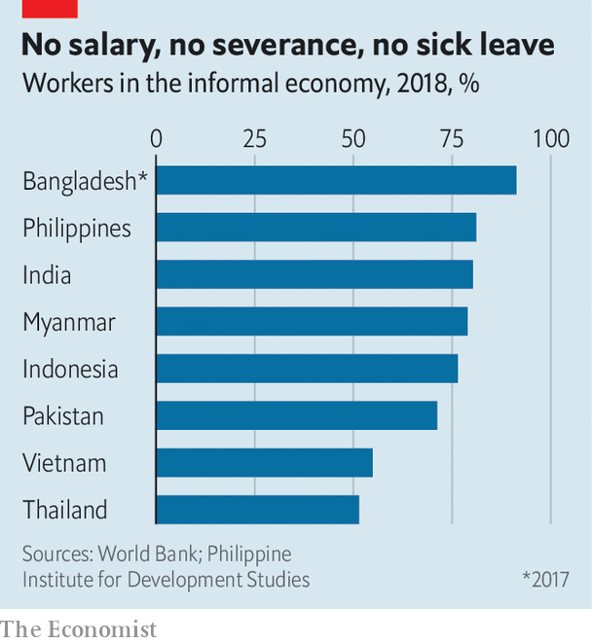

Governments in poorer Asian countries realise there is little point declaring a lockdown if their citizens cannot afford to abide by one, and so are trying to help. It is a daunting task. Informal workers are “not in the government databases”, says Hamza Malik of ESCAP. Identifying them is “extremely challenging”, according to Guy Ryder, director-general of the International Labour Organisation (ILO). Bureaucrats are consulting censuses or lists of those who already receive some sort of help from the state. But these often miss people, and quickly go out of date. Indonesia’s Unified Database, which contains the details of the poorest 40% of the population—some 100m people—is supposed to be updated twice a year by local governments. However, two-fifths of them don’t have the budget or capacity to do so, reckons Vivi Yulaswati of the planning ministry.

The pandemic makes the task of identifying the needy all the more challenging by swelling their ranks. The ILO estimates that the reduction of working hours in Asia this quarter equates to 125m people losing their jobs. The World Bank expects the impending recession will push up to 11m Asians below a poverty line of $5.50 a day. That may be optimistic. Indonesia may need to start giving handouts to an extra 50m people, Ms Yulaswati speculates.

Given how patchy existing databases are, some countries are inviting victims of the pandemic to petition for help online. In Thailand and Kazakhstan informal workers can apply for a one-off cash grant via a dedicated website. Nearly 5m people in Kazakhstan—over a quarter of the population—have done so. Indonesia has launched a similar programme, for anyone whose income has been hit by the crisis. The very poorest, however, are also the least likely to have access to a smartphone to lodge an application online.

Once governments have identified whom they wish to help, they need to decide what to give them. Many Asian countries are handing out food. Bangladeshi officials have been distributing rice; their counterparts in Myanmar have added salt, lentils and onions; the Philippines also offers sugar, coffee and canned fish and meat. But doling out food can be expensive, involving as it does “the logistics of procurement, storage, warehousing and distribution”, notes Ugo Gentilini of the World Bank. Cash is cheaper and faster to distribute, and tends to work just as well, as long as recipients have access to markets, which people in remote villages sometimes do not. So Asian countries are providing both types of aid. In India more than 800m people who were already eligible for subsidised food are getting extra rations, while over 300m poor women, pensioners, farmers and construction workers are receiving small sums of cash. In addition, India has placed a three-month moratorium on loan repayments. In Sri Lanka those leasing vehicles can defer payments for six months.

Inevitably, there have been flaws and oversights. In Bangladesh several local politicians have been arrested for funnelling free rice to friends and supporters. (Zohirul, the injured rickshaw-driver in Dhaka, has yet to receive any.) Technical glitches prevented many Kazakhs from applying for a cash grant. Protesters in Thailand say the handout scheme there is too narrow. Even when assistance does reach the poor, it is seldom enough. The sum being given to the 12m poorest households in Pakistan is 3,000 rupees ($18) a month—less than a fifth of the minimum wage.

Despite their limited resources, poor countries could improve public health care and expand safety nets, says Mr Malik of ESCAP. On average, developing countries in Asia spend just 3.7% of GDP to help citizens on the skids, far below the global average of 11%. The Asian Development Bank and World Bank have pledged billions of dollars to help Asian countries fight the virus. Governments should use that money, Mr Malik argues, “to create a different world”. ■

Dig deeper:  
For our latest coverage of the covid-19 pandemic, register for The Economist Today, our daily [newsletter](https://www.economist.com/newslettersignup), or visit our [coronavirus tracker and story hub](https://www.economist.com/coronavirus)

This article was downloaded by calibre from <https://www.economist.com/asia/2020/04/18/asias-workers-cant-afford-to-stay-at-home>

|  |  |  |  |
| --- | --- | --- | --- |
| Previous | Articles | Sections | Next |

|  |  |  |  |
| --- | --- | --- | --- |
| Previous | Articles | Sections | Next |

#### Déjà flu

# A second wave of covid-19 hits northern Japan

Hokkaido imposes its second state of emergency in two months

Apr 18th 2020 | TOKYO

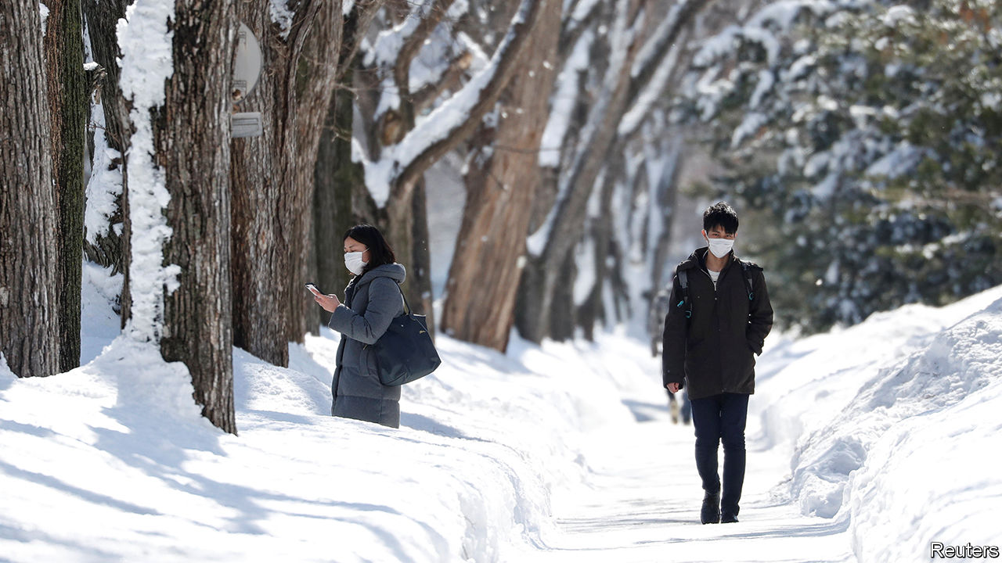

Editor’s note: The Economist is making some of its most important coverage of the covid-19 pandemic freely available to readers of The Economist Today, our daily newsletter. To receive it, register [here](https://www.economist.com/newslettersignup). For our coronavirus tracker and more coverage, see our [hub](https://www.economist.com/coronavirus)

POINTING TO A chart showing a flattened curve, Suzuki Naomichi, the governor of Hokkaido, announced on March 18th that the region had contained its coronavirus outbreak and could therefore lift its three-week-old state of emergency. “We were on defence until now, but we hope to enter a new stage,” he said. Less than a month later Mr Suzuki warned that Hokkaido was “facing a crisis of a second wave”. He reimposed a state of emergency on April 12th.

The prospect of this sort of reversal haunts governments around the world. The lesson is clear, says Shibuya Kenji of King’s College London: “Even if you manage to control a local outbreak, once you lift the lockdown, there’s a high risk of resurgence.”

When the virus first spread to Japan, Hokkaido was the hardest-hit region. Although home to only 4% of the population, it racked up a third of the 206 confirmed cases in the country by the end of February. Mr Suzuki declared the first state of emergency on February 28th, asking residents to restrict outings and schools to close. Locals largely complied. On March 17th Hokkaido had its first day with no new cases in more than a month. Schools reopened and restaurants became busy again. “A lot of people thought the worst was over,” says Sasada Hironori of Hokkaido University. “People dropped their guard.”

But the number of new cases began rising again, from 198 on April 7th to 296 on April 15th. Though low in absolute terms, the uptick unsettled the local government. The first wave had been linked to Chinese tourists visiting a winter festival in early February, making transmission relatively easy to trace. The second wave seems to have been caused by locals returning from Tokyo or abroad, and so is much more diffuse. Patchwork restrictions and continuing inter-regional transport have undermined containment efforts, argues Mr Shibuya.

Pollsters say 95% of locals supported Mr Suzuki’s first state of emergency in February. His approval rating hit 88% in early April. The public disapproves, meanwhile, of the national government’s delay in following suit. Hokkaido’s new state of emergency is due to end on May 6th, in line with the one the prime minister, Abe Shinzo, declared in six prefectures in early April. That, says a bureaucrat in Hokkaido, “is probably too optimistic”. He should know.

Dig deeper:  
For our latest coverage of the covid-19 pandemic, register for The Economist Today, our daily [newsletter](https://www.economist.com/newslettersignup), or visit our [coronavirus tracker and story hub](https://www.economist.com/coronavirus)

This article was downloaded by calibre from <https://www.economist.com/asia/2020/04/18/a-second-wave-of-covid-19-hits-northern-japan>

|  |  |  |  |
| --- | --- | --- | --- |
| Previous | Articles | Sections | Next |

|  |  |  |  |
| --- | --- | --- | --- |
| Previous | Articles | Sections | Next |

#### Infectious enthusiasm

# A landslide for South Korea’s ruling party in parliamentary elections

Voters were happy with the government’s handling of the covid-19 pandemic

Apr 18th 2020 | SEOUL

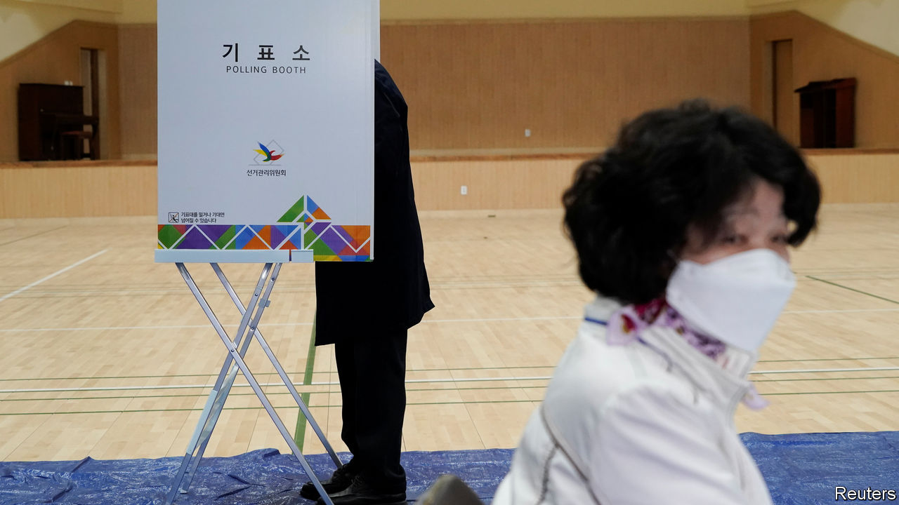

THE YOUNG man outside the polling station was adamant. “Of course it was right to hold these elections. It’s our basic right,” said Kim Su-ho, a 24-year-old voter in Seoul, the capital. “We’re not like Europe or America where they failed to slow the spread. There was no reason to postpone them.” His fellow South Koreans, it appeared, agreed: by the time the polls closed on April 15th, 66.2% of eligible voters had cast a ballot, more than in any parliamentary election since 1992. As much of the world remained in virus-induced lockdown, South Koreans donned face masks and plastic gloves to show that even in a pandemic, the journey to the polling booth is essential.

The virus-defying vote brought a resounding victory for the ruling Minjoo (Democratic) Party of Moon Jae-in, the president. Minjoo won 180 of the 300 seats in the National Assembly, including seats won by an affiliated party it set up to contest the proportional portion of the vote in the country’s hybrid electoral system. (At the previous election, in 2016, Minjoo won 123 seats.) United Future, the main conservative opposition party, came a distant second with 103 seats including proportional ones from its affiliate, down from 122 seats in 2016. Hwang Kyo-ahn resigned as the conservatives’ leader after losing his constituency in central Seoul. Minor parties, which had contested the election in record numbers following the introduction of new electoral rules designed to improve their chances, barely featured.

The main reason for Minjoo’s unprecedented success seems to have been the government’s response to the covid-19 pandemic. Before the outbreak, Mr Moon’s fortunes had been taking a turn familiar to previous South Korean presidents towards the middle of their term. His flagship policies of reining in the country’s big conglomerates and pursuing rapprochement with North Korea had flagged. But over the past few weeks, as the number of new confirmed cases of covid-19 fell below 50 a day, Mr Moon’s approval rating rose to its highest level in 18 months. With the opposition in disarray, the evident competence of South Korea’s public-health authorities rubbed off on the ruling party.

The result bodes well for Mr Moon’s agenda during the remaining two years of his term. The president is still short of the two-thirds majority required to pass his proposals for constitutional reform. But Minjoo’s absolute majority will put an end to the parliamentary deadlock, if not the physical altercations, that have hampered lawmaking during the early stages of his term. It will allow the ruling party to push through the remaining elements of Mr Moon’s promised reforms of the prosecution service, which a majority of South Koreans still regard as too powerful. It will also ease the process for appointments that are made by the president but must be approved by parliament, such as the prime minister and the country’s chief judges. More immediately, the government will be able to implement the economic stimulus it has proposed to contain the fallout from the covid-19 pandemic. In particular, a supplementary budget to award cash handouts to the bottom 70% of households, which the opposition has criticised, should now sail through.

Still, claims that the election marks a fundamental shift in South Korean politics seem premature. The partisan divide between progressive strongholds in Seoul and the south-west and the conservative heartland in the south-east was even more pronounced than at the previous election. Many of Minjoo’s additional seats were won back from the People’s Party, a progressive outfit that split from Minjoo before the vote in 2016. And the result does little to ease the external difficulties with which the government will continue to have to grapple. North Korea has reverted to its typical, hostile form, and has conducted five sets of missile tests so far this year. And however successful South Korea has been in managing the covid-19 outbreak, that will not shield it from the global downturn the virus is causing. ■

This article was downloaded by calibre from <https://www.economist.com/asia/2020/04/18/a-landslide-for-south-koreas-ruling-party-in-parliamentary-elections>

|  |  |  |  |
| --- | --- | --- | --- |
| Previous | Articles | Sections | Next |

|  |  |  |  |
| --- | --- | --- | --- |
| Previous | Articles | Sections | Next |

#### Banyan

# Big parts of the Great Barrier Reef are dying

The bleaching adds to Australia’s summer of unnatural calamities

Apr 18th 2020 |



OVER THE southern hemisphere’s summer, mercifully now at an end, Australia burned under a pitiless sun. Bush fires down the continent’s eastern flank consumed 46m acres of countryside, destroying homes, taking lives and driving rare animals towards extinction. To many Australians, the satellite pictures showing huge plumes of smoke drifting off to the east over the Great Barrier Reef seemed a portent of life in an age of man-made warming.

It turns out that high temperatures were wreaking havoc under the water as well. This month comes news that exceptionally warm seas have led the Great Barrier Reef, the world’s biggest coral system, to suffer its third mass bleaching in five years. The bush and the reef, both ravaged on a gargantuan scale: Australians almost define themselves by these two ecosystems, which once seemed boundless.

Coral bleaching takes place when sea temperatures spike, causing the coral polyps that make up reefs to eject the algae that generate their food via photosynthesis. Without the pigmented algae, coral soon dies, leaving the intricate colonies a ghostly white. Reefs can recover from occasional bleachings: the fastest-growing corals regenerate in a decade or so. But mass bleachings on the Great Barrier Reef are becoming ever more frequent. The first occurred only in 1998. There have since been four more: in 2002, 2016, 2017 and now this year. They have become so common that the Bureau of Meteorology issues forecasts for them.

The latest bleaching is not as severe as the worst one, in 2016, when about half of the northern part of the 2,300km-long reef died. But the run of recent bleachings had already killed off relatively heat-intolerant coral species. What is striking this year, says Terry Hughes of James Cook University in Queensland, who led a recent aerial survey of the reef, is that for the first time the bleaching extended to the southern part of the reef. There, closer to the pole, waters should be cooler. Not this year. February saw the highest sea-surface temperatures across the reef since monitoring began 120 years ago.

The biblical rains that recently extinguished the bush fires have also helped to lower water temperatures over the reef. The rains are proof to climate-change deniers—who are given a platform by Rupert Murdoch’s press and who are represented on the ruling coalition’s backbenches—that recent fires, droughts and floods are simply part of the natural cycle. They point with glee to the bush springing back to life. Yet while important habitats, such as those dominated by eucalypts, depend upon fire to regenerate, this summer’s fires, exceptionally, destroyed temperate rainforests too. They also incinerated perhaps a third of koalas in New South Wales—hardly a run-of-the-mill dip in the population.

Regarding the reef, the deniers play down the damage and insist on the ability of “nature to fix nature”. That is despite the cumulative effect of successive bleachings from which reefs struggle to recover. Mr Hughes says the Great Barrier Reef can no longer return to its state of even five years ago; in the coming decades, healthy coral is likely to be confined to ever smaller patches.

The bush fires threw the prime minister, Scott Morrison, off balance. Holidaying in Hawaii made him look out of touch, while his Liberal Party’s cosy links to oil, gas, coal and iron-ore interests came under closer scrutiny. Among big economies Australia ranks behind only Saudi Arabia in terms of greenhouse-gas emissions per head—and that does not count the emissions when its exports of coal and gas are consumed elsewhere.

Perhaps in this respect, the new coronavirus is a tonic for Mr Morrison. His polls, hurt by the fires, have risen as Australia has escaped an epidemic on a par with Europe or America. Meanwhile, the government intones it is on course to “meet and beat” national commitments under the Paris agreement on climate to cut emissions—although that is thanks in part to an accounting gimmick.

As for the latest bleaching, the government has largely ignored the news. Mr Morrison’s official “envoy” to the Great Barrier Reef, Warren Entsch, a Queensland politician, points out that “bleached corals are not dead corals” and predicts that many will recover. Although he admits climate change is a concern, he once complained that “indoctrinating” youngsters to be worried about it is a form of “child abuse”. Most Australians care both about climate change and about the Great Barrier Reef—but not enough, alas, to call their government out over such ambivalence.

This article was downloaded by calibre from <https://www.economist.com/asia/2020/04/18/big-parts-of-the-great-barrier-reef-are-dying>

|  |  |  |  |
| --- | --- | --- | --- |
| Previous | Articles | Sections | Next |

|  |  |  |
| --- | --- | --- |
| Asia | Sections | Middle East and ... |

China

Global influence: Thanking big brother

.

Chaguan: China’s self-censoring nationalists

.

|  |  |  |
| --- | --- | --- |
| Asia | Sections | Middle East and ... |

|  |  |  |  |
| --- | --- | --- | --- |
|  | Articles | Sections | Next |

#### Thanking big brother

# China’s post-covid propaganda push

China is handing out medical kit, and making sure the cameras see it

Apr 16th 2020 | NEW YORK AND JOHANNESBURG

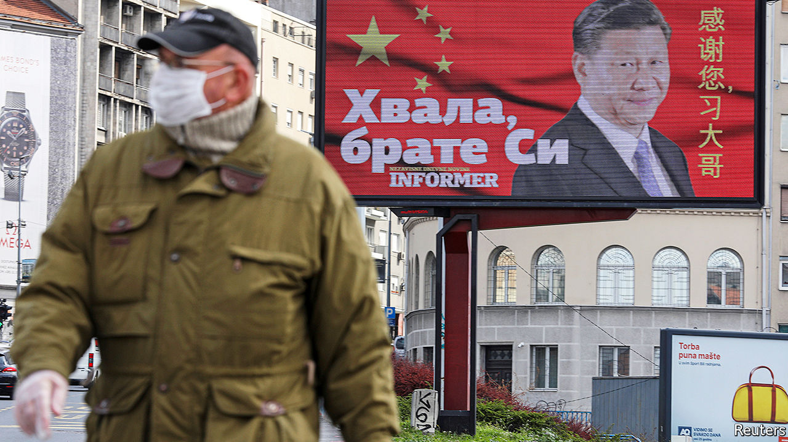

Editor’s note: The Economist is making some of its most important coverage of the covid-19 pandemic freely available to readers of The Economist Today, our daily newsletter. To receive it, register [here](https://www.economist.com/newslettersignup). For our coronavirus tracker and more coverage, see our [hub](https://www.economist.com/coronavirus)

CHINA CALLS it the biggest emergency-aid operation that it has mounted abroad since 1949, when the Communist Party seized power. Hardly a day goes by without news of Chinese medical supplies, from masks to ventilators, reaching grateful recipients; and of Chinese medical teams flying to foreign countries to help them fight covid-19. Just a few weeks ago China was by far the biggest victim of the new coronavirus, and its government was widely chided for covering up the initial outbreak. Now China is trying to paint a new picture—of itself as a model for taming the disease, and as the world’s saviour.

State media are on hand to trumpet each donation, no matter how small. On March 21st a freight train set off from the eastern Chinese city of Yiwu bound for Madrid, more than 13,000km away. In addition to its cargo of commercial goods were 110,000 masks and nearly 800 protective suits donated by a state-owned firm (they arrived more than two weeks later). The aid was worth less than $50,000. But a state-media website called it a “new turning-point” in the building of a “health silk road”. Among slogans reportedly affixed to the train was one saying: “Come on, matadors!”

It is hardly surprising that China is turning its attention to the plight of other countries. Its covid-related data are of dubious quality, but it has clearly achieved a dramatic reduction in infections at home. Almost all of its newly reported cases involve travellers from abroad. As the world’s biggest producer of much of the medical kit that is most urgently needed globally, and with its own demand for it much reduced, China is well placed to assist. Indeed, in a pandemic, “to help others is also to help oneself”, as a Chinese spokeswoman put it.

China, however, also sees potential political rewards. A big one is enhancing its power abroad. Even before the pandemic China had been jostling with America for global influence. Now it sees America crippled by the coronavirus, and the country’s president, Donald Trump, fumbling in his response to the crisis and unwilling to organise an international effort to fight the disease. At a five-yearly party congress in 2017, President Xi Jinping said his country would become a global leader by mid-century in terms of “international influence”. That goal is evident in China’s descriptions of how the world should evolve in response to covid. In effect, it should have China even more at the centre.

Another political gain that the party may hope to reap is at home. Playing up China’s help for stricken countries, and their desire to learn from China’s success, helps to deflect public criticism of the party’s early response to the disease—its gagging of doctors who shared information about it online and its failure to warn citizens despite evidence of human-to-human transmission. State media insist that China’s battle against covid-19 has shown the “superiority” of Chinese-style socialism, with its “unique” ability to marshal people and resources. Burnishing Mr Xi’s image as a figure of global stature helps to reinforce this message. Any phone call between Mr Xi and a world leader to discuss the crisis makes the headlines of state television’s nightly news, no matter how banal the publicly released content. Mr Xi is the dependable, magnanimous statesman. No prizes for viewers who can guess who, by implication, is not such a politician.

The party’s propaganda about the aid effort is suffused with Mr Xi’s catchphrases. Take the health silk road that the train to Spain symbolically followed. The metaphor was first used by Mr Xi in 2017, when China signed an agreement with the World Health Organisation (WHO) to establish a health-related subset of the Belt and Road Initiative, China’s global infrastructure-building project (to which the WHO was the first UN body to sign up). The belt-and-road idea, and all associated silk-road-branded schemes, are closely linked with Mr Xi. Their content is vague—no clear definition has been offered, for example, of a health silk road. But the intent is clear: to portray China as fundamentally benign. The roads span the globe, but all lead back to China.

In his discussions with world leaders about covid-related aid, Mr Xi likes to use another of his favourite expressions: building a “community with a shared future for mankind”. It sounds harmless enough, but central to this idea is a principle that China holds dear, namely that of respecting other countries regardless of their political systems. Various formulations of this have been used since the days of Mao Zedong (Mao’s favoured term, the “five principles of peaceful coexistence”, remains in use). It means that other countries should swallow any misgivings about the way China is ruled and show it respect.

On March 26th, at an online meeting of G20 leaders, Mr Xi prefaced his offer to share China’s experience of fighting the disease and co-operate in the search for a vaccine by emphasising China’s commitment to “the notion of a community with a shared future for mankind”. The “urgency and importance” of creating such a community had become “even more evident” during the pandemic, he told the president of Kazakhstan, Kassym-Jomart Tokayev, two days earlier.

Some commentators in China say the country’s medical aid could help to strengthen China’s attractive “soft power”, as opposed to the hard kind involving military and economic might. Building such power has been one of the party’s goals since a party congress in 2007. Mr Xi has devoted particular attention to it, beefing up projects such as Confucius Institutes and global broadcasting ventures that aim to convey sanitised news about China to Western audiences, delivered in a disarmingly Western style. During the pandemic, China’s state media as well as the country’s diplomats have been using Twitter and Facebook (which are blocked in China itself) to promote China’s charitable efforts. Experts say that thousands of the Twitter accounts used for this are “sock-puppet” ones set up to spread disinformation.

The propaganda campaign has been helped by America’s virtual absence from the world stage during the pandemic—in part because of Mr Trump’s lack of interest in global leadership, and in part because of the damage caused by covid-19 at home. America has even found itself in the embarrassing position of clawing back aid it was meant to give. In March its Agency for International Development (USAID), which played a crucial role in helping African countries contain Ebola in 2014-16, began cancelling shipments of medical supplies abroad because they were needed in America. And as the Trump administration and American governors and hospitals scour the world for masks, gowns and the like, they are infuriating allies who need the same things. Early this month officials in France and Germany accused America of diverting shipments of medical masks that had been intended for use in their countries. Officials in Washington have denied the reports, but they reinforce the view, held in much of the world, that America is looking out only for itself. Mr Trump’s decision on April 14th to suspend his country’s payments to the WHO because of its handling of the pandemic will strengthen this belief, even though many Western officials sympathise with his view that the WHO failed to challenge China’s early claims about the low risk of transmission among humans (see [article](https://www.economist.com/science-and-technology/2020/04/16/the-world-health-organisation-is-under-fire-by-americas-president)).

However, winning hearts and minds is not proving easy for China, either. It does not help that, for all its propaganda about Chinese generosity, the value of China’s donations is far eclipsed by that of its sales of medical kit (occasionally of low quality, buyers allege) on commercial terms. Between March 1st and April 4th China exported $1.45bn of medical supplies globally. Most of the sales to the rich world have been at market prices. By the time the train arrived in Madrid, Spain had already bought similar equipment from Chinese suppliers worth about 10,000 times as much as the stuff sent by rail.

It may be that China has not worked out an aid strategy, with a clear sense of which countries to target as a priority and how much should be given away free. Indeed, it has been happy to let companies, both state-owned and private, do much of the work. Some of the country’s largest firms have taken up the challenge, but they are relative newcomers to philanthropy. They also have commercial interests at stake in many of the recipient countries.

## Bounty from businessmen

Jack Ma, the billionaire co-founder of Alibaba, an e-commerce giant, has been at the forefront. Along with Alibaba’s charitable foundation, he has sent planeloads of ventilators, protective kit and covid-19 tests for distribution to all 54 African countries. Huawei, a telecoms firm treated by America as a threat to its security, has already delivered a large share of its pledge of 500,000 masks, 50,000 goggles, 30,000 gowns and 120,000 gloves to hospitals in New York. The company has also donated millions of masks to countries that are pondering whether to allow Huawei into their 5G networks, including Canada and the Netherlands.

In parts of Europe, China’s aid may have won admirers. A large billboard thanking “big brother Xi”, paid for by a pro-government Serbian tabloid, appeared in Serbia’s capital, Belgrade (see picture above,). Lucrezia Poggetti of MERICS, a think-tank in Berlin, says public discontent with the EU and distrust of Mr Trump’s America has worked in China’s favour. This month a poll commissioned by an Italian television station asked people which country they would prefer as an ally outside Europe. Of 800 respondents, 36% favoured China and only 30% chose America.

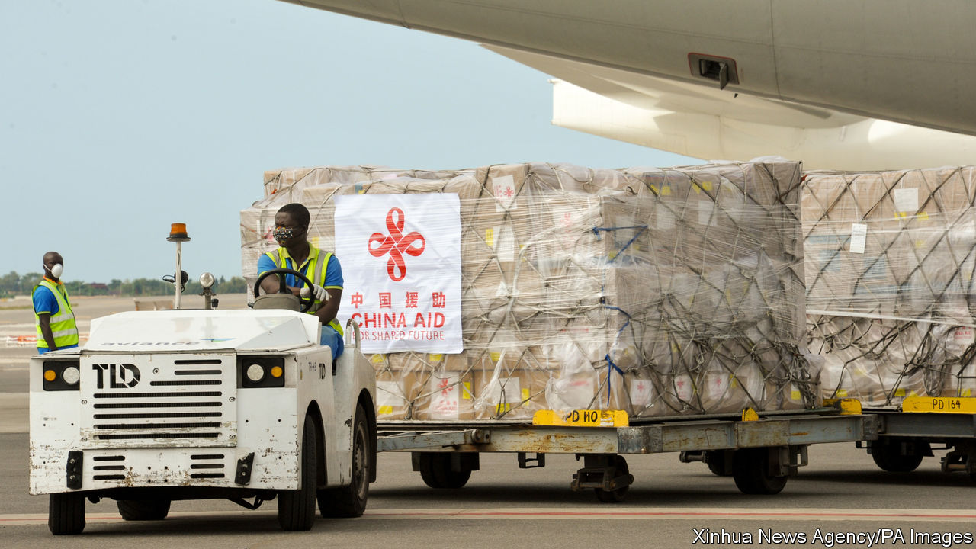

Do the masks have strings attached?

But to many in the West, China’s propaganda drive sounds cynical, exploitive and forgetful of the aid that the West gave China at its time of need. In early February America and Europe sent 30 tons of medical supplies (much of it privately donated). President Emmanuel Macron of France complained that people talk of Chinese and Russian aid to Europe. “But no one talks about France and Germany delivering 2m masks and tens of thousands of medical gowns to Italy,” he said. The EU’s foreign-policy chief, Josep Borrell, warned about the “politics of generosity”.

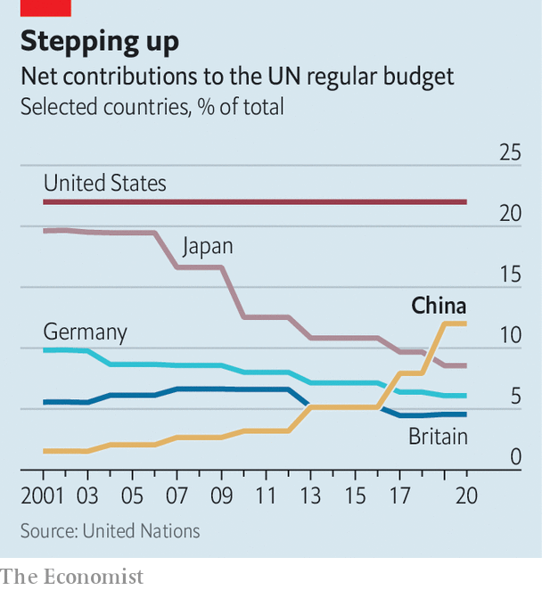

In poor countries, China’s charity may prove more effective. In Africa the shipments are urgently needed—a point that China’s extensive media network on the continent is keen to highlight (news outlets across Africa use stories from Xinhua, China’s state news agency). But America is still a far bigger donor on the continent and to the UN. Last year China gave $368m to the UN’s general budget, 55% of America’s contribution (see chart).

China’s image has taken a severe hit in Africa as a result of the recent evictions of some Africans from their residences in the southern Chinese city of Guangzhou after reports that a few of them had been infected by covid-19. Images of Africans forced to sleep on the streets have been widely shared by social media in their native countries. The Daily Nation, a Kenyan newspaper, accused China of “betrayal”. Several Chinese envoys in Africa have been summoned for dressings-down by host governments. China says it will gradually lift health-related restrictions on Africans in Guangzhou, and denies discrimination.

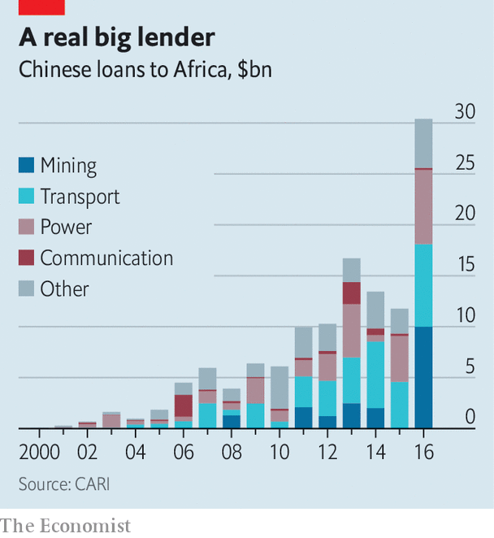

Among developing countries, China is as likely, if not more so, to win support by providing economic help as it is by giving medical aid. In Africa, China is the largest bilateral creditor, having lent more than $140bn since 2000 (see chart). On April 6th Ken Ofori-Atta, Ghana’s finance minister, said China should “come on stronger” by restructuring or writing off some loans, which he said would require $8bn to service this year. The World Bank and the IMF have proposed that creditors co-ordinate to provide debt relief.

On April 15th the G20, which includes China, agreed to allow developing countries to suspend debt payments to its members for the rest of the year. But when it comes to restructuring loans, China may prefer to go it alone rather than work closely with other lenders. In recent years it has been willing to change the terms of its debts, for instance last year those owed by the Republic of Congo. But it likes to act quietly, case-by-case. That way it can maintain the political leverage that its lending provides. Last year China reportedly cancelled $78m owed by Cameroon. A month later Cameroon withdrew its candidate (and the African Union’s choice) for director-general of the Food and Agriculture Organisation, a UN body, clearing the way for China’s candidate to get the job. Some Western critics called this a quid pro quo.

During the pandemic, China has shown readiness to shake its fists as well as woo countries with kindness. Its deployment of “sharp power”, as some call it, has been evident in its response to suggestions that China may have exacerbated the pandemic with its early cover-up. Chinese embassies in several countries have sputtered with outrage when prominent personalities, from the son of Brazil’s president, Jair Bolsonaro, to Mario Vargas Llosa, a Peruvian author, have aired such a heretical thought. China’s embassy in Lima accused Mr Vargas Llosa of making “absurd and baseless criticisms” of China in a column blaming the initial cover-up on China’s dictatorial system. Some Chinese diplomats have even reacted with fury when people point out that the virus originated in China.

Chinese leaders do not offer a clear blueprint for shaping the global order. But back in 2017 Mr Xi gave a hint of China’s long game when he proclaimed that it had taken “a driving seat” in international affairs and would be “moving closer to centre stage and making greater contributions to mankind”. This does not appear to involve converting countries to Chinese-style socialism. China’s aims are often self-defensive, to protect itself from criticism and challenges to its territorial claims. (When Bruce Aylward, an adviser to the WHO, pretended not to hear a reporter’s question about Taiwan, China’s media were delighted.) However, China does try to persuade others to adopt its peculiar view of human rights. It discounts individual freedoms, gives priority to economic development and thinks governments should police the internet as they wish.

Whether China will be able to take advantage of the pandemic to strengthen its global power will depend not least on the politics and economies of China and America post-covid. By stoking its economic growth following the global financial crisis of 2007-09, China gained much clout while the West slumped. It may not be able to replicate that effect this time: another massive dose of stimulus could cripple the country with debt. China is wary of repeating the tactic (see article).

As the world emerges from the crisis, the West’s attention is likely to become more focused on China’s early handling of the outbreak, the reliability of its covid-related data and on Western vulnerability to China’s control of vital supply-chains, not least in medical industries. Such issues could fuel anxieties about China’s global influence and make it harder for China to shape the world to its liking. Should he win America’s presidential election in November, Joe Biden may reassert a liberal vision of the world order, including support for multilateral institutions and regional alliances that have been disparaged and neglected by Mr Trump. And China may stumble. Another wave of infections could undermine the party’s claims to superior handling of the disease. Soaring unemployment could exacerbate social tensions at home and deter China’s leaders from engaging in a triumphalist march abroad.

For now, as America flounders, China appears a diffident leader at best. Its hesitancy was on display at the UN last month, when it was China’s turn to act as president of the Security Council. Throughout the month, it did not convene a single session about the pandemic. (On April 9th the council did hold one, but China insisted that the meeting, held by video-conference, be closed to the public.) Envoys to the UN say China did not want to give America a chance to assign blame for the pandemic. “It’s irresponsible,” says a Security Council diplomat. Instead two diehard rivals refuse to lead. One is in retreat; the other is uncertain whether it really wants to take on global responsibility. The world suffers. ■

Dig deeper:  
For our latest coverage of the covid-19 pandemic, register for The Economist Today, our daily [newsletter](https://www.economist.com/newslettersignup), or visit our [coronavirus tracker and story hub](https://www.economist.com/coronavirus)

This article was downloaded by calibre from <https://www.economist.com/china/2020/04/16/chinas-post-covid-propaganda-push>

|  |  |  |  |
| --- | --- | --- | --- |
|  | Articles | Sections | Next |

|  |  |  |  |
| --- | --- | --- | --- |
| Previous | Articles | Sections | Next |

#### Chaguan

# A diarist in Wuhan faces fury for sharing her story with the West

These days, public discourse in China is dominated by national pride

Apr 18th 2020 |

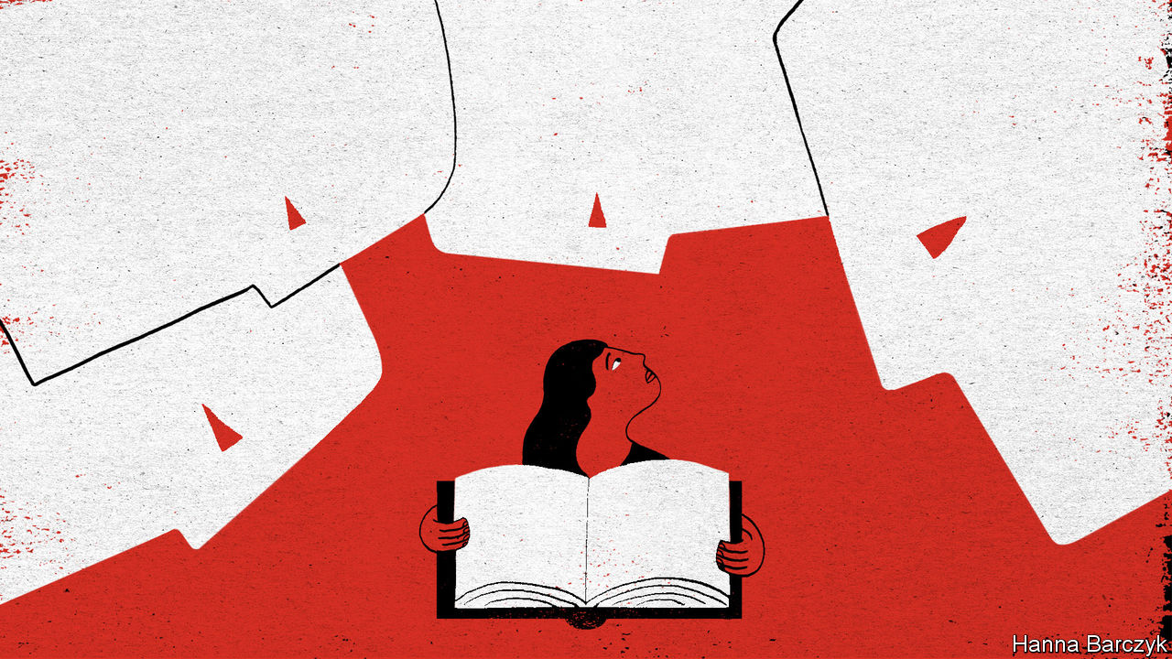

Editor’s note: The Economist is making some of its most important coverage of the covid-19 pandemic freely available to readers of The Economist Today, our daily newsletter. To receive it, register [here](https://www.economist.com/newslettersignup). For our coronavirus tracker and more coverage, see our [hub](https://www.economist.com/coronavirus)

CLUMSY DESPOTS use fear and coercion to keep foreign ideas at bay. Smart regimes know that nationalism is a more subtle tool. Bring a society to the right pitch of rage against foreign rivals, and people will scorn outside influences of their own accord. Something like that is happening in China, four months into the outbreak of covid-19. In early February it was easy to find Chinese livid about cover-ups by their government. Now it is not hard to find the opposite: Chinese seething with resentment against Western criticism, and expressing pride as their country carefully reopens while death rates soar in the rest of the world. Propaganda chiefs pound home the lesson to be drawn: because Western governments botched their virus-control work they are looking to demonise and scapegoat China. To be sure, Chinese public opinion is not monolithic, and it is hard to judge the true popularity of nationalism in a country that censors other expressions of anger. But a defensive, intolerant tone now marks too many Chinese discussions of this global pandemic.

Consider the fate of Fang Fang, a writer who spent February and March being lionised by millions of Chinese for publishing online diaries of a rare candour about life under quarantine in Wuhan, her hometown and the city where covid-19 was first detected. Supporters hastened to copy and share each new posting before it was deleted by censors. Fans praised the authenticity of Fang Fang’s accounts of life under lockdown, as she shared grim anecdotes sent to her by doctors, mourned friends and neighbours and demanded accountability from officials. Fang Fang—the pen-name of Wang Fang, a 64-year-old author of prizewinning works of bleakly realist fiction—boldly asserted personal claims to speak with authority, as an eyewitness to Wuhan’s horrors, and as a survivor of dark chapters in history. A notable clash was sparked by an open letter, purportedly from a 16-year-old boy, who scolded her for airing China’s “shameful business”. Recalling the Cultural Revolution, when young Maoist zealots denounced, beat and killed their elders, she chided him: “When I was 16, life was much harder than yours,” adding that he would one day shake off the “poison” filling his brain. Many of her roughly 4m followers on social media cheered.

Then news broke that Fang Fang’s “Quarantine Diaries” would be translated and published in America and Germany this summer. Back home, the shift in opinion was brutal. The social-media hashtag “Fang Fang’s Diaries” has received 550m views and 194,000 comments. Recent posts are overwhelmingly hostile. Netizens have been challenging her moral authority, lobbing the revealing insult “Ni bu pei!”, or “You are not qualified!” Though Fang Fang has pledged to give away her book royalties, she is charged with seeking fame at the expense of the dead—eating “buns made with human blood” as some have put it, borrowing an image from Lu Xun, China’s greatest 20th-century literary moralist.

China’s tightly censored internet is unusually exhausting just now, filled with the din of performative patriotism, and rows about who has a right to be heard. A self-declared ex-fan of Fang Fang’s, claiming to be a surgeon from Hubei, the province of which Wuhan is the capital, fumed that she had handed a sword to China’s enemies. The surgeon said history, as written by the Chinese people, would judge her harshly. His post earned more than 118,000 likes. Various conspiracy theories have cast the diarist as a mercenary. Her links to the China Writers Association, a semi-official body, have led to accusations that she is betraying her country while on the public payroll. The Global Times, a Communist Party newspaper, cited an unnamed “whistleblower” who alleges that she owns five villas. Fang Fang denies any illicit wealth, and says she will sue her accusers. State media have noted netizens’ suspicions that her work was translated so quickly that, in their view, foreigners surely commissioned her to write an anti-China screed. Fang Fang retorts that she began writing with no plans for a book, and learned only later that her work was being translated.

## How a clash of civilisations begins

A larger shift in opinion lurks behind this assault on a diarist’s credibility. Fang Fang’s co-operation with Western publishers sparks rage because the perceived moral standing of the West, starting with President Donald Trump’s America, is in free-fall. When a candid Chinese writer is embraced by foreigners, the motives of all involved are assumed to be suspicious.

In China, the most benign interpretation put on Fang Fang’s actions is ignorance. Chairman Rabbit, a well-connected, Harvard-educated blogger with 1.5m followers, wrote recently that Fang Fang comes from a generation that naively idealises the West, so fails to see how she is serving the “anti-China industry”. He contrasted the diarist with his own generation who, in his telling, have the worldly confidence to compare the West and China objectively.

Chairman Rabbit’s real name is Ren Yi. He is the 40-year-old grandson of Ren Zhongyi, a reformer who served as party secretary of Guangdong province in the 1980s. Over coffee in Beijing, Mr Ren (his pen-name comes from childhood pets) calls covid-19 a historic turning-point. Chinese now see America’s systemic weaknesses, he declares. “Chinese students are trying to escape the US and the UK to make it back to China. They are confident in this government.” He charges that Westerners have embraced Fang Fang because she criticises China’s government, and predicts that her voice may have a disproportionate impact on global views of China’s response to the virus. That upsets many Chinese “because China feels so alone in the world, and has no voice”, he says.

Outsiders may scoff at the idea of swaggering, assertive China as a voiceless underdog. But Chinese public discourse is dominated, currently, by a mix of national pride and resentment of a West that is widely assumed to be acting in bad faith. In their millions netizens are demanding less freedom of speech, if a compatriot’s candour helps the West. It is an autocrat’s dream. ■

Dig deeper:  
For our latest coverage of the covid-19 pandemic, register for The Economist Today, our daily [newsletter](https://www.economist.com/newslettersignup), or visit our [coronavirus tracker and story hub](https://www.economist.com/coronavirus)

This article was downloaded by calibre from <https://www.economist.com/china/2020/04/18/a-diarist-in-wuhan-faces-fury-for-sharing-her-story-with-the-west>

|  |  |  |  |
| --- | --- | --- | --- |
| Previous | Articles | Sections | Next |

|  |  |  |
| --- | --- | --- |
| China | Sections | Europe |

Middle East and Africa

Public health: What South Africa learned from AIDS

.

Remittances and Africa: Covid dries up a cash cow

.

Gaming in the Middle East: Covideo heaven

.

The war in Yemen: Looking for an exit

.

Quackery in Iran: A bad time for bad medicine

.

|  |  |  |
| --- | --- | --- |
| China | Sections | Europe |

|  |  |  |  |
| --- | --- | --- | --- |
|  | Articles | Sections | Next |

#### Don’t trust the internet

# What South Africa learned from AIDS

Experience of a previous pandemic informs the fight against covid-19

Apr 18th 2020 | JOHANNESBURG

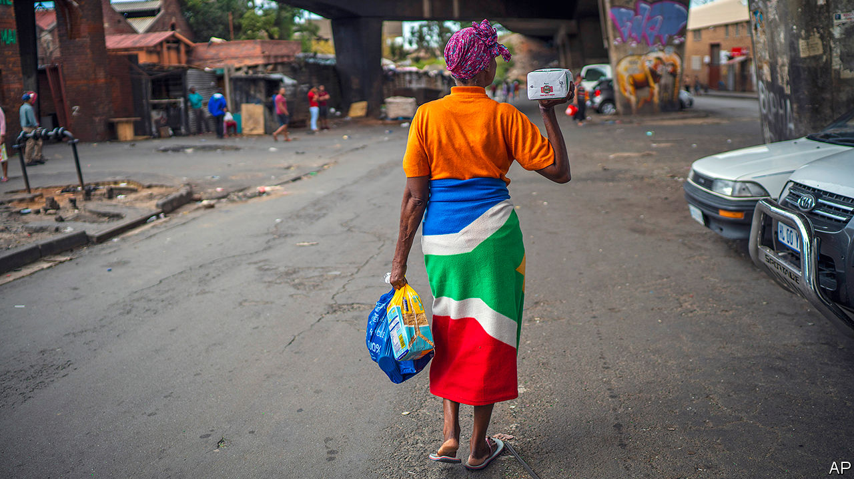

Editor’s note: The Economist is making some of its most important coverage of the covid-19 pandemic freely available to readers of The Economist Today, our daily newsletter. To receive it, register [here](https://www.economist.com/newslettersignup). For our coronavirus tracker and more coverage, see our [hub](https://www.economist.com/coronavirus)

IN ALMOST EVERY year of the past two decades more than a third of deaths in South Africa have been AIDS-related. Thabo Mbeki, the president from 1999 to 2008, swallowed a crank theory he found online that the human immunodeficiency virus (HIV) does not cause AIDS, which it does. He delayed life-saving treatment, cutting short hundreds of thousands of lives. The pandemic struck down adults in their productive prime, leaving grandmothers to raise orphans. Today South Africa still has more people infected with HIV than any other country.

Yet that pandemic has given South Africa vast knowledge of how—and how not— to tackle infectious diseases. “HIV/AIDS was a training ground for what we’re doing,” says Salim Abdool Karim, an epidemiologist who leads a group of doctors advising the government on the covid-19 pandemic. As a result of its tragic past, South Africa is deploying a unique strategy in the present—one that, if successful, may prove influential in other countries.

HIV has shaped South Africa’s response in two main ways, says Professor Karim. The first was to convince politicians to listen to medical experts and act quickly. The current president, Cyril Ramaphosa, has done just that. Social-distancing measures were introduced on March 15th, followed by a national lockdown on March 27th. “I failed miserably” to convince Mr Mbeki of the seriousness of HIV, reflects Professor Karim. “This government is much easier to work with.”

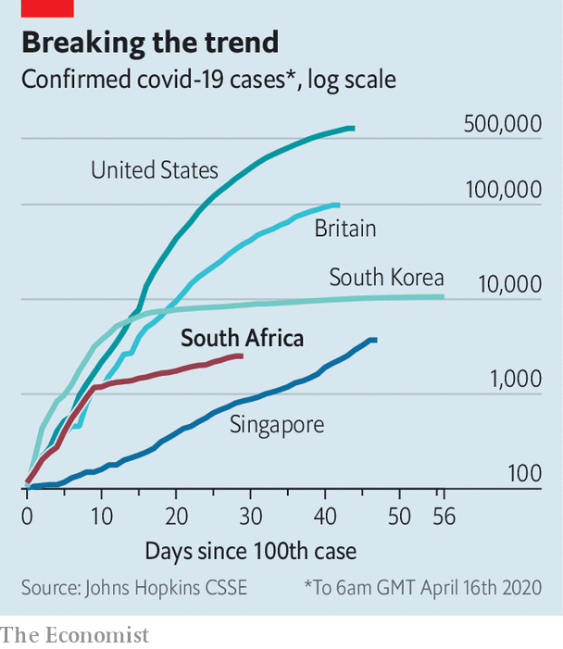

Restrictions seem to have had an effect. In the week to March 28th the number of confirmed cases quadrupled. But it took 17 days for the reported tally to double after that date. What looked at first like a Britain-style trajectory has come to appear more like South Korea’s (see chart). Confirmed cases depend on the number of tests, but Mr Karim believes that the deceleration reflects reality and that it is mostly due to the government’s measures.

To keep flattening the curve will require applying the second lesson from the HIV epidemic, he says. “You need to go house to house, be in the community.” Once South Africa stopped waiting for people to show up at hospitals with AIDS and sought to prevent or treat HIV, it slowed that pandemic. To screen, test and trace people with covid-19, South Africa has recruited about 30,000 community health workers. Many were already working in projects to prevent HIV or trace the contacts of people who are infected with tuberculosis.

Hundreds are being sent out in the Cape Flats, sprawling townships on the outskirts of Cape Town. In these poor, dense areas “self-isolation is just not feasible,” says Neal David, the doctor in charge of screening. Once a positive result for covid-19 is identified, his teams help the resident with medical care and, if necessary, quarantine. Those living in surrounding homes will be screened and potentially tested.

The results of the programme will help determine whether the lockdown is eased after April 30th, its provisional end date. The government wants to screen 10% of South Africa’s population, almost 6m people, before then. Such screening will need to be coupled with more testing. After a slow start the government aims to increase testing in its own laboratories to 10,000 per day by the end of the month, in addition to the thousands of tests that are being done in private facilities.

The doctors advising the government recognise that South Africa can only delay, rather than avoid, an eventual escalation in cases. But their aim is to buy the country time, so it can add critical-care beds, prepare quarantine facilities and build field hospitals. “We can’t pretend we are going to dodge the bullet,” says Dr David. “That would be naive.”

The public-health measures should also give South Africa time to organise an economic response. Before the pandemic the country was in its second recession in two years and unemployment was close to 30%. Things are now even worse. The central bank has slashed interest rates. But the rest of the government has been missing in action. There has been little financial help for those most in need.

## Testing times

This is not for a lack of options. The Democratic Alliance, the main opposition party, has proposed a 300bn rand ($16bn) stimulus package that would include 50bn rand in direct cash payments to the poorest South Africans via the social-grant system. Most of this would be funded by new borrowing from institutions such as the IMF. Tito Mboweni, the finance minister, says that he has been in discussions with international lenders. But he is reluctant to borrow if the money comes with strings attached, reflecting concerns in the ruling African National Congress (ANC) that this would dilute the country’s sovereignty.

The slow economic response could jeopardise the impressive public-health work. Parts of the Cape Flats have seen violent protests, with residents demanding food parcels. There are many reports of beatings by police and soldiers in townships. Those pushed deeper into poverty may not take kindly to the state knocking on their doors.

Across the world covid-19 has held up a mirror to societies, revealing their virtues and their flaws. South Africa has world-class scientists and doctors, many of whom won their spurs fighting AIDS. It has vibrant NGOs, full of community activists keen to help where the state has failed. But it has shocking levels of poverty and violence—legacies of apartheid and, more recently, misrule by the ANC. In responding to covid-19 South Africa is drawing on its past. It is also battling it. ■

Dig deeper:  
For our latest coverage of the covid-19 pandemic, register for The Economist Today, our daily [newsletter](https://www.economist.com/newslettersignup), or visit our [coronavirus tracker and story hub](https://www.economist.com/coronavirus)

This article was downloaded by calibre from <https://www.economist.com/middle-east-and-africa/2020/04/18/what-south-africa-learned-from-aids>

|  |  |  |  |
| --- | --- | --- | --- |
|  | Articles | Sections | Next |

|  |  |  |  |
| --- | --- | --- | --- |
| Previous | Articles | Sections | Next |

#### A cash cow dries up

# Covid stops many migrants sending money home

Red tape makes matters worse

Apr 18th 2020 | KAMPALA

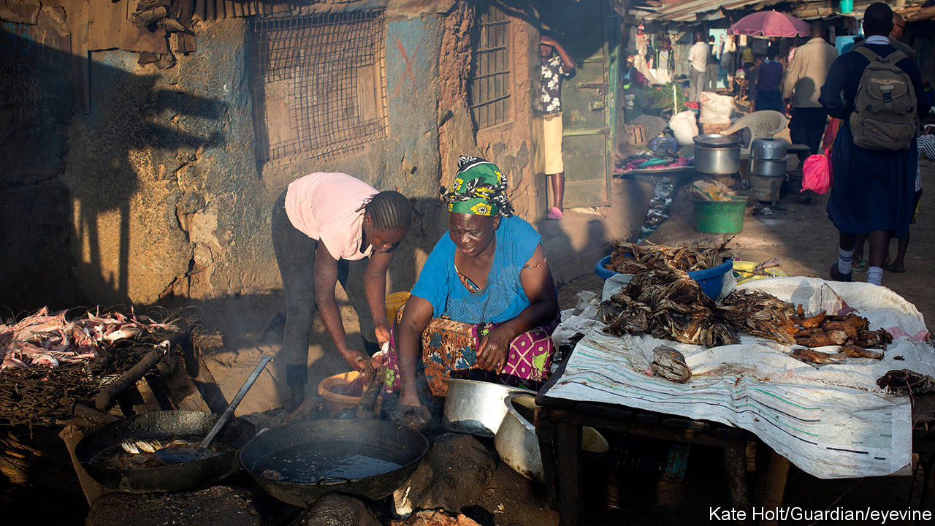

Editor’s note: The Economist is making some of its most important coverage of the covid-19 pandemic freely available to readers of The Economist Today, our daily newsletter. To receive it, register [here](https://www.economist.com/newslettersignup). For our coronavirus tracker and more coverage, see our [hub](https://www.economist.com/coronavirus)

WHEN A VIRUS spreads, so does hardship. A partial lockdown in Uganda has forced Barbara Nakyewa to close her hair salon in Kampala, the capital. Half a world away, in Philadelphia, her husband’s work as a lorry driver has dried up. He used to send home about $80 a month. Now he has not a cent to spare. Each morning Ms Nakyewa cooks porridge for her five children from a dwindling bag of maize, hoping for a government food handout.

Remittances are falling sharply across Africa. At one payments company, transfers from Britain to east Africa may have fallen by 80%. Another has seen flows from Italy to Africa drop by 90%. The effects are painful. Remittances bring much-needed cash directly to millions of families. They are also one of the continent’s main sources of foreign currency. In 2018 officially recorded remittances were worth $46bn in sub-Saharan Africa, far more than foreign direct investment of $32bn that year. The OECD, a club of mostly rich countries, reckons undeclared remittances could be worth another $16bn-35bn a year.

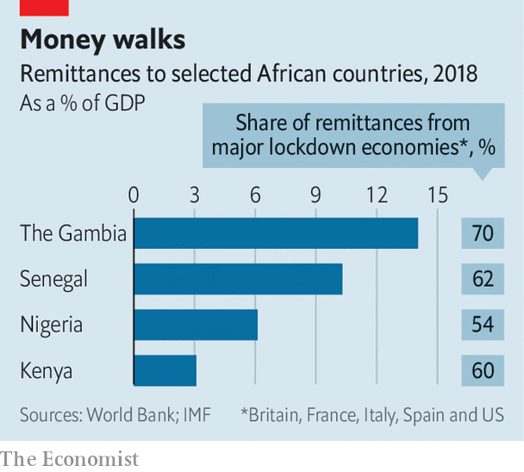

Some countries are particularly exposed (see chart). In Lesotho remittances are worth almost 16% of GDP. In Senegal they amount to 10% of GDP. Half of that comes from France, Spain and Italy, where nearly everyone is locked down. In Nigeria, where they are usually worth 6% of GDP, inflows dropped by half in February, says the central bank.

The virus and the global economic shutdown are hitting remittances with multiple blows. Migrants’ incomes have plummeted. Many work in industries that have almost completely shut down, such as construction, restaurants and hotels. They are often ineligible for welfare or stimulus payments. Many are sent packing if they lose their jobs—or sometimes just because they are African. Saudi Arabia has been deporting thousands of Ethiopians.

Sending money has been made tougher, too. Most payments still begin with cash being dropped off in person, often at a corner shop that doubles as a money agent. Many of these shops are now closed. Picking up the cash in Africa is harder because of lockdowns there. Mobile and online payments are standing up better, but they make up only about 15-20% of remittances; switching to digital is not always easy, since opening an account can require identity documents, proof of address, and in many European countries a work permit or residence visa.

The virus causes trouble in other surprising ways. Many money-transfer firms routinely fly stacks of banknotes via the Middle East to their African agents. They cannot send the money through the banking system since many Western banks refuse to transact with African remittance firms because of onerous American anti-money-laundering regulations. This is one reason why remittances to Africa are more expensive than elsewhere, with fees of about 9% of the transaction against 5% globally. That adds up: getting the price of remittances to Africa down to the average might save $1.8bn a year.

With planes grounded, bundles of banknotes are piling up in remittance shops around the rich world. One operator says that he will have to suspend his business if planes do not soon start flying again. Empty skies also mean informal remittance flows, often carried by passengers, are shrivelling. Bankers in Somalia, where remittances are worth 23% of GDP, say they are running out of notes.

How far remittances fall depends chiefly on the severity of the downturn. Before the global financial crisis they were rising by about 10% a year, but in 2009 they slumped by 5%. The plunge this year will probably be far worse. Remittance flows normally go up when African economies are slumping, because migrants hear more urgent pleas for help from relatives back home. Now they are dropping at the same time as African economies are stumbling. This week the IMF forecast a 1.6% fall in GDP across sub-Saharan Africa. (Annual population growth is over 2%.)

Rich countries are trying to soften covid-19’s impact on poor countries by offering debt relief. But there are other steps they could take that would cost nothing and would make it easier for migrants to help their families back home. Money-laundering regulations could be relaxed to let operators wire money instead of flying it, and make it easier for people to open digital accounts. And how about classifying money agents everywhere as essential services, allowing them to stay open? ■

Dig deeper:  
For our latest coverage of the covid-19 pandemic, register for The Economist Today, our daily [newsletter](https://www.economist.com/newslettersignup), or visit our [coronavirus tracker and story hub](https://www.economist.com/coronavirus)

This article was downloaded by calibre from <https://www.economist.com/middle-east-and-africa/2020/04/18/covid-stops-many-migrants-sending-money-home>

|  |  |  |  |
| --- | --- | --- | --- |
| Previous | Articles | Sections | Next |

|  |  |  |  |
| --- | --- | --- | --- |
| Previous | Articles | Sections | Next |

#### Covideo heaven

# Arabs and Persians are battling it out—virtually

Not all governments in the region are amused by a popular video game

Apr 18th 2020 | BEIRUT



Editor’s note: The Economist is making some of its most important coverage of the covid-19 pandemic freely available to readers of The Economist Today, our daily newsletter. To receive it, register [here](https://www.economist.com/newslettersignup). For our coronavirus tracker and more coverage, see our [hub](https://www.economist.com/coronavirus)

IT WAS A fraught conversation, but not for the reason many are these days. As he rummaged around his house, a young Saudi man vented about life under lockdown. The hotel where he works has no guests. Unmarried, he lives at home, with no escape from overbearing parents. Then, perhaps to ease his frustrations, he beat your correspondent to death with a frying pan.

Even before the virus swept the region, video games were popular in the Arab world, with its large, youthful and often idle population. Perhaps none has become a bigger sensation than “PlayerUnknown’s Battlegrounds” (pictured), known as PUBG, or bubji in Arabic. The premise is simple: a group of players, usually 100 of them, are dropped onto an island and fight to the death; the last one standing wins. In-game voice chat is often a mélange of Arabic dialects and Farsi, in a space where young people can socialise away from prying eyes and ears.

The mobile version, which has 50m active users worldwide, is a distraction across the Gulf, everywhere from shisha cafés to five-star-hotel lounges. A researcher estimates that 4m people in Saudi Arabia play it each month. When Iraqis began protesting against their government last year, some came dressed as characters from the game.

The Middle East and Africa are home to 14% of the world’s gamers, says Newzoo, a research firm. A study from 2019 by Northwestern University in Qatar found that close to half of young people in Egypt, Jordan and other Arab countries play at least once a day. Computers are out of reach for some, but gaming lounges are scattered around cities and towns. Muhammad bin Salman, the young Saudi crown prince, unwinds with “Call of Duty”, a shooter franchise, in rather more opulent surroundings.

Both developers and governments see an economic opportunity. The Middle East and Africa generated $5bn in revenue from gaming in 2019—only 3% of the global take, but up by 11% on the previous year. Tencent, the Chinese developer of PUBG, opened an office in Dubai last year. Saudi Arabia hosted a tournament in December with a $300,000 prize pool and hopes to expand the “e-sports” industry. The United Arab Emirates has organised its own events.

Not everyone is so enthusiastic. Young Arabs joke that their acceptable job options are limited to doctor, lawyer, engineer or disappointment. Convincing mum and dad that video games are a career is a hard sell. Iraqi politicians and parents dismiss young people as the “PUBG generation”. Last year parliament banned the game, a decision that proved ineffective. Jordan followed suit in July.

Panics about video games are not unique to the region. Lawmakers in America periodically seek to blame them for school shootings. Simulated violence seems less of a worry for officials in the Middle East, where the evening news is often more tragic than anything in “Call of Duty”. Some have been banned for sex scenes or for perceived slights against religion. The concern with PUBG seems to be simply that young people spend too much time on it. Tencent added a feature last year that lets parents restrict playing time—though, with their children now trapped at home, they may be happy to turn that feature off.

Dig deeper:  
For our latest coverage of the covid-19 pandemic, register for The Economist Today, our daily [newsletter](https://www.economist.com/newslettersignup), or visit our [coronavirus tracker and story hub](https://www.economist.com/coronavirus)

This article was downloaded by calibre from <https://www.economist.com/middle-east-and-africa/2020/04/18/arabs-and-persians-are-battling-it-out-virtually>

|  |  |  |  |
| --- | --- | --- | --- |
| Previous | Articles | Sections | Next |

|  |  |  |  |
| --- | --- | --- | --- |
| Previous | Articles | Sections | Next |

#### The kingdom’s quagmire

# Saudi Arabia looks for an exit to the war in Yemen

But after years of fighting, the Houthi rebels have the upper hand

Apr 18th 2020 |

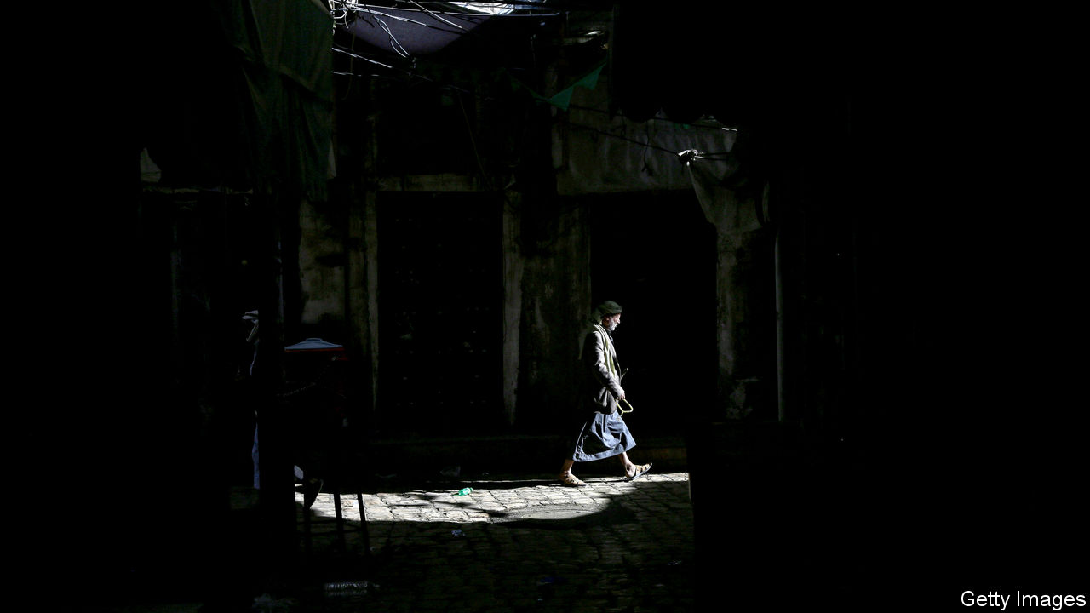

RARELY HAS Saudi Arabia sounded so magnanimous. For five years it has been fighting the Houthis, a group of Shia rebels in Yemen, on behalf of the government they toppled. The war has devastated Yemen’s infrastructure and killed more than 100,000 people. But on April 8th Saudi Arabia and its allies promised to lay down their arms for two weeks. The reason for the ceasefire, said a Saudi official, was “to alleviate the suffering of the brotherly Yemeni people and maintain their health and safety”. Two days later Yemen, the region’s poorest country, announced its first confirmed case of covid-19.

Cynics doubt that compassion is truly motivating Saudi Arabia, a majority Sunni nation. For years its bombs have hit hospitals, houses and schools in Yemen—often, it seemed, on purpose. Rather, the war is turning and the Saudis are losing heart.

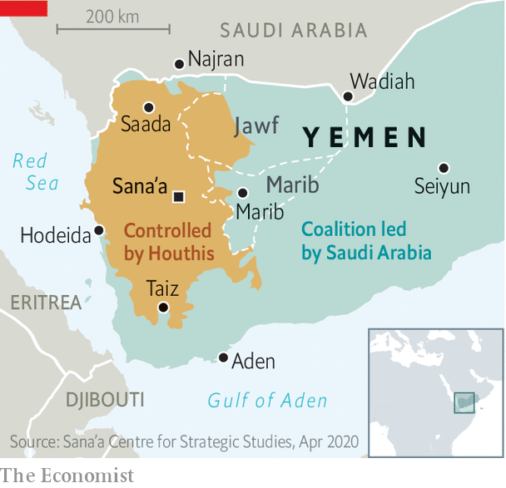

Despite its vicious air campaign, Saudi Arabia has been unable to dislodge the Houthis from most of Yemen’s population centres, including the capital, Sana’a (see map). Its main international ally, the United Arab Emirates, began scaling back its involvement in the war last year. The Saudis themselves are bombing less: their air strikes are down by more than 90% compared with 2015. In recent months they have held secret talks with the Houthis. Gone is the hope of returning Abd Rabbo Mansour Hadi, the exiled Yemeni president, to Sana’a. Now the kingdom’s goal is to stop Houthi missile strikes on its own territory. “The Saudis want a way out and are using the coronavirus as a figleaf,” says Abdulghani al-Iryani, a Yemeni analyst.

The Saudi intervention began as a vanity project for Muhammad bin Salman, the crown prince, who sought to flex his muscles in the face of rival Iran. But the Houthis stood tough and Shia Iran, sensing an opportunity, increased its support for the rebels. Prince Muhammad is now looking at a quagmire that is diverting resources at a time of plummeting oil revenues. Houthi attacks on the kingdom threaten its reputation for stability. Their missiles have struck oil pipelines and targeted the capital, Riyadh. Saudi Arabia does not want anything to upset its hosting of the G20 summit in November. So Prince Muhammad hopes to disengage and lock the Houthis inside Yemen, much as Israel does with Hamas, a Palestinian militant group, in Gaza.

But the Houthis sense Prince Muhammad’s desperation and want a better deal. They rejected the ceasefire, while putting forward their own peace plan. It demands that Saudi Arabia lift its air and sea blockade of Yemen, pay reparations for the damage it has caused (as well as ten years of government salaries) and recognise the Houthis as the legitimate government. If the Saudis do not agree, the Houthis promise “a major escalation inside the kingdom”. Analysts think they are planning a ground assault on Najran, a city in southern Saudi Arabia with a largely Shia population (albeit of a different strain from that of the Houthis).

The Houthis are already pushing deeper into the Yemeni provinces on the border with Saudi Arabia. They have made gains in Jawf and are fighting in the crags above Marib, an oil-and-gas hub. Control of Marib would not only hand the Houthis valuable resources; it would also make it harder for the government and allied tribes to wage war. Government-aligned forces use bases in Marib city to launch air and ground attacks in the north. The city sits on a road linking Saudi Arabia to the Indian Ocean and its anti-Houthi allies in the south. Marib would bring the Houthis closer to the main Saudi crossing at Wadiah, the airport in Seiyun and the border with Oman.

Mr Hadi has had to move some of his ragtag army from the north to deal with separatists and jihadists in the south. That leaves Marib largely in the hands of Sunni tribes that support Islah, an Islamist movement. Many fiercely oppose the Houthis, fearing they will try to revive the country’s ancient Shia imamate. But they also worry that Prince Muhammad might soon withdraw. Some therefore think that they should follow the lead of the tribesmen in Jawf who negotiated with the Houthis and helped them push into the province.

Hanging over all of this is the threat of covid-19. The war has knocked out half of Yemen’s clinics and hospitals. Over three-quarters of its 28m people need some kind of humanitarian aid. An outbreak of cholera last year was one of the world’s worst, says the UN. An outbreak of covid-19 could be even deadlier. ■

This article was downloaded by calibre from <https://www.economist.com/middle-east-and-africa/2020/04/18/saudi-arabia-looks-for-an-exit-to-the-war-in-yemen>

|  |  |  |  |
| --- | --- | --- | --- |
| Previous | Articles | Sections | Next |

|  |  |  |  |
| --- | --- | --- | --- |
| Previous | Articles | Sections | Next |

#### Quackery in Iran

# Desperate Iranians are getting bad medical advice

Perfumes and fruit juice are not a cure for covid-19

Apr 18th 2020 |

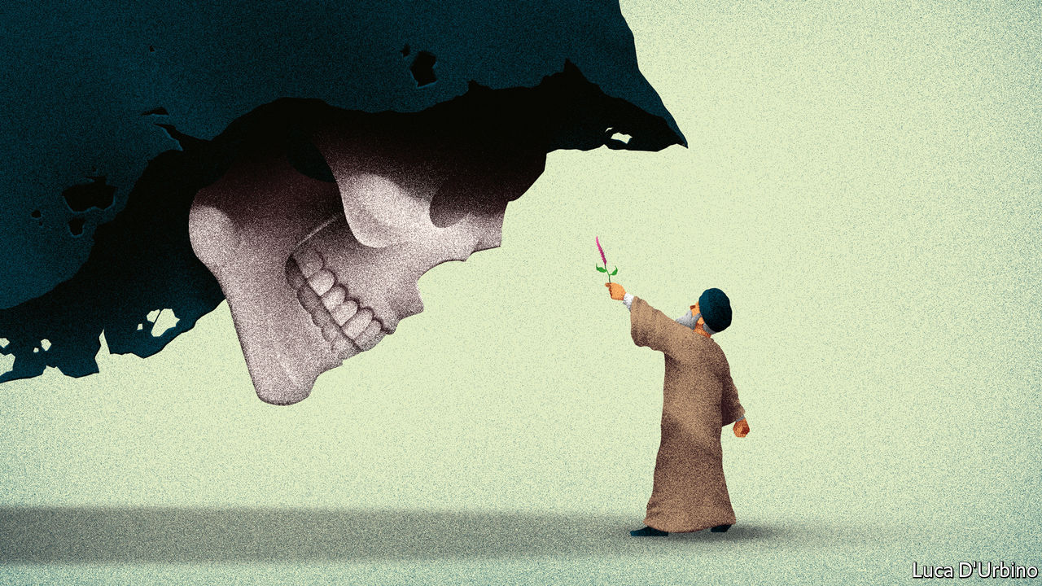

Editor’s note: The Economist is making some of its most important coverage of the covid-19 pandemic freely available to readers of The Economist Today, our daily newsletter. To receive it, register [here](https://www.economist.com/newslettersignup). For our coronavirus tracker and more coverage, see our [hub](https://www.economist.com/coronavirus)

“DRENCH COTTON wool in violet oil before bedtime,” instructs Abbas Tabrizian, then “insert into your anus.” Not only will you smell flowery, you will ward off covid-19, says the Iranian ayatollah, who runs a popular online shop called the Islamic Medical Centre. Hossein Ravazadeh, another prominent quack, recommends bitter gourd oil dropped into the ears twice a day. If those remedies sound a little too uncomfortable, one could dab an ointment called the “Prophet’s perfume” under the nose, or drink a concoction of fruit juices.

None of this works, of course. There is as yet no cure for covid-19. But as the death toll mounts in Iran, home to one of the world’s worst outbreaks, desperate people are turning to alternative medicine. The country’s 15,000 attaris, or Islamic apothecaries, report a roaring trade. Their medicinal herbs and spices are an affordable substitute for scarce and costly drugs, which are difficult to import because of American sanctions. Palliatives such as peppermint arak are cheaper than aspirin—and work just as well, suggest some of Iran’s leaders.

Ayatollah Ali Khamenei, the supreme leader, says covid-19 might be the work of jinns (evil spirits) working with America. He champions alternative medicine as zealously as he spurns Western imports. His most trusted adviser, Ali Akbar Velayati, heads the Traditional and Islamic Medicine Group at the Academy of Medical Sciences in Iran. Both extol Avicenna, a Persian physician from the 11th century who attributed illness to an imbalance in bodily fluids, and prescribed herbs for relief. Under their leadership, Iran’s best medical schools have opened departments of homeopathy. The health ministry requires apothecaries to study it for a year before getting a licence.

All this quackery gives the virus a free pass. Several top clerics have died after relying on herbal remedies. They include Mahmoud Hashemi-Shahroudi, an ayatollah who was tipped to succeed Mr Khamenei, and Mohyeddin Haeri-Shirazi, another firebrand. In March a junior cleric, Morteza Kohansal, posted a video of himself in a hospital ward, not wearing any protective gear, applying the Prophet’s perfume to covid-19 patients. Hundreds of Iranians have died from drinking high-proof alcohol, which is wrongly believed to kill the virus. Mr Velayati went into self-isolation after showing symptoms of covid-19.

The more rational parts of Iran’s leadership are speaking out, denouncing charlatans and scams. Unauthorised clerics are “engaging in the darkness of superstition and ignorance”, said the health ministry. Police have raided Mr Tabrizian’s warehouses. On April 4th they arrested Mr Kohansal, who has since been released. Many quacks are still out there, peddling bad medicine in the name of Islam. ■

Dig deeper:  
For our latest coverage of the covid-19 pandemic, register for The Economist Today, our daily [newsletter](https://www.economist.com/newslettersignup), or visit our [coronavirus tracker and story hub](https://www.economist.com/coronavirus)

This article was downloaded by calibre from <https://www.economist.com/middle-east-and-africa/2020/04/18/desperate-iranians-are-getting-bad-medical-advice>

|  |  |  |  |
| --- | --- | --- | --- |
| Previous | Articles | Sections | Next |

|  |  |  |
| --- | --- | --- |
| Middle East and ... | Sections | Britain |

Europe

Spain: A house divided

.

The coronabonds row: Dutch courage

.

Poland’s election: Epidemocracy

.

Wildlife encroaches in Italy: Rus in urbe

.

Charlemagne: Unlucky millennials

.

|  |  |  |
| --- | --- | --- |
| Middle East and ... | Sections | Britain |

|  |  |  |  |
| --- | --- | --- | --- |
|  | Articles | Sections | Next |

#### From lockdown to smackdown

# Nasty politics returns to Spain

As the first wave of the pandemic peaks, politicians go back to bickering

Apr 18th 2020 | MADRID

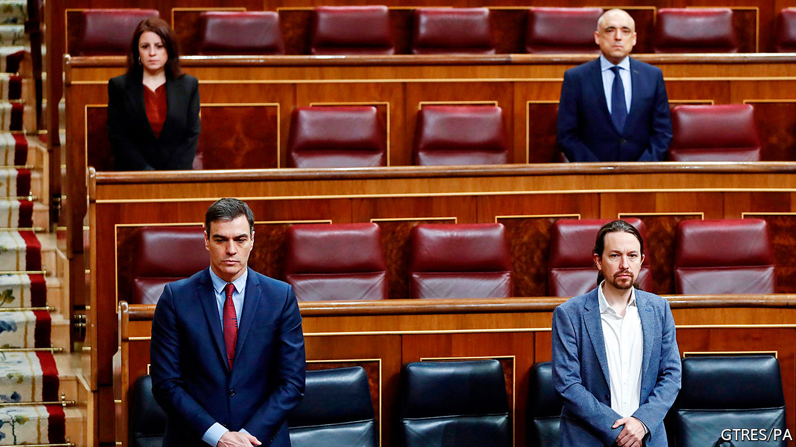

Editor’s note: The Economist is making some of its most important coverage of the covid-19 pandemic freely available to readers of The Economist Today, our daily newsletter. To receive it, register [here](https://www.economist.com/newslettersignup). For our coronavirus tracker and more coverage, see our [hub](https://www.economist.com/coronavirus)

BACK LAST summer Pedro Sánchez, Spain’s Socialist prime minister, said that if he agreed to a coalition government with Podemos, a far-left outfit, “I wouldn’t sleep at night.” After another indecisive election—the fourth in four years—he formed just such a coalition, which took office in January. Weeks later Spain was laid low by the novel coronavirus, and the novel minority coalition is struggling to cope, leaving the prime minister scrambling for broader support.

Mr Sánchez’s decision to impose a state of emergency and lockdown on March 14th, centralising command of health care and security in the national government, received widespread public and political backing. Five weeks on, the hospitals are no longer overflowing and the peak of the epidemic has passed, for now at least. The government is starting to think, gingerly, about how and when to get the country back to work (see article). But the toll has been heavy. By April 16th 18,812 people had died, according to official figures. The economy is in meltdown: 900,000 jobs were lost in March alone, some 3.5m workers are furloughed, and the IMF forecasts that Spain’s GDP will contract by 8% this year, the second-biggest fall in Europe after Italy.

The government must deal with all this with a slender stock of political capital. During the lockdown public opinion has been volatile. Approval for the government’s handling of the virus fell from 64% to 39% during March, according to Metroscopia, a pollster. Much of the opposition has broken ranks. Vox, a hard-right party with 52 of the 350 seats in Congress, wants a “national emergency government” of technocrats. Pablo Casado, the leader of the mainstream conservative People’s Party (PP), has accused Mr Sánchez of “arrogance, incompetence and lies”. This contrasts with the rallying round seen in many other European countries.

Mr Sánchez has responded by calling for a “pact for national reconstruction”, in theory involving the opposition, regional governments, businesses and unions. This is a conscious echo of the Moncloa Pacts of 1977, a set of agreements on economic measures between government and opposition which were a pillar of Spain’s transition from dictatorship to democracy. One poll found 92% in favour of another such pact—but 79% thought it improbable.

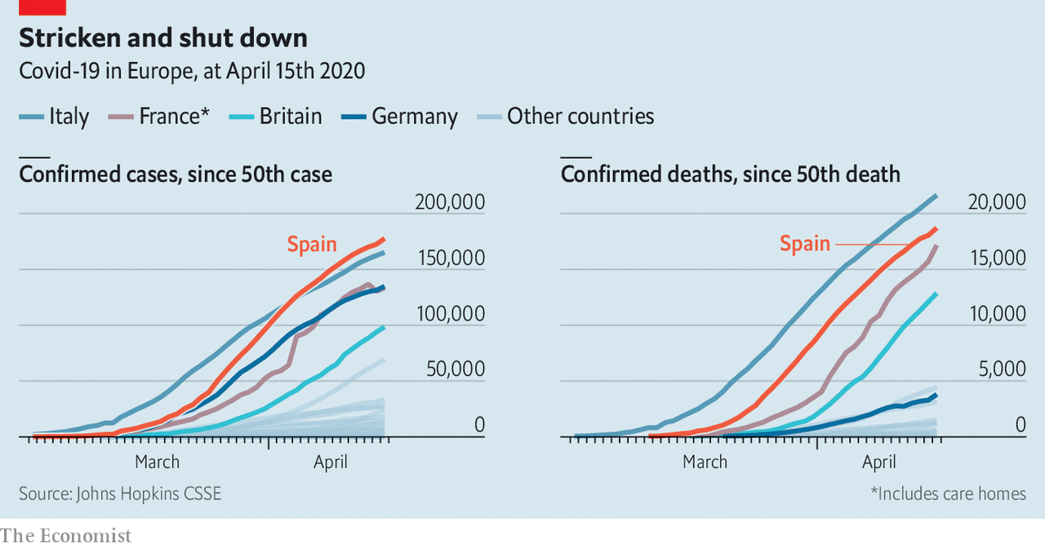

One explanation for the government’s difficulties is its own shortcomings, both technical and political. It bungled an announcement on March 28th that the lockdown would temporarily tighten, leaving many vital details initially uncertain. It is harder to co-ordinate such measures in a decentralised country with powerful regional governments. Even so, Mr Sánchez’s practice has been to pre-announce measures, and to consult only after their implementation. That has left businesses and some regional presidents fuming. “It’s a government that lacks not just experience but also deep knowledge of the state and how it works,” says a former senior official. “The sense of improvisation is very strong.”

Podemos and its leader, Pablo Iglesias, have added to the problems. Perhaps with some justification, he has seemed desperate to leave his ideological mark on government policy. At his instigation the government issued a decree making sackings during the pandemic unlawful, even as it has forced many businesses to suspend trading. Mr Iglesias’s hostility to the private sector and the monarchy (and the Moncloa Pacts) arouses widespread mistrust. The government finds it hard to speak with one voice; Mr Sánchez has had to devote much time and effort to internal debate.

Governments everywhere have struggled to deal with a crisis that demands swift, momentous and costly decisions. In Spain, a fragmented opposition adds to the problems. “We’re not starting from a blank slate, but rather from years of institutional deterioration,” says Sandra León, a political scientist. The country’s political system has not regained its balance since the last economic slump, of 2008-12, which fractured a stable two-party system into five and fuelled separatism in Catalonia.

Political competition is now not just between left and right but within each of those two blocs, which makes it more confrontational. Take Mr Casado’s position. He heads what was once the loyal opposition, but he must now also try to contain Vox. Another battleground will be over decentralisation. Quim Torra, the separatist head of the Catalan administration, has attempted to exploit the crisis to claim that independence would have provided more protection against the virus. Since he still runs nursing homes and hospitals in his region, that has cut little ice. Rather, there is evidence from polling data that in this crisis Spaniards want the centre to take charge as Mr Sánchez has done, argues Ms León. But that is inimical to the moderate and influential Basque nationalists, as well as to their Catalan counterparts.

Some in the PP say that one condition for a national agreement should be the departure of Podemos from the government. Mr Sánchez has ruled that out. Although it was his route to office, he knew the tie to Podemos “wouldn’t work for governing”, says Jorge del Palacio of King Juan Carlos University in Madrid. But “he can’t break the coalition without an alternative.” A centrist grand coalition looks unlikely, though it is not impossible. The coming months of mass unemployment, business failures and spiralling public debt will be gruelling for Spain and for its government. The last crisis upended the country’s politics in unforeseen ways. This one could yet do so, too. ■

Dig deeper:  
For our latest coverage of the covid-19 pandemic, register for The Economist Today, our daily [newsletter](https://www.economist.com/newslettersignup), or visit our [coronavirus tracker and story hub](https://www.economist.com/coronavirus)

This article was downloaded by calibre from <https://www.economist.com/europe/2020/04/18/nasty-politics-returns-to-spain>

|  |  |  |  |
| --- | --- | --- | --- |
|  | Articles | Sections | Next |

|  |  |  |  |
| --- | --- | --- | --- |
| Previous | Articles | Sections | Next |

#### A euro row

# The Dutch grumble over Europe's coronavirus cheque

The rest of the euro zone is getting fed up

Apr 18th 2020 | AMSTERDAM

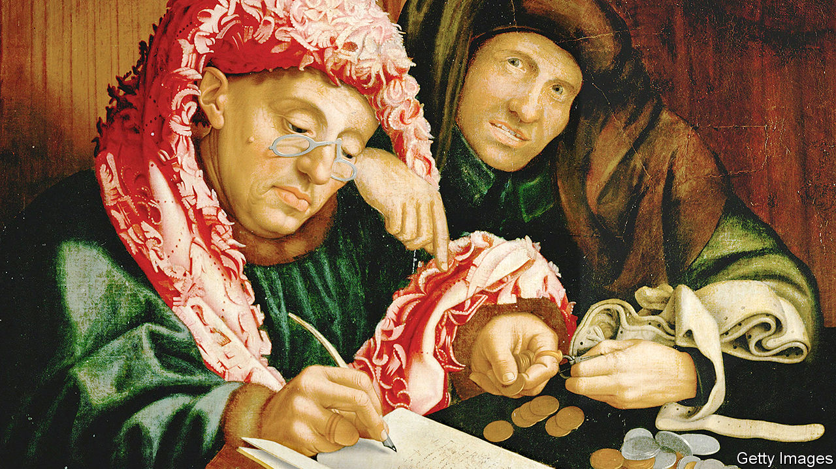

Editor’s note: The Economist is making some of its most important coverage of the covid-19 pandemic freely available to readers of The Economist Today, our daily newsletter. To receive it, register [here](https://www.economist.com/newslettersignup). For our coronavirus tracker and more coverage, see our [hub](https://www.economist.com/coronavirus)

THE DUTCH Golden Age fell apart in 1672, when surrounding powers—England, France and a pair of German principalities—teamed up to sack the Netherlands and seize its colonies. Ever since, the small country’s diplomats have made it a principle never to become isolated against a united European front. Yet as the Eurogroup (the finance ministers of the 19 countries that use the euro) planned their response to covid-19 this month, the Netherlands found itself alone. For 36 hours the thrifty Dutch were the sole holdouts against a deal to help afflicted countries tackle recession.

On April 9th, after two teleconferences, the Eurogroup compromised. There will be a €200bn ($215bn) European Investment Bank programme and a €100bn fund from which governments can borrow to support unemployment benefits and salaries. For medical expenses, countries can unconditionally borrow up to 2% of their GDP from the European Stability Mechanism (ESM), an emergency fund set up during the euro crisis of 2010-12. But the Dutch refusal to go further has made lots of Europeans angry.

The target of their ire is the blunt-spoken finance minister, Wopke Hoekstra. Before the negotiations, he sententiously chided southern Europe for failing to cut deficits to prepare for a downturn, as the Netherlands had. (In fact, Italy’s spending cuts were comparable to the Netherlands’, but the Dutch economy grew faster.) In the Eurogroup meeting he rejected a proposal by nine countries, including France, Italy and Spain, to issue collective euro-zone debt (eurobonds, or in this case “coronabonds”). In this he was joined by Austria, Finland and Germany. But on the ESM he stood alone, insisting that countries that tapped it for non-medical spending had to agree to economic reforms.

Italy and Portugal were incensed. Both have national debts of well over 100% of GDP, and neither wants its budget picked apart in the midst of a pandemic. Before the negotiations, Portugal’s prime minister called Mr Hoekstra’s criticism “disgusting”. Afterwards, he wondered whether it would be possible for the euro zone to continue with all 19 members (“and I am talking about the Netherlands”).

Yet while Mr Hoekstra was criticised abroad, he was lauded at home. The Dutch, like the Germans, have a cultural aversion to debt, especially when shared with those they do not trust. Mr Hoekstra told a parliamentary committee that eurobonds are unacceptable because the European Union “has no central authority that can force countries to reform”. The euro crisis reinforced the Dutch conviction that credit without conditions is not solidarity but irresponsibility.

Cynics note that the Netherlands faces elections next year, and that Mr Hoekstra will be vying for the leadership of his Christian Democratic party as well as competing against the Liberal prime minister, Mark Rutte. Both parties must fend off challenges from Eurosceptic outfits. Yet Mr Hoekstra’s stance is popular because it reflects beliefs he shares with most Dutch voters. “Dutch foreign policy is often deeply moralising: because we are wealthy we know the truth, and we are going to tell you how to reform,” says Rem Korteweg of the Clingendael Institute, a Dutch think-tank.

Olaf Scholz, Germany’s finance minister, may be secretly grateful for Mr Hoekstra’s stubbornness, which allows him to play the role of peacemaker. But as the response to covid-19 evolves, other forms of collective spending will be on the table, notably at a videoconference of EU leaders on April 23rd. Self-righteousness is not winning the Netherlands many friends. ■

Dig deeper:  
For our latest coverage of the covid-19 pandemic, register for The Economist Today, our daily [newsletter](https://www.economist.com/newslettersignup), or visit our [coronavirus tracker and story hub](https://www.economist.com/coronavirus)

This article was downloaded by calibre from <https://www.economist.com/europe/2020/04/18/the-dutch-grumble-over-europes-coronavirus-cheque>

|  |  |  |  |
| --- | --- | --- | --- |
| Previous | Articles | Sections | Next |

|  |  |  |  |
| --- | --- | --- | --- |
| Previous | Articles | Sections | Next |

#### Epidemocracy

# A postal vote in Poland could entrench populists

Thanks to covid-19, the opposition can barely campaign

Apr 18th 2020 | WARSAW

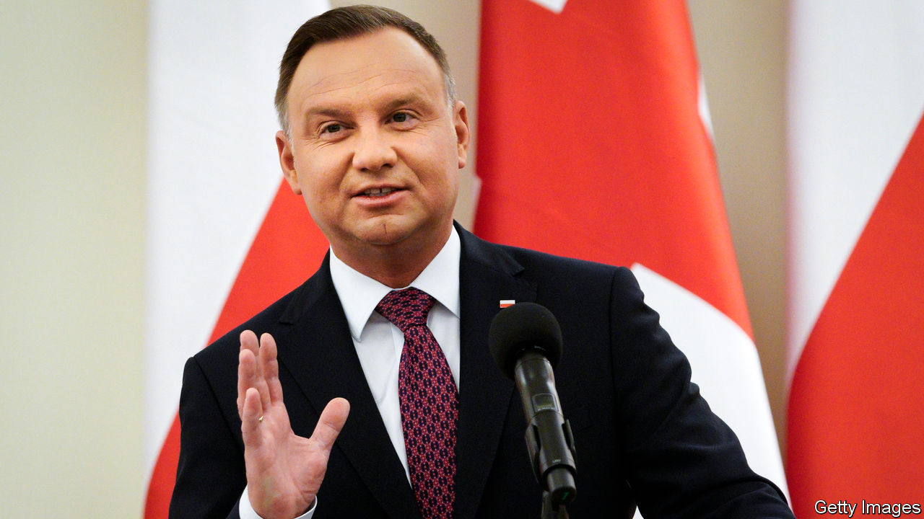

ALMOST UNNOTICED amid the covid-19 crisis, last week the European Court of Justice (ECJ) took a modest step towards stopping a European Union member from sliding into autocracy. Ever since it won power in 2015, Poland’s populist Law and Justice party (PiS) has been trying to get control of the country’s courts, while independent judges appeal to the EU to block it. On April 9th the ECJ ordered Poland to suspend immediately the disciplinary chamber of its Supreme Court, a body that can punish judges, and to freeze a new law restricting judicial independence. The European court said these violated EU treaties guaranteeing the rule of law.

The government is not giving up. A judge linked to PiS has challenged the order in Poland’s constitutional court, which is currently dominated by government-friendly judges. But that court has no authority in the case: the ECJ is the final arbiter of EU law. Its orders “cannot be questioned on the basis of national constitutions, national law or rulings of national courts”, says a European Commission spokesman. If Poland sets aside the verdict, it will be defying the court, the commission and the structure of the EU.

It is shaping up to be a fateful spring for Polish democracy. As in many European countries, a national lockdown has been in effect since mid-March to prevent the spread of covid-19. But Poland is scheduled to hold a presidential election on May 10th. In some countries opposition parties worry that an election might be suspended; in Poland, they are angry it is going ahead.

Andrzej Duda, the PiS-backed incumbent, faces five main challengers, ranging from the centre-left to the far right. His chief rival is Malgorzata Kidawa-Blonska of the centrist Civic Platform party. Polls put Mr Duda far in the lead, but perhaps short of the 50%-plus needed to win in the first round. The opposition charges that the lockdown’s ban on public events makes it impossible for them to campaign.

That suits Jaroslaw Kaczynski, PiS’s leader, just fine. He wants to hold the election before disenchantment with the crisis can hurt the government’s approval rating. Bills restricting abortion and sex education are moving ahead too, now that the demonstrations that stopped them in 2018 are barred. The government almost split over the public-health risk of staging the election: the leader of Porozumienie, a junior coalition party, called for it to be postponed. Ignored, he resigned on April 6th, but his party stayed in the coalition.

Later that day, PiS passed a bill to shift the entire election to postal voting. Postal unions warn that this is impossible: they would have to handle 30m voting packages, up from 43,000 in the previous presidential election in 2015. They are also leery of the infection risk such a huge operation would pose to their workers. One group is calling for a postal strike on election day if the government goes through with it. A poll last week showed 78% of the public want the voting postponed.

If the election goes ahead, low turnout and voting mishaps are expected. Another problem stems from PiS’s changes to the courts. Besides the disciplinary chamber that the ECJ ordered to be suspended, the government established a chamber of “extraordinary control” whose duties include certifying elections. Critics charge that it, too, is invalid under EU law, rendering the election illegitimate.

Poland’s government may evade these conflicts. The independent-minded president of the Supreme Court, long a thorn in PiS’s side, finishes her term at the end of April, and Mr Duda can appoint a more sympathetic one. That could smooth any trouble over the election. As for the EU, its tools are limited. The ECJ can impose fines if Poland defies its order. Other states could make it clear that Poland will fare less well in the apportionment of pandemic recovery aid and the EU’s multi-year budget. With covid-19 on its mind, Poland may have less appetite for fights over the rule of law. Then again, so may the EU. ■

This article was downloaded by calibre from <https://www.economist.com/europe/2020/04/18/a-postal-vote-in-poland-could-entrench-populists>

|  |  |  |  |
| --- | --- | --- | --- |
| Previous | Articles | Sections | Next |

|  |  |  |  |
| --- | --- | --- | --- |
| Previous | Articles | Sections | Next |

#### Wildlife in Italy

# Covid-19 has emboldened Italy’s fauna

A pilfering bear named after a convict isn’t welcome, though

Apr 18th 2020 | FLORENCE

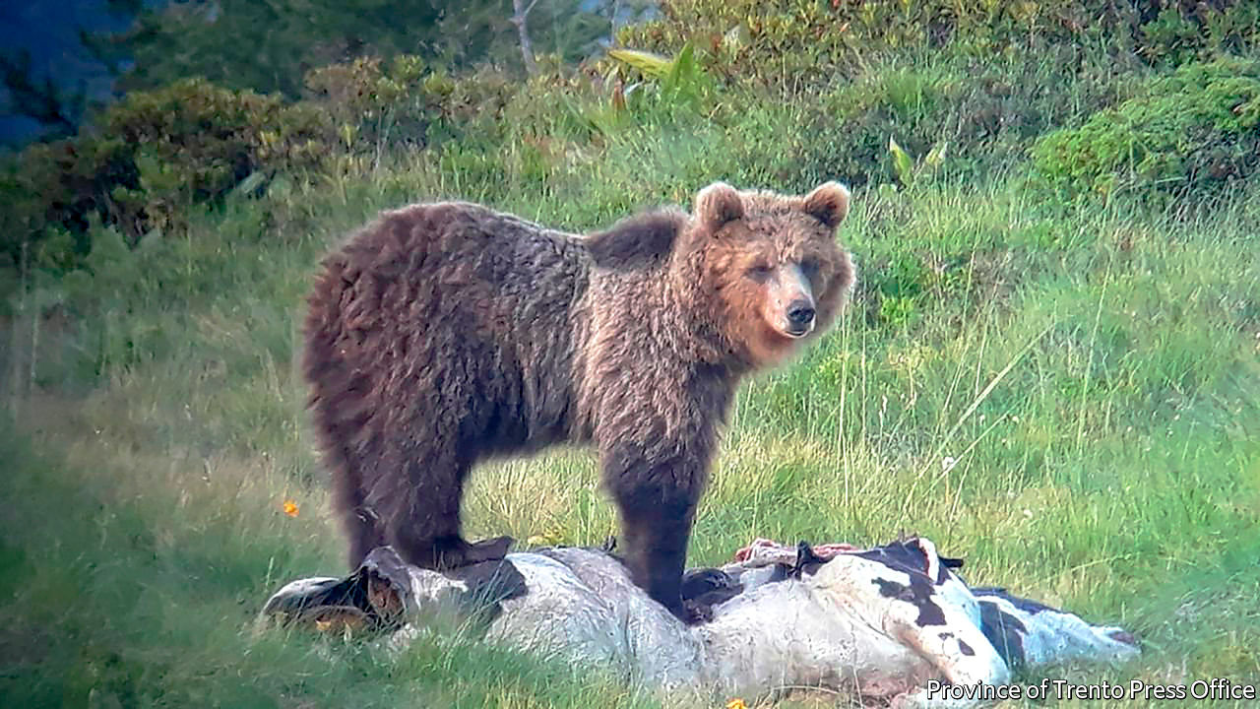

Editor’s note: The Economist is making some of its most important coverage of the covid-19 pandemic freely available to readers of The Economist Today, our daily newsletter. To receive it, register [here](https://www.economist.com/newslettersignup). For our coronavirus tracker and more coverage, see our [hub](https://www.economist.com/coronavirus)

A WOLF SLINKS out of a park in Sesto Fiorentino, an industrial centre near Florence. Goslings waddle behind their mothers along deserted thoroughfares in Treviso. Fallow deer invade a golf course on Sardinia and take a dip in the clubhouse swimming pool. As Italians entered the sixth week of Europe’s longest covid-19 lockdown on April 13th, one thing they had to cheer them up was the sight of animals in spaces that humankind had temporarily abandoned.

At Cagliari on Sardinia, bottlenose dolphins have long been known to wait at the mouth of the port to play in the wake of departing motor vessels. But since the lockdown some have entered right into the port, where they have been filmed swimming up and down under a quay, looking at the humans above. A similar phenomenon has been observed at Trieste. “A non-scientist might speculate that the dolphins are thinking: ‘Why aren’t you moving around in your boats any longer?’” says Giuseppe Bogliani, formerly a University of Pavia professor.

Mr Bogliani cautions against assuming that nature is reclaiming its own. Some mammals, like foxes, may have been in the cities already, prowling undetected at night. A golden eagle spotted gliding above a main road in Milan posed a different question: “Is it there because of the lockdown, or did we just see it because of the lockdown?”

Not all reappearances have been welcomed. Residents in Alpine areas of the province of Trento have been advised not only to stay at home, but to refrain from leaving out rubbish that might attract Italy’s most wanted animal, a brown bear known to scientists as M49 and to the public as “Papillon” (because of his escape last year over three electrified fences). Papillon is nicknamed after Henri Charrière, the only man to escape from the French penal colony on Devil’s Island. Like the late Mr Charrière, the bear has a substantial criminal record. It includes breaking and entering (Alpine cottages and refuges) and attacks on cattle. Last year the government of Trento issued an order for Papillon’s capture. He has now been spotted heading for Veneto, which has not (yet) issued a warrant. Smart bear.

Dig deeper:  
For our latest coverage of the covid-19 pandemic, register for The Economist Today, our daily [newsletter](https://www.economist.com/newslettersignup), or visit our [coronavirus tracker and story hub](https://www.economist.com/coronavirus)

This article was downloaded by calibre from <https://www.economist.com/europe/2020/04/18/covid-19-has-emboldened-italys-fauna>

|  |  |  |  |
| --- | --- | --- | --- |
| Previous | Articles | Sections | Next |

|  |  |  |  |
| --- | --- | --- | --- |
| Previous | Articles | Sections | Next |

#### Charlemagne

# Southern Europe’s millennials suffer two huge crises by their mid-30s

Will their pain turn them radical?

Apr 18th 2020 |

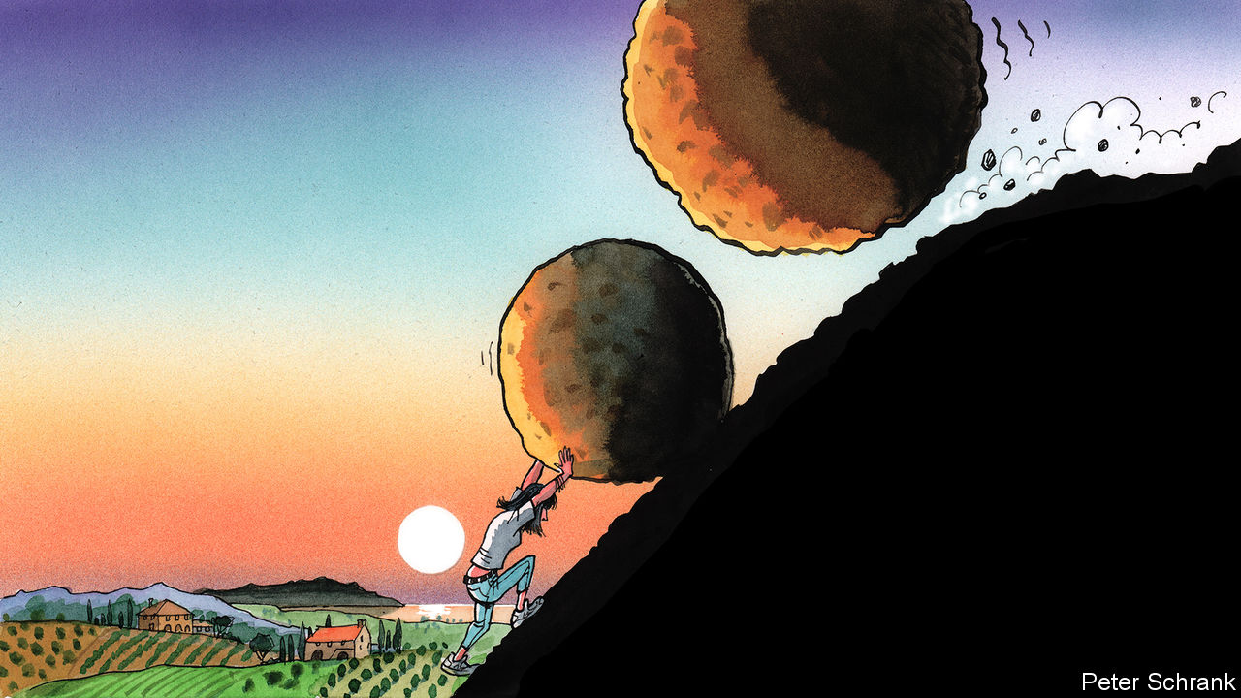

Editor’s note: The Economist is making some of its most important coverage of the covid-19 pandemic freely available to readers of The Economist Today, our daily newsletter. To receive it, register [here](https://www.economist.com/newslettersignup). For our coronavirus tracker and more coverage, see our [hub](https://www.economist.com/coronavirus)

THE YEAR 1985 should have been a good one to be born in Europe. Elisa Zugno, now a 35-year-old copywriter who lives in Milan, was able to benefit from the tailwinds of the 1990s and early 2000s. Economies ticked along and higher education opened up. Various forms of discrimination were outlawed. History had ended. Life was good.

Then in 2008, just as Ms Zugno was graduating from university, history juddered into action again with the financial crisis. The first few years of her career were familiar to any well-educated millennial in southern Europe. Rather than a share of the spoils given to globalisation’s supposed winners—degree-toting multilinguists—Ms Zugno and her ilk were greeted with a mix of unpaid internships and low-paid work.

Instead of a recovery, the financial crisis morphed into the euro-zone crisis, with renewed pain for Europe’s youngsters. Unemployment shot up. Four out of every ten young Italians did not have a job in the middle of the last decade, while half of young workers in Spain were in the same boat. (In contrast, even at the peak of the crisis, only 11% of young Germans were unemployed.) The result: Ms Zugno was 31 before she landed the first permanent contract of her working life. A few years on, after belatedly finding its feet, Ms Zugno’s generation now finds itself pushed to the floor once more, with the second major economic crisis of their short adult lives surrounding them.

In the aftermath of the financial crisis, analysts were quick to split the world into the winners and losers of globalisation. On the one side were those furnished with education, open horizons and language skills, who were supposed to thrive in the new order. On the other were those with no such luck, stuck in careers set to be overtaken by innovation. A third category containing southern Europe’s young must be added: globalisation’s pyrrhic victors. These people fulfilled the requirements of the winners’ club, armed with both the mindset and means—even possessing a passport from the EU, the institution that most embodies 21st-century globalisation. Yet thanks to repeated economic shocks, they have singularly failed to reap the expected benefits.

All generations suffer during a crisis. But the consequences last longer for the young. Economic misery has a tendency to compound. Low wages now beget low wages later, and meagre pensions after that. The prospect of middle-aged drudgery beckons. For older generations, a recession is an unfortunate pot-hole, which most will drive over without even blowing a tyre. But for southern Europe’s younger people, it is an enormous sinkhole from which it will be hard to clamber out. Youth unemployment in Spain and Italy is below its peak, but still stood at about 30% even before covid-19 arrived in Europe. This time, for many, the crisis begins in a far worse place than it did last time.

Coming of age in a crisis has longer-term political consequences. People’s values tend to crystallise in their mid-20s, points out Christian Welzel of Leuphana University of Lüneburg in Germany. When basic needs are taken care of by a growing economy, voters can focus on “post-material” issues—the scholarly jargon for topics like equality, environmentalism and freedom of expression. Young people are supposed to be the vanguard of this shift away from economic concerns towards intangible ones. Values change over generations, typically becoming dominant because generations rise and fall, rather than because people change their minds en masse. Liberal attitudes towards, say, gay rights stick with people throughout their lives.

Instead, millennials in southern Europe have found themselves unceremoniously shoved down the order of priorities. In such circumstances, the economic basics trump more complex issues when it comes to politics; those in northern Europe can still afford to care about other topics. This split is starting to show up electorally. Europe’s Green parties enjoyed their best-ever performance in the 2019 European Parliament elections, nearly doubling their number of MEPs as young voters from across northern Europe flocked to them. Spain, Italy and Greece—about a quarter of the EU’s population—boast a grand total of one Green MEP.

## Apathy, escape or radicalism

After two big crises at a formative period of their lives, a politicised and traumatised generation will need to be catered for. Emigration was an option for southern Europe’s discontented young last time round; this time all of the EU’s economies are tanking simultaneously, while Britain—a popular destination in the previous crisis—is intent on reducing immigration. There is no ripcord that Europe’s afflicted young can easily pull. Apathy is another potential path. “I would say 80% are just complaining and getting depressed and 20% at least are trying to gather energy,” says Ms Zugno of her peers.

But the anger built up during the previous crisis has not receded. About two-thirds of Spaniards declare themselves dissatisfied with democracy in their country. This provides fertile ground for populist parties, points out Ignacio Jurado, an academic at University Carlos III of Madrid: “People are more interested in politics, but they expect less. They trust less in government. They are more dissatisfied.” In Spain, the result has been straightforward. New parties such as Vox on the right and Podemos on the radical left have flourished, with younger voters in particular constituting their core support. In Italy, just under half of all voters aged between 25 and 34 opted for the Northern League, a hard-right anti-immigration party, or the Five Star Movement, a more leftist populist group, at last year’s European elections. Europe’s mainstream parties will find it hard to win them back. A resurgence of a left-right split on economics could help these established parties. But many voters will feel that the social contract has been so badly breached that they would rather rip it up altogether. ■

Dig deeper:  
For our latest coverage of the covid-19 pandemic, register for The Economist Today, our daily [newsletter](https://www.economist.com/newslettersignup), or visit our [coronavirus tracker and story hub](https://www.economist.com/coronavirus)

This article was downloaded by calibre from <https://www.economist.com/europe/2020/04/18/southern-europes-millennials-suffer-two-huge-crises-by-their-mid-30s>

|  |  |  |  |
| --- | --- | --- | --- |
| Previous | Articles | Sections | Next |

|  |  |  |
| --- | --- | --- |
| Europe | Sections | International |

Britain

Covid-19: What went wrong?

.

Farm labour: Your polytunnel needs you

.

Care homes: Careless

.

Small business: The bank manager will see you now

.

Magazines: Glitz-krieg

.

Newspapers and covid-19: Breaking: news

.

Government debt: Printing money

.

Brexit negotiations: Extension rebellion

.

Bagehot: The establishment strikes back

.

|  |  |  |
| --- | --- | --- |
| Europe | Sections | International |

|  |  |  |  |
| --- | --- | --- | --- |
|  | Articles | Sections | Next |

#### Covid-19 deaths

# Why Britain has so many covid-19 deaths

Britain faces a worse pandemic than other European countries. That seems partly the government’s fault, but not entirely

Apr 18th 2020 |

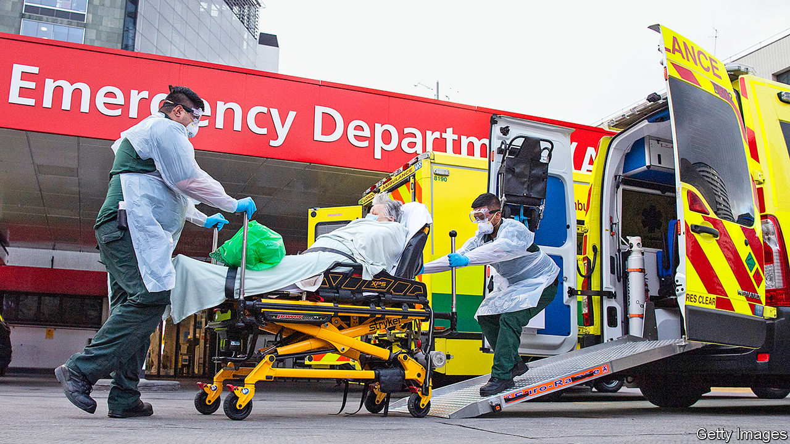

Editor’s note: The Economist is making some of its most important coverage of the covid-19 pandemic freely available to readers of The Economist Today, our daily newsletter. To receive it, register [here](https://www.economist.com/newslettersignup). For our coronavirus tracker and more coverage, see our [hub](https://www.economist.com/coronavirus)

ON MOST SOCIAL, political and economic issues, Europe divides into north and south, and Britain sits comfortably among the more orderly, prosperous and efficient northern states. But on covid-19, that’s not how it looks. Britain appears closer to badly hit southern European countries. Indeed, Sir Jeremy Farrar, a member of the government’s scientific advisory council, has said that Britain is on track to be among the worst—if not the worst—affected country in Europe.

Growth in the number of cases in Britain is now slowing, but as The Economist went to press, 12,868 people were confirmed to have died from covid-19 in hospital. Although Britain looks to be some way off the peak in France (see chart), France’s figures include deaths that occur in care homes—nearly half the total—while Britain’s do not.

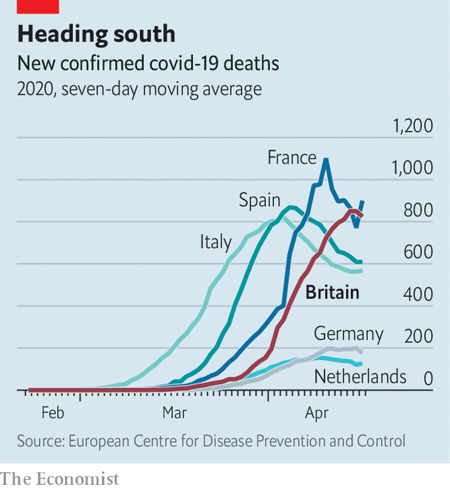

A clearer picture of the pandemic requires evidence of its impacts on all deaths, including those as a result of measures introduced to stop its spread. More detailed, though lagging, data from the Office for National Statistics suggest that many more are dying both of other causes (as trips to hospitals are put off) and outside of hospitals (often in care homes). On the week ending April 3rd, there were 16,387 deaths, more than a third higher than normal at this time of year. Excess deaths in Britain are in the same range as those in France, Spain and Italy at a similar point.

Britain’s problem is not a shortage of intensive-care capacity. Hospitals have reorganised swiftly and seven new field hospitals have been hurriedly set up. They may yet fill up but, according to the Health Service Journal, a specialist website, the capital’s Nightingale Hospital, designed for 2,900 patients, treated just 19 over the Easter weekend.

Instead, the problems appear to have started earlier. The British government gave up quickly on the sort of test-and-isolate strategy common in countries that have kept deaths down. Its aim became simply to protect the vulnerable and the health service, accepting the virus would spread among the population, which would at least build herd immunity.

On March 9th, when Britain had more than 300 confirmed cases, Sir Patrick Vallance, the government’s scientific adviser, said old people could attend church, and that other public events should go ahead. Stopping all interaction, he said, was something “you can’t and shouldn’t do.” According to a tracker maintained by the University of Oxford’s Blavatnik School of Government, Britain was slower than European neighbours including France and Italy to introduce restrictions.

From this followed less of an emphasis on testing. Recognising its failure, the government has struggled to increase capacity in the past few weeks. On April 4th Matt Hancock, the health secretary, belatedly outlined a plan to do so, using facilities in hospitals, universities and the private sector (before then, testing had been focused in laboratories run by Public Health England). The number of tests has since risen to 15,000 or so a day, up from 10,000—an improvement, but still short of most other rich countries. The government cannot escape blame by pointing the finger at Public Health England: unlike NHS England, which runs the health service at arm’s length from the government, it is directly accountable to the secretary of state.

At the time, ministers repeatedly emphasised that they were following scientific advice. Minutes from the government’s advisory committee support this: experts were not considering a complete lockdown, which was thought infeasible in a country like Britain, and worried about the impact of self-isolation. The concern is that scientists were trying to act like politicians (in judging what would be acceptable to a prime minister suspicious of government intrusion) and the politicians were trying to act like scientists (by doing exactly as the scientists instructed).

So far, the advisers’ fears about the public’s appetite for a lockdown appear unfounded. Polls show that the British are enthusiasts for the measures, with nine in ten backing them; reduced train and car travel suggests people are obeying the rules. Britain appears to be more a nation of curtain-twitchers than freeborn pub-goers, at least at a time of crisis.

Yet the government may be getting an unfair share of the blame. Critics have made comparisons between Britain and Ireland, which is seeing roughly half as many deaths per person and went into lockdown earlier. But deaths lag behind infections by several weeks, and the virus has been spreading for longer in Britain. Travel may also play a part. As Keith Neal, an epidemiologist at the University of Nottingham, notes, international hubs are particularly vulnerable; London is home to a quarter of Britain’s cases. Northern Ireland, where the lockdown followed the same path as in the rest of the United Kingdom, but which shares an island with the Republic, has seen a similar number of deaths per person as in the south.

Careful accounting will require adjustment for a huge range of things like the prevalence of comorbidities (Britain has high rates of obesity, for instance), geography (it is denser than most European countries) and demography (it is relatively young, and should thus fare better in this regard), and indeed for factors which affect the disease’s transmission but of which we are not yet aware. It will also require more data on the number of additional deaths, not just those that have occurred directly as a result of the virus, as well as on the economic and social costs of the lockdown.

Britain has failed to get on top of the the virus in the way other countries have managed to. At this stage, it is clear that the government has made mistakes. It is not yet clear, however, quite how damaging they have been. ■

Dig deeper:  
For our latest coverage of the covid-19 pandemic, register for The Economist Today, our daily [newsletter](https://www.economist.com/newslettersignup), or visit our [coronavirus tracker and story hub](https://www.economist.com/coronavirus)

This article was downloaded by calibre from <https://www.economist.com/britain/2020/04/18/why-britain-has-so-many-covid-19-deaths>

|  |  |  |  |
| --- | --- | --- | --- |
|  | Articles | Sections | Next |

|  |  |  |  |
| --- | --- | --- | --- |
| Previous | Articles | Sections | Next |

#### Agricultural labour

# Not enough Britons want to work on farms

A drive to get furloughed workers and students to pick fruit has had an inadequate response

Apr 18th 2020 |

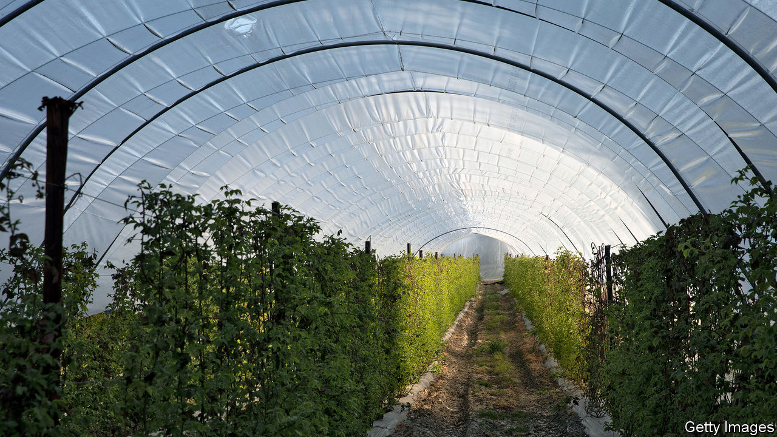

“NORMALLY ON HOLIDAYS, I spend money,” says James Mwendwa, a geology student at Bristol University. “This holiday I’ll be making it.” Mr Mwendwa has signed up with a scheme designed to get students and furloughed workers to spend their summers on British farms. He has been promised a caravan to share with his friends on a farm in Norfolk. “In the evenings you’re allowed to just chill with your mates,” a rare luxury in current circumstances.

Finding enough summertime labour has often been a struggle for British farmers. Factory workers used to move south en masse to enjoy a family holiday while picking fruit or hops. In recent years, the indigenous population has turned its nose up at agricultural work, and farmers have come to rely on importing Bulgarians and Romanians. Uncertainty around migrants’ rights and Brexit led to a decline in worker numbers last year, and around 16m apples were left to rot in orchards. A near-shutdown on European movement has only deepened the crisis.

Invoking the Women’s Land Army that kept the nation’s farms going throughout the second world war, the British Growers Association is trying to recruit a new “Land Army” to fill a shortfall of some 70,000 workers. The government’s “Pick for Britain” campaign similarly aims to tap into the wartime spirit.

So far Britons seem largely unmoved by the appeal to patriotism. Concordia, Fruitful and HOPS, three agricultural recruiters that have formed the Ethical Alliance of Labour Providers, say that 32,000 have applied, but only 13% have so far turned up for online interviews.

Even if enough native workers can be found, that may not solve the problem. Britons have a reputation for being work-shy. “Often, you have people who want to start, and we’ll say, come on Tuesday or whatever, and then they simply don’t turn up.” says Sebastian Hall, a recruiter in Suffolk.

Alison Capper of the National Farmers’ Union, herself a farmer, wonders whether new recruits “will be able to pick at the same rate as people who are practised in these jobs”. Jack Ward, boss of the British Growers Association, worries about timing. Although new workers may arrive just in time to save the nation’s asparagus, an early end to the lockdown could send students and furloughed workers scurrying back to their real lives and jobs.

For some farmers, the risk of relying on Britons is too great. To avert a crisis in the polytunnels, they have started shipping planeloads of Romanians into the country. Air Charter Services, whose customers are normally the uber-rich, has been hired by G’s Fresh, one of Britain’s biggest salad producers, to fly 150 Romanians into Stansted airport on April 16th; a further five flights are lined up. Each seat will set G’s Fresh back £250 ($313), and the passengers (who have been deemed essential workers by the Romanian government) will be kept apart on the flight and tested for covid-19 on touch-down. The airlift may spoil the wartime-spirit narrative, but it may save the nation’s broccoli.

This article was downloaded by calibre from <https://www.economist.com/britain/2020/04/18/not-enough-britons-want-to-work-on-farms>

|  |  |  |  |
| --- | --- | --- | --- |
| Previous | Articles | Sections | Next |

|  |  |  |  |
| --- | --- | --- | --- |
| Previous | Articles | Sections | Next |

#### Care homes

# The impact of covid-19 on care homes

People in care homes are acutely vulnerable to the virus; little has been done to help protect them

Apr 18th 2020 |

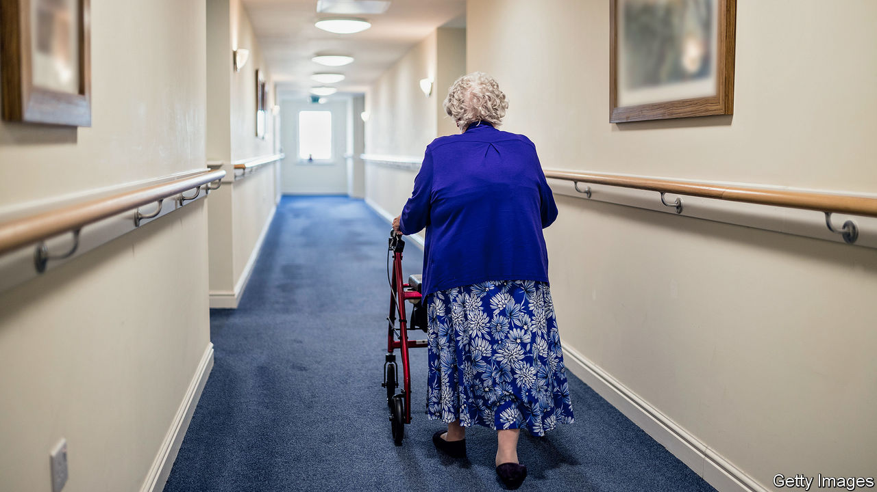

IN EARLY MARCH a resident at Oaklands nursing home in Hove on the south coast of England caught covid-19 from a visiting relative. Though staff tried to isolate the patient, 14 residents had been infected before a test could be done. A number have now died, though staff at the home did not want to confirm how many.

Across Britain, thousands of care homes are now experiencing what Oaklands did in March. Ministers are nervous. Helen Whateley, the social-care minister, has said it is “almost unavoidable” that the virus will spread further in care homes. On April 15th the government promised more tests would be available for care workers. Yet much of the sector is still acutely underprepared. And certain government decisions seem almost certain to accelerate the spread.

There are roughly 11,300 care homes in Britain that look after the elderly, with some 410,000 residents, many suffering from dementia. These people are acutely vulnerable to covid-19. According to Chris Whitty, England’s chief medical officer, one in seven care homes in the country has already had a confirmed case. Since testing has been limited, the true figure may be higher. Sir David Behan, the director of HC-One, one of the biggest care groups in the country, told the BBC that the virus had infected people in two-thirds of the group’s 329 homes. There are scant data for Britain as a whole, but in Scotland a quarter of cases are in care homes.

Although the government has poured resources into Britain’s National Health Service, Britain’s care homes are mostly small private businesses and have been left to deal with the crisis themselves. Some patients’ fees are paid by local authorities, but the bulk of care homes’ revenue comes from fees paid by patients or their families. Even at the best of times, staff shortages are endemic, points out Nadra Ahmed, the chair of the National Care Association, an industry group. Despite doing difficult and valuable work, such as bathing and cleaning infirm people, the majority of care-home workers are paid the minimum wage or only a little above it. Budgets have been squeezed for years.

The government has not yet banned care-home workers from working in several homes, even though they could carry the virus between them, notes Peter Kyle, the Labour MP for Hove and Portslade. Money has been made available—about £2.9bn—through local authorities, but care homes say they have not been able to gain access to it. Most homes have each been sent 300 masks by the government, but that is a fraction of what is needed if they are used properly (and the guidance has been confusing). Getting more is next to impossible. “You go to your normal suppliers and they say that the NHS has commandeered the lot,” says the manager of one care home in Birmingham which has been hit badly. Eventually the home started making its own kit, putting new air filters into reusable masks.

Those that have not yet been hit are awaiting the worst. Sandra Stinton, the manager of Grange Rest Home in Hove, says if the virus gets into her care home “it’s going to be our worst nightmare”. Already she is refusing to take patients discharged from hospitals, as she cannot be sure they have not been infected. She has been informed that she will have to prepare end-of-life palliative care, but she has no medical staff or equipment to provide it. “I haven’t got a problem supporting dying people…but how are you going to offer pain management?” she asks.

Mr Kyle thinks that the government’s poor response is the consequence not so much of a policy choice as of disorganisation. Ms Whateley does not attend cabinet meetings. The health secretary, Matt Hancock, who does, has plenty to deal with trying to manage the impact of the virus on hospitals. “The whole system hasn’t been working properly for a very long time,” says Sally Copley of the Alzheimer’s Society, a charity. That failure may now cost the lives of thousands of people. Even after the virus recedes, the need for reform will only be more apparent.■

This article was downloaded by calibre from <https://www.economist.com/britain/2020/04/18/the-impact-of-covid-19-on-care-homes>

|  |  |  |  |
| --- | --- | --- | --- |
| Previous | Articles | Sections | Next |

|  |  |  |  |
| --- | --- | --- | --- |
| Previous | Articles | Sections | Next |

#### Help for business

# Why the scheme to help small business isn’t working

It may short-change firms and taxpayers

Apr 18th 2020 |

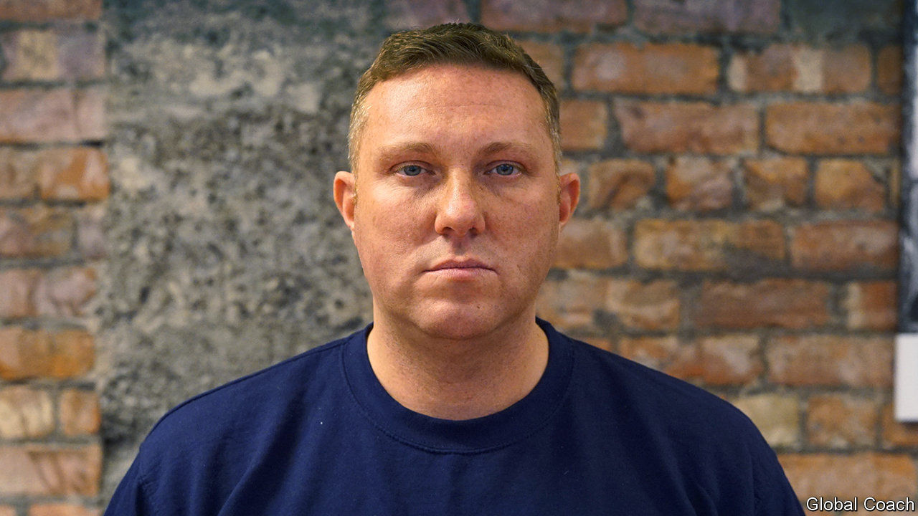

Editor’s note: The Economist is making some of its most important coverage of the covid-19 pandemic freely available to readers of The Economist Today, our daily newsletter. To receive it, register [here](https://www.economist.com/newslettersignup). For our coronavirus tracker and more coverage, see our [hub](https://www.economist.com/coronavirus)

AFTER COVID-19 blew the whistle on the football season, business as usual stopped for Premier League clubs. That in turn made things difficult for their suppliers, including Globall Coach, a firm with software that produces animations for coaches to drill players on match tactics.

Because Globall Coach will not be able to collect £170,000 ($213,000) it is owed until football gets going again, Emile Coleman (pictured above), its boss, needs to borrow £73,000 through the government’s new £330bn Coronavirus Business Interruption Loan Scheme (CBILS). But Mr Coleman’s bank, NatWest, part of RBS, is asking questions about the quality of the firm’s profits. Even though the government guarantees 80% of CBILS loans (which can be up to £5m and are interest-free for a year) Globall Coach may not receive one. Its future is uncertain.

Chronic uncertainty now afflicts most of Britain’s nearly 6m small and medium-sized enterprises (SMEs). Such firms are accustomed to coping with fluctuations in operating conditions, but not the enforced closures that the lockdown imposes, says Adam Marshall, director general of the British Chambers of Commerce (BCC).

Insolvency rates have not yet soared, but the BCC says that 59% of its members have money to continue only for three months or less. Almost a third of businesses in the Midlands and the north of England are at high risk of collapse because of the virus’s impact on supply chains, reckons Durham University Business School.

The government’s response to impending disaster looks generous. As well as CBILS, there are other measures such as allowing some firms to stop paying business rates and to furlough staff on 80% of their salaries (up to a maximum of £2,500 a month); the government picks up the bill. The insolvency regime is to be loosened.

But so far, CBILS, one of the biggest weapons in the armoury, has failed. By mid-April, 1.4% of the 300,000 firms that sought help from the scheme had received loans. Entrepreneurial hard-luck stories resonate with the public, so its impotence is embarrassing.

Most of the blame has fallen on the banks, somewhat unfairly. They have to use a cumbersome legacy system, the Enterprise Finance Guarantee scheme of the British Business Bank (a government lender that is managing CBILS). Banks are now throwing resources at making it work. Lloyds Banking Group has shifted 700 staff onto processing CBILS loans.

Because CBILS got off to such a bad start, things may now veer too far in the other direction. There are calls for the Treasury to guarantee 100% of new loans to small businesses, as Germany and Switzerland have done. Banks would act chiefly as a conduit and would not scrutinise SMEs’ finances as closely. Such a guarantee would see the cost to taxpayers soar. Banks reckon that a tenth of small firms were not viable before the pandemic and can’t support more debt.

Taxpayers will get some protection from unviable firms thanks to the Treasury’s stipulation that any “undertaking in difficulty” (defined as a firm whose accumulated losses are higher than half their share capital) will not have access to CBILS. But it may end up excluding successful British firms which incurred losses a long time ago, or high-growth ones that have recent losses and limited share capital.

Even SMEs that were thriving before the pandemic may find it hard to service additional debt taken on through CBILS. It will take time for that to become clear. For now, the focus is on the very short-term. On April 20th the web portal for companies to apply for furlough payments opens. SMEs are praying it will be a seamless experience compared with CBILS. ■

Dig deeper:  
For our latest coverage of the covid-19 pandemic, register for The Economist Today, our daily [newsletter](https://www.economist.com/newslettersignup), or visit our [coronavirus tracker and story hub](https://www.economist.com/coronavirus)

This article was downloaded by calibre from <https://www.economist.com/britain/2020/04/18/why-the-scheme-to-help-small-business-isnt-working>

|  |  |  |  |
| --- | --- | --- | --- |
| Previous | Articles | Sections | Next |

|  |  |  |  |
| --- | --- | --- | --- |
| Previous | Articles | Sections | Next |

#### Magazines

# Glitz-krieg

Glossy magazines adjust to a gloomy time

Apr 18th 2020 |

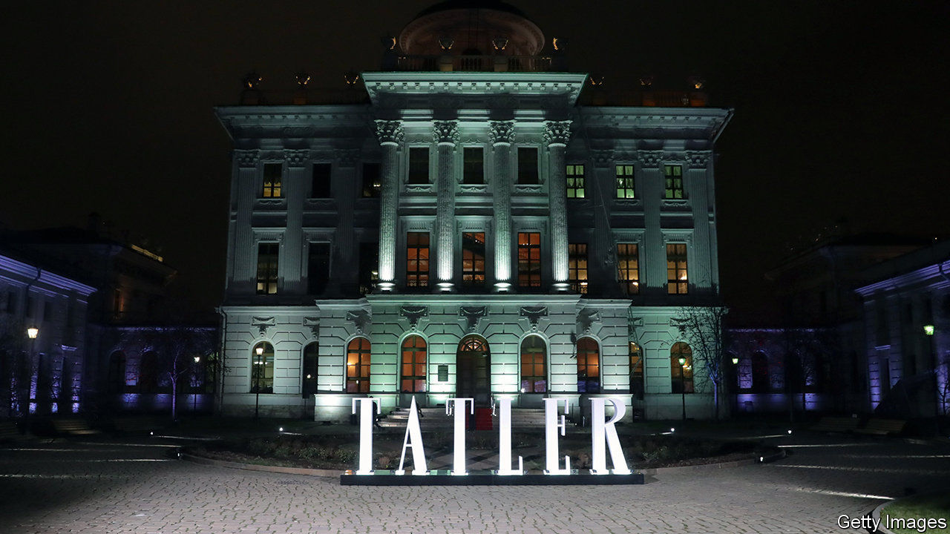

ONE OF ITS editors used to think of Tatler, the house magazine of the country-house classes, as a theme park. Peopled by debutantes, crusty aristocrats and crumbling piles, its pages give the impression there is nothing in life so serious as a ball. But with Britain in lockdown, gatherings attract the attention of the police, not the photographer from Tatler. Each day brings headlines that are more JG Ballard than PG Wodehouse. As Sophia Money-Coutts, a former senior editor, puts it, “the theme park is closed”.

It is not the only glossy magazine grappling with the difficulty of covering a less glossy world. How do you run a publication obsessed with stepping out when everybody’s staying in? And now that most aspects of daily life are deemed “non-essential”, pages devoted to parties, travel, fashion and luxury risk looking more frivolous than ever.

House & Garden has shifted its emphasis from grand designs to practical projects for lockdown. A new “staying in” section gives advice on growing vegetables and rustling up simple meals. At Hello!, spreads of society weddings have made way for puzzles and short stories. “We’re reinventing the magazine on a weekly basis,” says Rosie Nixon, its editor-in-chief. The royal family’s hairdressers are being tapped up to coach readers on cutting their own hair. At least celebrities seem keen to send in their own photographs, says Ms Nixon. “Lots of people haven’t got much to do.”

Other glossies are avoiding the news. Even in normal times, many such magazines are as much about feeding fantasies as doling out practical advice. For an hour or two, readers of the latest issue of Tatler can, for instance, imagine they have a spare £77,500 to spend on a necklace, or might at any moment be invited to a bash at the Gstaad Yacht Club. At times of strain, such escapism can be a welcome antidote to a grim reality. After considering 130 options for the cover of the May issue, Melinda Stevens, editor-in-chief of Conde Nast Traveller, eventually plumped for the headline “Looking forward: destinations to dream about”.

This article was downloaded by calibre from <https://www.economist.com/britain/2020/04/18/glitz-krieg>

|  |  |  |  |
| --- | --- | --- | --- |
| Previous | Articles | Sections | Next |

|  |  |  |  |
| --- | --- | --- | --- |
| Previous | Articles | Sections | Next |

#### Media and covid-19

# The newspaper industry is taking a battering

Ad sales and circulation are collapsing even as online traffic surges

Apr 18th 2020 |

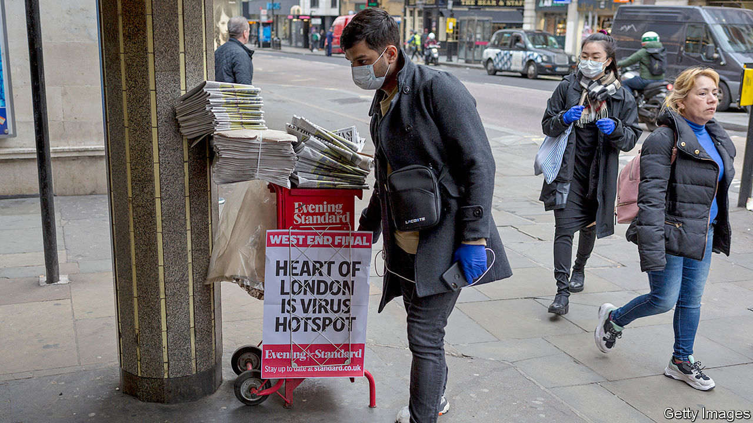

Editor’s note: The Economist is making some of its most important coverage of the covid-19 pandemic freely available to readers of The Economist Today, our daily newsletter. To receive it, register [here](https://www.economist.com/newslettersignup). For our coronavirus tracker and more coverage, see our [hub](https://www.economist.com/coronavirus)

FIRST, SOME good news. The Yorkshire Post added roughly 1,000 subscribers in recent weeks. JPIMedia, which publishes that newspaper as well as the Scotsman and lots of other titles, has seen traffic to its websites rise by 20-50%. And some advertisers, including a car dealership and an estate agent, have promised to spend all the money they have already committed.

The bad news is that the paper’s overall sales are down by 30% as folk stay indoors, says James Mitchinson, its editor. At some JPI titles as much as 80% of advertising revenue has been lost. Almost all ad-sales staff have been furloughed. So have dozens of journalists. The rest have taken pay cuts of 10-15%, rising to 20% for board members. The paper has become noticeably thinner.

Unlike many other industries that have been badly affected by the crisis, news providers are seeing booming demand for their product. Traffic to news websites has risen across the board. Online subscriptions are rising at four to six times normal rates. But paper purchases, which mostly dwarf digital subscriptions, have collapsed and income from online ads is pennies to print pounds. Some advertising categories, such as retail and travel, have evaporated.

The Guardian expects revenue to drop by £20m, or 10%, and is furloughing 100 staff. Daily Mail and General Trust, which owns the Daily Mail and Metro, is cutting salaries by up to a quarter. The Jewish Chronicle and the Jewish News plan to merge. In January Enders Analysis, a research firm, forecast that ad sales in the British press would fall by 8% this year. It now puts that figure at 30%. Circulation is expected to halve. British newspapers are particularly hard-hit because they rely more on news-stand sales than papers in continental Europe and America. Some 4,000 newspaper retailers have closed, including branches of W.H. Smith.

The crisis will only accelerate long-standing trends. Ad revenues have been falling for years and print readers have long been moving online (or dying of old age). Even before the current crisis, revenues at the Telegraph Media Group, publisher of the Daily Telegraph, fell from £32m in 2004 to £900,000 last year.

The big worry is what happens when the lockdown ends. In 2009 print advertising fell by 25% before returning to normal levels of decline. This time, 40-50% of what is lost may never come back, reckons Alice Pickthall of Enders Analysis. The same is true of circulation. People simply get out of the habit of picking up a paper, says Ms Pickthall. Yet new habits are also being formed, such as paying for news online. And many new digital subscriptions are being taken out by young people. If they stick around to become long-term subscribers, that might form a slim silver lining to the dark clouds hovering over the British news business. ■

Editor’s note: The Economist is making some of its most important coverage of the covid-19 pandemic freely available to readers of The Economist Today, our daily newsletter. To receive it, register [here](https://www.economist.com/newslettersignup). For our coronavirus tracker and more coverage, see our [hub](https://www.economist.com/coronavirus)

Dig deeper:  
For our latest coverage of the covid-19 pandemic, register for The Economist Today, our daily [newsletter](https://www.economist.com/newslettersignup), or visit our [coronavirus tracker and story hub](https://www.economist.com/coronavirus)

This article was downloaded by calibre from <https://www.economist.com/britain/2020/04/18/the-newspaper-industry-is-taking-a-battering>

|  |  |  |  |
| --- | --- | --- | --- |
| Previous | Articles | Sections | Next |

|  |  |  |  |
| --- | --- | --- | --- |
| Previous | Articles | Sections | Next |

#### Deficit finance

# Why the Bank of England is directly financing the deficit

The Bank is doing what it hates, but what needs to be done

Apr 18th 2020 |

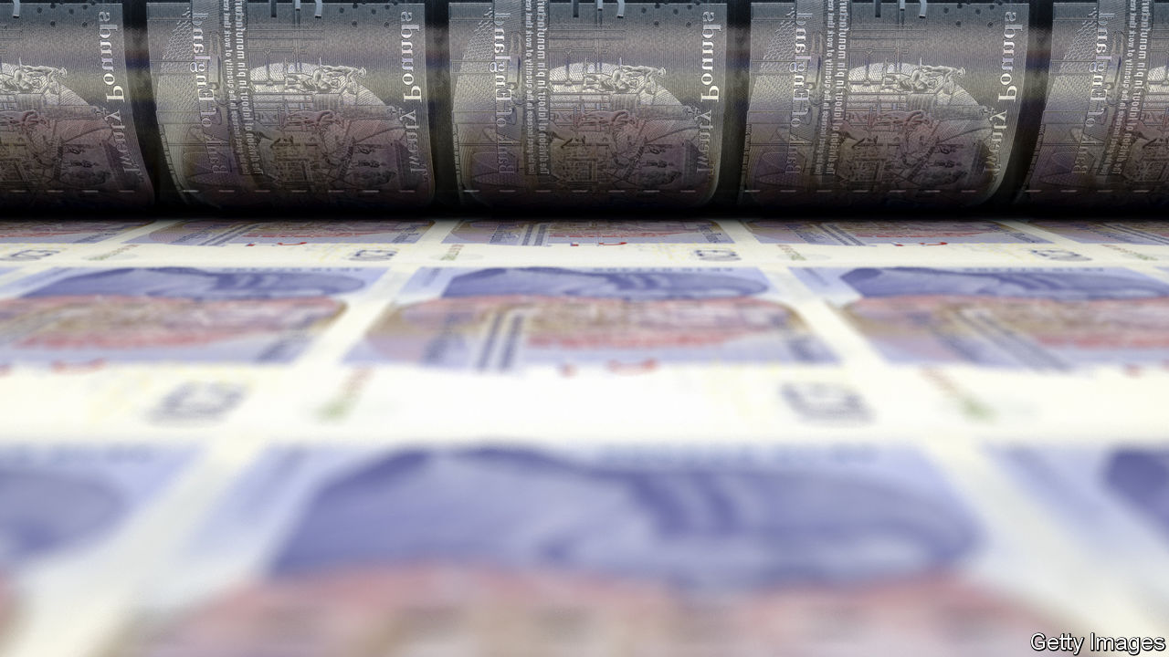

Editor’s note: The Economist is making some of its most important coverage of the covid-19 pandemic freely available to readers of The Economist Today, our daily newsletter. To receive it, register [here](https://www.economist.com/newslettersignup). For our coronavirus tracker and more coverage, see our [hub](https://www.economist.com/coronavirus)

MONETARY FINANCING is a modern term for one of the oldest taboos for central banks: printing money to fund government spending. On April 5th Andrew Bailey, governor of the Bank of England, insisted in the Financial Times that the bank would not directly fund the government since such action would damage its credibility. Four days later the bank announced that some monetary financing would in fact take place via an expansion of the so-called Ways and Means facility.

Mr Bailey had described the facility, which is as old as the bank itself, as a “historical feature”. It is a bit like an overdraft. The bank will create new money and transfer it to the government, which will later, it says, borrow in financial markets to pay the balance down. During the global financial crisis of 2007-09 some £20bn ($25bn) of borrowing was funded this way.

Monetary financing, with its echoes of Zimbabwe and Weimar Germany, raises fears that investors will lose confidence in a central bank seen to be under the thumb of a finance ministry—hence Mr Bailey’s earlier caution. But modest use of the Ways and Means facility is not likely to lead to inflation, let alone hyperinflation.

The bank’s actions so far look like sensible support for the government in exceptional circumstances. Tax receipts are plummeting just as spending is rising to cushion the economic impact of covid-19. The Office for Budget Responsibility, a watchdog, reckons this year’s deficit could reach 14% of GDP. Even with its new line of credit from the bank the government plans to issue £45bn of gilts in April alone, well above the previous monthly peak of £28bn in September 2009. The overdraft at the bank allows the government to smooth its borrowing in markets over a longer period, rather than risk investors choking on the sudden surge in its debt.

Mr Bailey’s volte-face is unlikely to do him much harm. During a crisis “being right is more important than being consistent,” argues a fund manager. Gilt investors are relaxed about the temporary use of the facility and confident about the bank’s independence; government bond yields barely budged on the news. Mr Bailey can afford to relax a little, too.

Dig deeper:  
For our latest coverage of the covid-19 pandemic, register for The Economist Today, our daily [newsletter](https://www.economist.com/newslettersignup), or visit our [coronavirus tracker and story hub](https://www.economist.com/coronavirus)

This article was downloaded by calibre from <https://www.economist.com/britain/2020/04/18/why-the-bank-of-england-is-directly-financing-the-deficit>

|  |  |  |  |
| --- | --- | --- | --- |
| Previous | Articles | Sections | Next |

|  |  |  |  |
| --- | --- | --- | --- |
| Previous | Articles | Sections | Next |

#### Brexit negotiations

# Why the government will not ask for a Brexit extension

Despite widespread support for an extension to the transition period, the government insists it will not ask for one

Apr 18th 2020 |

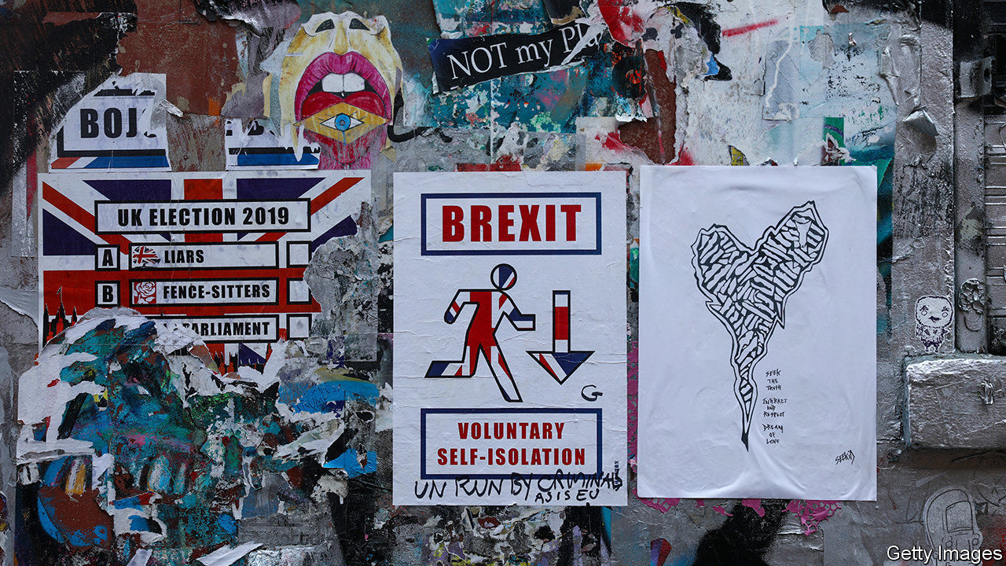

Editor’s note: The Economist is making some of its most important coverage of the covid-19 pandemic freely available to readers of The Economist Today, our daily newsletter. To receive it, register [here](https://www.economist.com/newslettersignup). For our coronavirus tracker and more coverage, see our [hub](https://www.economist.com/coronavirus)

ON APRIL 15th the Brexit negotiators, Michel Barnier for the European Union and David Frost for Britain, resumed their talks by video. They agreed that both teams should now restart online negotiations, after two months with little contact. Yet few diplomats expect the process to narrow the wide gaps between the two sides.

That makes the end-December deadline for a trade deal more problematic. When a transition period was first proposed, it was due to last for 21 months. Little more than six months are now left to strike a deal, which experience suggests is too short a period both to negotiate and to ratify one (see chart). Covid-19 has already led to the postponement of much else, from the Olympics to the COP26 climate summit. So why not use the clause in the Brexit withdrawal treaty providing that, before end-June, the deadline can be extended by mutual agreement for up to one or two years?

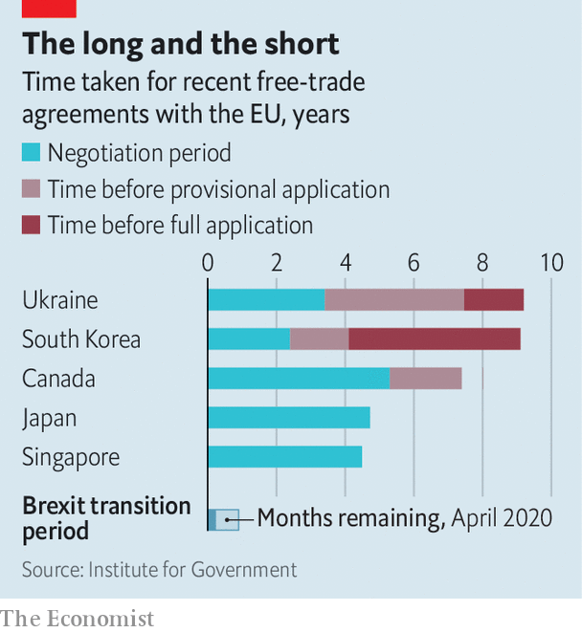

Officials on both sides now think this would be sensible, given the likely economic damage, on top of that from covid-19, of a December departure with no trade deal. Opinion polls suggest that a clear majority of voters would accept an extension. But the government insists that it will not ask for one.

The objections are purely political. When it comes to Brexit, Boris Johnson’s team are allergic to missed deadlines. They link them to Theresa May and the former parliament. The point of winning a big majority in December was to avoid being trapped by fears of no deal into endless rounds of negotiation on the EU’s terms.

Many Brexiteers also see transition as a form of vassalhood, because it entails observing almost all EU rules without a say—and paying for the privilege. Any extension beyond December 2020 could require further British contributions to the EU budget of up to £800m ($1bn) a month. Another 12 months of talks might not be long enough to produce an agreement, because of both sides’ entrenched positions. As for the costs of walking away with no trade deal, Brexiteers think they are exaggerated—and might anyway be swamped by the consequences of covid-19.

Meanwhile staying in the EU single market and customs union into 2021 would preclude early trade deals with America and others, as well as prolonging EU regulations in Britain. Some point to renewed strains in the euro zone as an additional reason for getting clear of it. That those calling for extension are mostly Remainers who are still questioning Mr Johnson’s choice of the hardest possible Brexit reinforces many Leavers’ doubts about any deadline extension.

Is there a way through? Mujtaba Rahman of the Eurasia Group, a consultancy, expects an extension as his base forecast, on the grounds that the mood among politicians may have changed by June. He suggests that the EU could facilitate the process by making clear that an extension of, say, 12 months, could be curtailed if a deal were reached in early 2021.

Another idea would be to fudge the question of who has to call for an extension. The EU has said it would welcome one, but it has also made clear that it is up to the British government to propose it. To ward off the risk of an impasse, Georgina Wright of the Institute for Government, a think-tank, suggests that the joint committee overseeing Brexit could, at its meeting in early June, quietly agree to suggest an extension, without either side being seen to have been the demandeur.

More flexibility in Brussels might indeed help. Yet the chances of the British government being ready to accept an extension even in June still look small. And sadly, the let-out of waiting until November or December may not be available. The provision in the withdrawal treaty will expire in June. Thereafter any extension would require an entirely new treaty, which might have to be ratified by all EU parliaments, a tortuous process at best. It looks like end-June or bust—and, for now, bust is as likely an outcome as any. ■

Dig deeper:  
For our latest coverage of the covid-19 pandemic, register for The Economist Today, our daily [newsletter](https://www.economist.com/newslettersignup), or visit our [coronavirus tracker and story hub](https://www.economist.com/coronavirus)

This article was downloaded by calibre from <https://www.economist.com/britain/2020/04/18/why-the-government-will-not-ask-for-a-brexit-extension>

|  |  |  |  |
| --- | --- | --- | --- |
| Previous | Articles | Sections | Next |

|  |  |  |  |
| --- | --- | --- | --- |
| Previous | Articles | Sections | Next |

#### Bagehot

# The populist revolution may become a victim of Covid-19

The establishment bites back

Apr 18th 2020 |

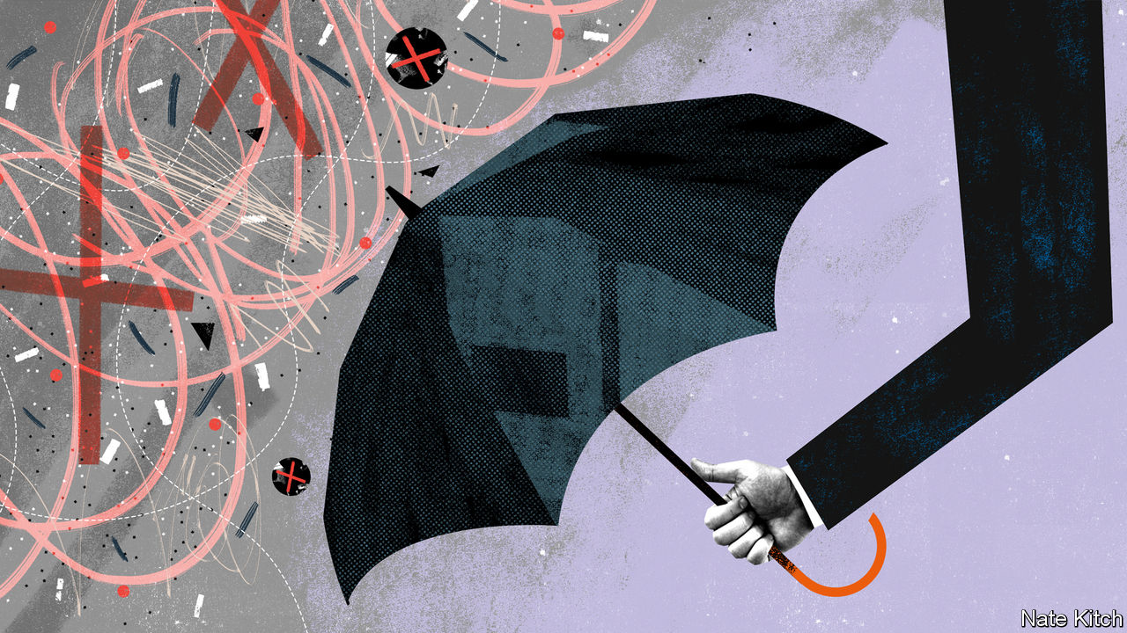

Editor’s note: The Economist is making some of its most important coverage of the covid-19 pandemic freely available to readers of The Economist Today, our daily newsletter. To receive it, register [here](https://www.economist.com/newslettersignup). For our coronavirus tracker and more coverage, see our [hub](https://www.economist.com/coronavirus)

BRITISH HISTORY has been shaped by periodic revolts against the establishment. In the Victorian era liberals charged the landed elite with nepotism and corruption. In the 1960s the young chided the old guard with regressive social attitudes. In the 1980s the Thatcherites accused Westminster and Whitehall of peddling managed decline. All three revolts led to profound change.

Only the other day Britain was engaged in another revolt, driven by the referendum on EU membership. Brexiteers furiously denounced the great and the good for acting as impediments to the will of the people. And with the 2019 election they gained a mandate to clean things up. The BBC, the universities, the Supreme Court, the senior civil service—all of them trembled in the government’s firing line.

Four months on and the establishment is back in charge. Government ministers have taken to appearing at press briefings flanked by the chief scientific adviser and the chief medical officer. The Treasury works closely with the Confederation of British Industry and even the Trades Union Congress. The army is building temporary hospitals and delivering lorries full of oxygen. The BBC is being rewarded with both plaudits and eyeballs: in early April the number of people watching the corporation’s television channels was up more than a third on the same period last year. Two-fifths of the public tell pollsters that they have more trust in the government than they did before the crisis.

The establishment loves nothing more than acronym-heavy committees. SAGE (the Scientific Advisory Group for Emergencies) offers advice on how long to keep the British population locked down. (Wonderfully, SAGE is itself advised by three other committees: NERVTAG, SPI-M and SPI-B.) NICE (the National Institute for Health Care Excellence) weighs in on how to balance the risks and benefits of various treatments. Public Health England rules on whether tests may be carried out in the private as well as the public sectors. All this wisdom is assessed in a Cabinet committee named COBRA. In normal times, nobody outside a magic circle has ever heard of any of them, but now they trip off the public tongue.

On April 5th the establishment was at its polished best. The queen delivered a pitch-perfect address to the country—one of only five such addresses she has delivered in her 68-year reign. Even as she spoke Boris Johnson was rushed to hospital for what turned out to be life-saving treatment. A trio of top mandarins—Sir Mark Sedwill, the cabinet secretary, Martin Reynolds, the prime minister’s principal private secretary, and Sir Edward Young, the queen’s private secretary—stepped in to ensure continuity of government and to keep the monarch informed.

At the same time the wild men of Brexit have been consigned to the shadows. Jacob Rees-Mogg and Mark François have disappeared entirely; Priti Patel, the home secretary, emerged briefly to perform poorly in a press briefing and has since vaporised. Even hard-core Brexiteers have begun to treat Donald Trump as a mad uncle in the attic rather than the leader of a global realignment. And more moderate Brexiteers have transformed themselves into centrists. On leaving hospital Mr Johnson delivered a rhapsodic—and moving—address about the NHS (“the best of us”). Rishi Sunak, the chancellor, has taken to calling the TUC “social partners” in a way that makes him sound like a German Christian Democrat or pre-Thatcher Tory.

The Labour Party, too, has been reclaimed from the revolutionaries. Not only has Sir Keir Starmer, the party’s new leader, replaced Comrade Corbyn, but Anneliese Dodds, a soft leftist, has replaced John McDonnell, a self-professed Marxist, as shadow chancellor, and Nick Thomas-Symonds, a former Oxford don and barrister, has replaced Diane Abbott, a professional protester, as shadow home secretary.

Not that the establishment will escape criticism of its management of the pandemic. Though it is hard to judge at this early stage, Britain’s performance so far appears to have been middling at best, and future inquiries into the response will surely put some of the blame on the great and the good as well as the professional politicians. The advice to favour “herd immunity” over a lockdown may have been responsible for thousands of premature deaths. Public Health England’s prejudice against private-sector testing smacks of blind protectionism. The civil service’s failure, over many years, to ensure that Britain has a succession plan in place if the prime minister falls ill amounts to professional neglect, and has left the acting prime minister, Dominic Raab, without the power to make vital decisions on when to end the lockdown.

And the establishment, like much of the country, will suffer from the fiscal squeeze that will inevitably follow the splurge in spending driven by the pandemic. The NHS may be safe from the scalpel of cost-cutting and the bludgeon of reform. But the BBC and the army are unlikely to escape. Squeezed between the need to balance the books on the one hand and deliver something to its new Northern voters on the other, the government may be driven by the need for greater efficiency into launching an ambitious programme to re-engineer the state.

Even so, this resurgence will leave a mark, for the establishment is as much a cast of mind as a collection of people and institutions. Establishment types maintain above all that government is a serious business which should be conducted by serious people. They believe in the wisdom of institutions rather than that of crowds, in facts rather than emotions, and in continuity rather than disruption. The past few years have seen all these beliefs mocked. America elected a reality-television star as its president. British populists ridiculed experts, made up data and fetishised disruption. The covid-19 crisis has demonstrated the foolishness of this. The state is back at the heart of British life. And thanks to his personal and professional tussle with the virus Mr Johnson has rediscovered the essential dignity of statecraft. ■

Dig deeper:  
For our latest coverage of the covid-19 pandemic, register for The Economist Today, our daily [newsletter](https://www.economist.com/newslettersignup), or visit our [coronavirus tracker and story hub](https://www.economist.com/coronavirus)

This article was downloaded by calibre from <https://www.economist.com/britain/2020/04/18/the-populist-revolution-may-become-a-victim-of-covid-19>

|  |  |  |  |
| --- | --- | --- | --- |
| Previous | Articles | Sections | Next |

|  |  |  |
| --- | --- | --- |
| Britain | Sections | Business |

International

How to end lockdowns: Emergency exit

.

Jobs at The Economist: We’re hiring

.

|  |  |  |
| --- | --- | --- |
| Britain | Sections | Business |

|  |  |  |  |
| --- | --- | --- | --- |
|  | Articles | Sections | Next |

#### Emergency exit

# Governments are starting to ease restrictions

Gradually, cautiously and with only a hazy idea of what works

Apr 18th 2020 | BEIJING, BERLIN, MADRID AND SEOUL



Editor’s note: The Economist is making some of its most important coverage of the covid-19 pandemic freely available to readers of The Economist Today, our daily newsletter. To receive it, register [here](https://www.economist.com/newslettersignup). For our coronavirus tracker and more coverage, see our [hub](https://www.economist.com/coronavirus)

AFTER SPENDING the long Easter break cooped up at home some Spaniards went back to work this week. They were greeted at transport hubs by police officers and Red Cross volunteers handing out face-masks. Though reported as a “relaxing” of the lockdown imposed a month ago, the government insists that it is not. Only those who cannot work from home are allowed to go back to their workplaces. Most shops remain closed, as do schools, bars, restaurants and hotels. Outdoor exercise is still banned and enforcement is tight: between March 14th and April 6th the police arrested 3,267 people and levied 340,000 fines for breaking the lockdown.

Spain seems to have turned a corner in one of the worst outbreaks of covid-19. The daily number of cases has begun to fall, compared with a daily increase of around 30% a month ago. Hospitals which were overwhelmed a fortnight ago now have some spare capacity. But Pedro Sánchez, the prime minister, was clear. “We aren’t even beginning the second phase,” he said on April 12th. “De-escalation will begin in a fortnight at the earliest, and it will be gradual and cautious,” Mr Sánchez insisted.

Governments around the world are trying to work out how to exit their covid-19 lockdowns. Several other European countries, including Austria, Germany, Norway and the Czech Republic, are reopening nurseries, schools and shops as their efforts to stop the spread of covid-19 start, as in Spain, to pay off (see table). In various American states discussions of exit strategies are gaining traction. In New York state, where covid-19 has killed more than 10,000 people in just a month, the total number of cases in hospitals is starting to plateau. On April 13th, along with five other states on the east coast, it disclosed it was working on a strategy for reopening the region’s economy. On the same day three states on the west coast, including California, announced a similar project.

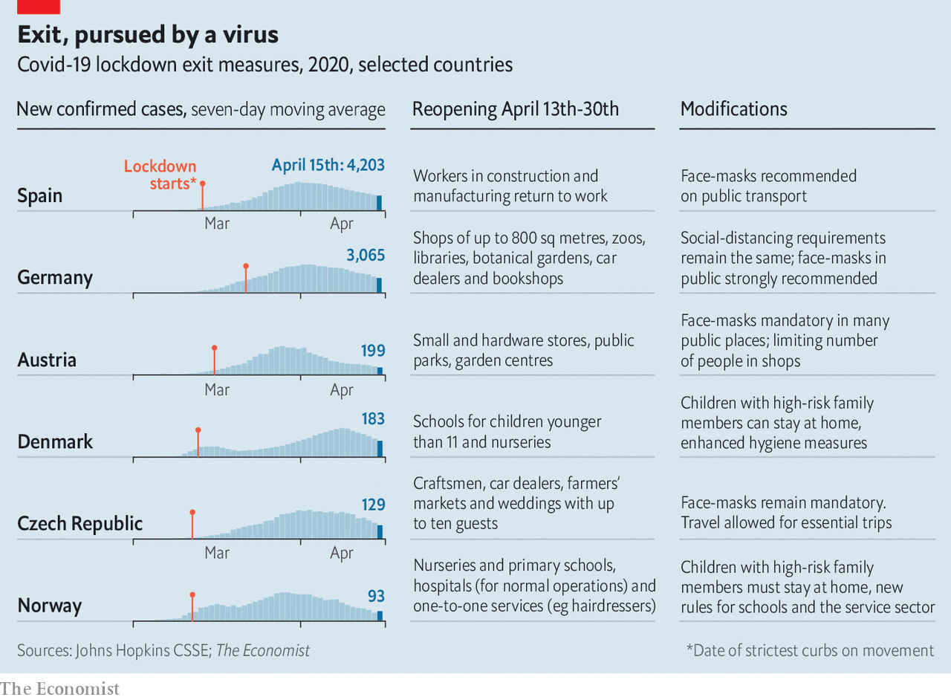

The big unknown is whether any of the exit strategies being considered or implemented will avoid a second wave of infections. Researchers at Imperial College London estimate that, even when the many infections that were never registered are added to the total, just 1-15% of people in Europe had some immunity to covid-19 at the end of March. Until a vaccine is available, governments will need to keep sufficient numbers of infected people tightly quarantined to prevent new outbreaks that would overwhelm their health systems. But most failed to do this during the early days of covid-19. That is why the epidemics grew so bad that they needed to implement full lockdowns to save hospitals from disaster. It is not yet clear that they will do well enough the second time around to prevent a resurgence of the disease.

Governments in countries that are already past the peak of the first wave of their epidemics have some breathing space to plan for their post-lockdown future. More important, they have better data. They have a clearer sense of how their hospitals will cope with a certain number of cases of covid-19. They no longer need to rely on data from China to make educated guesses about how their populations and health systems might fare. Such experience matters for all sorts of reasons. For example, the spread of the disease among the close-knit intergenerational households in southern Europe is different from the paths it takes in the insular societies of northern Europe where a large share of old people live alone or in care homes.

Even with these data, however, government planners do not know which restrictions they should begin to ease and when. “There are no absolutes here,” says Mike Ryan of the World Health Organisation (WHO); the evidence that when countries reach a specific number of cases they should take particular actions does not yet exist. The accepted wisdom is that countries can begin to consider easing restrictions when the number of new cases is tapering off, and their hospitals have free beds—in other words, when they can accommodate a surge in infections that could follow the easing of a lockdown.

Those easing lockdowns are using one principle: the epidemic must be under control. Austria was the first European country to announce a comprehensive plan detailing when various sectors would be allowed to reopen. In the first week of April tests of a random sample of about 1,600 people found that fewer than 1% had active covid-19 infections. Norway decided to begin reopening kindergartens from April 20th after scientists advising the government reported that the epidemic’s reproduction rate—the number of new infections generated by each case—had fallen to 0.7. If the reproduction rate of a contagion is lower than one then an epidemic will die down over time. Spain’s health ministry plans to test a sample of at least 30,000 families around the country over the next three weeks to get a sense of the real scale of the outbreak and the extent to which the population has acquired any immunity.

Harder than the decision about when to lift restrictions is choosing which to lift first. The reasoning varies from country to country, but the conclusions are often the same. Norway’s commission, which assessed the long-term costs to society of various combinations of restrictions, found that closing primary schools and nurseries were among the costliest policies. In Denmark, too, nurseries and primary schools opened first on April 15th; older children may be allowed back to school a month later. (Not all parents were impressed; 40,000 Danes have joined a Facebook group called “My kid is not going to be a Guinea Pig for Covid-19”.) And in Germany, which outlined an exit strategy on April 15th, schools will start to reopen on May 4th, but only for those children facing exams. “Emergency” services for the parents of younger children will be expanded.

## Back to abnormal

Nowhere, however, is the slow lifting of lockdowns a return to business as usual. Europeans going back to shops, trains and offices will have to follow new hygiene and social-distancing rules—some of which were introduced during the lockdowns. Austrians and Czechs are already required to wear face-masks in public spaces, including at work; Spain is considering a similar requirement. Shops in many countries will have to limit the number of customers in at any one time. Norway’s guidelines, released on April 15th, say that children in nurseries must be split into smaller cohorts, with three-year-olds in groups of three and older children in groups of six; each group will be assigned one adult. Changes to the cohorts will be permitted no more than once a week.

Like the lockdowns themselves, many of these new rules are transplants from China, which has, its government says, avoided a second wave of infections. In Beijing employers must keep their employees separated, so many firms have only a fraction of their workers on-site each day, with the rest working at home where possible. Restaurants must limit the number of customers to keep them apart. Chinese schools which have welcomed back their students have introduced measures to minimise infections: constant ventilation of classrooms; extra spacing between desks; frequent cleaning and disinfecting; the reduction of the size of classes; staggered dismissal times, to avoid crowding; assigned seating and installation of partitions in dining areas. The list goes on and on. And officials stress that they will pull back and make adjustments if they see signs of a second wave.

There is no solid evidence that any one of these measures alone is particularly effective in reducing the transmission of the new coronavirus. The hope is that in combination they could work reasonably well. In China, however, the easing of lockdown has been accompanied by stringent efforts to identify and quarantine those infected and their close contacts. In some areas restaurants must sign in every customer—and if any later test positive to notify those who visited at the same time. China’s strategy suggests that Europe and America’s plans to stop infections after they lift their lockdowns with masks, good hygiene and social distancing may not be enough.

Instead post-lockdown life might more closely resemble that in South Korea, a democracy with a population similar in size to England’s, throughout its covid-19 outbreak. Unlike America and much of Europe, South Korea has never instituted a complete lockdown. Even at the height of the outbreak people remained mostly free to go about their lives thanks to extensive testing, tracing and isolation of infections. In only 10% of cases have public-health investigators been unable to determine the source of infection. New daily infections are now below 30.

## It’s life, Jim, but not as we know it

Despite the pandemic on April 15th South Korea held legislative elections. But schools, universities, museums and many churches have been closed for weeks, and there are no plans to reopen them. Travellers returning from abroad must quarantine themselves for two weeks, either at home or in government-provided facilities. Breaking quarantine can lead to fines, jail or, for foreigners, deportation. The government advice still discourages leaving home for non-essential reasons, especially socialising in groups.

Compliance with social-distancing recommendations, however, is flagging. Using data gathered from mobile-phone masts, South Korea’s disaster-response agency estimates that people moved around about 16% more in the last week of March compared with the last week of February, which was the height of the outbreak. That number is likely to have ticked up further in recent days. Seoul’s restaurants are filling up again. Hiking trails teemed with people over the weekend.

And yet of the roughly 57,000 people currently in strict self-isolation, just over 100 have been caught violating it. After various groups voiced concerns about privacy, the government abandoned a plan to issue electronic wristbands to everyone in quarantine. Instead, it will now provide them only to those who have broken their quarantine and even then only with the person’s consent. The public supports the idea either way; in a poll conducted by the culture ministry, more than 80% said the wristbands were a good idea.

South Korea’s experience has prompted some European countries and a few American states to begin ramping up their contact-tracing capacity as they prepare to lift their lockdowns. That requires expanding public-health departments; calling everyone an infected person has been in close contact with—and checking on them regularly during their 14-day quarantine—is hugely labour-intensive.

## Is antibody out there?

It is not a highly skilled job; anyone with a secondary-school education can be trained in a day. But with a disease that spreads as easily as covid-19, enormous numbers of workers are needed. Public-health departments in America are currently doing this sort of work for outbreaks of sexually transmitted diseases, tuberculosis and the occasional measles outbreak. But the numbers involved are minuscule compared with a respiratory bug like covid-19. Calculating on the basis of the number of contact-tracers used to contain the outbreak in Wuhan, the Chinese city hit hardest by the country’s epidemic, public-health experts recently convened by Johns Hopkins University estimated that more than 260,000 new hires would be needed at local and state public-health departments in America—up from just 2,200 at present. To make a start, they recommend that America recruits 100,000 such new hires dedicated to covid-19. Their salaries for a year would add up to $3.6bn—a rounding error on the cost of shutting down the American economy.

Massachusetts has begun hiring 1,000 additional contact-tracers and social workers who would support people under quarantine by shopping for food and collecting medications, for example. American universities are developing crash training courses for contact-tracers. Similar efforts are starting to appear in Europe. In March Germany’s public-health institute put out a job advertisement aimed at students for “containment scouts” to do contact-tracing; 10,000 applied. Germany plans to have at least one five-person team per 20,000 inhabitants to help with contact-tracing. In badly affected areas the army and other personnel will be called in. The Czech Republic may also use army recruits.

Apps that will help health officials track where hotspots of covid-19 may be emerging and trace the contacts of infected people are being developed (see article). Such apps are already widely used in China. They can make contact-tracing more efficient, says Anita Cicero of Johns Hopkins University, but they cannot replace the traditional methods of contact-tracing—nor the humans who do it. The European Commission, which on April 15th unveiled a “road map” to ensure that EU member-states co-ordinate the lifting of their restrictions, wants them to agree on a common framework for such an app; at the moment, many countries are forging ahead with their own plans.

Many experts doubt that such apps, which people will have to install voluntarily, would be popular. “I don’t think Americans are going to go for that,” says Michael Fraser of the Association of State and Territorial Health Officials in America. “I’ve been surprised before, though,” he concedes. If the alternative is being cooped up at home, lots may opt in. Almost two-thirds of Germans told one survey they would forgo the privacy of their data to protect the lives of others; a separate poll found that 70% of respondents would be happy to install a contact-tracing app.

But organising quarantines on the scale required by covid-19 would require more than just manpower and technology, notes Mr Fraser. Most of the new contact-tracers can work from home, by phone or using other technologies. Some, however, would need to go to people’s homes. For that, they would need face-masks and gloves to protect them—which are in short supply globally. At a local level, isolation facilities are needed for people who cannot isolate themselves at home. These must be safe, private and comfortable.

Above all, every country that wants to contain a second wave will need to test everyone suspected of being infected with covid-19 and their contacts. This will have to be rapid diagnostic testing, says Ms Cicero, where people get the results in less than an hour. Testing sites would need to be set up in every health-care facility. The way things are now in America, people often wait for their results for several days—too long for a virus that they can spread before they develop symptoms.



Testing capacity everywhere has been growing. But at its current pace America will take months to attain the level needed for effective contact-tracing, says Mr Fraser. In many countries, the crimped global supply of materials, including reagents (chemicals necessary for tests), means that testing is reserved primarily for those hospitalised with covid-19 and health-care workers. The dearth of reagents means that Austria may not be able to increase its testing as planned, even though it has the capacity to carry out ten times the number of tests it conducts now.

Reagents are not the only thing in short supply. Swabs to take samples from patients, glass tubes, machines and trained technicians with protective masks and gloves are also scarce. With so many different inputs, bottlenecks can easily occur. And when every single country in the world needs enormous supplies, it will be a while before there is no shortage of them.

## Corona and out

Every plan and guideline for what a country must have in place before it lifts its lockdown puts expanded testing near the top of the list, but few outline how to do this fast. For countries hoping to be rid of both their lockdowns and a runaway covid-19 epidemic, no problem is as urgent.■

Dig deeper:  
For our latest coverage of the covid-19 pandemic, register for The Economist Today, our daily [newsletter](https://www.economist.com/newslettersignup), or visit our [coronavirus tracker and story hub](https://www.economist.com/coronavirus)

This article was downloaded by calibre from <https://www.economist.com/international/2020/04/18/governments-are-starting-to-ease-restrictions>

|  |  |  |  |
| --- | --- | --- | --- |
|  | Articles | Sections | Next |

|  |  |  |  |
| --- | --- | --- | --- |
| Previous | Articles | Sections | Next |

#### Jobs at The Economist

# We’re hiring

Apr 18th 2020 |

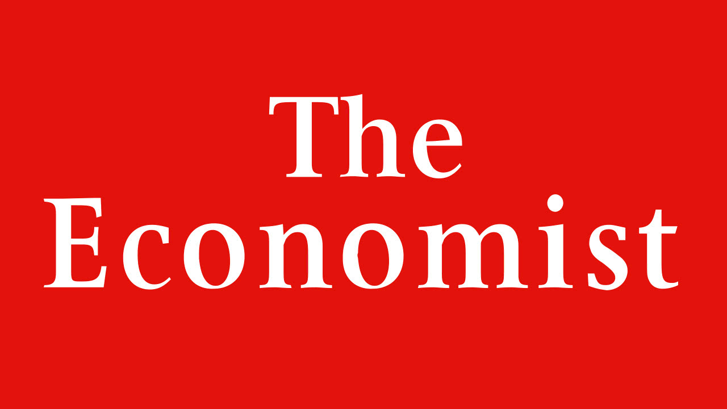

Writers wanted: The Economist is looking for an international correspondent based in London; and also for paid interns to work on the foreign desk. For details, go to [www.economist.com/foreignjobs](https://www.economist.com/foreignjobs)

This article was downloaded by calibre from <https://www.economist.com/international/2020/04/18/were-hiring>

|  |  |  |  |
| --- | --- | --- | --- |
| Previous | Articles | Sections | Next |

|  |  |  |
| --- | --- | --- |
| International | Sections | Finance and ... |

Business

Corporate fraud: Who’s lost their trunks?

.

ByteDance: Unabashed

.

Dividends and buy-backs: Chop chop

.

Non-essential retailers: Fashion victims

.

Bartleby: Lessons from the front line

.

Schumpeter: Slumbering serpents

.

The world after covid-19: By invitation: Mark Carney

.

|  |  |  |
| --- | --- | --- |
| International | Sections | Finance and ... |

|  |  |  |  |
| --- | --- | --- | --- |
|  | Articles | Sections | Next |

#### Who’s lost their trunks?

# The economic crisis will expose a decade’s worth of swindling and aggressive accounting

Downturns are corporate fraudsters’ worst enemy

Apr 18th 2020 |



Editor’s note: The Economist is making some of its most important coverage of the covid-19 pandemic freely available to readers of The Economist Today, our daily newsletter. To receive it, register [here](https://www.economist.com/newslettersignup). For our coronavirus tracker and more coverage, see our [hub](https://www.economist.com/coronavirus)

WHEN BERNIE MADOFF owned up to a $65bn Ponzi scheme in December 2008, it was not out of guilt. He knew the game was up. Three months earlier Lehman Brothers had imploded. The market meltdown sent clients clamouring to withdraw from his funds, leaving them depleted with many investors still unpaid. American regulators had not spotted the fraud, despite a tip-off years earlier. It was not them that did for Mr Madoff, but recession.

Booms help fraudsters paper over cracks in their accounts, from fictitious investment returns to exaggerated sales. Slowdowns rip the covering off. As Baruch Lev, an accounting professor at New York University, puts it, “In good times everyone looks good, and the market punishes you harshly for not keeping up.” Many big book-cooking scandals of the past 20 years emerged in downturns. A decade before the crisis of 2007-09 the dotcom crash exposed accounting sins at Enron and WorldCom perpetrated in the go-go late 1990s. Both firms went bust soon after. As Warren Buffett, a revered investor, once put it: “You only find out who is swimming naked when the tide goes out.” This time, thanks to a pandemic, the water has whooshed away at record speed.

## Hell and low water

Much of the swimwear was already threadbare: a borrowing binge has strained many corporate balance-sheets. Some dirty secrets are beginning to come out. Take Luckin Coffee, which had expanded to take on Starbucks in China, attracting big-name investors like Blackrock and Singapore’s sovereign-wealth fund. On April 2nd the Nasdaq-listed Chinese chain announced an ongoing internal probe amid allegations that its chief operating officer and other employees may have fabricated over 2bn yuan ($280m) in sales. On April 14th Citron Research, a short-seller, accused GSX, a Chinese online-tutoring firm listed in New York, of inflating last year’s sales. In a statement GSX denied the allegations and said Citron’s report was misleading and “full of subjective maliciousness”.

These revelations have revived fears over the flaky corporate governance of Chinese firms listed on foreign exchanges, whose audits, conducted at home, China’s government makes it hard for outsiders to inspect. A gaggle of fraud-hunters like Citron and Muddy Waters, which outed Luckin, claimed numerous scalps after the first wave of such listings a decade ago. This time they are looking beyond China.

Blue Orca Capital, an Asia-focused fund targeting corporate “zeros”, expects opportunities to pop up in other emerging markets, Europe and America. “My entire career has been in a bull market,” says its founder, Soren Aandahl. “This is exciting.” Mr Aandahl is eyeing any firms with discrepancies between the amount of capital they need to raise and the cash their accounts say they are generating. Others are focusing on industries hit hardest by the pandemic, such as travel, entertainment and property.

Only a small minority of firms resort to outright fraud. Far more prettify profit-and-loss statements with accounting wheezes that fall in a grey area. This accounts for much of what John Kenneth Galbraith, an economist, called “the bezzle” and “psychic wealth”: gains that appear real but prove illusory.

In the bull market startups became masters of conjuring up novel metrics that flatter performance. WeWork’s “community-adjusted” earnings before interest, taxes, depreciation and amortisation (EBITDA) transformed a hefty loss for 2018 under Generally Accepted Accounting Principles (GAAP) into a profit. Illegal? No. A red flag? Absolutely. Many investors turned a blind eye because they bought into what Mr Aandahl calls “the myth in the shareholder list”: all would be well if other high-profile backers were on board (as with Luckin).

Non-GAAP adjustments have spread like wildfire through corporate accounts, making it harder to discern what numbers reflect a firm’s true financial position. The average number of non-GAAP measures used in filings by companies in the S&P 500 index has increased from 2.5 to 7.5 in the past 20 years, according to PwC, a consultancy. In credit agreements analysed by Zion Research Group, the definition of EBITDA ranges from 75 words to over 2,200. GAAP is far from perfect, but some of the divergence from it has clearly been designed to pull wool over investors’ eyes. One study found that non-GAAP profits were, on average, 15% higher than GAAP profits.

Playing around with earnings and revenue-recognition metrics is this generation’s equivalent of dotcoms using bots and other tricks to boost “eyeballs” 20 years ago, says Jules Kroll of K2 Intelligence, the doyen of corporate sleuths. “When an area is hot to the point of overheated, there is a growing temptation to juice the numbers.” In an ominous sign, SoftBank, a Japanese technology conglomerate which bet big on WeWork and dozens of other startups, said this week that it expects an operating loss of ¥1.4trn ($12.5bn) in its last fiscal year.

Besides exposing old schemes, the pandemic is likely to give rise to new ones. When economic survival is threatened, the line separating what is acceptable and unacceptable when booking revenues or making market disclosures can be blurred. Mr Kroll reckons that “amid such massive dislocation, some will inevitably cheat.”

Bruce Dorris, head of the Association of Certified Fraud Examiners, the world’s largest anti-fraud outfit, says the effects of covid-19 look like “a perfect storm for fraud”. It may engender everything from iffy accounting to stimulus-linked scams as thousands of firms—including bogus applicants—hustle for help. One fraud investigator points to private-equity-owned firms as potential targets. “There are lots of them, they are highly leveraged and they may not qualify for bail-outs because they have deep-pocketed sponsors,” he says. That increases the temptation to resort to unseemly practices. The ebbing tide is likely to reveal plenty of corporate nudity. That will not stop some businesses from taking up naturism.■

Dig deeper:  
For our latest coverage of the covid-19 pandemic, register for The Economist Today, our daily [newsletter](https://www.economist.com/newslettersignup), or visit our [coronavirus tracker and story hub](https://www.economist.com/coronavirus)

This article was downloaded by calibre from <https://www.economist.com/business/2020/04/18/the-economic-crisis-will-expose-a-decades-worth-of-swindling-and-aggressive-accounting>

|  |  |  |  |
| --- | --- | --- | --- |
|  | Articles | Sections | Next |

|  |  |  |  |
| --- | --- | --- | --- |
| Previous | Articles | Sections | Next |

#### ByteDance

# ByteDance is going from strength to strength

America doesn’t like it one bit

Apr 18th 2020 | BEIJING AND HONG KONG

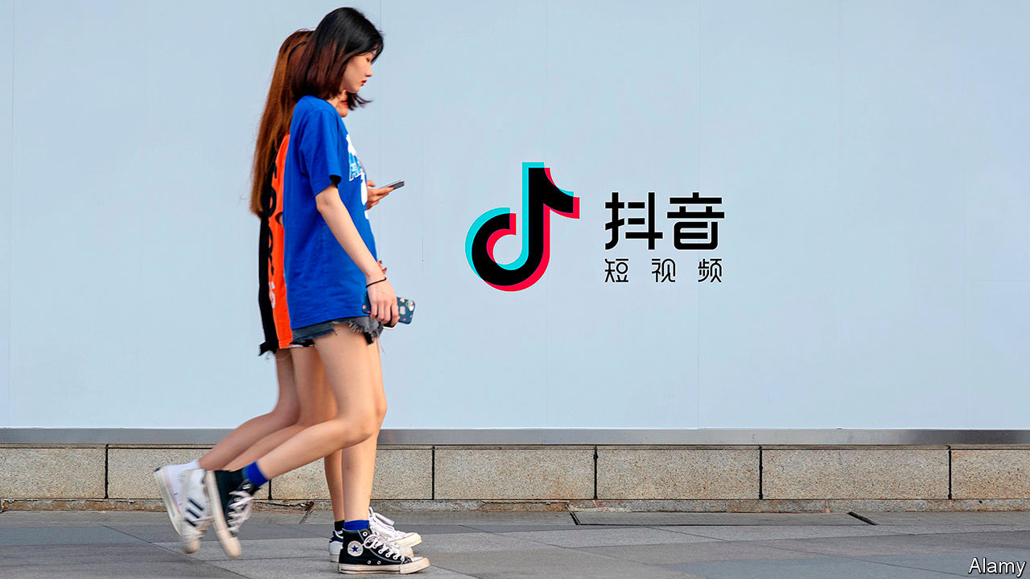

AS COVID-19 has forced the world’s teenagers out of school and into their rooms, they have turned to a familiar digital companion, TikTok. The short-video app was downloaded 115m times in March. Its nearly 1bn regular users enjoy silly clips of dog antics alongside pandemic advice from the World Health Organisation. Collectively, TikTok videos tagged with #coronavirus have been watched 53bn times.

TikTok’s popularity over the past two years has shone the spotlight on ByteDance, its Beijing-based developer. Founded by a Chinese computer scientist, Zhang Yiming, in 2011, it is now the world’s biggest unlisted technology “unicorn”, recently valued at between $90bn and $100bn. It is also the only technology firm bar Apple with more than 100m users in both China and America, where TikTok has taken on the likes of YouTube and Instagram.

And ByteDance isn’t done. The 60,000 people in its buzzy offices—“We are like flies,” says one former employee—crank out one app after another. In the past year it has launched a worldwide corporate-software service (Lark), a music-streaming app in India and Indonesia (Resso) and, in China, a messaging rival to WeChat. As other firms sack workers amid covid-19, ByteDance is hiring 10,000 globally. It plans to employ 30,000 on top of that this year.

ByteDance is not the first Chinese firm with foreign ambitions. Commodity giants such as CNOOC, an oil firm, have been buying foreign reserves, and rivals, since the 1990s. In the past decade industrial giants have pursued Western competitors from carmaking (as with Geely’s purchase of Volvo) to chemicals (ChemChina’s of Syngenta). More haphazardly, conglomerates like Fosun and Anbang splurged on trophy assets (including Club Med and the Waldorf Astoria hotel, respectively).

Unlike most of its peripatetic predecessors, though, ByteDance has built its empire by making products that appeal beyond China. It is China’s first global software giant. It has also courted foreign investors. Filings in Hong Kong show that it has used an arrangement called the “Sina structure”, which allows it to accept money from abroad, since its founding (many Chinese tech firms turn to this structure only when eyeing a stockmarket listing in America). Around 80% of ByteDance’s investors are non-Chinese. So are four of its five board members. The other is Mr Zhang.

All this helps ensure ByteDance is not, in contrast to many Chinese tech upstarts, in hock to Alibaba, Baidu and Tencent—which is handy, for Bytedance competes with China’s tech titans for ad revenue. It makes most of its money selling ads in its two main Chinese apps: Douyin, a Chinese TikTok, and Toutiao, a multimedia-and-news app akin to Facebook’s newsfeed (its WeChat rival, Duoshan, disappointed).

How much money it makes, exactly, is unclear: as a private company Bytedance does not publish its accounts. But leaks and statements from investors put last year’s revenue at between 104bn yuan and 140bn yuan ($15bn-20bn), more than Uber, Snapchat and Twitter combined. Its ad revenues in China surpassed Tencent’s and Baidu’s and now trail only those of Alibaba. It reportedly turned a profit in June 2019, a feat in the world of loss-making unicorns.

If the firm generates $25bn in sales this year, as it is expected to despite covid-19, it will have done so three years faster than Facebook. It is the only big Chinese firm whose share of the domestic advertising market is growing fast, from 9% to 17% in 2019, according to Bernstein, a research firm. A recently launched advertising network, Pangle, which lets advertisers reach consumers across any of its non-Chinese apps, may at last help it monetise TikTok.

No wonder American rivals are trying to clip its wings. Facebook’s TikTok clone, Lasso, has flopped. YouTube is said to be developing another (called Shorts). But the biggest threat has emerged in the form of America’s government, wary of China’s rise in any sphere.

Politicians in Washington fear that data on American users is being handed to Beijing; that Chinese algorithm designers are infecting impressionable Western youngsters with communist propaganda; and that ByteDance content is censored in line with party whims. In March two Republican senators introduced a bill that would ban TikTok from all government devices. The Committee on Foreign Investment in the United States (CFIUS) is reviewing ByteDance’s acquisition in 2018 of Musical.ly, another app, which had 60m users in America and Europe.

In statements, TikTok has said that it stores all American “user data in the United States” and that its American operations are “not influenced by any foreign government, including the Chinese government”. The firm is trying to mollify critics and has hired prominent security and legal experts in America to help it. Last month it opened a “transparency centre” in Los Angeles, where it promises to share information about its content-moderation, privacy and security controls, and said it would stop using moderators in China to handle content from users outside the country.

That, most lawyers and technologists reckon, may help get CFIUS off its back. Listing ByteDance in Hong Kong, which is under consideration, may also foster trust. So would anointing a non-Chinese successor—though, at 37, Mr Zhang may not be ready to retire. As a last resort, he is said to be willing to contemplate spinning TikTok off. That would cement the digital divide between China and the West—until another hit ByteDance app tries to bridge it. ■

This article was downloaded by calibre from <https://www.economist.com/business/2020/04/18/bytedance-is-going-from-strength-to-strength>

|  |  |  |  |
| --- | --- | --- | --- |
| Previous | Articles | Sections | Next |

|  |  |  |  |
| --- | --- | --- | --- |
| Previous | Articles | Sections | Next |

#### Chop chop

# Companies are slashing payouts to shareholders

Expect dividends and share buy-backs to shrivel this year

Apr 18th 2020 |

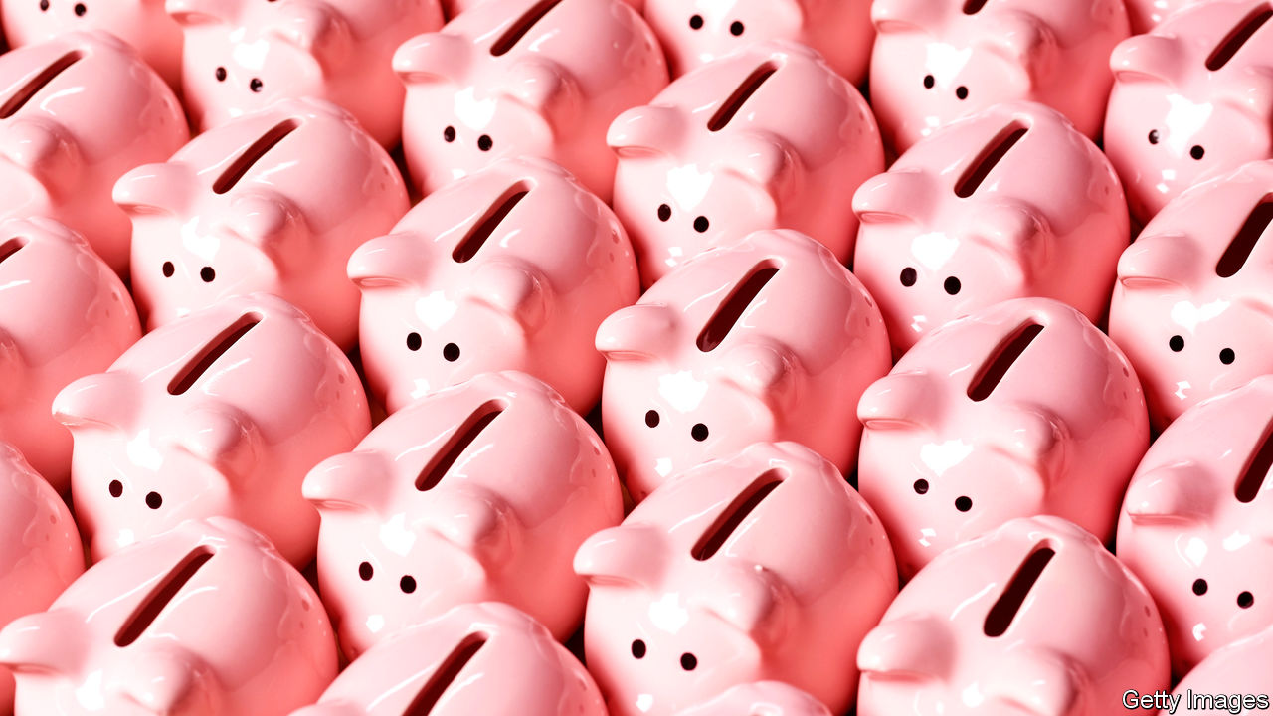

Editor’s note: The Economist is making some of its most important coverage of the covid-19 pandemic freely available to readers of The Economist Today, our daily newsletter. To receive it, register [here](https://www.economist.com/newslettersignup). For our coronavirus tracker and more coverage, see our [hub](https://www.economist.com/coronavirus)

SHAREHOLDERS THE world over have had a rotten 2020. Some might have hoped the collapsing value of their portfolios would at least be in part offset by dividends—the profits firms pay out to owners. Others were counting on companies to buy back their own shares. As corporate earnings season kicks off, both groups have little to look forward to.

Blame poor performance, present and expected. Dividends and buy-backs are a sign of profits and confidence, both in short supply in a pandemic. Derivatives markets where investors can bet on the size of dividends imply these will fall by at least a quarter in America. If the crisis of 2007-09 is anything to go by, buy-backs (popular mainly among American firms for tax reasons) will be halved.

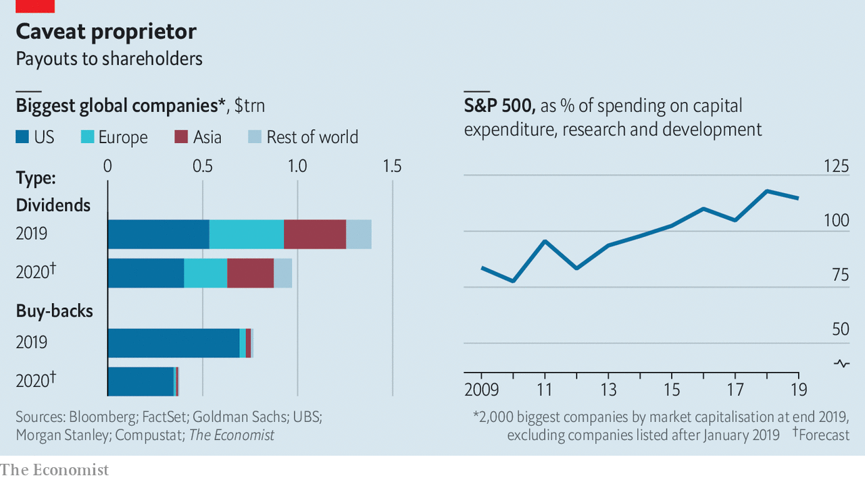

All told, global payouts to shareholders are expected to tumble from $2.2trn in 2019 to $1.4trn this year, according to The Economist’s rough estimate (see chart). The cuts could go deeper. If the crisis worsens (or regulators step in), banks in America, which have suspended buy-backs, may do the same with dividends, which they have kept. Policymakers in Europe, where dividends are higher as a share of profits, are asking all firms to show restraint.

Withheld payouts remain on firms’ balance-sheets, helping to pare down net debt. Once pruned, dividends take time to grow back—welcome news for those who think shareholders have been rewarded too richly of late. In America companies now return more money to owners than they spend on capital investments, research and development.

Dig deeper:  
For our latest coverage of the covid-19 pandemic, register for The Economist Today, our daily [newsletter](https://www.economist.com/newslettersignup), or visit our [coronavirus tracker and story hub](https://www.economist.com/coronavirus)

This article was downloaded by calibre from <https://www.economist.com/business/2020/04/18/companies-are-slashing-payouts-to-shareholders>

|  |  |  |  |
| --- | --- | --- | --- |
| Previous | Articles | Sections | Next |

|  |  |  |  |
| --- | --- | --- | --- |
| Previous | Articles | Sections | Next |

#### General retail

# Fashion retailers struggle to manage their inventories

Matching supply and demand in a pandemic is proving a headache

Apr 18th 2020 | BERLIN

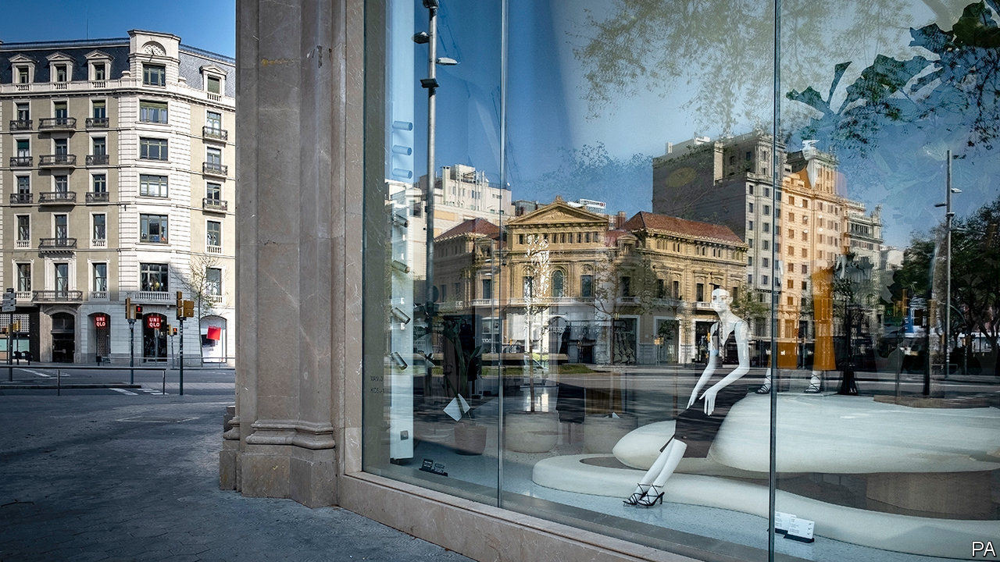

Editor’s note: The Economist is making some of its most important coverage of the covid-19 pandemic freely available to readers of The Economist Today, our daily newsletter. To receive it, register [here](https://www.economist.com/newslettersignup). For our coronavirus tracker and more coverage, see our [hub](https://www.economist.com/coronavirus)

“NO ONE WANTS to buy clothes to sit at home in,” Simon Wolfson, boss of Next, told analysts in March. On the same call the British fashion retailer revealed it might lose up to £1bn ($1.2bn), or 25%, in annual sales this year because of the covid-19 pandemic. Fashion retailers have been clobbered by the mandatory lockdowns in Europe and America. Since they sell non-essential goods, many, including Next, have been forced to close warehouses and stop online sales, too. A season’s worth of clothing will go unsold.

Many retailers flogging non-essential goods are stuck with useless inventory—with more piling up as pre-pandemic orders stream in from factories in faraway emerging markets. But it is a particular headache for fashion firms. Unlike food or some medicines, their products do not go off. But many go out of style—sometimes, as with seasonal apparel collections, rather quickly. Inditex, the world’s biggest fashion retailer, announced that it is taking a €287m ($313m) hit to inventories. Other big fashion retailers will follow suit, predicts Aneesha Sherman of Bernstein, a research firm. American retail sales in March fell by 8.7% from February, the biggest monthly decline since 1992. Those of clothes fell by half.

Inventories are not easy to get right in good times—which these are not. Retailers always run the danger of cutting orders too aggressively, warns Knut Alicke of McKinsey, a consultancy. They endanger the survival of their suppliers. Supply-chain experts refer to the “bullwhip effect”, named after the way the amplitude of a whip increases down its length—just as the relative shock to small suppliers, which risk losing all their custom at once, is bigger than to larger, more diversified firms further up the value chain. Retailers risk missing out on the recovery, because they do not have enough stuff to fill shelves, or the wrong kind.

The pandemic has cracked the whip with force. One way retailers are coping with the jolt is by shifting what they can online at deeply discounted prices. H&M of Sweden has slashed prices by up to 70% at its post-Easter “mid-season sale”. The online sale of women’s clothes at GAP, an American company, offers 50% off previously discounted prices. Japan’s Uniqlo is selling sweatpants and leggings (“to work out from home”) on the internet for a song.

Another widespread tactic is to unceremoniously cancel deliveries. Marks & Spencer, a British firm, sent a note to suppliers in late March suspending its orders. Ross Dress for Less, an American chain of discount department stores, announced that it will cancel all merchandise orders until mid-June. So far European and American retailers have binned about $1.5bn-worth of garment orders from Bangladesh. Many invoked force majeure clauses in their contracts, though aggrieved suppliers may challenge this in court—if they survive.

Where cancellations are impossible retailers are asking partners to ship them more slowly. Literally. Green activists have lobbied for “slow steaming” for years, to cut shipping’s greenhouse-gas emissions, but were roundly ignored. No longer. Companies are using container ships as floating warehouses to save on storage fees on land. In addition, Maersk and MSC, the world’s biggest shipping firms, are offering “suspension of transit” programmes that allow customers to store unwanted shipments at cheaper locations such as Lomé in Togo.

As places like Austria, Spain and the Czech Republic slowly begin to ease restrictions on businesses, fashion retailers see a silver lining. Summer collections are less lucrative than pricey winter coats and jackets. If shoppers return in September, companies with solid balance-sheets, such as Inditex (which owns Zara, Massimo Dutti and Bershka), may recover quickly—if they can keep their suppliers alive. In the meantime, many are resigned to grasping at straws. Next reopened its website on April 14th—but shut it again within two hours because it had reached the maximum number of orders it could fulfil with skeleton staff. ■

Dig deeper:  
For our latest coverage of the covid-19 pandemic, register for The Economist Today, our daily [newsletter](https://www.economist.com/newslettersignup), or visit our [coronavirus tracker and story hub](https://www.economist.com/coronavirus)

This article was downloaded by calibre from <https://www.economist.com/business/2020/04/18/fashion-retailers-struggle-to-manage-their-inventories>

|  |  |  |  |
| --- | --- | --- | --- |
| Previous | Articles | Sections | Next |

|  |  |  |  |
| --- | --- | --- | --- |
| Previous | Articles | Sections | Next |

#### Bartleby

# Lessons from the front line

How managers have coped with the pandemic

Apr 18th 2020 |

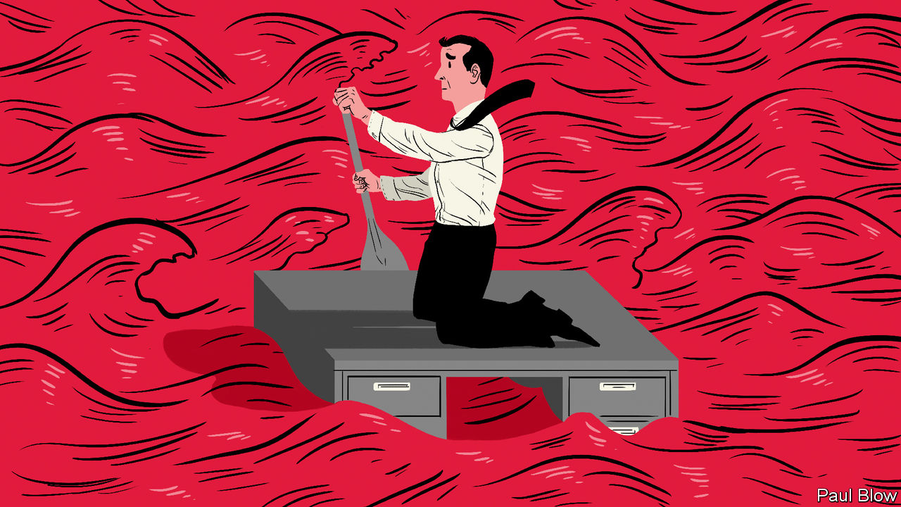

Editor’s note: The Economist is making some of its most important coverage of the covid-19 pandemic freely available to readers of The Economist Today, our daily newsletter. To receive it, register [here](https://www.economist.com/newslettersignup). For our coronavirus tracker and more coverage, see our [hub](https://www.economist.com/coronavirus)

MANY BUSINESSES have faced their sternest test in the past few months, dealing with a pandemic that few will have anticipated. Managers have been forced to make crucial decisions under severe pressure. For a sense of how some of them fared, Arthur D. Little, a firm of management consultants, surveyed 25 chairmen and chief executives of telecoms, transport and utilities firms in Hong Kong, Singapore and Italy, three of the earliest places to be affected by the virus. They were asked to reflect on how the reality of this crisis differed from their expectations—and from their disaster-recovery plans. This was an extreme form of shock therapy.

Four surprises stood out. First, the difficulty of finding reliable information (as opposed to what one respondent dismissed, fairly or not, as “media representations”). The second was the speed at which the crisis unfolded. Third, firms did not foresee a disruption that would simultaneously hit their entire “ecosystem” of suppliers and business partners; unlike most natural disasters, which affect only small parts of the world, the pandemic is everywhere. The final shock was uncertainty about what comes next.

Karim Taga, one of the report’s authors, observes that Asian companies were generally better prepared, having experienced both the SARS epidemic of 2002-03 and, in some cases, having had to deal with the social unrest that gripped Hong Kong for much of 2019. Many Asian firms, for instance, immediately set up a “war room” to take actions in the first few days of an outbreak.

The immediate priority for any firm is to secure the safety of employees and customers. This means setting up clear rules on social distancing and getting hold of personal protective equipment—not an easy task. At one surveyed company all staff were given a two-month supply of surgical masks for themselves and their families. Another distributed more than 4,000 laptops so that employees could work at home.

The other priority is operational continuity. A drive for efficiency in recent decades has led companies to rely on tight supply chains vulnerable to disruption. Getting hold of alternative suppliers is proving impossible for many; the pandemic has affected everyone, everywhere. But firms can create backup teams internally, to ensure critical corporate functions keep going. Prudently, some firms in the survey ordered original teams and their backups to be physically separated at all times to avoid cross-infection.

More than ever, speed is of the essence. This can be uncomfortable for managers, who rely on analysis to inform decisions. Now, says Mr Taga, bosses had to decide “before the analysis was available”. One manager warned that rather than waiting for surging prices of face-masks to come down it is wise to overpay to secure immediate supply. “Better to make a mistake than to wait and to waste time,” echoed another. At any other time shareholders would punish such ideas.

The crisis is forcing CEOs to change in other ways. They must replace forgettable memos—all too often an exercise in jargon-filled banalities—with clear, and frequent, communication. One told Mr Taga that he spent most of the week talking to a list of 60 important managers. He also called a sample of employees in middle management, with no agenda, just to check in on them. Other bosses should take note.

Many executives may dismiss talk of stakeholders as well-meaning guff, but the pandemic has shown that shareholders are not the only source of corporate support. What surprised Mr Taga was “the human aspect”. CEOs “were really determined to look after their employees.” One even praised unions (which, in his words, were “doing a great job in this situation”). Firms do indeed have reason to collaborate with organised labour to protect staff and the firm itself—not least because, as some bosses acknowledged, hanging on to key personnel is critical.

Will any of these crisis lessons outlive the pandemic? Certainly, some working practices may change for good. As one respondent remarked, “It will be difficult go back to traditional offices after such a long home-office time.”

The bigger change may be to produce a cohort of managers who are more risk-averse. Until a vaccine is developed and distributed economic conditions may be volatile. Countries could ease restrictions, then reimpose them. Like the cinema audience at a horror movie, executives scarred by covid-19 may forever be bracing for the next jump scare.

Dig deeper:  
For our latest coverage of the covid-19 pandemic, register for The Economist Today, our daily [newsletter](https://www.economist.com/newslettersignup), or visit our [coronavirus tracker and story hub](https://www.economist.com/coronavirus)

This article was downloaded by calibre from <https://www.economist.com/business/2020/04/18/lessons-from-the-front-line>

|  |  |  |  |
| --- | --- | --- | --- |
| Previous | Articles | Sections | Next |

|  |  |  |  |
| --- | --- | --- | --- |
| Previous | Articles | Sections | Next |

#### Schumpeter

# Activist investors have gone quiet during the pandemic

They’ll be back

Apr 18th 2020 |

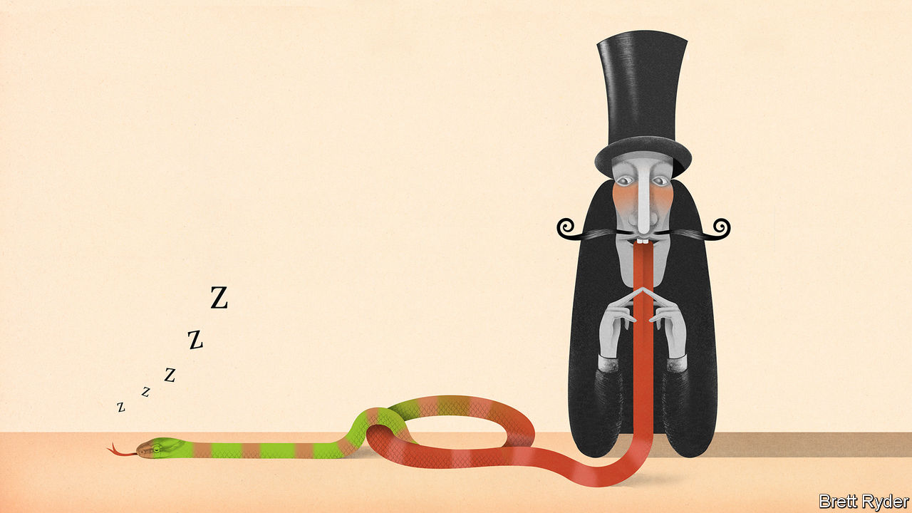

Editor’s note: The Economist is making some of its most important coverage of the covid-19 pandemic freely available to readers of The Economist Today, our daily newsletter. To receive it, register [here](https://www.economist.com/newslettersignup). For our coronavirus tracker and more coverage, see our [hub](https://www.economist.com/coronavirus)

IF THE MERGER of Hewlett-Packard (HP) and Compaq Computer in 2002 was “a slow-motion collision of two garbage trucks”, Xerox’s $33bn unsolicited bid for HP this winter was more like two garbage trucks in a high-rev demolition derby. Both companies’ best days are long gone. Their original businesses, copying and printing, have been heading for the waste-paper bin. And HP was more than three times the size of Xerox, which therefore needed a huge pile of debt to finance the transaction. The hostile approach looked more like an act of desperation than of strategic thinking.

Egging them on from the sidelines was Carl Icahn, an 84-year-old activist investor who held stakes in both firms and initially reaped big rewards in the first quarter as their share prices rose. As a brilliant strategist, but with a tongue like a viper, he is an almost Dickensian caricature of the win-at-all-costs renegade. According to Mark Stevens, his biographer, he thinks some chief executives are “morons”, surviving because of a “reverse Darwinism”. He plunders corporate balance-sheets in order to return cash to shareholders, making sure he is the biggest beneficiary. He appears comfortable with his venomous reputation. “If you want a friend on Wall Street, get a dog” is one of his aphorisms.

On March 31st the unexpected happened. Xerox withdrew its bid, blaming the economic and financial disruption caused by the covid-19 crisis. Mr Icahn’s investments plummeted in value. The man himself has gone uncharacteristically quiet. So have many other activist investors. Insiders say activism has not been so subdued since the financial crisis of 2007-09.

It is predictable that the world’s business elite will cheer the retreat of boardroom scourges like Mr Icahn. With the covid-19 crisis causing economic misery and massive job losses, survival is the focus of most firms. Yet bosses should not be complacent. The activists will be back—and so should they be. As the pandemic eases, businesses will need more investor scrutiny than ever.

Corporate raiders have plenty of reasons to bide their time. Though hardly paragons of compassionate capitalism, they may fear a reputational hit if they are perceived as greedy while workers are being laid off. They may struggle to value their targets accurately, given the collapse in revenues. Their funds may face crisis-induced redemptions from investors, distracting their attention. Whatever the causes, some of the most prolific are settling with their adversaries rather than stepping up aggressions. A few days before the suspension of the Xerox-HP battle Mr Icahn gave up his fight reportedly aimed at removing the board of Occidental Petroleum, which he blames for approving a value-busting deal with Anadarko, a rival oil firm (he won the right to designate three directors instead). The same month Elliott Management cited market turmoil as the reason for ending its long resistance in France to the takeover by Capgemini, a consultancy, of its smaller rival Altran, in which it held shares. Activist Insight, a data gatherer, says the number of companies targeted by activists globally in the first quarter fell by 25% compared with the same period last year. It is expected to plummet further in coming months.

To be sure, some activist strategies would be tin-eared in the current climate. It would be foolish, for instance, to force a company to shrink its balance-sheet and return cash to shareholders when companies are desperate to conserve whatever resources they have. Hostile takeovers may be off the table, too. They would be a distraction that companies fighting for survival in the midst of a pandemic do not deserve, even if they would benefit from a friendly approach. Proxy campaigns to replace board members in this year’s annual general meetings (AGMs) also have their drawbacks: they are expensive; many AGMs will be held virtually because of social distancing; and shareholders have more pressing questions for executives than bickering over board membership. Activists will struggle to make their voices heard.

## Corporate antivenin

Sensing a shift in mood, companies are strengthening their anti-activist defences. “Poison pills”—rights plans in which newly issued shares are offered to shareholders in order to dilute the stake of a dominant one after it surpasses a certain level—are surging. Some call them “anti-coronavirus pills”. Activist Insight counts 17 new ones in America in March alone, just one fewer than in the whole of 2019. Normally, large investors oppose such corporate sleights of hand, arguing that they can be used to shield managers from accountability to a company’s owners. But even ISS, one of the two big firms that advises shareholders how to vote in proxy contests, has softened its criticism. Provided that poison pills last less than a year and are justified by a sharp fall in a company’s share price, ISS says, they should be judged on a case-by-case basis. Anti-activist lawyers are encouraging clients to have a poison-pill strategy “on the shelf and ready to go”, as one puts it.

Such measures—and the trying circumstances—may deter activists for the time being. But not for ever. As lawyers at Schulte, Roth & Zabel, a pro-activist firm, note, some of them may be using the lull to build up their war chests. The market turmoil will expose those management teams whose poor performance has been disguised by a booming stockmarket. Activists may not have to wait long before opportunities arise.

Companies’ defensive manoeuvres may also come back to haunt them. Inevitably, some of Mr Icahn’s morons will have used the crisis to entrench themselves and avoid scrutiny, making them targets of attack once things get back to something akin to normal. Moreover, an easing of the pandemic is likely to lead to a surge in takeovers, as the strong gobble up the weak and government cash washes through the corporate world. In such circumstances, it will be all the more important for activists to hold executives to account. Without them cronyism and corporate sprawl could run rampant in the post-coronavirus world. ■

Dig deeper:  
For our latest coverage of the covid-19 pandemic, register for The Economist Today, our daily [newsletter](https://www.economist.com/newslettersignup), or visit our [coronavirus tracker and story hub](https://www.economist.com/coronavirus)

This article was downloaded by calibre from <https://www.economist.com/business/2020/04/18/activist-investors-have-gone-quiet-during-the-pandemic>

|  |  |  |  |
| --- | --- | --- | --- |
| Previous | Articles | Sections | Next |

|  |  |  |  |
| --- | --- | --- | --- |
| Previous | Articles | Sections | Next |

#### The world after covid-19

# By invitation: Mark Carney on how the economy must yield to human values

In recent years, the market economy has become the market society. The virus could reverse that trend

Apr 16th 2020 |

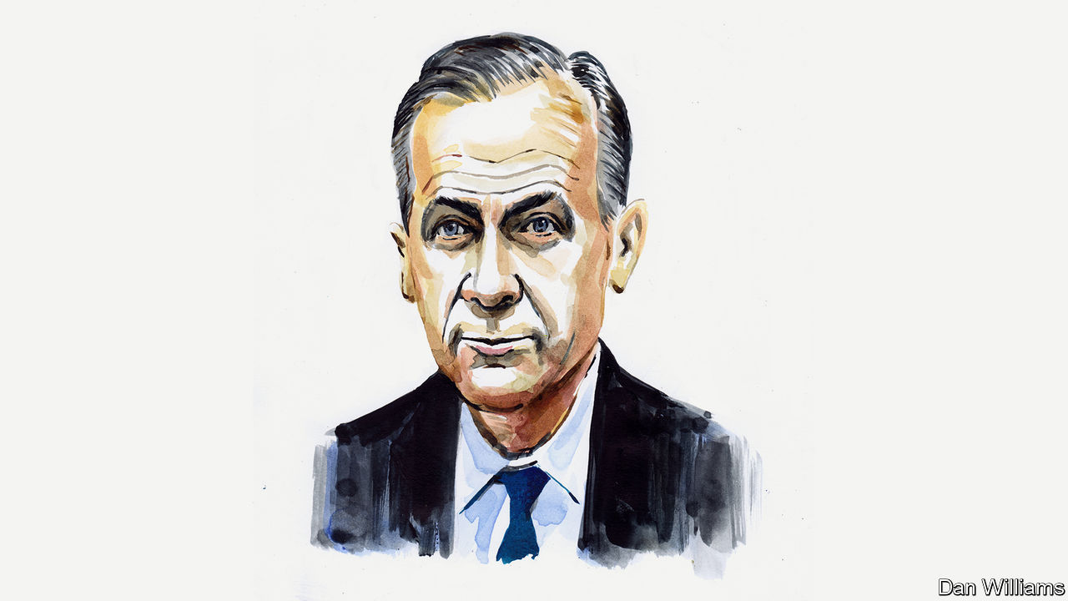

Editor’s note: The Economist is making some of its most important coverage of the covid-19 pandemic freely available to readers of The Economist Today, our daily newsletter. To receive it, register [here](https://www.economist.com/newslettersignup). For our coronavirus tracker and more coverage, see our [hub](https://www.economist.com/coronavirus)

VALUE WILL change in the post-covid world. On one level, that’s obvious: valuations in global financial markets have imploded, with many suffering their sharpest declines in decades. More fundamentally, the traditional drivers of value have been shaken, new ones will gain prominence, and there’s a possibility that the gulf between what markets value and what people value will close.

Current financial-market valuations reflect profound uncertainty over the path of the virus and the length of time that the global economy will remain shuttered. How many quarters of earnings will be lost? How quick will the recovery be once it comes?

Deeper concerns include the extent to which economies are experiencing supply destruction not mere disruption. How many once-viable companies will be permanently impaired? And how many people will lose their job and their attachment to the labour force? The answers to these questions—more than the scale of any short-term plunge in GDP—will be the true measures of the effectiveness of the responses of governments, companies and banks.

If these were the only issues, classic value mantras would apply (“when to catch the falling knife” or buying when “there’s blood on the streets”) and attention would turn, as it already has for some, to the very real opportunities the crisis has revealed: in teleworking, e-health, distance learning, and the acceleration across our economies from moving atoms to shifting bits.

As our digital and local lives expand and our physical and global ones contract, this sea change will create and destroy value. Creativity and dynamism will still be highly prized, but new vectors will shape value: economic, financial, psychological and societal. In ascending order, consider:

First, the crisis is likely to accelerate the fragmentation of the global economy. Until a vaccine has been found and widely applied, travel restrictions will remain. Even afterwards, local resilience will be prized over global efficiency.

Second, much of the enterprise value of companies will be taken up by extraordinary financial support and destroyed by lost cashflow. Their higher debt will increase the riskiness of the underlying equity and weigh on the capacity for growth.

The financial relationship between the state and the private sector has already deepened dramatically. What will the exit look like and how long will it take? Will the state remain enmeshed in commerce, and so restrain private dynamism?

Third, the searing experience of the simultaneous health and economic crises will change how companies balance risk and resilience. We are entering a world in which firms will be expected to prepare for black swans by valuing anti-fragility, as the writer Nassim Nicholas Taleb called them, and planning for catastrophe. The financial sector learned these lessons the hard way during the global financial crisis, which is why banks still have enough capital to be part of the solution. Which companies will operate with minimal liquidity, stretched supply chains and token contingency plans? Which governments will rely on global markets to address local crises?

Fourth, people’s economic narratives will change. After decades of risk being downloaded onto individuals, the bill has arrived, and people do not know how to pay it. Entire populations are experiencing the fears of the unemployed and sensing the anxiety that comes with inadequate or inaccessible health care. These lessons will not soon be forgotten. They will have lasting consequences for sectors that rely on aggressive borrowing by households, a booming housing market and a vibrant gig economy.

This points to a final, deeper issue. As the philosopher Michael Sandel has argued, in recent decades, subtly but relentlessly, we have been moving from a market economy to a market society. Increasingly, to be valued, an asset or activity has to be in a market. For example, Amazon is one of the world’s most valuable companies, yet the Amazon region appears on no ledger until it is stripped of its foliage, and converted to farmland. The price of everything is becoming the value of everything.

This crisis could help reverse that relationship, so that public values help shape private value. When pushed, societies have prioritised health first and foremost, and then looked to deal with the economic consequences. In this crisis, we know we need to act as an interdependent community not independent individuals, so the values of economic dynamism and efficiency have been joined by those of solidarity, fairness, responsibility and compassion.

All this amounts to a test of stakeholder capitalism. When it’s over, companies will be judged by “what they did during the war”, how they treated their employees, suppliers and customers, by who shared and who hoarded.

From value to values and back

After the covid crisis, it’s reasonable to expect people to demand improvements in the quality and coverage of social support and medical care, greater attention to be paid to managing tail risks, and more heed to be given to the advice of scientific experts.

The great test of whether this new hierarchy of values will prevail is climate change. After all, climate change is an issue that (i) involves the entire world, from which no one will be able to self-isolate; (ii) is predicted by science to be the central risk tomorrow; and (iii) we can only address if we act in advance and in solidarity.

Many have compared the covid crisis to armed conflict. After the first world war was won, the rallying cry was to make Britain “a fit country for heroes to live in”. Once this war against an invisible enemy is over, our ambitions should be bolder—nothing less than to make “a fit planet for our grandchildren to live on”. ■

Mark Carney was governor of the Bank of England. This is part of a series from outside contributors on the world after covid-19. More articles can be found at [Economist.com/coronavirus](https://www.economist.com/coronavirus)

Dig deeper:  
For our latest coverage of the covid-19 pandemic, register for The Economist Today, our daily [newsletter](https://www.economist.com/newslettersignup), or visit our [coronavirus tracker and story hub](https://www.economist.com/coronavirus)

This article was downloaded by calibre from <https://www.economist.com/business/2020/04/16/by-invitation-mark-carney-on-how-the-economy-must-yield-to-human-values>

|  |  |  |  |
| --- | --- | --- | --- |
| Previous | Articles | Sections | Next |

|  |  |  |
| --- | --- | --- |
| Business | Sections | Science and ... |

Finance and economics

The recession in rich countries: Picking off the weak

.

Earnings on Wall Street: Dispatch from the front

.

China’s economy: Fighting with shadows

.

Finance and geopolitics: Bucking the trend

.

Buttonwood: A shrewd counterweight

.

Free exchange: The cost of living

.

|  |  |  |
| --- | --- | --- |
| Business | Sections | Science and ... |

|  |  |  |  |
| --- | --- | --- | --- |
|  | Articles | Sections | Next |

#### Picking off the weak

# How deep will downturns in rich countries be?

Those in central and southern Europe seem most vulnerable

Apr 16th 2020 |

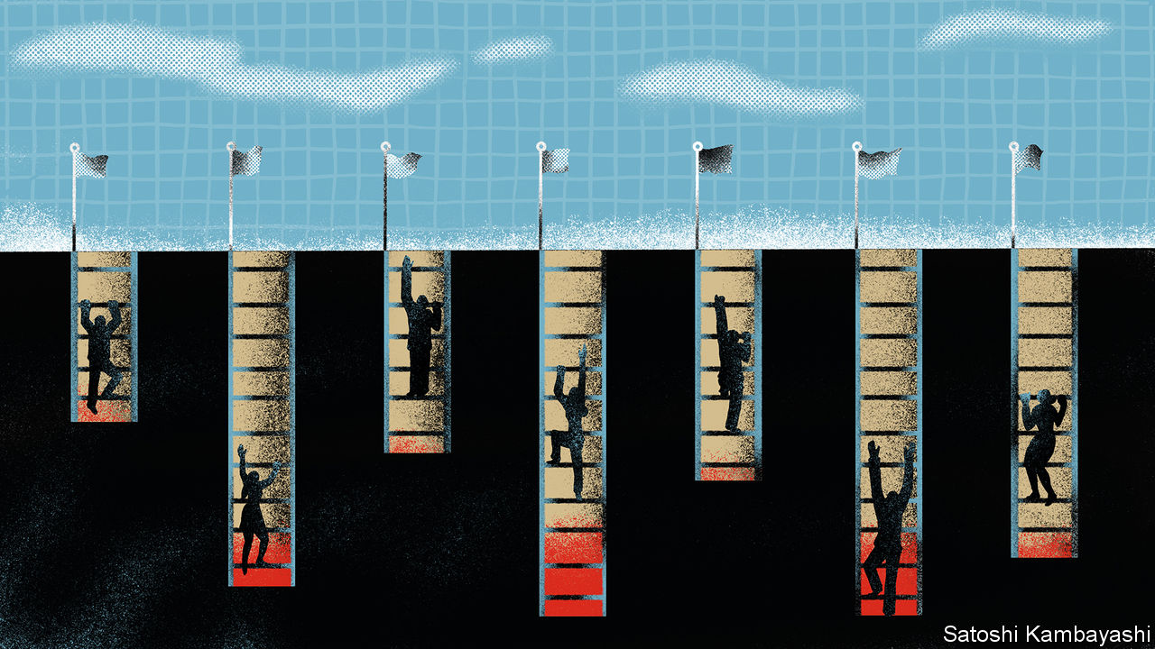

Editor’s note: The Economist is making some of its most important coverage of the covid-19 pandemic freely available to readers of The Economist Today, our daily newsletter. To receive it, register [here](https://www.economist.com/newslettersignup). For our coronavirus tracker and more coverage, see our [hub](https://www.economist.com/coronavirus)

AS THE VIRUS upends productive activity across the world, the question now is how bad things will get. On April 14th the IMF warned that the global recession would be the deepest for the best part of a century. But the severity of the pandemic and the uncertainty around the duration of lockdowns are such that economists’ models, trained on business cycles in the post-war era, are of little use. Some companies, such as Starbucks and Dell, have pulled their guidance on annual earnings, declining even to hazard a guess about the future. Amid the fog, however, one thing seems certain: some economies will suffer much more than others.

Economic crises expose and exacerbate structural weaknesses. Analysis by The Economist of five decades of GDP data finds that growth rates in rich countries tend to converge during expansions, as even the weakest economies are pulled along. Yet during downturns performance diverges markedly. In the first half of the 2000s the average annual gap between the GDP growth rates of the best- and worst-performing rich countries was five percentage points. In 2008-12, in the recession that followed the global financial crisis, the gap widened to ten points.

This recession will be no different. Three factors should help separate the bad economic outcomes from the dire ones: a country’s industrial structure; the composition of its corporate sector; and the effectiveness of its fiscal stimulus. The Economist has used indicators of these to rank, roughly, the exposure of 33 rich countries to the downturn. Some, such as those in southern Europe, appear far more vulnerable than America and northern European countries (see chart).

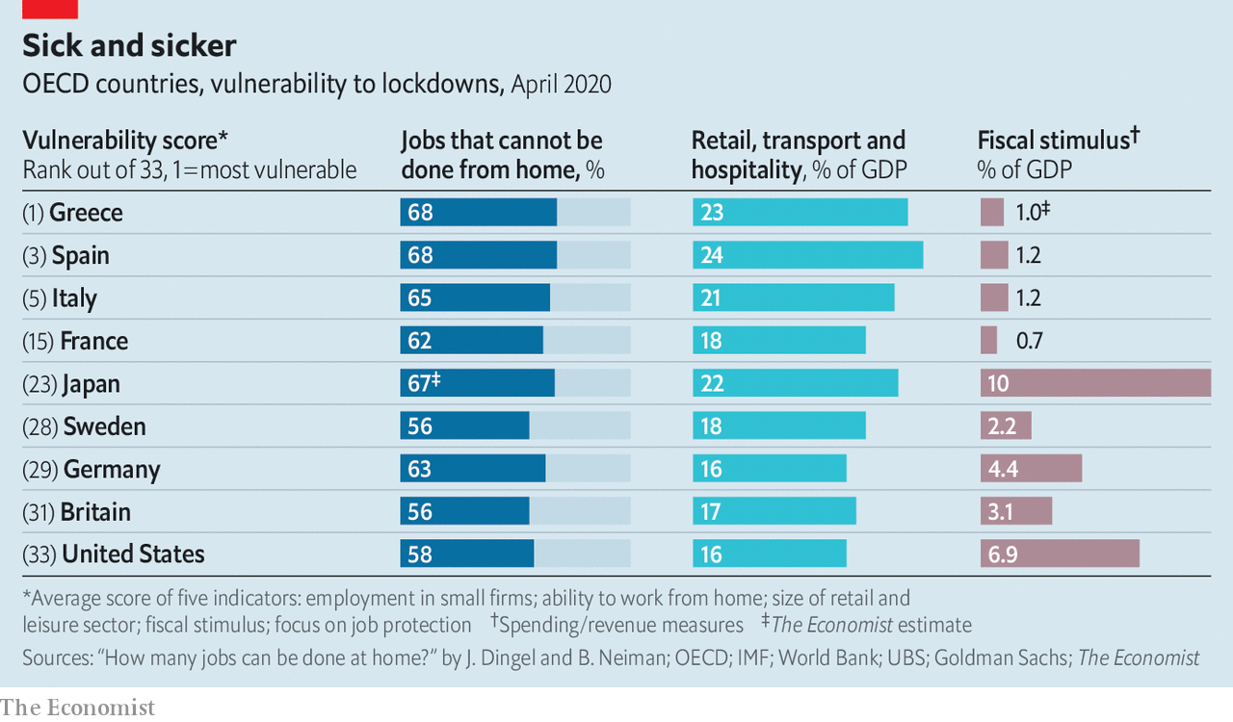

Take industrial structure first. Lockdowns will slam countries that depend on labour-intensive activities. Those with large construction sectors, such as many central European countries, look vulnerable. So do those that rely on tourism—it accounts for one in eight non-financial jobs in southern Europe. Conversely, those with large mining industries, which require less labour, may do better. Here Canada looks relatively insulated.

Industrial structure also influences the share of people who can work from home, and thus dodge the worst disruption of the lockdowns. In a paper published on April 10th Jonathan Dingel and Brent Neiman of the University of Chicago estimate that fully 45% of jobs in Switzerland could plausibly be done from home. Many Swiss work in industries, such as finance, where all they really need to do their job is a laptop. Others elsewhere do not have this luxury. Less than a third of jobs in Slovakia, a big manufacturing hub, can be performed remotely; home working is also difficult in southern Europe. Research by Indeed, a job-search website, and Ireland’s central bank finds that since the pandemic began, countries where home working is less prevalent have seen bigger falls in the number of online job advertisements.

The shape of the corporate sector is the second consideration. Economies with a large share of small firms are more likely to be scarred by long shutdowns. Minnows tend to have few if any cash buffers, making it hard for them to survive a drought in revenues. A survey by researchers at the University of Chicago, Harvard University and the University of Illinois finds that a quarter of small firms in America do not have enough cash on hand to last even a month. Nearly half of Italians and Australians work for firms with fewer than ten employees, compared with a fifth in Britain and an even lower share in America.

A third determinant of the economic pain to come is the nature of fiscal support. Rich countries have deployed stimulus on an unprecedented scale. Even by the most conservative estimate, these packages are more than twice as large as in 2008-09. But the size of the stimulus varies widely across countries. Most tallies find that support in America and Japan is the most generous, as a share of GDP; investors, who see their assets as a haven, are happy to provide the necessary funding. Yet some euro-area governments with high debt levels are more cautious, perhaps constrained by the fear that, as members of a currency union, they enjoy only a partial backstop from the central bank. The average fiscal boost in France, Spain and Italy, as a share of GDP, is about half of that provided in Germany.

The design of the stimulus, though, matters as much as its size. Broadly speaking, rich countries have taken one of two approaches to preserving living standards. Some are concentrating on supplementing household incomes. America is sending cheques to families and making unemployment benefits far more generous; Japan is offering handouts to the needy. By contrast, policy in northern Europe and Australia aims mostly to maintain employment by subsidising wages.

Government pledges to protect jobs are normally a bad idea. They prevent workers moving from failing sectors to up-and-coming ones, slowing the recovery. The coronavirus recession may be different, however. If the lockdowns are lifted soon, some European economies will be able to resume production quickly. Elsewhere workers will have to search for jobs, and bosses to hire them. Some American workers will even do better to stay on benefits than find work; according to Noah Williams of the University of Wisconsin-Madison, benefits in six states could exceed 130% of the average wage. That will mean it takes longer for GDP to recover its pre-pandemic level once the lockdowns lift. Instead of leading to a painful few months, the damage could be much longer-lasting. ■

Dig deeper:  
For our latest coverage of the covid-19 pandemic, register for The Economist Today, our daily [newsletter](https://www.economist.com/newslettersignup), or visit our [coronavirus tracker and story hub](https://www.economist.com/coronavirus)

This article was downloaded by calibre from <https://www.economist.com/finance-and-economics/2020/04/16/how-deep-will-downturns-in-rich-countries-be>

|  |  |  |  |
| --- | --- | --- | --- |
|  | Articles | Sections | Next |

|  |  |  |  |
| --- | --- | --- | --- |
| Previous | Articles | Sections | Next |

#### Dispatch from the front

# Wall Street prepares for a wave of loan losses

Banks’ first-quarter earnings reveal how customers are coping with the pandemic

Apr 18th 2020 | NEW YORK

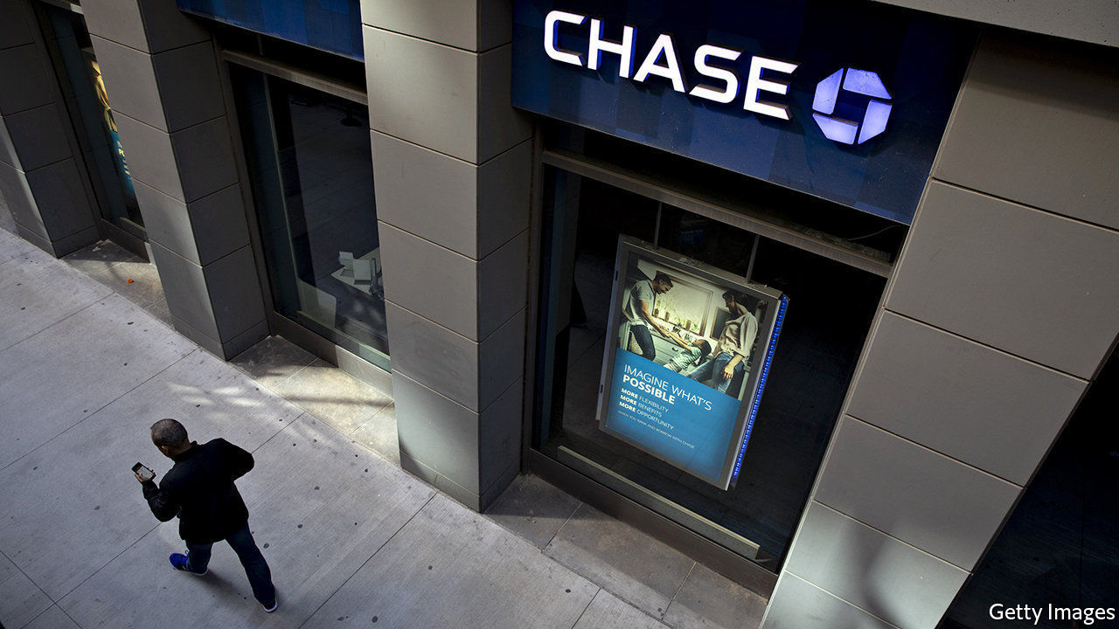

Editor’s note: The Economist is making some of its most important coverage of the covid-19 pandemic freely available to readers of The Economist Today, our daily newsletter. To receive it, register [here](https://www.economist.com/newslettersignup). For our coronavirus tracker and more coverage, see our [hub](https://www.economist.com/coronavirus)

IF DOCTORS AND nurses are on the front-line of the health crisis caused by the pandemic, then bankers are on the front-line of the economic response. Investors dumping stocks have stuffed the money into bank deposits. Cash-strapped businesses are drawing down credit lines. Laid-off workers are delaying mortgage payments. And governments are stepping in to dole out cash to firms in need, using the banks as their delivery system.

So when American lenders reported their first-quarter earnings on April 14th and 15th, the results revealed how customers are coping with the pandemic. JPMorgan Chase, the country’s largest bank, said that credit-card transaction volumes at supermarkets in March were twice those in March 2019. Bank of America reported that a sixth of its small-business customers have deferred loan payments.

Banks’ balance-sheets have swollen as they have issued loans to firms, creating new deposits. Loans outstanding at JPMorgan, Bank of America, Citigroup, Goldman Sachs and Wells Fargo grew from $3.8trn to $4.0trn between the end of last year and March 31st. (America’s other big beast, Morgan Stanley, was due to report results as The Economist went to press.) A torrent of trading in financial markets pushed transaction volumes to new highs. As a result, trading revenues were up by 32% at JPMorgan and 28% at Goldman Sachs, compared with the same period in 2019.

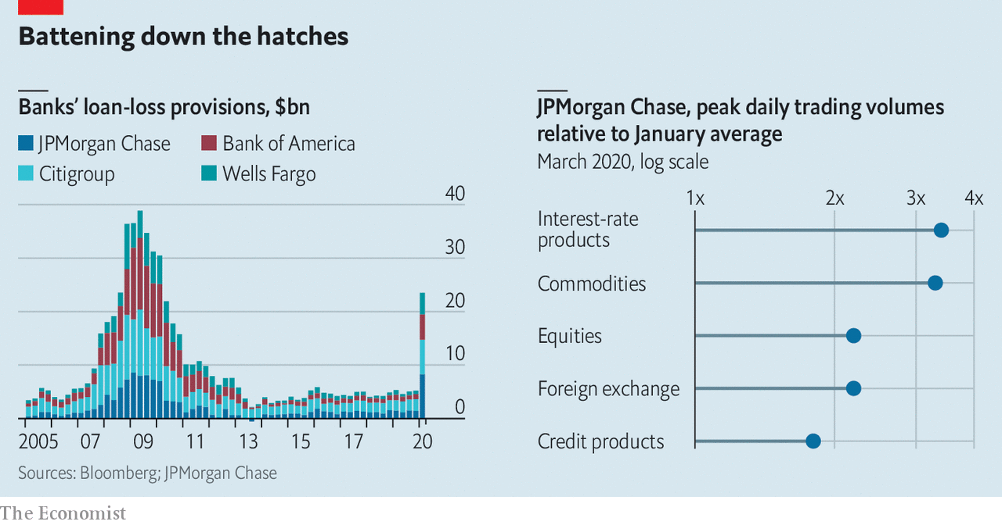

But the worst is yet to come. The frenetic pace of trading activity is unlikely to last. Lower interest rates will eat into interest margins. And banks are bracing for loan losses. America’s four large lenders booked $24.1bn in provisions for credit losses, an increase of $18.7bn compared with the first quarter of 2019. That dragged down profits: the same banks reported a total of $10.1bn in net earnings in the first quarter, down from $27.1bn in the same period a year ago.

The question is how much more the banks need to set aside. Provisions in the first quarter amounted to around 0.6% of their loan portfolios. In their calls with investors bank executives across Wall Street were asked whether provisions would have to climb further in the second quarter. Most point to the 2007-09 global financial crisis, or the scenarios they must model under the Federal Reserve’s annual stress tests, as possible worst cases. These would mean JPMorgan, which booked an extra $6.9bn in credit provisions in the first quarter, could end up bearing loan losses of up to $45bn.

Bank bosses suggested that the bill for loan losses would grow, but they also admitted they did not know by how much. “There are no models that have dealt with GDP down 40% and unemployment growing this rapidly,” noted Jamie Dimon, JPMorgan’s boss. Nor have banks had to deal with the type and scale of government intervention being undertaken. As with health care, the pandemic has dropped lenders into uncharted territory.■

Dig deeper:  
For our latest coverage of the covid-19 pandemic, register for The Economist Today, our daily [newsletter](https://www.economist.com/newslettersignup), or visit our [coronavirus tracker and story hub](https://www.economist.com/coronavirus)

This article was downloaded by calibre from <https://www.economist.com/finance-and-economics/2020/04/18/wall-street-prepares-for-a-wave-of-loan-losses>

|  |  |  |  |
| --- | --- | --- | --- |
| Previous | Articles | Sections | Next |

|  |  |  |  |
| --- | --- | --- | --- |
| Previous | Articles | Sections | Next |

#### Fighting with shadows

# Why has China’s stimulus been so stingy?

The lingering threat of covid-19 forestalls a bigger stimulus

Apr 16th 2020 | NANJING

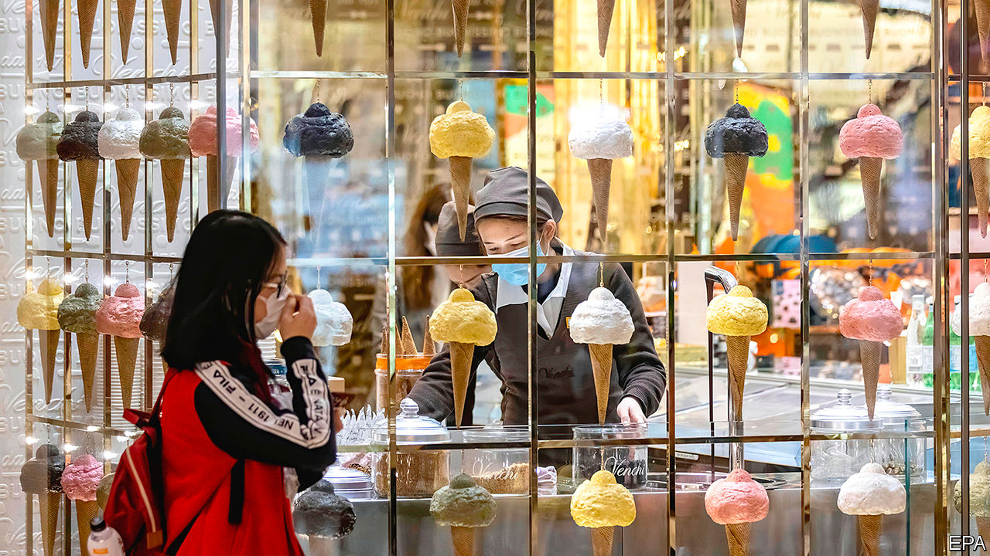

Editor’s note: The Economist is making some of its most important coverage of the covid-19 pandemic freely available to readers of The Economist Today, our daily newsletter. To receive it, register [here](https://www.economist.com/newslettersignup). For our coronavirus tracker and more coverage, see our [hub](https://www.economist.com/coronavirus)

GOLDEN EAGLE WORLD is a glistening monument to commerce, a nine-storey mall with endless stores and restaurants, virtual-reality arcades and spas, even a zoo. But it is now trying something more basic, setting up food stalls outside to drum up business. Although China is back to work, customers have been slow to return. The giant mall in the eastern city of Nanjing has used giveaways and promotions, all to limited effect. “We’ve got to be prepared for a protracted war,” says one of its executives.

Most in China would recognise the term “protracted war”. It is a reference to Mao’s strategy for fighting Japan’s invading army in the 1930s: be patient and, little by little, wear the enemy down. It also happens to be a good description for the government’s approach to bringing the economy back from the coronavirus shutdown. It is shaping up to be a long, grinding battle, not a rapid victory.

Growth in the first quarter compared with the prior year, reported after The Economist went to press, was expected to be negative—China’s first official contraction in more than four decades. In the past this would have guaranteed a big stimulus. Yet this time its response has been more restrained. Other countries have announced huge spending packages. Why has China been so stingy?

There are two critical things to note. First, appearances are somewhat deceptive; a closer look reveals similarities between China’s economic policy response and those of other countries. Second, China would like to do more, but the lingering covid-19 threat is holding it back.

Start with the obvious contrasts between China’s actions and those of other governments. Japan’s fiscal stimulus, for instance, is around 10% of its GDP, and rises to twice that when loans and loan guarantees are included. China, meanwhile, has made no special announcement, instead rolling out a hodgepodge of policies that, added up, reach perhaps 3% of its GDP.

Many governments are using new tools to help struggling businesses. Corporate bail-outs have been a core element. America has earmarked $850bn for loans to companies. Britain set aside £330bn ($412bn) for loan guarantees. China, by comparison, does not need such fiscal parachutes. They are built into the system: as much as 80% of corporate loans go to state firms and hence already enjoy implicit guarantees.

China, without any fanfare, is in fact leaning on state-owned banks. The total amount of new credit issued last month was equivalent to 5% of last year’s GDP—the highest for any month since 2010, the tail-end of a giant stimulus. Arrangements are often discreet. The Golden Eagle executive says that in late February a group of bankers came to the mall to determine which tenants they could prop up.

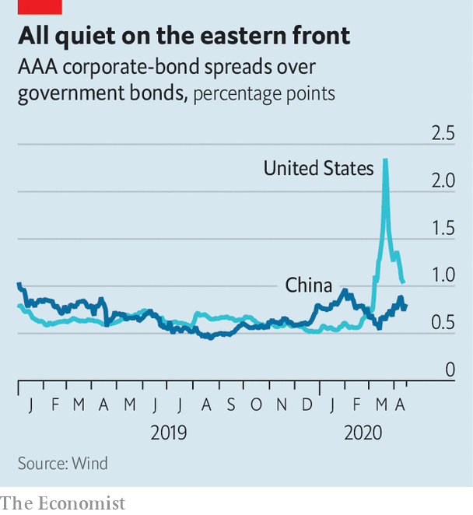

With such backstops in place, the financial fallout from the outbreak has been limited so far. The peak-to-trough drop in China’s stockmarket was 16%, less than half of America’s plunge. Credit spreads exploded in Western bond markets; in China they have barely widened (see chart). Defaults have been rare. In the past two months just four companies missed bond payments in China for the first time, less than half as many as during the same period last year. “In the bad times you see more advantages of the system,” says Yu Yongding, a former adviser to China’s central bank.

But make no mistake. This is still a major departure from China’s customary largesse. A typical stimulus policy—variations of which were seen in 2009, 2012 and 2016—would involve some combination of a surge in infrastructure spending, incentives to spur consumption, and loosened restrictions on the property market. All have been conspicuously absent so far.

In part this reflects a newfound prudence. Given China’s heavy debt load, economic authorities have fought to rein in leverage and snuff out financial risks over the past few years. They are loth to see their progress undone. But there is also a more important reason for restraint. Many economists in China have come to the conclusion that it is simply too soon for an all-out push to revive growth.

Peng Wensheng, chief economist with Everbright Securities, a brokerage, wrote in a recent essay that the unknowns of covid-19 mean that policy is sure to be wrong. If the government is overly optimistic about the pandemic, it will stoke the economy too soon, forcing it to backtrack. If overly pessimistic, it will wait too long to ease curbs, requiring more stimulus later on. The risks, he concluded, were asymmetric: it would be far better to defer the rebound than to reimpose lockdowns. Mr Yu puts it more bluntly. “Until the pandemic is under control, the main objective is survival,” he says. Zhong Zhengsheng, chief economist of CEBM, an advisory firm, adds that stimulus will be more effective when global supply chains are up and running—an argument that no country, not even one as big as China, can get too far ahead of the rest of the world.

In practice China’s economy is undergoing a daily stress test. The authorities are letting more activity resume, probing the limits of what is safe and how comfortable people feel. At Golden Eagle World, managers had hoped for a full recovery by now. Instead, business is still as much as 20% below normal, a gloomy portent for the economy. Such are the uncertainties that China’s leaders have not yet declared an economic-growth target for this year, a figure that normally serves as a lodestar for officials up and down the country.

The uncertainty touches even basic matters, such as whether to eat in restaurants. Last month Nanjing launched a campaign to encourage residents to leave their homes, handing out 318m yuan ($45m) in shopping vouchers. But signs around the city still admonish people to avoid crowds and stay in well-ventilated spaces. The pandemic descended on China and the world suddenly—but its shadow will take much longer to disappear. ■

Dig deeper:  
For our latest coverage of the covid-19 pandemic, register for The Economist Today, our daily [newsletter](https://www.economist.com/newslettersignup), or visit our [coronavirus tracker and story hub](https://www.economist.com/coronavirus)

This article was downloaded by calibre from <https://www.economist.com/finance-and-economics/2020/04/16/why-has-chinas-stimulus-been-so-stingy>

|  |  |  |  |
| --- | --- | --- | --- |
| Previous | Articles | Sections | Next |

|  |  |  |  |
| --- | --- | --- | --- |
| Previous | Articles | Sections | Next |

#### Bucking the trend

# The dollar’s dominance masks China’s rise in finance

The pandemic is a fillip for China’s currency and fintech firms

Apr 16th 2020 | HONG KONG AND NEW YORK

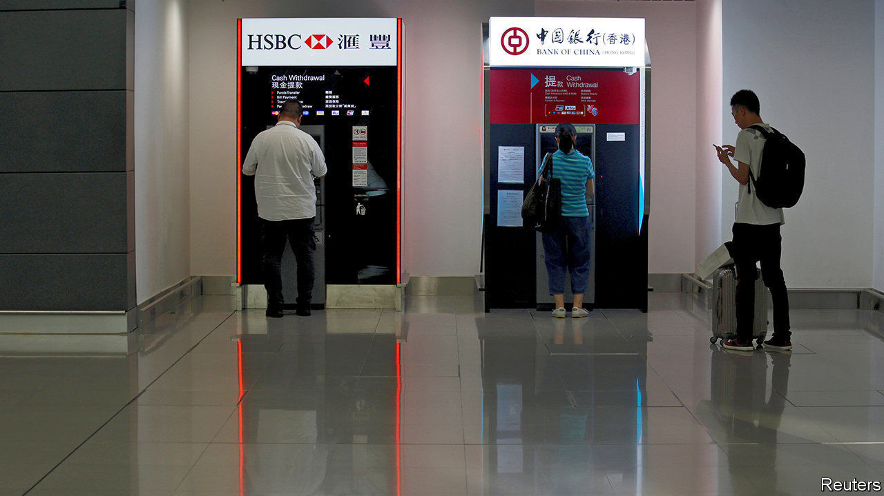

Editor’s note: The Economist is making some of its most important coverage of the covid-19 pandemic freely available to readers of The Economist Today, our daily newsletter. To receive it, register [here](https://www.economist.com/newslettersignup). For our coronavirus tracker and more coverage, see our [hub](https://www.economist.com/coronavirus)

IN HONG KONG’s deserted airport, two cash machines face each other. One is run by HSBC, a British bank that is one of the territory’s main conduits for accessing American dollars. The other, operated by the Bank of China, dispenses Hong Kong dollars and Chinese yuan. Flashing in the eerie, pandemic-induced silence, they are a metaphor for China’s discreet quest for financial influence.

The dollar is still the king of currencies. It underpins four-fifths of global supply chains and around two-thirds of securities issuance and foreign-exchange reserves. Though China is the world’s second-largest economy, its financial clout lags far behind that of America. But it wants to catch up, and the pandemic could speed its progress.

At first blush, last month’s global rush for dollars might suggest otherwise. The outbreak of covid-19 presaged widespread lockdowns and an intense liquidity crunch. Spooked, investors sold whatever they held. Dollars became highly sought after. Australia’s currency hit its lowest level against the greenback since 2002. The Indian rupee fell to a record low. Even the Japanese yen and Swiss franc, usually havens, tumbled.

Funding markets also hinted at a serious dollar shortage. The three-month “cross-currency basis” swap rate, which tracks the premium traders pay to temporarily exchange euros for dollars, reached its highest point since 2011. The cost of borrowing greenbacks in the interbank market soared. Alarmingly, the value of American Treasury bills started falling, suggesting investors were selling their safest assets to free up cash.

The problem was that covid-19 boosted dollar demand while choking off supply. Trade stalled, leading firms to draw down credit lines. Investors dumped emerging-market assets, causing a record $100bn in portfolio outflows. Redemption requests prevented money-market funds from filling the gap. All this made dollars more expensive. Emerging markets, hurt by crashing commodity prices and bulging debt repayment costs, were the hardest hit.

In order to ease the pressure, the Fed set up swap lines for rich-world central banks and those in some emerging markets, which now cover 14 countries. On March 31st it also created a “repurchase” facility, allowing other central banks to temporarily swap their holdings of American Treasuries for dollars, rather than be forced to sell them into an illiquid market. The measures seem to have worked: the euro-dollar basis touched a 12-year low on April 6th.

This “magnanimity” will only heighten dollar dependence, says Eswar Prasad of Cornell University, as central banks amass yet more American bonds as a buffer for the next crunch. But to some that very prospect is a reason to diversify. The Fed’s “repo” facility does not help nations with few reserve assets. America’s rivals fear being denied access. Others may reckon that reliance on a keystone currency could amplify future shocks. And the fortunes of many economies are now more tightly bound to their best trading buddy—China—than to America.

China cannot yet satisfy them. The yuan makes up just 2% of payments and global reserves. But three factors mean that Beijing could emerge from the current crisis with a stronger hand: the increasing allure of China’s government bonds; its role as a creditor; and its technological clout.

Take bonds first. China is winning kudos as a trusted debtor, which props up the yuan. Even as other markets froze, its government-bond market was undisturbed. The gap between prices at which investors want to buy and sell—the “bid-ask” spread—has stayed low, as has volatility. According to an index compiled by JPMorgan Chase, returns on emerging-market bonds fell by 15.5% in the first quarter, but Chinese debt returned 1.3% (see chart). The bond market also recorded 60bn yuan ($8.5bn) in net foreign inflows. “The Chinese market has proven that it is somewhat independent from other global markets,” says Edmund Goh of Aberdeen Standard Investments, an asset manager.

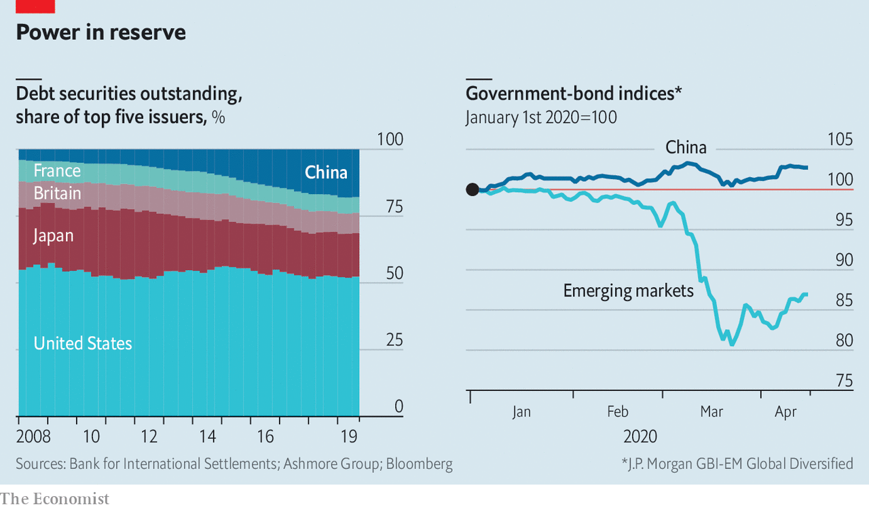

That makes China’s $13trn bond market, the world’s second-largest, a haven among emerging peers. And it is a more lucrative option than rich-world bonds: China’s five-year treasuries yield 2.24%; American ones, 0.35%. As interest rates stay low in the West, that gap will endure. It should help that China’s bonds are being gradually included in two popular indices. Passive—and sticky—money should stream in.

Another factor in China’s rise is its status as a big creditor. As the world recovers from coronavirus, this could yield strategic benefits—and dilemmas. Its apparent willingness to back a G20 deal to suspend bilateral loan repayments by poor countries for the rest of this year—much of which would have gone to China—will help inspire more faith in its credit and, by extension, the yuan. In the private sector, though, it may be more hard-headed. Since 2008 Chinese banks have become some of the world’s largest lessors of planes and ships. As a halt to trade and travel threatens to push lessees into default, lenders seem to be “playing hardball”, says Richard Skipper of DLA Piper, a law firm. A lack of forgiveness now could alienate future borrowers.

A final factor, and perhaps China’s trump card, is technology. Tencent and Ant Financial, which run “digital wallets” with over 1bn users each, are investing in peers across Asia. OneConnect, an offshoot of Ping An, China’s largest insurer, provides cloud-based services that power financial institutions in 16 countries. All should get a boost as covid-19 forces money and staff to migrate online. Some are already talking to bankers about buying upstarts that investors no longer want to bankroll, says Frank Troise of SoHo Capital, an investment firm. China’s growing influence over the profitable plumbing of Asian finance will in time be hard to ignore.

China will need an open capital account and a trusted legal system for the yuan to become a reserve currency. If its resilient bond market and whizzy tech attract big inflows, officials in Beijing could become more confident about relaxing cross-border controls. For the growing number of countries and companies with reason to ditch the dollar, that would make China a more viable alternative. ■

Dig deeper:  
For our latest coverage of the covid-19 pandemic, register for The Economist Today, our daily [newsletter](https://www.economist.com/newslettersignup), or visit our [coronavirus tracker and story hub](https://www.economist.com/coronavirus)

This article was downloaded by calibre from <https://www.economist.com/finance-and-economics/2020/04/16/the-dollars-dominance-masks-chinas-rise-in-finance>

|  |  |  |  |
| --- | --- | --- | --- |
| Previous | Articles | Sections | Next |

|  |  |  |  |
| --- | --- | --- | --- |
| Previous | Articles | Sections | Next |

#### Buttonwood

# The case for emerging-market stocks

The ideal diversifier is something that contrasts with what you own

Apr 18th 2020 |

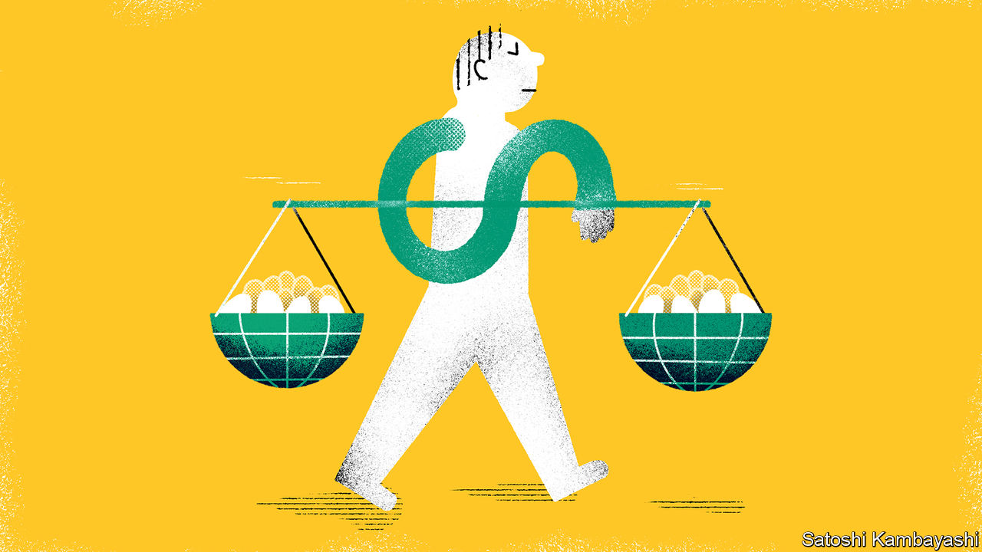

Editor’s note: The Economist is making some of its most important coverage of the covid-19 pandemic freely available to readers of The Economist Today, our daily newsletter. To receive it, register [here](https://www.economist.com/newslettersignup). For our coronavirus tracker and more coverage, see our [hub](https://www.economist.com/coronavirus)

YOU KNOW by now, if you’ve been paying attention, that the coronavirus pandemic is, if not a turning point in history, then the midwife to profound change or, at the very least, an opportunity for a bit of a rethink. Everything has changed—except, perhaps, minds. Those who expected China (or the European Union or shareholder capitalism) to blow up are now more convinced it will. Believers in globalisation’s retreat, or inflation’s comeback, have fewer doubts.

And if you were chary of emerging markets you might be more so now. In March, when there was a mad scramble for cash, the cash everyone wanted was dollars. When the dollar gets bid up, it hurts emerging markets. If inflation returns, meanwhile, it will surely show up first in the developing world.

Yet if these vices seem more apparent, so does the virtue of diversification. The ideal diversifier is not just something other than what you own, but something that contrasts with it. The typical portfolio is rich in dollar assets—in Treasuries and the leading American shares. It needs a counterweight, an anti-dollar trade. A benchmark basket of emerging-market stocks is a good one.

It helps that such stocks are cheap. Valuations based on company earnings are often misleading at the start of recessions. Recent earnings figures flatter the appraisal; forward-looking estimates of profits take time to reflect grim reality. A way around this is to use a measure that takes in company profits over the cycle: the CAPE (cyclically adjusted price-earnings ratio) popularised by Robert Shiller of Yale University. A snapshot taken at recent market lows by James Montier of GMO, an asset-management firm, shows a healthy margin of safety. Emerging-market shares look very cheap relative to both their history and to America’s S&P 500 index of shares.

Rich-world investors must also consider exchange-rate risk. Forecasting currencies is a mug’s game. Even so, a shrewd investor should at least check she is not buying a currency that is obviously riding high, and thus at greater risk of a dramatic fall. A broad analysis by Charles Robertson of Renaissance Capital, an investment bank, finds that after recent declines, emerging-market currencies are as cheap in real terms as they have been since the mid-2000s.

Should inflation pick up faster in the developing world than in the rich one, the reckoning would change. Currencies would then need to fall further in nominal terms to keep the exchange rate steady in real terms, so that exports stay competitive. Emerging-market economies tend to be more inflation-prone than richer ones. Because of that, central banks have generally been vigilant. A weaker currency has been typically met with higher interest rates to counter imported inflation—even if that hurts an already weak economy. But a lot of central banks in the developing world have relaxed monetary policy recently—understandable, given the severity of the economic shock.

For some countries, though, the dangers of inflation are not great. These more closely resemble rich-world economies, where a weak currency leads to a temporary burst of inflation. The wealthier parts of Asia are like this. But in other places inflation sticks around if not stomped upon. That tends to be because wages are indexed to prices; industry is somewhat cartelised; or trust in the currency is low, encouraging the local use of the dollar. Parts of Latin America come to mind. So does Turkey. Indeed the options a country has when its currency falls define its status, says Eric Lonergan of M&G, a fund-management group. If it must raise interest rates to counter inflation, it is an emerging market; if it has the room to cut rates without fear, it is developed.

Definitions matter, of course. Part of the appeal of indices of emerging-market stocks is that they are dominated by Asian economies that are fairly rich and well-run. They count as emerging markets, because the buying and selling of financial assets is not quite frictionless. Taiwan and South Korea together make up a quarter of the MSCI index. China accounts for a further third. All may prove quite resilient as the world emerges from lockdown. At the very least, the way they perform is likely to be different from rich-world economies.

That feature alone should be appealing to a certain kind of investor. If the world is indeed changed radically by this health crisis, it may be in ways that are hard to imagine today. And if you are unsure of the future, it makes all the more sense to spread your bets.

Dig deeper:  
For our latest coverage of the covid-19 pandemic, register for The Economist Today, our daily [newsletter](https://www.economist.com/newslettersignup), or visit our [coronavirus tracker and story hub](https://www.economist.com/coronavirus)

This article was downloaded by calibre from <https://www.economist.com/finance-and-economics/2020/04/18/the-case-for-emerging-market-stocks>

|  |  |  |  |
| --- | --- | --- | --- |
| Previous | Articles | Sections | Next |

|  |  |  |  |
| --- | --- | --- | --- |
| Previous | Articles | Sections | Next |

#### Free exchange

# Covid-19 could lead to the return of inflation—eventually

Once the virus is truly beaten, the crisis could weaken structural forces weighing on demand

Apr 18th 2020 |

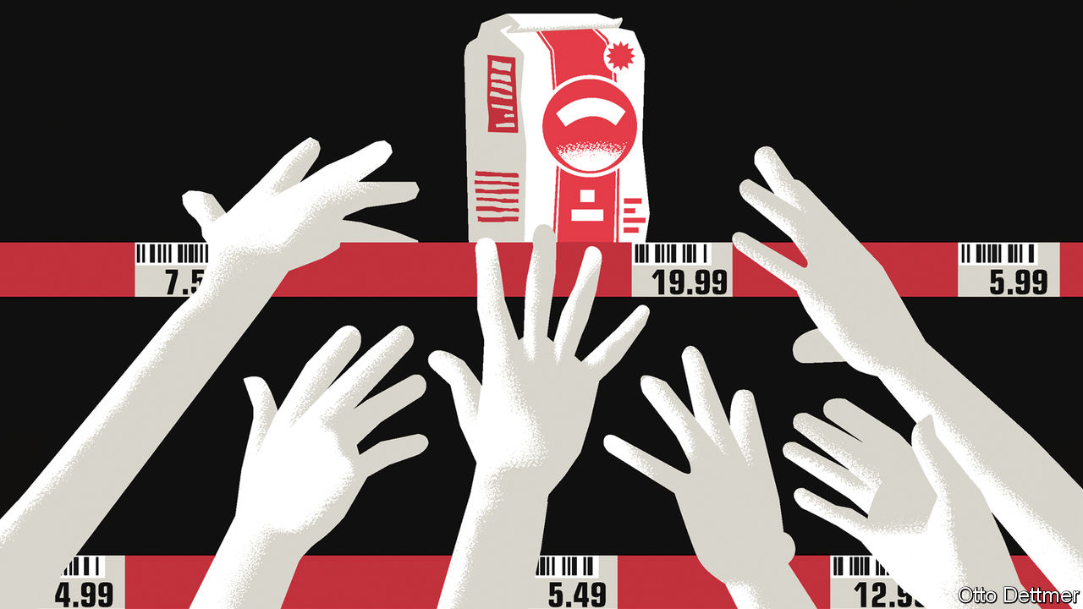

Editor’s note: The Economist is making some of its most important coverage of the covid-19 pandemic freely available to readers of The Economist Today, our daily newsletter. To receive it, register [here](https://www.economist.com/newslettersignup). For our coronavirus tracker and more coverage, see our [hub](https://www.economist.com/coronavirus)

INFLATION IN THE rich world resembles a fairy-tale beast. Older members of society frighten younger ones with stories of the creature’s foul deeds, but few serious people expect to see one and some doubt it ever existed. Although high inflation seemed a fixture of the economic landscape in the 1970s, changes to policy and the structure of the global economy since have ushered in four decades of ever meeker growth in prices. As covid-19 shutters businesses and leaves supermarket shelves bare, some economists fret that the pandemic could lead to inflation making an unwelcome return. Though the future is shrouded in more uncertainty than ever, inflation seems unlikely to rear its head—until, perhaps, the world’s struggle with covid-19 nears its end.

Worries about soaring prices start with the observation that virus-fighting measures choke off production. Crudely put, inflation is the result of too much money chasing too few goods. At present the amount of goods and services available for purchase is tumbling. Many service industries are shut down. The virus is playing havoc with the supply of some products. On April 12th Smithfield Foods, a meat-processing firm, said it would close a plant producing nearly 5% of American pork, after more than 200 workers fell ill; it has since shut down others. Workers involved in the logistics operations for e-commerce platforms, such as Amazon and Instacart, have gone on strike to demand higher pay and safer working conditions. If supply interruptions translate into shortages in shops, then higher prices could follow.

Massive stimulus programmes are another potential source of inflation. Governments around the world are borrowing heavily to finance schemes that support firms and workers. Central banks are flooding economies with newly created money. Over the past month the balance-sheet of the European Central Bank has grown by €550bn ($600bn), or nearly 12%, and that of the Federal Reserve by nearly $2trn, more than 40%. Printing money during the global financial crisis did not spark rapid inflation. Yet its coincidence with a collapse in supply might lead you to expect rocketing prices.

The prices of some goods and services might indeed rise sharply while economies are locked down. Those for some medical equipment in America, for instance, have reportedly risen as state governments compete for scarce supply. But the broad, sustained increases in price levels associated with accelerating inflation are unlikely to materialise in the short run, because lockdowns both interrupt supply and undercut workers’ ability to earn and spend. Closing a restaurant limits food-service supply, but it also means that sacked waiters and kitchen staff have no income. And in some circumstances the drop in demand induced by a supply shock may be larger than the decline in supply—a source of deflationary, rather than inflationary, pressure.

This idea is explored in a new working paper by Veronica Guerrieri of the University of Chicago, Guido Lorenzoni of Northwestern University, Ludwig Straub of Harvard University and Iván Werning of the Massachusetts Institute of Technology. If some sectors of the economy shut down entirely, affected workers will curtail their spending dramatically. Spending by other workers could make up for the shortfall—only if the goods and services that can still be produced are substitutes for those that cannot. The abrupt drop in consumers’ spending on plane tickets or hotel bookings is unlikely to be offset by more purchases of teleworking software instead, for instance. In the absence of good substitutes, say the authors, the economy experiences a “Keynesian supply shock”, where demand falls by more than supply. They provide another useful way to think about this state of the world: that consumption will be much more valuable in the future, as goods and services that cannot be had today become available once more. So it makes sense to spend less now, and more later.

Available figures suggest that fewer goods are indeed being chased by even less spending. In March annual consumer-price inflation slowed in both America and the euro area, compared with rates in February. Much of that reflected tumbling energy costs; but core inflation—which strips out food and energy prices—also decelerated. Financial-market measures of inflation expectations suggest the drop is not a one-off. Expectations for average annual inflation in America over the next decade, as calculated by the Federal Reserve Bank of Cleveland, sank from 1.7% in January to 1.2% in April.

Those expectations could shift as economies reopen. Rehired workers could spend a high share of their incomes; demand from earners whose incomes were unaffected by shutdowns could overwhelm slowly recovering supply. Disinflationary pressures will remain, though. Across rich economies, services account for half or more of the consumption baskets used to calculate consumer-price inflation. For as long as fears of viral contagion linger, many businesses could struggle to attract new custom—and so be forced to offer steep discounts. Technologies adopted during lockdowns could allow companies to serve more customers without hiring many more workers, thus adding more to supply than to demand.

## Hold on for dear life

Inflationary effects are most likely to appear once the virus is truly beaten. The crisis could weaken structural forces weighing on demand. Take inequality, for instance, which concentrates income in the hands of the thrifty rich. More generous post-pandemic safety-nets, or progressive taxes enacted to pay down large government debts, could redirect income towards freer spenders, creating inflationary pressure. So could a change in policymaking attitudes. The economic traumas of the early 21st century may push governments and central banks to prefer high economic growth and low unemployment to low and stable inflation, as happened after the second world war. Inflation is not certain to return after covid-19. But its re-emergence seems less fantastic a possibility. ■

Dig deeper:  
For our latest coverage of the covid-19 pandemic, register for The Economist Today, our daily [newsletter](https://www.economist.com/newslettersignup), or visit our [coronavirus tracker and story hub](https://www.economist.com/coronavirus)

This article was downloaded by calibre from <https://www.economist.com/finance-and-economics/2020/04/18/covid-19-could-lead-to-the-return-of-inflation-eventually>

|  |  |  |  |
| --- | --- | --- | --- |
| Previous | Articles | Sections | Next |

|  |  |  |
| --- | --- | --- |
| Finance and ... | Sections | Books and arts |

Science and technology

Contact-tracing: A global microscope, made of phones

.

Disease transmission: Not so guilty

.

Climate change: Scorched earth

.

Global health: WHO’s in trouble?

.

Solitude and its consequences: Immunity from being alone

.

|  |  |  |
| --- | --- | --- |
| Finance and ... | Sections | Books and arts |

|  |  |  |  |
| --- | --- | --- | --- |
|  | Articles | Sections | Next |

#### Covid-19

# App-based contact tracing may help countries get out of lockdown

But only as part of a bigger system

Apr 16th 2020 |

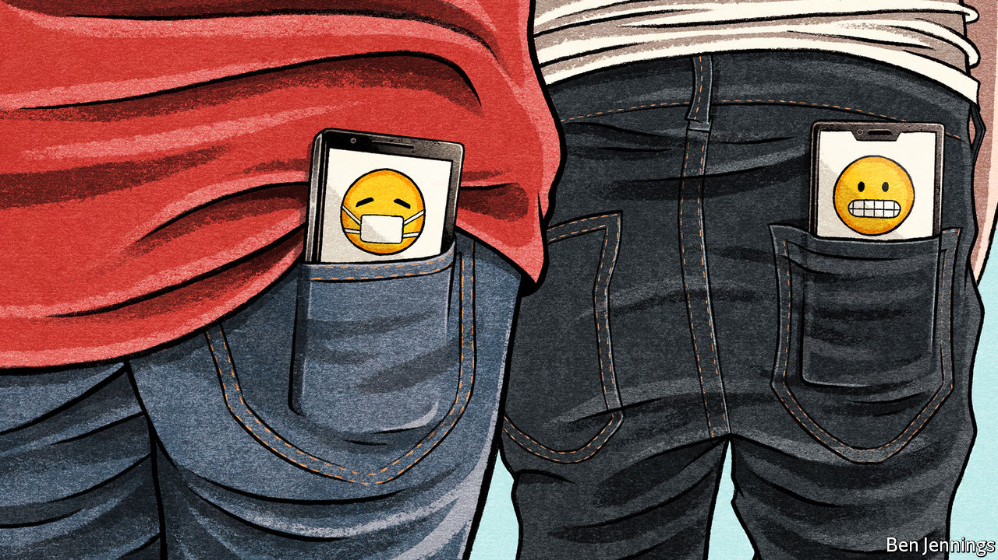

Editor’s note: The Economist is making some of its most important coverage of the covid-19 pandemic freely available to readers of The Economist Today, our daily newsletter. To receive it, register [here](https://www.economist.com/newslettersignup). For our coronavirus tracker and more coverage, see our [hub](https://www.economist.com/coronavirus)

ON APRIL 10TH Apple and Google did something unusual: they announced plans to work together. These two firms exert varying degrees of control over almost every operational smartphone on Earth—Apple through its production of both iPhones and the software that runs them, and Google thanks to a range of programs found in nearly all of the iPhone’s Android-powered rivals. As a result, the two companies have access to a planet-spanning network of sensors and computing power some 3.5bn devices strong. Their plan is to combine their assets to assist the tracking of the covid-19 pandemic.

Normally, collaboration between two such oligopolists would raise eyebrows to the roof. But these are not normal times. Tracing who is infected is essential to controlling the transmission of SARS-CoV-2, the virus causing the pandemic—and the ubiquity of mobile phones makes them plausible agents for doing so. The two firms’ networks will be joined together by a unifying update to their Bluetooth short-range wireless protocols. Bluetooth lets nearby devices communicate. The unification means it will be easier for others to build contact-tracing apps that work, without modification, on either platform.

America, Britain, Germany, Ireland and many other countries were already building apps to track infection. They will now rewrite their software to take advantage of this new arrangement. These apps will work by broadcasting, from each phone they are installed on, a string of numbers and letters unique to that handset. These broadcasts will be detectable by any other phone within Bluetooth range (about nine metres) that has the same app installed. An app will also, simultaneously, listen for strings that other phones are broadcasting. Each phone carrying such an app will record all the character strings it hears, and thus all the phones it has been close to. For reasons of security (and because Apple’s and Google’s underlying cryptographic protocols demand it), the string of characters a phone broadcasts will change every 15 minutes. Also, at least to start with, the records of strings received will be stored only on the receiving phone. That makes hacking or abusing the system hard.

If, however, a phone-user develops symptoms and then tests positive for covid-19, this arrangement changes. Different strings of characters—one for each day that the person in question was potentially infectious—are now broadcast by the authorities to every other app in the network. These strings, which Apple calls diagnosis keys, command all apps so contacted to search records collected since that person’s putative time of infection for signs of proximity to the infected individual’s phone.

## Blessed are the appmakers

What happens when a match is found is up to whoever deployed the app. A good response, though, would be to notify the person of interest, and ask him or her to get in touch and arrange to be tested. This way, infections will be detected quickly, and infected individuals offered suitable advice—and possibly quarantined.

It all sounds like high-tech wizardry. And it is. But it is important not to get carried away. Smartphone contact-tracing is just one part of a broader infrastructure that must be built to track down SARS-CoV-2 faster than it can spread through the population. It will not, for instance, be worth much unless ways of testing and diagnosing people en masse are also rolled out. Without these, there will be no information to feed back into the app network about who may be spreading the virus.

Ideally, such infrastructure will be built around testing stations that people can visit to have their noses and throats swabbed. Countries would in any case be well advised to construct these facilities, even if they do not deploy contact-tracing apps. Indeed, one option for ending the lockdowns many places are experiencing is to be able to test everyone so frequently that the authorities could be sure the virus was not spreading. This would be expensive, though, and deeply unpleasant (think having a Q-tip shoved up your nose once a week for the next two years). Contact-tracing helps to direct testing more precisely at those likely to be infected. Using apps helps speed this up.

But only, though, if phone users are willing to adopt the app. Here, Singapore’s experience is salutary. Its government rolled out a contact-tracing app, TraceTogether, on March 20th. So far, however, this has been downloaded by only a sixth of the country’s population—barely a quarter of the 60% epidemiologists reckon is needed if it is to be effective in breaking the local epidemic. Perhaps the most used contact-tracing app in the world is that deployed by Iceland. Yet Rakning C-19 (“Rakning” is Icelandic for “tracking”) is used by only 40% of the country’s 364,000 people. If such a small, homogenous place cannot reach the required 60% download rate, what hope is there for large, diverse ones like America?

If tracing apps are to be widely adopted, they must make people want to use them, says Ciro Cattuto, an epidemiologist at the University of Turin, in Italy. “People need to feel like they are contributing to a common good,” he observes. “They need to feel empowered.” Maintaining public trust will be crucial. Since any such app will need to be updated as the situation develops, that trust can be maintained only by extreme transparency, Dr Cattuto says. This means no function creep.

It is also important not to invest too much in the idea that automation is everything. Apps and phones can certainly provide location and proximity data, but only human tracers can bring human intelligence to bear on the matter. For example, in late January Taiwan’s contact-tracing team successfully used a mixture of data from the country’s national-health-insurance system and its mobile-phone firms to track down the source of infection for the island’s first covid-19 death—the unlucky taxi driver had picked up a Chinese businessman at the airport. They did this without resort to Bluetooth tracking apps, albeit that their ability to scrutinise the data they needed required the invocation of national-emergency powers.

As well as developing high-tech networks for tracking infection, information-technology firms should therefore also be writing software that improves the productivity of human contact-tracers like Taiwan’s. Interview forms for potential contacts, visualisation dashboards for relevant data, telemedicine for remote diagnostics—all these would be useful. Apps built using Apple’s and Google’s new protocol ought to focus on providing information to technologically empowered human contact-tracing teams, not on automating the whole process. ■

Dig deeper:  
For our latest coverage of the covid-19 pandemic, register for The Economist Today, our daily [newsletter](https://www.economist.com/newslettersignup), or visit our [coronavirus tracker and story hub](https://www.economist.com/coronavirus)

This article was downloaded by calibre from <https://www.economist.com/science-and-technology/2020/04/16/app-based-contact-tracing-may-help-countries-get-out-of-lockdown>

|  |  |  |  |
| --- | --- | --- | --- |
|  | Articles | Sections | Next |

|  |  |  |  |
| --- | --- | --- | --- |
| Previous | Articles | Sections | Next |

#### Disease transmission

# Bats spread viruses

But they are no worse in this respect than other species

Apr 18th 2020 |

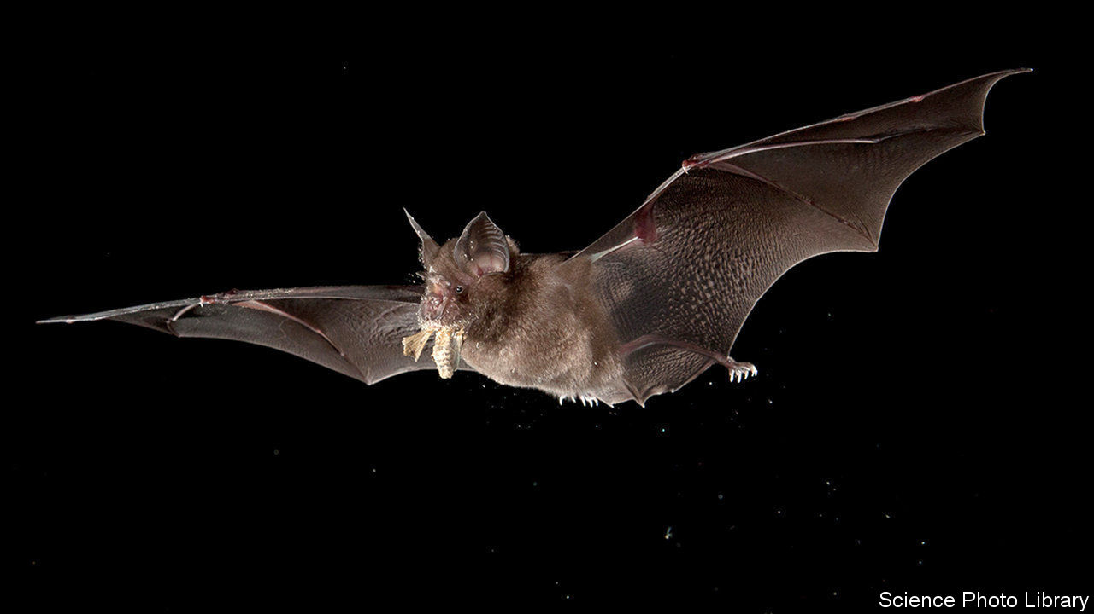

Editor’s note: The Economist is making some of its most important coverage of the covid-19 pandemic freely available to readers of The Economist Today, our daily newsletter. To receive it, register [here](https://www.economist.com/newslettersignup). For our coronavirus tracker and more coverage, see our [hub](https://www.economist.com/coronavirus)

WHICH ANIMAL SARS-CoV-2 leapt from to infect human beings remains unknown. But the evidence suggests that bats were involved at some point—perhaps not as the immediate source of the virus, but probably as the reservoir from which it ultimately came.

Almost certainly that was true of the virus which caused the original SARS outbreak, in 2002. Though this was transmitted to people by palm civets, they probably caught it from horseshoe bats (pictured). MERS, another coronavirus, is similarly suspected of starting in bats, though the immediate source of human infection is camels. Bats are also reckoned to be behind the spread of Ebola and Marburg fevers, which are viral infections as well, though not caused by coronaviruses. And vampire bats famously carry another virus, rabies.

The idea that this may not be a coincidence has led people to ask if there is something special about bats which encourages the evolution within them of viruses predisposed to jump the species barrier and infect other sorts of animals. At the moment, the evidence is mixed.

In favour of the idea is an experiment conducted recently by Cara Brook of the University of California, Berkeley, and published in February in eLIFE. This suggests a possible mechanism. Some bats have unusual immune systems, in which an antiviral process known as the interferon pathway is always active, rather than being switched on in response to infection. Dr Brook and her colleagues conducted experiments on cells from bats that have this arrangement and on others which do not (and also on cells from monkeys, as a control). They concluded that always-on interferon pathways probably do speed up viral evolution. That would make bats more abundant sources of virulent new viruses than other groups of mammals.

Against the idea, however, is work published this week in the Proceedings of the National Academy of Sciences by Nardus Mollentze and Daniel Streicker of the University of Glasgow. Dr Mollentze and Dr Streicker found that the number of viruses which have passed to people from 11 orders of mammals and birds is pretty much proportional to the number of species in each order. Bats are the second-most diverse mammalian order, after rodents. “It is therefore not surprising”, Dr Mollentze observes, “that as a group they are associated with a large number of viruses.” Although bat immune systems do indeed have the unusual features that interested Dr Brook and her colleagues, Dr Mollentze and Dr Streicker found no evidence these caused bat-associated viruses to be more numerous or more prone to infect people than viruses associated with other animal groups.

This study is in line with work done specifically on coronaviruses by Tracey Goldstein of University of California, Davis. In 2017 she and her colleagues published a piece of research in which they had tested for coronaviruses in bats, rodents and primates (including people) in 20 countries in Africa, South America and Asia. Individual bat species normally had between one and five types of coronavirus. (For comparison, human beings have seven, including the newly emerged SARS-CoV-2.) Scale that up for the 1,400 different species of the animals and it means there are potentially more than 3,000 coronaviruses circulating in bats. This certainly increases the odds that bats will be responsible for generating a coronavirus dangerous to people. But only because there are lots of them.■

Dig deeper:  
For our latest coverage of the covid-19 pandemic, register for The Economist Today, our daily [newsletter](https://www.economist.com/newslettersignup), or visit our [coronavirus tracker and story hub](https://www.economist.com/coronavirus)

This article was downloaded by calibre from <https://www.economist.com/science-and-technology/2020/04/18/bats-spread-viruses>

|  |  |  |  |
| --- | --- | --- | --- |
| Previous | Articles | Sections | Next |

|  |  |  |  |
| --- | --- | --- | --- |
| Previous | Articles | Sections | Next |

#### Climate change

# The American west’s drought is its second-worst for 12 centuries

People are partly to blame

Apr 18th 2020 |



THE SOUTH-WEST of the United States, together with adjacent parts of Mexico across the Rio Grande, is one of the driest parts of the North American continent. But, over the past two decades, even that expected dryness has been taken to the limit. According to Park Williams, who works at Columbia University’s Lamont-Doherty Earth Observatory, the current lack of rainfall in the area constitutes a megadrought of a magnitude seen on only four other occasions in the past 1,200 years.

Dr Williams and his collaborators studied the annual growth rings of 1,586 ancient trees from Oregon and Montana all the way down to the northern reaches of Mexico, in order to reconstruct soil-moisture patterns going back to 800AD. During warm, wet years trees grow fast, producing wide rings. During cold, dry ones they grow more slowly, producing narrow rings. During a drought, a tree might not grow much at all.

As they describe in this week’s Science, the team identified dozens of droughts over the centuries in question. But four stood out: those of the late 800s, mid 1100s, 1200s and late 1500s. They then took the mean soil-moisture value for the current drought (which has lasted 19 years so far) and compared it with sequential 19-year averages from the previous four, one of which lasted nearly a century. This showed that the region is already drier than it was during the first three of the previous megadroughts, and is on a par with the event of 1575-1603.

In a world where human actions are driving temperatures up, Dr Parker and his colleagues wondered how much people are to blame for this state of affairs. To estimate that, they turned to climate modelling.

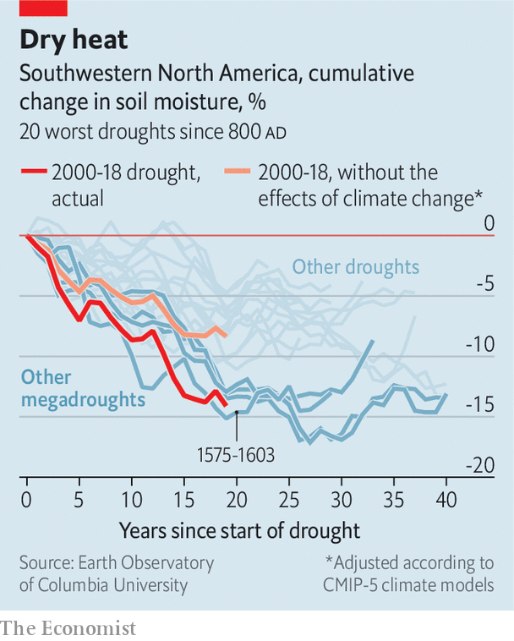

Climate models are able to re-run the past with and without the warming effects of human activity, offering a way to compare what actually happened with what might have done. In their simulated world in which anthropogenic emissions had not ramped up the greenhouse-gas effect, the team found that a drought did indeed still engulf the western reaches of North America during the first two decades of the 21st century. But this fictitious dry spell was considerably less severe than the real one—ranking 11th rather than 2nd in the period under study (see chart).

Worse still for those who live in the area, Dr Parker’s research also confirmed suspicions that the area’s water-management policies, which govern abstraction rates from its rivers and aquifers, and which are mostly set on the assumption that 20th-century rainfall levels represent historical normality, are actually out of kilter. He found that, compared with most of the previous millennium, the 20th century was a period of abundant moisture. With nature providing less water than usual, and people taking more than seems wise, the future of the region looks parched indeed.

This article was downloaded by calibre from <https://www.economist.com/science-and-technology/2020/04/18/the-american-wests-drought-is-its-second-worst-for-12-centuries>

|  |  |  |  |
| --- | --- | --- | --- |
| Previous | Articles | Sections | Next |

|  |  |  |  |
| --- | --- | --- | --- |
| Previous | Articles | Sections | Next |

#### Global Health

# The World Health Organisation is under fire from America’s president

Mostly, though, his charges are trumped up

Apr 16th 2020 |

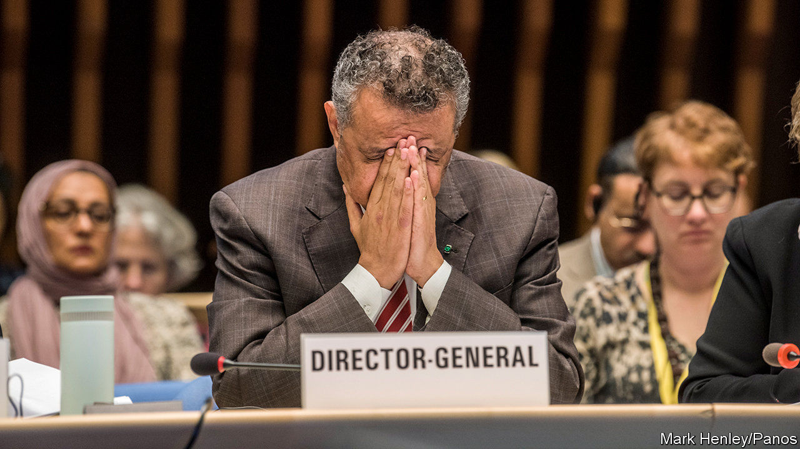

Editor’s note: The Economist is making some of its most important coverage of the covid-19 pandemic freely available to readers of The Economist Today, our daily newsletter. To receive it, register [here](https://www.economist.com/newslettersignup). For our coronavirus tracker and more coverage, see our [hub](https://www.economist.com/coronavirus)

DONALD TRUMP, America’s president, often acts as if he has never seen an international body that he likes the look of. The latest group in his cross-hairs is the World Health Organisation (WHO), together with its leader, Tedros Adhanom Ghebreyesus, a microbiologist who was once Ethiopia’s health minister. Mr Trump accuses the WHO of mismanaging the coronavirus pandemic currently sweeping the planet. As a consequence, he says, he will halt America’s payments to the WHO pending a formal investigation. Since America’s taxpayers stump up 15% of the WHO’s $4.5bn annual budget, that is no mean threat.

Critics such as Mr Trump are correct to observe that the WHO’s panjandrums have been obsequious towards China, the geographical source of the covid-19-causing virus, SARS-CoV-2. Dr Tedros himself has praised China’s president, Xi Jinping, for his “political leadership”. However, he has also praised Mr Trump for his “great work”. Such emollience is a consequence of the fact that only with the co-operation of its member countries can the WHO get on with its day job of acquiring data, weighing them up, and dispatching consequent advice and support around the world. This applies not only to unexpected epidemics like that now raging, but also to quotidian killers such as measles, malaria, HIV, tuberculosis, polio, diarrhoea, malnutrition, cancer and diabetes.

Doing that job well in the context of the epidemic involves providing information to member states on how the coronavirus can be contained, gathering evidence on which measures are effective and which not, and collecting data on everything from drug use to how doctors treat patients. The WHO also provides support for coronavirus -testing programmes, and advice about what tests should be used and how they should be executed, as well as helping to develop ways of testing the efficacy of tests. It is also co-ordinating research into, and trials of, drugs and vaccines against SARS-CoV-2.

Certainly, the organisation has flaws. It was, for example, criticised last year over its reluctance to declare an international public-health emergency during an outbreak of Ebola in the Democratic Republic of Congo (DRC), though it eventually gave way. Its response during and after an earlier outbreak of Ebola in west Africa in 2013 also led to criticism, though this was before Dr Tedros’s time. A report on the matter published in 2017 by the Royal Society, Britain’s top science academy, said that “while the WHO did offer some normative leadership during the Ebola outbreak, as per its constitution, it did not provide an effective operational response”. That criticism was, however, followed by the pertinent point: “yet nor did it have a mandate to do so.” Without the clear support of its members, the WHO cannot act.

When asked for fair criticisms of the WHO, David Heymann, of the London School of Hygiene and Tropical Medicine turns the question around, saying that what is actually remarkable is the rapidity with which an understanding of what is going on with SARS-CoV-2 has been developed, and that tensions between states have not halted the flow of technical information those states have provided. He said, for example, that on April 14th China’s Centre for Disease Control and Prevention had shared information with the WHO on the lockdown in their country, their unlocking strategies, what they are finding out about how to go about lifting lockdowns, and their general concerns regarding the matter of locking down.

Dr Tedros has been leading an attempt to reform the organisation, but this is hard. Because much of the money it receives is tied to member countries’ pet projects, it has little cash for other matters. When faced with an emergency such as covid-19 it must therefore raise funds on the hoof. It cannot, however, be faulted for lacking in foresight. Last year, when Dr Tedros was having trouble raising money for the response to the Ebola outbreak in DRC, he remarked that donors do not pay until there is “fear and panic”. The solution, he suggested, was more routine funding, to allow better preparation for epidemics. If only.■

Dig deeper:  
For our latest coverage of the covid-19 pandemic, register for The Economist Today, our daily [newsletter](https://www.economist.com/newslettersignup), or visit our [coronavirus tracker and story hub](https://www.economist.com/coronavirus)

This article was downloaded by calibre from <https://www.economist.com/science-and-technology/2020/04/16/the-world-health-organisation-is-under-fire-from-americas-president>

|  |  |  |  |
| --- | --- | --- | --- |
| Previous | Articles | Sections | Next |

|  |  |  |  |
| --- | --- | --- | --- |
| Previous | Articles | Sections | Next |

#### Combating loneliness

# Acts of kindness prevent a downward spiral from solitude to loneliness

To be alone and to be lonely are not the same thing

Apr 18th 2020 |

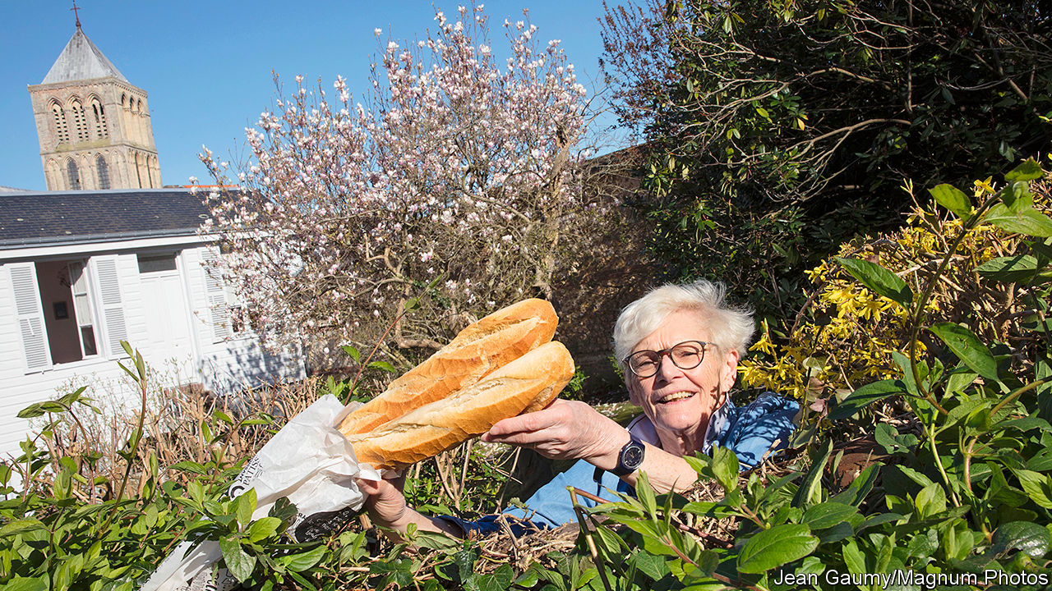

LONELINESS IS BAD for your health—certainly as bad as being obese, and possibly as bad as being a moderate smoker. So, in these days of plague, when enforced solitude is the order of the day in many places, how to stop solitude turning into loneliness is a pressing medical question.

One part of the answer is to try to understand the physiology of the change. And that has, for the past few years, been the objective of Steven Cole of the University of California, Los Angeles. Dr Cole began his work with a study he published in 2015, in collaboration with John Cacioppo of the University of Chicago. The pair led a team of psychologists, neuroscientists and immunologists who found that the pattern in people’s blood of immune cells called myeloid cells is notably different in those who score as “very lonely” on loneliness tests compared with those who do not.

Lonely people have unusually low numbers of a type of myeloid cell that generates what are known as interferon responses, which hamper viral replication. This makes them particularly vulnerable to viral infections. They also have an abundance of a second type of myeloid cell, one that promotes the activity of genes which drive inflammation—and it has been known for years that those who feel lonely experience more inflammation than those who do not.

These correlations are intriguing, but do not explain which comes first, the loneliness or the myeloid response. Dr Cole and Dr Cacioppo addressed that question by repeatedly measuring perceptions of social isolation in individual volunteers, while simultaneously tracking, from blood samples, their gene-expression patterns and other changes in their physiology. They found that, initially, volunteers’ feelings of isolation coincided with an increase in their inflammation genes’ activity and a concomitant increase in the circulation of immature immune cells, called monocytes, that are involved in inflammation—and which are also known to travel into the brain and promote anxiety. They noted, too, increased levels in the brain of signalling molecules associated with both inflammation and behaviours such as social withdrawal, feelings of suspicion towards the outside world and a tendency to act more defensively by making decisions that involve few risks. That, of course, promotes further feelings of loneliness. Which, in turn, trigger a further myeloid response. And so on.

It seems, therefore, that though loneliness starts with solitude, it can quickly take on a physiological life of its own. Dr Cole thus worries that the enforced isolation, brought about by current circumstances, of those who are already living alone may create in many people a state of chronic loneliness that is difficult to escape from when things start returning to normal.

Dealing with this will not be a simple matter of allowing people to socialise once again. Because the myeloid feedback loop makes those affected more defensive and suspicious, the mere presence of others is not enough to restore the status quo. Something else is needed, too.

In search of that something Dr Cole carried out—this time in collaboration with Sonja Lyubomirsky, a psychologist at the University of California, Riverside—a series of experiments that encouraged healthy people to direct simple acts of kindness towards their fellow creatures: things like running an errand for an elderly neighbour or helping a colleague with a computer problem. Participants had their blood drawn in order to examine their myeloid responses. Those directed to show kindness to others on a weekly basis had precisely the opposite gene-expression activity to that previously seen in the lonely by Dr Cole and Dr Cacioppo.

Dr Lyubomirsky now picked up the baton. In collaboration with Dr Cole and with Megan Fritz, a colleague at Riverside, she repeated the study, but with a twist. Instead of looking only at participants’ myeloid responses, she also asked them specific questions about loneliness.

As she and her colleagues reported to this year’s conference of the Society for Personality and Social Psychology, held in New Orleans in February, they found that in the case of loneliness, the saying about it being more blessed to give than to receive is true. Asking lonely people to perform acts of kindness to others significantly reduced the offerer’s feelings of loneliness, as well as the myeloid response that drives inflammation. Also, and perhaps portentously given the meeting’s timing, Dr Fritz and Dr Lyubomirsky reported the preliminary results of a second study. This compared the effect on a lonely person’s feelings of acts of kindness he or she performed face to face with those performed online: donating money to a gofundme effort, for example, or writing a thank-you note to a friend.

The study’s results suggest that online kindness has the same beneficial effect as the face-to-face variety. And that could help to address Dr Cole’s fears of a post-covid loneliness epidemic. No doubt (though this was beyond the scope of these studies) merely having contact with others while staying in isolation is beneficial to those at risk of loneliness. But asking lonely people to use those means to commit random acts of kindness to others might go beyond this, and be just what the doctor ordered.■

This article was downloaded by calibre from <https://www.economist.com/science-and-technology/2020/04/18/acts-of-kindness-prevent-a-downward-spiral-from-solitude-to-loneliness>

|  |  |  |  |
| --- | --- | --- | --- |
| Previous | Articles | Sections | Next |

|  |  |  |
| --- | --- | --- |
| Science and ... | Sections | Economic and ... |

Books and arts

Covid-19 and entertainment: Sealed without a kiss

.

Tales of survival: Exodus and odyssey

.

Demography: The big ask

.

Lives of the plutocrats: The money tree

.

Johnson: Locked and learning

.

Home Entertainment: Listen to Bertrand Russell, the English Voltaire

.

Home Entertainment: The joy of making your own tortellini

.

|  |  |  |
| --- | --- | --- |
| Science and ... | Sections | Economic and ... |

|  |  |  |  |
| --- | --- | --- | --- |
|  | Articles | Sections | Next |

#### Sealed without a kiss

# Brazil’s beloved telenovelas have sputtered to a halt

When the cameras roll again, the world will not be the same

Apr 18th 2020 | SÃO PAULO



Editor’s note: The Economist is making some of its most important coverage of the covid-19 pandemic freely available to readers of The Economist Today, our daily newsletter. To receive it, register [here](https://www.economist.com/newslettersignup). For our coronavirus tracker and more coverage, see our [hub](https://www.economist.com/coronavirus)

“AMOR DE MÃE” (“Mother’s Love”) is a telenovela about three mothers from different social classes whose lives become entwined in Rio de Janeiro. Its run began in November on Rede Globo, Brazil’s largest free television channel, in an evening slot that can attract a quarter of the population. Then, on March 16th, Globo shut its studios to combat the spread of covid-19, sending home some 9,000 workers and, for the first time ever, replacing ongoing soap operas with reruns. Neither military dictatorship nor the Rio Olympics halted production of Brazil’s famous novelas, which are broadcast six days a week for single seasons of around 150 episodes apiece.

Manuela Dias, the writer of “Amor de Mãe”, and José Luiz Villamarim, its director, scrambled to re-edit existing footage to suspend the story on a cliffhanger. One of the mothers, Thelma, commits a murder to prevent another, Lurdes, finding out that Thelma’s adopted child and Lurdes’s long-lost son are one and the same. That was the easy part. Now Globo, a huge media empire that broadcasts news, sports and entertainment, must answer the question facing television executives from Hollywood to Bollywood: how to bridge the gap between the pre- and post-pandemic worlds—and what to produce on the other side.

The filming of soap operas has been suspended in other countries, too, but nowhere will the hiatus matter more than in Brazil. Shoddy state-run schools and vast TV audiences mean that, as well as being a cherished form of entertainment, the shows are a vehicle for education and a mirror for current affairs. “Novelas helped me understand a part of history that literature in school didn’t show,” says Ondina Saidy, a 61-year-old social worker. For instance, a corruption scandal in the 1980s inspired “What King Am I?”, an allegory set in a European kingdom that poked fun at politicians. “Avenida Brasil”, one of the most successful soaps in Brazilian history, depicted life in a favela, sparking conversations about race and class when it began in 2012. Rates of organ donation rose after the practice saved a popular character’s life.

In short, says Maria Immacolata Vassallo de Lopes of the Centre for the Study of Telenovelas at the University of São Paulo, these shows are “a resource capable of mobilising people”. They are also part of a global market: millions of Americans and Europeans watch Brazilian and Mexican novelas, even if “K-Dramas” from South Korea have begun to supplant them. (Colombians, for their part, prefer Turkish yarns.) Now this supply chain has ground to a halt, leaving fans bereft when they most need the consolation of melodrama.

To sustain the ritual viewing in Britain, the BBC is eking out episodes already in the can of “EastEnders”, its flagship soap, scheduling two per week instead of four. In Mexico, Televisa has put scores of old telenovelas online to be streamed free. In Brazil, Globo is carefully selecting its reruns. They include a modern-day Cinderella tale and a historical drama with a sequel coming out later this year. Meanwhile, actors are connecting with fans on Facebook. Networks are exploring variety-show formats involving home-made videos—chefs in their own kitchens, quizzes in which celebrity panellists beam themselves in.

A rare holdout from the pre-covid era is “Big Brother Brazil” (BBB), a venerable reality show that confines 20 attractive young people in a house together. Globo decided to keep filming even as versions in Canada and Italy ended early. The network reduced staff to minimise the risk of infection and on March 16th broke into the contestants’ isolation to tell them about the pandemic; a similar scene played out on “Big Brother Germany”. The ensuing tear-filled episodes drove up the already high ratings (Rede Globo’s audience in March was its biggest in a decade: 38% of televisions in the country were tuned in). It is comforting to feel that “the whole world is here, at the same time, living through the same emotion”, says BBB’s director, J.B. Oliveira.

With novelas suspended, football cancelled and millions of Brazilians stuck at home, BBB has become a national pastime. Celebrities and politicians, including a son of President Jair Bolsonaro, have identified their favourite contestants on Twitter. A recent elimination round drew 1.5bn online votes. In a habit previously reserved for football matches, Brazilians have been shouting at the screen. “Stop that, for the love of God!” cries Bianca Cardoso, the founder of a Facebook group for TV fans, when participants engage in what in the covid era seems like risky behaviour, such as sharing dishes and embracing.

Soon, she may not have to worry. Globo is considering banning kissing when production of novelas resumes, at least initially. Crowd scenes will also be avoided to limit the need for extras. Smooching will surely return (though some quarantine habits, such as videoconferencing, will doubtless linger both in life and on screen). But the pandemic’s wider impact on television entertainment is unpredictable.

## Soap and disinfectant

Experimenting with low-budget productions, as Globo has, could help in the long run, reckons Chico Barney, a Brazilian TV critic. Networks are anticipating a downturn after people return to work, audiences dip, advertising shrinks and subscriptions are cancelled. But there will still be demand for dramas, and—as is always true after such a seismic event—some are bound to focus on the pandemic. In Brazil, as elsewhere, the crisis has spotlighted the issue of inequality: wealthy travellers imported the virus, but poor people, who depend on the strained public health system, will suffer most. As in the past, soaps will reflect and shape viewers’ understanding of what happened and why.

Ms Dias, the writer of “Amor de Mãe”, has returned to her storyboard, pondering one urgent question in particular. The novela is set in present-day Rio, but the bustling streets and mobbed beaches that it depicts now seem like relics of a bygone age. “I agonised over what to do,” she says. “Do I let coronavirus into the novela, or do I spare my characters?”

Unlike the writers of “The Archers”, a British radio drama about a fictional village where the virus will arrive in May, Ms Dias decided to be merciful. The novela already grapples with death and inequality, she figures, and by the time it returns Brazilians will be sick of hearing about the disease. “The drama of whether or not Lurdes finds her son would turn into whether or not Lurdes gets coronavirus,” she jokes. “All the plot lines would become medical stories.”

Instead, an environmental activist who has a child with one of the mothers will warn the UN that the world is unprepared for a pandemic. That is a lesson that the audience has already learned. ■

Dig deeper:  
For our latest coverage of the covid-19 pandemic, register for The Economist Today, our daily [newsletter](https://www.economist.com/newslettersignup), or visit our [coronavirus tracker and story hub](https://www.economist.com/coronavirus)

This article was downloaded by calibre from <https://www.economist.com/books-and-arts/2020/04/18/brazils-beloved-telenovelas-have-sputtered-to-a-halt>

|  |  |  |  |
| --- | --- | --- | --- |
|  | Articles | Sections | Next |

|  |  |  |  |
| --- | --- | --- | --- |
| Previous | Articles | Sections | Next |

#### Exodus and odyssey

# Why is this Haggadah different from all others?

The latest chapter in the story of an extraordinary Passover book

Apr 18th 2020 | SARAJEVO



WHY, JEWISH children asked at the Passover meal last week, is this night different from all others? The question is stipulated in the Haggadah, a ritual book that recounts the Israelites’ escape from bondage in Egypt. One example, known as the Sarajevo Haggadah, is itself different from all others. At least 650 years old, its calfskin pages are still vibrantly illuminated with gold, lapis lazuli and malachite. It has withstood war and persecution, bearing silent witness to tumultuous events; and, as in the biblical episode it relates, the Haggadah has always found new life—recently in literature, and soon in film.

Alongside vivid illustrations of Bible scenes, among them Moses parting the Red Sea, the text contains images of contemporaneous Jews, possibly including the Haggadah’s original owners. Its past, like its pages, holds many mysteries. It was made in medieval Spain, probably in Barcelona, by unknown hands in around 1350. After Spain expelled its Jews in 1492, it found its way to Italy where it was spared by the Inquisition, before reaching multicultural Bosnia (with a stint in Vienna for restoration). Over the centuries it collected wine stains and errant doodles that whisper of the people who turned its parchments.

In 1894 the National Museum of Bosnia and Herzegovina bought the Haggadah from a Sephardic family in Sarajevo. During the second world war, when most of the city’s Jews perished, German troops searched for the legendary tome. The museum’s director, Jozo Petrovic, a Catholic Croat, and Dervis Korkut, a Muslim curator, bravely hid the Haggadah in a mountain village, reputedly inside a mosque.

Half a century later, when Sarajevo was besieged during the Balkan wars, Serbian-backed forces shelled the National Museum. This time a Muslim librarian, Enver Imamovic, and his colleagues saved the Haggadah and stashed it in a bank vault. Bosnian police told him he was crazy to risk his life for “a dusty old book”, Mr Imamovic recalled to Geraldine Brooks, a journalist who covered the conflict.

Ms Brooks first heard about the Sarajevo Haggadah when, as they hunkered in a hotel bar during a bombardment, fellow war correspondents speculated about its fate. Afterwards she wrote a bestselling, fictionalised account of the Haggadah’s history, “People of the Book”. “It’s the same story repeating itself in different eras in different countries,” she says of the saga. “Something rises up and wants to wipe out everyone who doesn’t belong.” Yet as the Haggadah’s existence attests, “there are always a few people who stand up and say ‘no’.”

The leather-bound artefact was long considered too delicate to be exhibited; over more than 100 years, it was on public view for just four hours in total. But since 2018, with the aid of French funding, it has been displayed for two hours a week in a climate-controlled, theft-proof room in the cavernous museum. Now Danis Tanovic, a Bosnian director who won an Oscar in 2001 for “No Man’s Land”, is set to make a film adaptation of Ms Brooks’s novel. Mr Tanovic was in Sarajevo during the siege and joined the fire brigade’s effort to salvage cultural treasures.

For him, the book symbolises “fighting, kindness from some, and persecution”; but, like the flight from Egypt that it commemorates, it also tells a “story of survival”. Filming has been delayed by the pandemic; even so, it is clear that there are more chapters to be written in the Haggadah’s chronicle of exile, heroism and endurance. ■

This article was downloaded by calibre from <https://www.economist.com/books-and-arts/2020/04/18/why-is-this-haggadah-different-from-all-others>

|  |  |  |  |
| --- | --- | --- | --- |
| Previous | Articles | Sections | Next |

|  |  |  |  |
| --- | --- | --- | --- |
| Previous | Articles | Sections | Next |

#### The big ask

# A lively and enlightening history of the census

It charts the evolving relationship between people and the state

Apr 18th 2020 |

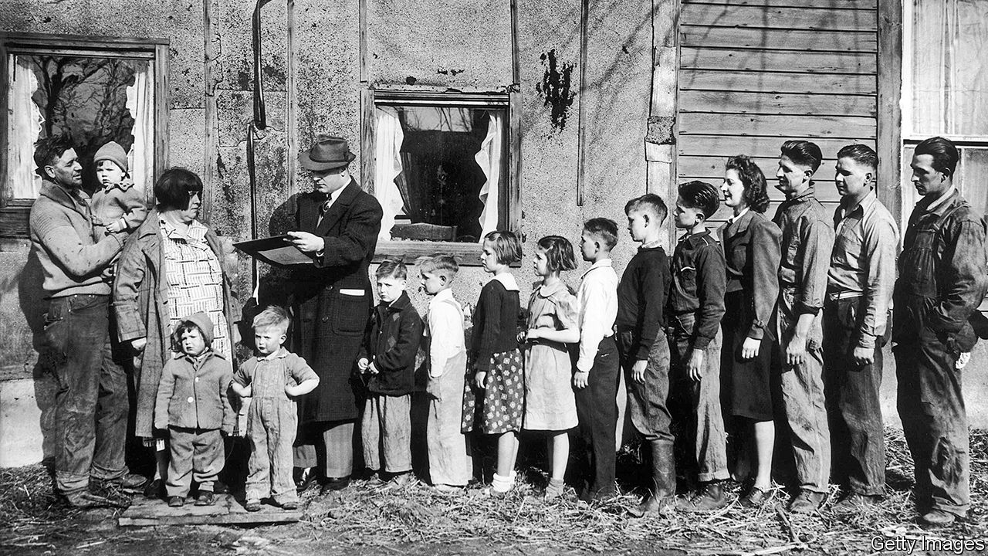

The Sum of the People. By Andrew Whitby. Basic Books; 277 pages; $30 and £25.50.

IT IS HARD to get excited about a census. As the latest decennial wave rolls through many countries in 2020 and 2021, people who fill out the forms, often urged by a knock on the door, will generally find it tedious. In Britain, nearly 400,000 pranksters tried to liven up the process in 2001 by listing their religion as “Jedi”. In America, the latest count might even cause fear. The Supreme Court blocked President Donald Trump’s attempt to ask about citizenship status, which would have discouraged undocumented immigrants from responding, but many may still be reluctant to share data with the government.

The officials who collect such information are seen as “the greyest of the grey-suited bureaucrats”, says Andrew Whitby, an economist most recently at the World Bank. In “The Sum of the People”, a new history of censuses, he drily notes that the United States Census Bureau is based in Suitland, a town near Washington.

Mr Whitby’s book, however, is anything but drab. The first half races from Emperor Yu arranging the first Chinese headcount around 2100BC to the advent of tabulation machines in 1890. These chapters are really a potted history of the relationship between state and people, interspersed with tales of great thinkers and intrepid data-gatherers (often travelling by boat). Originally, the census was an imposition by an all-powerful executive, undertaken to muster armies and collect taxes. Confucius was said to have deep respect for the procedure; Roman censors (from censere, to assess) were as revered as consuls, and would grade the status of each householder. William the Conqueror’s Domesday Book scoped out his new English kingdom.

Because censuses helped governors subjugate the governed, most people resented them. Scriptural accounts of God punishing King David’s census with a plague made Jews and Christians especially wary. Parliamentarians in Westminster were initially sceptical, rejecting a headcount in 1753 as “totally subversive of the last remains of English liberty”. It was America that made demography essential to democracy. The Founding Fathers knew that, to balance taxation and representation, they would need a record of who lived where. They stipulated a decennial census in the constitution (but gave black slaves three-fifths the weight of free whites).

Britain at last introduced one in 1801, after Thomas Malthus claimed that population growth would outstrip productivity, causing famine. Other countries followed. But America remained the crucible of modern census-taking. The edition of 1880 contained a billion data points—so Herman Hollerith, an engineer, designed a machine that could process individual records using punch cards, based on Charles Babbage’s uncompleted computers. Hollerith’s company later became part of the International Business Machines Corporation (IBM).

A chapter on the Holocaust is grimly fascinating. Punch-card technology was used in concentration camps, but Mr Whitby focuses on the bureaucrats who created identity-card systems, many compiled by hand, which helped the Nazis track down Europe’s Jews. Population data may have been a benign tool for democracies, but it remained lethal in dictatorships.

After this rapid journey through time, the final third of the book ambles through the post-war era of censuses. And their doubtful future: given how burdensome nationwide surveys are—America’s latest will cost $16bn—they may soon be replaced by digital registers drawn from various government documents. Mr Whitby’s is an entertaining and informative story, more about society than statistics. Leo Tolstoy, who helped conduct a census in Moscow, put it best: “The interest and significance of the census for the community lie in this, that it furnishes it with a mirror into which, willy-nilly, the whole community, and each one of us, gaze.” ■

This article was downloaded by calibre from <https://www.economist.com/books-and-arts/2020/04/18/a-lively-and-enlightening-history-of-the-census>

|  |  |  |  |
| --- | --- | --- | --- |
| Previous | Articles | Sections | Next |

|  |  |  |  |
| --- | --- | --- | --- |
| Previous | Articles | Sections | Next |

#### The money tree

# How to make a billion

William Leith has never managed it—but he has some tips

Apr 18th 2020 |

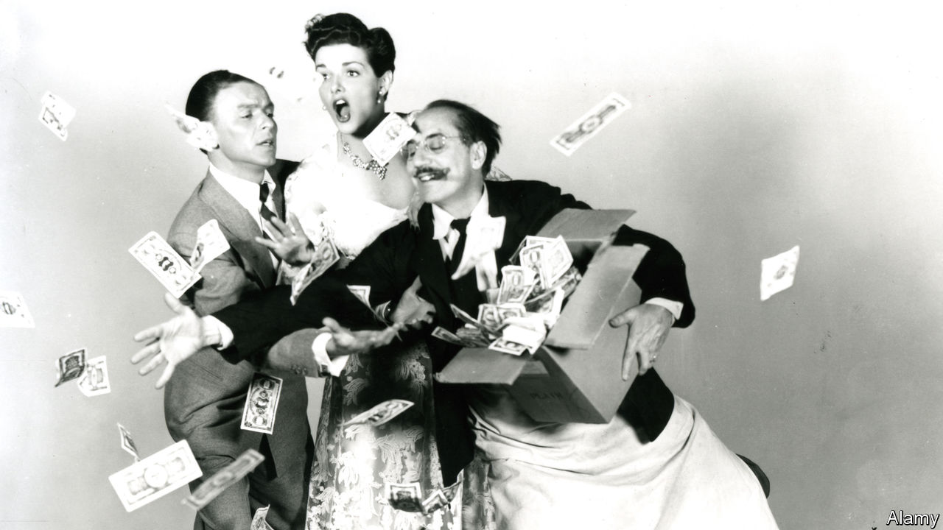

The Trick. By William Leith. Bloomsbury; 224 pages; £20.

EVEN MORE than most people, William Leith is fascinated by the super-rich. As a journalist, he devotes a lot of his time to interviewing them; by his own report, he spends much of the rest worrying about his own inability to make money. In his book he sets out to pin down the secrets that lead these modern pharaohs to succeed while he flounders in relative penury.

The title, it is not a surprise to learn, is itself a ruse. There is no simple “trick” to accumulating piles of cash; otherwise Mr Leith would be rich already (and he might be disinclined to share it). More accurately, the object of his inquiry, which he pursues with obsessive zeal, is whether there is a set of identifiable strategies that increase your chances of acquiring extreme wealth. Along the way, the reader learns a great deal about the lifestyles of the plutocrats, and quite a lot about Mr Leith himself.

His research takes him to places most people encounter only through films or prurient television shows. He is admitted to mansions, alights upon private tropical islands and goes to a nightclub in an underwater cavern in the Maldives. One of his subjects is the late Felix Dennis, a maverick British publisher, whose estate in Warwickshire Mr Leith visited. Ruthlessness was essential to amassing a fortune, reckoned Dennis, himself the author of a bestseller titled “How To Get Rich”. Indeed, he believed the first victim of any pursuit of riches must be the pursuer. Dennis’s own life, in which success turned out to be a prelude to drug-addiction, illustrated that bleak view only too well.

Making money, of course, can itself be very addictive. Mr Leith encounters Jordan Belfort, a former stockbroker and the author of “The Wolf of Wall Street”, a lurid memoir that was turned into a film by Martin Scorsese. Avarice got the better of Mr Belfort, and he was jailed for fraud. Still, for what it is worth, he thinks persuasiveness is one of the key requirements for financial success. He is a better persuader than most: a free man once again, he now delivers lectures on how to strike it rich. Naturally, he demands handsome fees for his insights.

Another route to opulence that Mr Leith analyses in depth is the “black swan” strategy, associated with the writer Nassim Nicholas Taleb. It involves betting heavily on unlikely events—because the odds are rewarding and the world is more chaotic and unpredictable than people expect. Winning business models, the author finds, often arise from a willingness to take hard choices, accept slow progress and, initially, swallow substantial losses. Among his case studies is Patrick Veitch, a talented mathematician whose losing bets on horse races helped him refine a method that subsequently brought in £1m ($1.25m) a year. He also cites Howard Schultz, who boldly decided to introduce Italian coffee culture to America. The outcome of Mr Schultz’s quixotic scheme was Starbucks.

But this is not a textbook. As well as his observations of the plutocracy and how to penetrate it, Mr Leith offers a tour of his own frantic inner world, reflecting on a dizzying array of subjects that he deems relevant to his mission. These range from cowboys and gangsters to the feeding habits of chimpanzees. His metastasising anecdotes and revelations are deeply personal, often wilfully tangential and always thought-provoking. It may console readers of modest means to learn that the author’s own finances remain disastrous. ■

This article was downloaded by calibre from <https://www.economist.com/books-and-arts/2020/04/18/how-to-make-a-billion>

|  |  |  |  |
| --- | --- | --- | --- |
| Previous | Articles | Sections | Next |

|  |  |  |  |
| --- | --- | --- | --- |
| Previous | Articles | Sections | Next |

#### Johnson

# How to learn a language in the lockdown

It is a quintessentially social skill—but easier than ever to develop at home

Apr 18th 2020 |

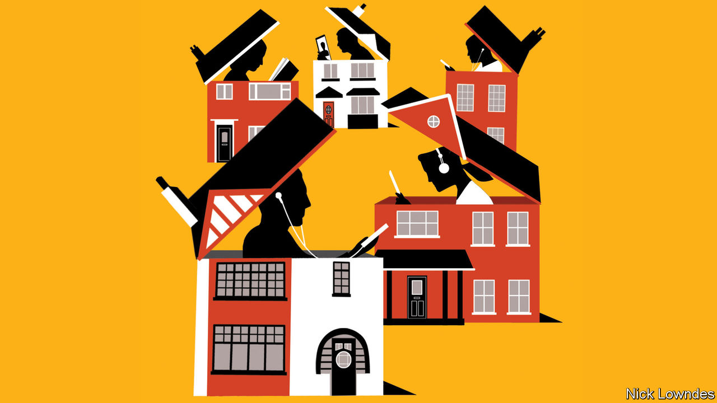

LIVING IN LOCKDOWN has led many people to undertake some self-improvement. Alongside baking or cramped fitness regimes, some have chosen intellectual projects—such as picking up or mastering a foreign language. This interactive skill might not seem to be one that is best honed alone. But learning a language in isolation is much easier than it used to be.

One summer many years ago, as he spent many hours driving alone to work, your columnist learned French with the help of an ancient course developed to train American diplomats. Not only were its text basic and cassettes low-tech; it was also low-concept. Exercises seemed to have much more repetition than was necessary: Mon frère va bien. Mon père va bien. Mon fils va bien. Mon ami va bien,murmured the tape, with pauses for repetition. (My brother is doing well. My father is doing well…)

There was method in this drudgery. The skeleton of the sentence was drummed in, with just one word changing: Mon X va bien. Next, another variable was altered. A new list of six sentences cited feminine nouns instead: Ma Z va bien. With little instruction, the variation between feminine and masculine was pounded home. It was slow, not much fun—and incredibly effective. (Many of these old courses are now free online at www.fsi-language-courses.net.)

That primitive method has since been replaced by whizzy programmes promising easier progress. In the end, though, language is a skill more than a body of knowledge, acquired not so much by learning as by doing. Put another way, learning a language with an app is a bit like getting fit with one. The device can guide you, but you still have to work.

Duolingo, a popular “freemium” app, has bite-sized lessons and gamified exercises. Babbel, an inexpensive subscription service, offers more structured lessons and useful real-world material. Busuu, another subscription, focuses on networking with other users. The best thing such apps can do is get you away from your screen, and talking. Learn a bit, then try to escape family or roommates and articulate your thoughts about your day and your life: J’aime la beurre. J’aime le pain. J’aime mon mari. Je n’aime pas le lockdown… It is better to repeat a formula to death than to move on too soon.

As for your initially meagre vocabulary, don’t be shy about substituting an English word into your muttering—but look up the equivalent as soon as you can. (If you have a smart speaker, their “How do you say ‘tree’ in Spanish?” features are rather good.) Keep a list of handy new words on your phone, ideally in a flashcard app. Two more tricks might help you learn more of them. A frequency dictionary has thousands ordered not by the alphabet but how often they are actually used: this quickly gives you the few dozen critical, functional words that glue a language together. To enhance your vocab, Memrise is another app that uses spaced repetition to drive words home. New ones are repeated insistently until they stick, then occasionally thereafter as reminders.

As soon as you can string a few sentences together, study in quarantine offers a consolation: a lot of language teachers are at home, too, and only a video-call away. For example, Sara, an Italian tutor in the Piedmont region, says her teaching hours have exploded. Italki is a platform that links teachers and students for surprisingly low hourly rates; casual conversation practice is especially cheap, formal instruction slightly pricier. Find a highly rated teacher and struggle through a half-hour’s conversation, shame-free. They can use the chat function of video-call apps to write down words that elude you or that you haven’t understood. Afterwards you can add them to your flashcards.

Finally, there is reading and writing. Keeping a journal can force you to write clearly those tricky bits you’ve been mumbling, making you confront half-learned material. As for reading, graphic novels are good for a realistic conversational style. And for no-nonsense written prose, find articles in the new language on Wikipedia on a subject you know well. Being able to guess unfamiliar terms gives a heartening sense of progress. Browser extensions can make looking up words a snap. Just double-click a word with Google Translate enabled on Chrome, for example.

There is no way to learn a language without time and effort. What technology does is make that effort pay off faster. Just remember the goal—interacting with native speakers in the flesh. You’ll be out in the world again one day.

This article was downloaded by calibre from <https://www.economist.com/books-and-arts/2020/04/18/how-to-learn-a-language-in-the-lockdown>

|  |  |  |  |
| --- | --- | --- | --- |
| Previous | Articles | Sections | Next |

|  |  |  |  |
| --- | --- | --- | --- |
| Previous | Articles | Sections | Next |

#### Home Entertainment

# Listen to Bertrand Russell, the English Voltaire

His greatest hits are a good substitute for the intelligent conversation you are missing

Apr 18th 2020 |

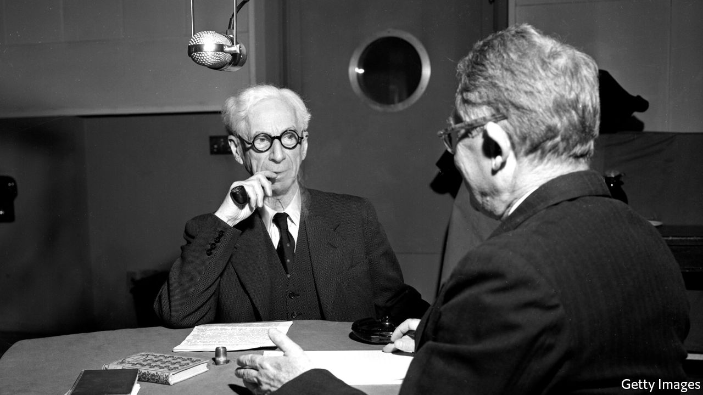



AMONG MANY other achievements, Bertrand Russell is the only philosopher to have cut an album of his work. Released in 1962, “Bertrand Russell Speaking” was a greatest hits of the many interviews he had given. Subjects range from science and religion on side A, to “taboo morality” and “fanaticism” on side B. If discovered in the bedroom of a teenager of the time, the record might have seemed as scandalous as any rock’n’roll track. Because, as well as being a pioneering logician, Russell was an uncompromising freethinker—and an early advocate of free love.

Fifty years after his death, Russell’s voice—an enduring call to liberal dissent—is preserved on YouTube, where self-isolating listeners can find a trove of his words and wisdom. With an unfailing wit, the recordings cover mathematics, literature, atomic physics and history. Entertaining and improving at once, they are a delightful stand-in for the intelligent conversation you might currently be missing.

Russell’s personal anecdotes are a highlight. Brought up by a grandfather who was twice prime minister, he grew up in the patrician splendour of the Liberal establishment. Once, at a dinner, the young Russell “was left tête-à-tête” with William Gladstone, the “Grand Old Man” of British politics. “I was only 17 and very, very shy, and it was by far the worst experience of my life,” Russell recalled. “Nothing since has terrified me.” He remembered Gladstone saying only one thing: “This is very good port, but why have they given it me in a claret glass?”

Despite his Victorian upbringing, Russell’s views and legacy are remarkably contemporary. He once speculated that only six people had read his “Principia Mathematica”, three of whom had been murdered by Hitler; nevertheless, the book laid the early foundations of computer science. Russell helped establish the analytic tradition, which rejected grand dogmas in favour of clear and precise inquiry, and became the basis of most university philosophy courses. And he was a famously committed atheist, using his formidable rhetorical skills to prosecute that cause.

In a debate broadcast by the BBC in 1948 Russell came up against Frederick Copleston, a Jesuit priest, in one of the listening public’s earliest exposures to the philosophical arguments against God. Thanks to YouTube, you can listen to the stand-off again. Copleston, palpably irritated and wearied by his opponent’s obstinance, pleads: “We seem to have reached an impasse.” “We can press the point a little I think,” Russell cheekily replies.

On his death, Russell was eulogised as “the English Voltaire”, a witty, polymathic rebel. As with Voltaire, though a few of his books are still in publication, most now gather dust. But through the alchemy of the internet, his voice lives on. One appreciative listener has commented: “Imagine if this guy had a podcast.” The informal online archive will have to suffice. ■

This article was downloaded by calibre from <https://www.economist.com/books-and-arts/2020/04/18/listen-to-bertrand-russell-the-english-voltaire>

|  |  |  |  |
| --- | --- | --- | --- |
| Previous | Articles | Sections | Next |

|  |  |  |  |
| --- | --- | --- | --- |
| Previous | Articles | Sections | Next |

#### Home Entertainment

# Make your own pasta

It's a moderate workout and good entertainment for children

Apr 18th 2020 |

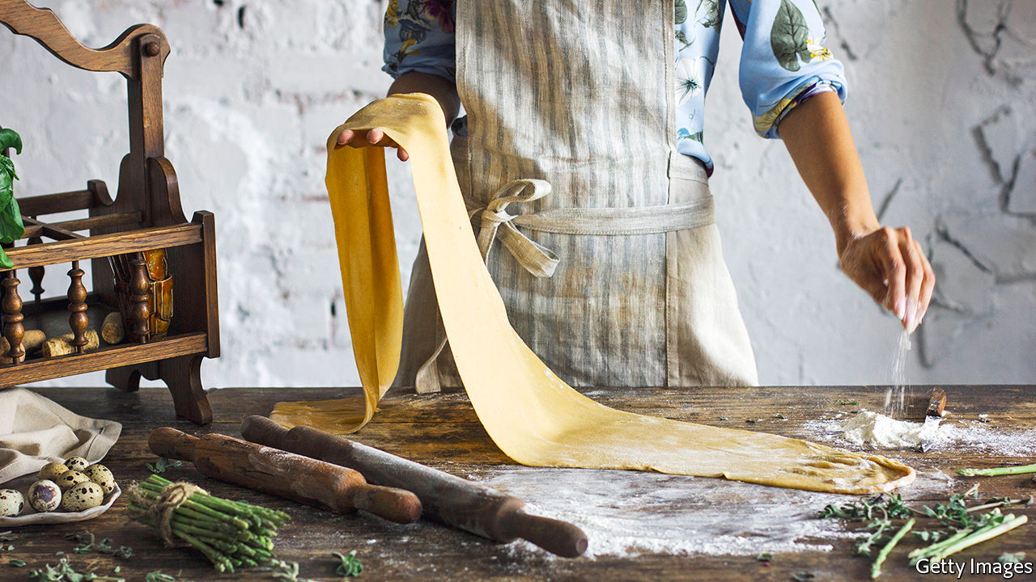



“IT CAN BE bought everywhere and in all the shops for very little money,” observed Goethe on a visit to Naples in 1787. “As a rule it is simply cooked in water and seasoned with grated cheese.” Pasta’s economy and convenience have since helped it conquer the world. Supermarkets from Kansas City to Qatar have recently been stripped of the stuff.

Pasta is probably a descendant of ancient Asian noodles (though the story of Marco Polo importing it from China is apocryphal). Etruscan and Roman forms, described by Horace and Cicero, are likely to have been baked or fried; then, in the fifth century, the Talmud mentioned the boiling of dough. This method took off in the Middle Ages, aided by a drying process brought to Sicily by Arabs. In northern Italy, egg-enriched doughs and filled pastas proliferated; but it was only in the 1970s that British and American diners looked beyond their ersatz spaghetti and meatballs or mac ’n’ cheese.

Today, making their own pasta offers locked-down cooks a moderate workout, an hour’s entertainment for children and a versatile kitchen staple in one fell farinaceous swoop. In its purest form, pasta—which means “dough”—has just two ingredients, water and flour. The best choice, say authorities such as your correspondent’s Sicilian mother-in-law, is farina di semola di grano duro rimacinata, a fine-ground semolina made from durum wheat. But in these straitened times pasta would be an honest end for any orphaned bag of flour, be it plain, chickpea or spelt.

Allow 100g per person and a little over half as much warm water, or, for egg pasta, substitute a single egg for the water. Heap the flour and sprinkle a little salt. Make a well in the centre, slowly add the liquid and mix with your fingers. Knead until the paste becomes a smooth, soft dough. Wrap and rest it in cling-film before shaping.

In an Italian kitchen, choosing the pasta’s shape is as important as deciding how to dress it. Try a little concave cavatelli (from cavare, to dig). Using both hands, roll the dough into a rope 1cm in diameter, then cut it into 1cm pieces. Push each piece down and away with your thumb, creating a curl to catch tomato sauce. For flat noodles, roll the dough as thinly as possible—thin enough to read newspaper headlines through it. Tagliatelle are roughly 1cm wide; any narrower and they become tagliolini, wider and they could be pappardelle. All will be delicious with ragu and grated hard cheese, properly Grana Padano, as the Bolognese use.

Fresh pasta is not always beautiful; it is never al dente. But there is a rare pleasure in a bowl of it formed by your own hand. Roll the dough out thinly again and cut it into squares, and you are halfway to tortellini. Fill with ham, cheese, black pepper and nutmeg; fold the squares into triangles, squeezing the edges to push out any air, seal them, then join the two bottom corners in the middle. Tortellini in brodo—cooked in stock and swimming in a soup bowl—is the ultimate comfort food. ■

This article was downloaded by calibre from <https://www.economist.com/books-and-arts/2020/04/18/make-your-own-pasta>

|  |  |  |  |
| --- | --- | --- | --- |
| Previous | Articles | Sections | Next |

|  |  |  |
| --- | --- | --- |
| Books and arts | Sections | Graphic detail |

Economic and financial indicators

Economic data, commodities and markets

.

|  |  |  |
| --- | --- | --- |
| Books and arts | Sections | Graphic detail |

|  |  |  |  |
| --- | --- | --- | --- |
|  | Articles | Sections | Next |

# Economic data, commodities and markets

Apr 18th 2020 |

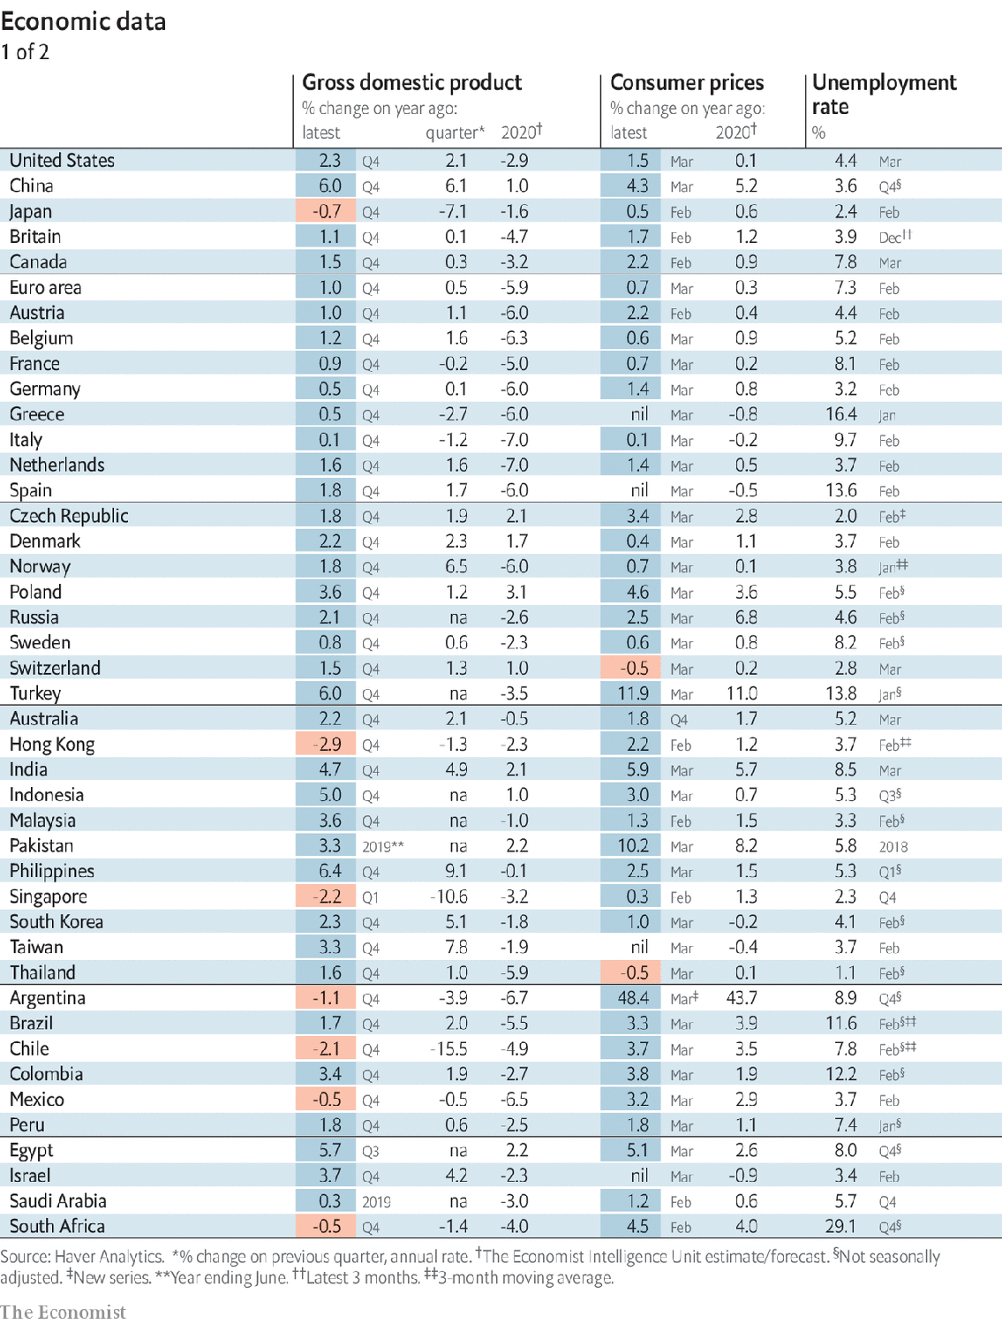

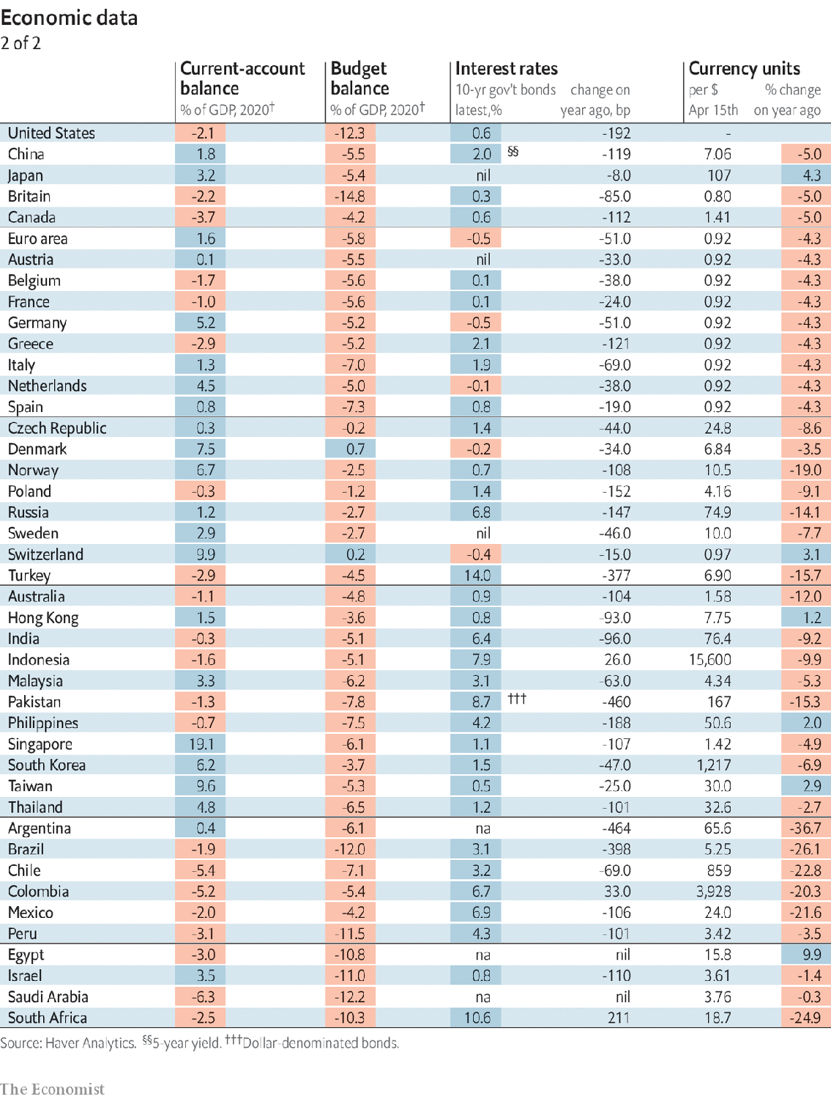

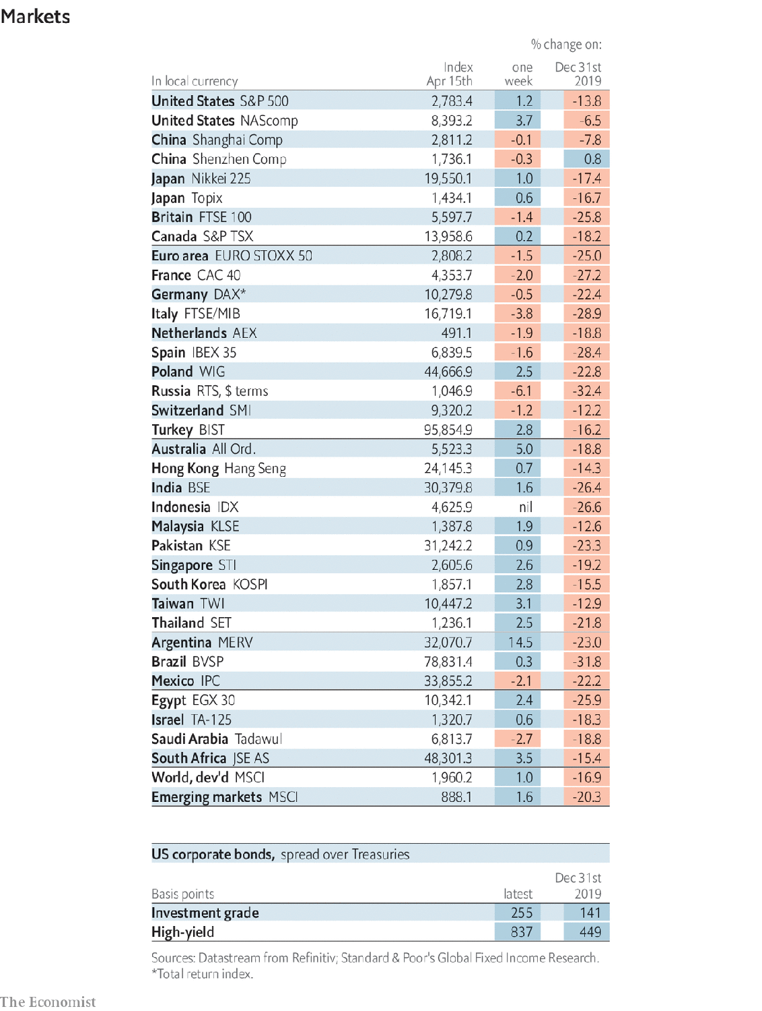

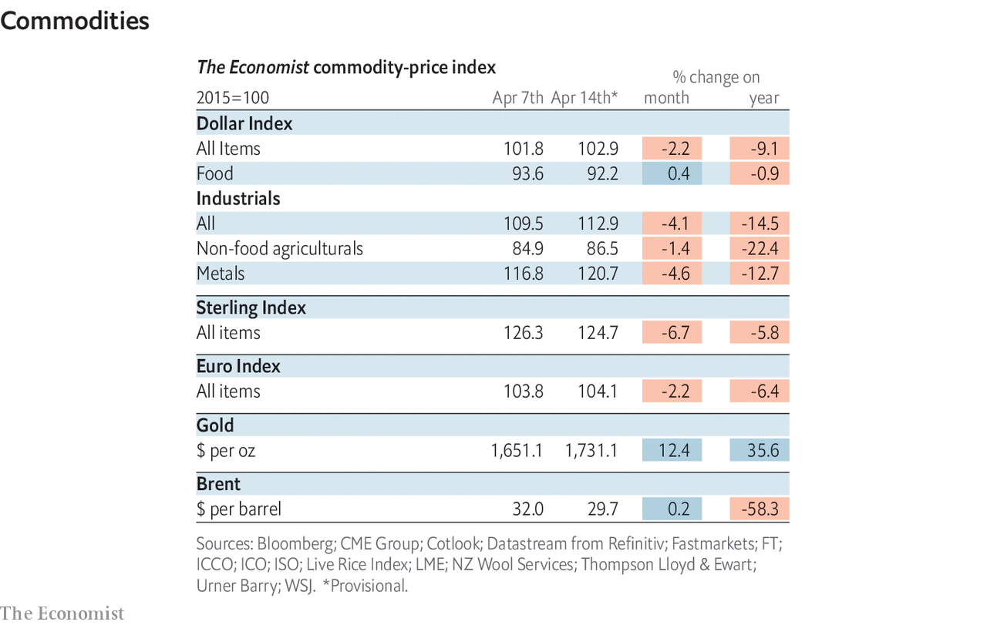

This article was downloaded by calibre from <https://www.economist.com/economic-and-financial-indicators/2020/04/18/economic-data-commodities-and-markets>

|  |  |  |  |
| --- | --- | --- | --- |
|  | Articles | Sections | Next |

|  |  |  |
| --- | --- | --- |
| Economic and ... | Sections | Obituary |

Graphic detail

The internet and covid-19: Get used to it

.

|  |  |  |
| --- | --- | --- |
| Economic and ... | Sections | Obituary |

|  |  |  |  |
| --- | --- | --- | --- |
|  | Articles | Sections | Next |

#### Get used to it

# How the internet has changed during lockdowns

Late-night Slack messages have replaced online dating

Apr 18th 2020 |

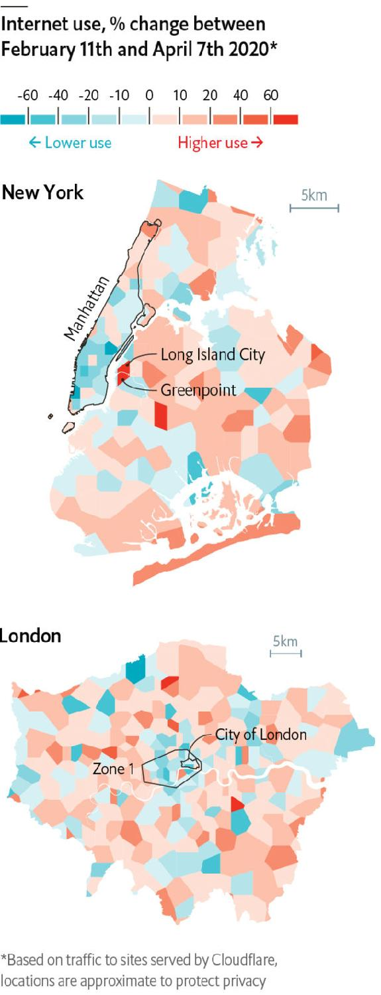

AS MANY CITIES approach a full month in lockdown, white-collar workers are settling into routines that previously would have seemed bizarre. A new poll by scholars at MIT found that 34% of American employees have switched from commuting to remote work. As offices have emptied, the virtual world has changed nearly as much as the physical one. And recent shifts in where, when and how the internet is used may be surprisingly durable.

The surge in remote working is apparent in the locations of data use tracked by Cloudflare, a network-infrastructure firm. In New York internet usage in Manhattan’s commercial core is down by around 30%. Conversely, usage in parts of gentrifying Greenpoint and Long Island City is up by over 60%. London displays a similar pattern, with steep drops in the city centre offset by heavier use in peripheral areas.

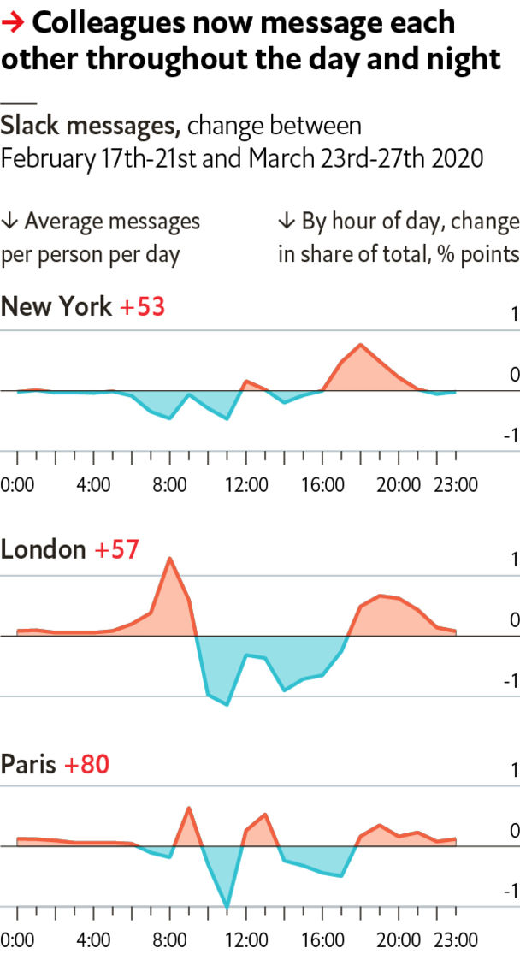

The timing of digital interactions shows how telecommuting has blurred the start and end of working hours. In Paris, London and New York the share of messages sent via Slack, a communication tool, during peak hours of 10am to noon and 2pm to 4pm has fallen. It has risen from 6pm to 9pm, as well as around 9am in London and Paris and at lunchtime in New York and Paris. One cost of not having to show up to work is that you also never get to unplug.

Some of the biggest changes are in how people spend time online. Surprisingly, traffic to gambling and pornography sites is flat. Visits to business and learning sites have risen the most, followed by games, e-commerce and streaming. The only category that has seen a decline is one incompatible with social distancing: online dating.

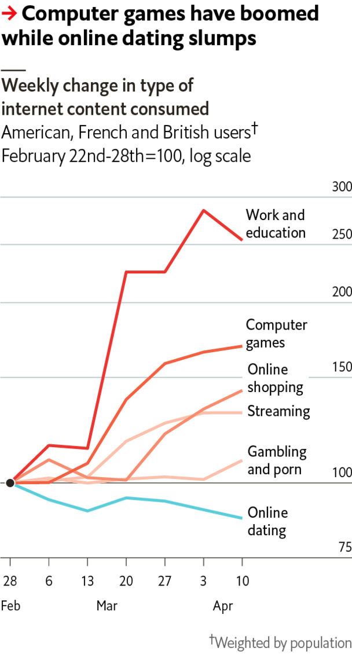

These trends could reverse once lockdowns are lifted. However, firms may not wish to turn back the clock. Researchers at Stanford found in 2015 that among workers at a Chinese call-centre, those randomly assigned to telecommute were 13% more productive than colleagues who stayed in the office. Companies that have now integrated remote workers can save on office space, and better retain staff during child-rearing years. In March Gartner, a research firm, asked 317 executives how many of their employees who have switched to remote work will not go back to the office; the average reply was 10%. Online dating will return one day. But office workers of the future may still have to fend off 9pm messages from telecommuting colleagues. ■

Sources: Cloudflare; Slack; SimilarWeb

This article was downloaded by calibre from <https://www.economist.com/graphic-detail/2020/04/18/how-the-internet-has-changed-during-lockdowns>

|  |  |  |  |
| --- | --- | --- | --- |
|  | Articles | Sections | Next |

|  |  |  |
| --- | --- | --- |
| Graphic detail | Sections |  |

Obituary

Hal Willner: Mr Music Man

.

|  |  |  |
| --- | --- | --- |
| Graphic detail | Sections |  |

|  |  |  |  |
| --- | --- | --- | --- |
|  | Articles | Sections | Next |

#### Mr Music Man

# Hal Willner died on April 7th

The music producer was 64

Apr 18th 2020 |

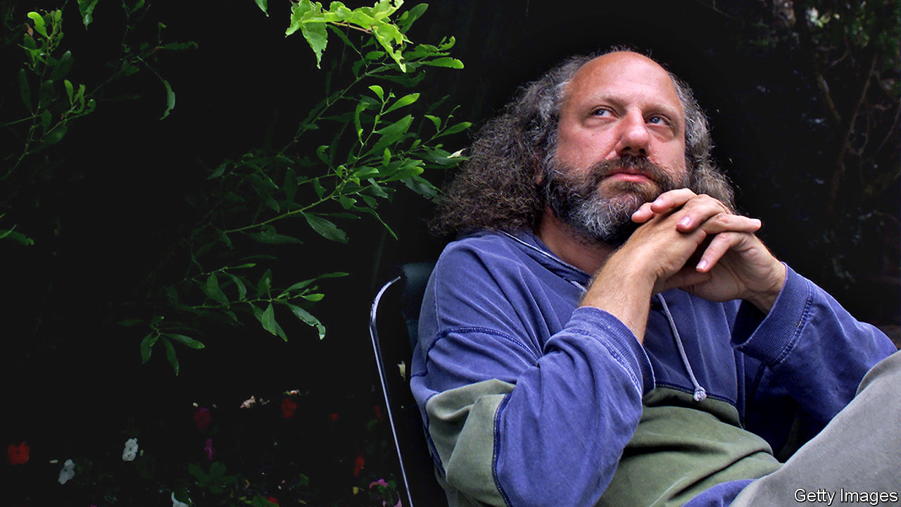

NEVER MIND that he was too young ever to have seen anything like it, he’d never heard anything like it either. The fans shrieking, the popping flash bulbs, the mics swimming with feedback. More than 50 years later, he told a reporter that hardly a fortnight went by without him recalling that Beatles gig in Philadelphia’s Convention Hall in 1964. “Well, shake it up baby. Twist and shout. Come on, come on, come on now...” For the eight-year-old nerd who’d been offered a ticket to the concert by a customer in his father’s deli, shaking it up was not just an affirmation of life, it became a talisman against dying.

Death played a big part in the making of Hal Willner. His father, Carl, who was born in Poland in 1923 and is still alive, survived two ghettoes, four labour camps and three death camps—Auschwitz, Buchenwald and Dachau. An SS guard tattooed the number on his arm. After the war Carl and his younger brother, Chiel, emigrated to America. Carl had just $2 in his pocket. The brothers went on to open Hymie’s delicatessen (named after their father) in Philadelphia. That 80 other members of the Willner family did not make it became a fixture in the carousel of family memories. It explained everything, Hal later said. He retreated into records, drawing cartoons, locking himself in his room and talking to himself.

In 1974, just as his father was thinking of selling Hymie’s to become a stockbroker, the 18-year-old record fiend started college in New York. He got a part-time job as assistant to Joel Dorn, who had produced popular albums for Bette Midler and Roberta Flack. The city then was bubbling with experimental comedy and the beginnings of punk. This was just as it was heading towards financial crisis and before the beautiful people with their shiny teeth were being photographed every night at Studio 54. New York was rough, he liked to say. It had a smell about it. The block he lived on had a gay bathhouse and the small midtown recording studio he rented soon filled up with posters of Laurel and Hardy, Pop-Eye puppets, Holocaust memories and a music box that played Karlheinz Stockhausen, a gift from Frank Zappa. Mr Willner, who had a mind like a reliquary, revered the music of T Rex as much as he favoured Kurt Weill, Lou Reed and Thelonious Monk.

Since the mid-20th century the music producer has become an iconic figure in the cultural world, as much impresario as director, bringing together singer and songwriter and conjuring up the character of an album as a living entity. The producer is the ship’s captain, magician and masterchef all rolled into one. As one friend of his liked to say: “The producer is in charge of everything.”

The first big project he dreamed up, aged 24, was to reimagine the music Nino Rota had composed for the films of Federico Fellini. He signed up Blondie’s Debbie Harry and Wynton Marsalis, then a promising young trumpeter who was not even 20, and flew to Rome to ask Fellini for the rights. It was like meeting Dickens, he later recalled. The two discovered they shared a passion for Laurel and Hardy. They bonded further over a multi-course Roman lunch and drove around the city before the director dropped him off with the words, “I leave you to your destiny.” La dolce vita never seemed quite the same after that.

With its jazz and pop bands, its congas and its steel drums, “Amarcord Nino Rota” showed him what was possible, not so much with composing new tunes, but with music that had already been written: imaginative pairings of musicians and instruments and the breaking down of barriers between musical aeons and musical genres: Lucinda Williams, a luscious American country singer, crooning Irish shanties like “Bonnie Portmore” or Marianne Faithfull, the chanteuse with the coal-tar voice—perfect for the music of underground Weimar Berlin—reimagining “The Ballad of the Soldier’s Wife” by Kurt Weill.

In 1980 he became the music co-ordinator for the sketches of “Saturday Night Live” (SNL), which allowed him to mine his musical memory and gave him a regular income while he worked on one-off projects like marrying up Scarlett Johansson, Courtney Love and the emcee from “Cabaret”, Joel Gray, for a charity evening at Carnegie Hall to raise funds for AIDS victims in Africa. Ms Faithfull, with whom he worked on putting music to the work of Gregory Corso, the last of the great Beat poets, described as him a “curator of souls, hipster, producer of miraculous albums” He never became an industry giant, but he gained a cult following, the Los Angeles Times said, “revered by a small but passionate confederacy of aficionados, critics and musicians”.

Like so many who had grown up in the shadow of the second world war, though, he knew that the difference between being OK and not OK was paper thin. As music and music production became increasingly computerised, he saw that he was no longer the new kid on the block. Death, which his musical energy had succeeded in banishing, now slunk back, first among his mentors and then his friends.

## And the band played on

Back in November, in between swinging punches at Donald Trump and Harvey Weinstein, his Twitter feed became a roll-call for the recently departed and a roster of just how many had called him a friend, starting with rock writer Nick Tosches. A salute to Michael Pollard, the actor with whom he worked on Terry Southern’s “Give Me Your Hump”, was followed by one to composer Irving Burgie and Stacey Foster of SNL. Then it was the turn of Monty Python collaborator Neil Innes on New Year’s Eve, McCoy Tyner for so long part of the John Coltrane Quartet, and Danny Thompson who played flute, alto sax, baritone sax and bassoon. On March 30th he was sending love to country singer John Prine, who was dying of coronavirus. The next week he, too, died of the virus, just a couple of days after he turned 64; the Beatles, with him to the end.■

This article was downloaded by calibre from <https://www.economist.com/obituary/2020/04/18/hal-willner-died-on-april-7th>

|  |  |  |  |
| --- | --- | --- | --- |
|  | Articles | Sections | Next |